

Data Advanced Analytics Google Certification

## Course 3 **Go Beyond the Numbers: Translate Data into Insights**

**Module 1:**

**What you’ll learn**

-Explore how to find and sculpt stories

-Discuss how PACE applies to telling stories using data

-Perform exploratory data analysis on a dataset in Python

-Data sources, data types, data structuring, and data cleaning

-Missing values, outliers, and categorical data

-Ethics of exploring and cleaning raw data

-Communicating your questions and findings

-Tableau

-Visuals and presentations

# Course 3 overview



Hello, and welcome to **Go Beyond the Numbers: Translate Data into Insights**, the third course in the Google Advanced Data Analytics Certificate. You’re on an exciting journey!

In this course, you will learn how to find and tell stories using data. You will explore how the elements of storytelling can enrich our understanding of data and how storytelling can help stakeholders interpret our data. You will learn how data professionals explore data, find intriguing trends and insights, and then share those stories with others in a data-informed presentation.

Then, you will learn basic principles and best practices of data exploration using Python. You will gain hands-on experience with data visualizations in Tableau, a specialized data visualization tool and explore how to create interesting visualizations, presentations, and talking points about your data. Finally, you will learn to prepare and deliver great presentations. All these skills will be foundational in your growing knowledge of data exploration and support your journey to become a data-informed storyteller.

## Course descriptions

The Google Advanced Data Analytics Certificate has seven courses. **Go Beyond the Numbers: Translate Data into Insights** is the third course.

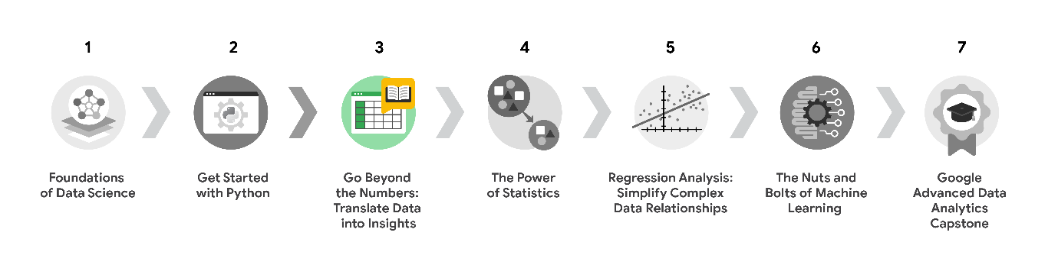

1. [**Foundations of Data Science**](https://www.coursera.org/learn/foundations-of-data-science/home/week/1) — Learnhow data professionals operate in the workplace and how different roles in the field of data science contribute to an organization’s vision of the future. Then, explore data science roles, communication skills, and data ethics.
2. [**Get Started with Python**](https://www.coursera.org/learn/get-started-with-python/home/week/1) —Discover how the programming language Python can power your data analysis. Learn core Python concepts, such as data types, functions, conditional statements, loops, and data structures.
3. [**Go Beyond the Numbers: Translate Data into Insights**](https://www.coursera.org/learn/go-beyond-the-numbers-translate-data-into-insight/home/week/1) — (current course) Learn the fundamentals of data cleaning and visualizations and how to reveal the important stories that live within data.
4. [**The Power of Statistics**](https://www.coursera.org/learn/the-power-of-statistics/home/week/1) — Explore descriptive and inferential statistics, basic probability and probability distributions, sampling, confidence intervals, and hypothesis testing.
5. [**Regression Analysis: Simplify Complex Data Relationships**](https://www.coursera.org/learn/regression-analysis-simplify-complex-data-relationships/home/week/1) — Learn to model variable relationships, focusing on linear and logistic regression.
6. [**The Nuts and Bolts of Machine Learning**](https://www.coursera.org/learn/the-nuts-and-bolts-of-machine-learning/home/week/1) — Learn unsupervised machine learning techniques and how to apply them to organizational data.
7. [**Google Advanced Data Analytics Capstone**](https://www.coursera.org/learn/google-advanced-data-analytics-capstone/home/week/1) — Complete a hands-on project designed to demonstrate the skills and competencies you acquire in the program.

## Course 3 content

Each course of this certificate program is broken into modules. You can complete courses at your own pace, but the module breakdowns are designed to help you finish the entire Google Advanced Data Analytics Certificate in about six months.

What’s to come? Here’s a quick overview of the skills you’ll learn in each module of this course.

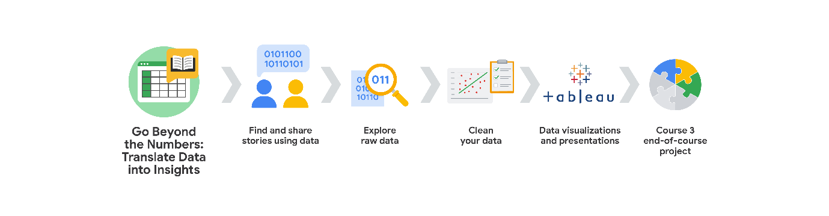

**Module 1: Find and share stories using data**

There are trends and stories hidden among the numbers and tables inside almost every dataset. In this part of the program, you will learn to tell stories using data and how to discover those stories by performing exploratory data analysis (EDA) and data cleaning. You’ll learn about the benefits and basic methods of data cleaning. You will explore different ways to visualize data and choose among them to suit the type of data you’re representing and your audience.

**Module 2: Explore raw data**

Cleaning a never-before-seen dataset can be daunting, but there is no need to fear. For this part of the program, you will be making sense of raw data by using powerful functions and libraries in Python. You will learn to perform EDA practices of discovering and structuring using Python, and you’ll discover that finding stories using EDA and the PACE workflow is all about gaining a thorough understanding of your data.

**Module 3: Clean your data**

At this point in the course, you’ll know what is in your dataset, but what’s next? In this part of the program, you will learn three more EDA practices: cleaning, joining, and validating. You will learn the importance of performing these practices on your data, and you’ll practice using Python notebooks to clean, validate, and join data.

**Module 4: Data visualizations and presentations**

Once you have learned how to find the story and clean the data, it’s time to share it with others. For this part of the program, you will learn to create and present your data stories in an ethical, accessible, and professional way. You will learn to use Tableau, one of the best visualization platforms for data scientists, at an advanced level.

**Module 5: Course 3 end-of-course project**

To conclude this part of the program, you will have the chance to demonstrate what you’ve learned in an end-of-course project. You will select a scenario outlining a business challenge, and you will be tasked with using the data provided to solve the problem. The concepts and skills you will learn in this part of the course will be critical to your success as a data analyst in the future.

## What to expect

Each course offers many types of learning opportunities:

* **Videos** led by Google instructors teach new concepts, introduce the use of relevant tools, offer career support, and provide inspirational personal stories.
* **Readings** build on the topics discussed in the videos, introduce related concepts, share useful resources, and describe case studies.
* **Discussion prompts** explore course topics for better understanding and allow you to chat and exchange ideas with other learners in the [**discussion forums**](https://www.coursera.org/learn/go-beyond-the-numbers-translate-data-into-insight/discussions).
* **Self-review activities** and **labs** give you hands-on practice in applying the skills you are learning and allow you to assess your own work by comparing it to a completed example.
* **Interactive plug-ins** encourage you to practice specific tasks and help you integrate knowledge you have gained in the course.
* **In-video quizzes** help you check your comprehension as you progress through each video.
* **Practice quizzes** allow you to check your understanding of key concepts and provide valuable feedback.
* **Graded quizzes** demonstrate your understanding of the main concepts of a course. You must score 80% or higher on each graded quiz to obtain a certificate, and you can take a graded quiz multiple times to achieve a passing score.

## Tips for success

* It is strongly recommended that you go through the items in each lesson in the order they appear because new information and concepts build on previous knowledge.
* Participate in all learning opportunities to gain as much knowledge and experience as possible.
* If something is confusing, don’t hesitate to replay a video, review a reading, or repeat a self-review activity.
* Use the additional resources that are referenced in this course. They are designed to support your learning. You can find all of these resources in the [**Resources**](https://www.coursera.org/learn/go-beyond-the-numbers-translate-data-into-insight/resources/iTmL7) tab.
* When you encounter useful links in this course, bookmark them so you can refer to the information later for study or review.
* Understand and follow the [Coursera Code of Conduct](https://www.coursera.support/s/article/208280036-Coursera-Code-of-Conduct?) to ensure that the learning community remains a welcoming, friendly, and supportive place for all members.

“When I heard about this, I was so excited. I said, wow, that is a really cool field to potentially get into.”

**What you’ll learn**

-Six practices of exploratory data analysis

-How PACE fits into the process of exploratory data analysis

-Importance of data visualization in the data exploration process

**Practices of EDA**

-Discovering

Data professionals familiarize themselves with the data so they can start conceptualizing how to use it

-Structuring

The process of taking raw data and organizing or transforming it to be more easily visualized, explained, or modeled

-Cleaning

-Joining

The process of augmenting or adjusting data by adding values from other datasets

The process of augmenting or adjusting data by adding values from other datasets

-Validating

## Question

What is the process data professionals use to investigate, organize, and analyze datasets in order to summarize the data’s main characteristics?

Exploratory data analysis

**Bias (in data structuring)**

Organizing data in groupings, categories, or variables that don’t accurately represent the whole dataset

# Case study: Deloitte

You’ve learned the definitions for each of the six practices of exploratory data analysis (EDA) — discovering, structuring, cleaning, joining, validating, and presenting. Next, you’ll discover how these practices apply to the data career space. In the following case study, members of Deloitte’s data team utilized the six practices of EDA to meet their client’s metrics and dashboarding needs. After you read more about the experiences of Deloitte’s team, you will have a tangible example of just how useful and empowering the application of these practices can be.



## Get to know Deloitte

[Deloitte](https://www2.deloitte.com/us/en.html) is an audit, consulting, tax, and advisory service. The company has over 100,000 employees and partners around the globe, and they work with many of the world’s biggest companies. Their services range from tax and accounting solutions to artificial intelligence and cyber security risk programs.



The multinational corporation’s business to business (B2B) model keeps their focus on working with their customers on a number of strategic and financial fronts, according to their individual needs. [Deloitte provides a range of services for client projects](https://youtu.be/8Gg5BsFexOU?list=PLl4by_vVwv0zjE2FRD7BMwI2lpaMCAgHh), such as auditing, consulting, financial advisory, risk advisory, taxes, data analysis, and regulation. Since 2008, Deloitte has made it their vision to be the standard of excellence in professional business services. Because of this focus, Deloitte has remained at the forefront of technology advancements, including the deployment of real-time metrics for their clients.

In just one of their many success stories,  Deloitte recently helped a billion-dollar cloud-based analytics and software company streamline the tracking and organization of their marketing leads and strategic analysis of their performance data. In this reading, you will see how Deloitte used EDA to analyze the client’s data in order to propose and apply a comprehensive solution they still use today.

## The challenges



One of Deloitte’s most important cloud-based software solution clients was facing a variety of challenges with their marketing and performance data. They asked Deloitte for help on all of them. Here are the specific challenges the client presented to Deloitte:

* Difficulty in following up on marketing leads
* Struggling to promptly track their marketing campaign performance
* A lack of personalized data dashboards displaying strategic company metrics

### **Following up on marketing leads**

Deloitte’s client offers a range of cloud-based analysis services and software products to businesses around the globe, making it a monumental task to follow up on each of the thousands of inquiries and potential sales leads they receive on a monthly basis. As a result, Deloitte’s client was seeking a solution to help them more adequately track and act on these leads.

### **Tracking marketing campaign performance**

Relying on just four data analysts for analysis of marketing campaign performance for a $1B multinational corporation was quickly becoming unsustainable. Before Deloitte stepped in to help, the client’s performance tracking system was a series of data tables updated manually and kept in a spreadsheet tab. Each region kept their own performance data, creating issues of consistency and hours of wasted energy for the analysts who had to compile and merge the data to get a corporation-wide performance picture.

### **Personalizing data dashboards**

Because of differing needs for each level of management and varying marketing regions across the globe, the client needed to be able to easily parse and group data specific to their employees' needs across the corporation. Because they were working off of multiple spreadsheets across several different departments and locales, the client found they could not easily filter the data according to their needs, and therefore were not able to adequately shift strategy to improve performance.

## The approach

As Deloitte began working with their new client, they designed an approach that would meet each of their client’s proposed needs. Refer to the following PACE entries to review this approach in detail.

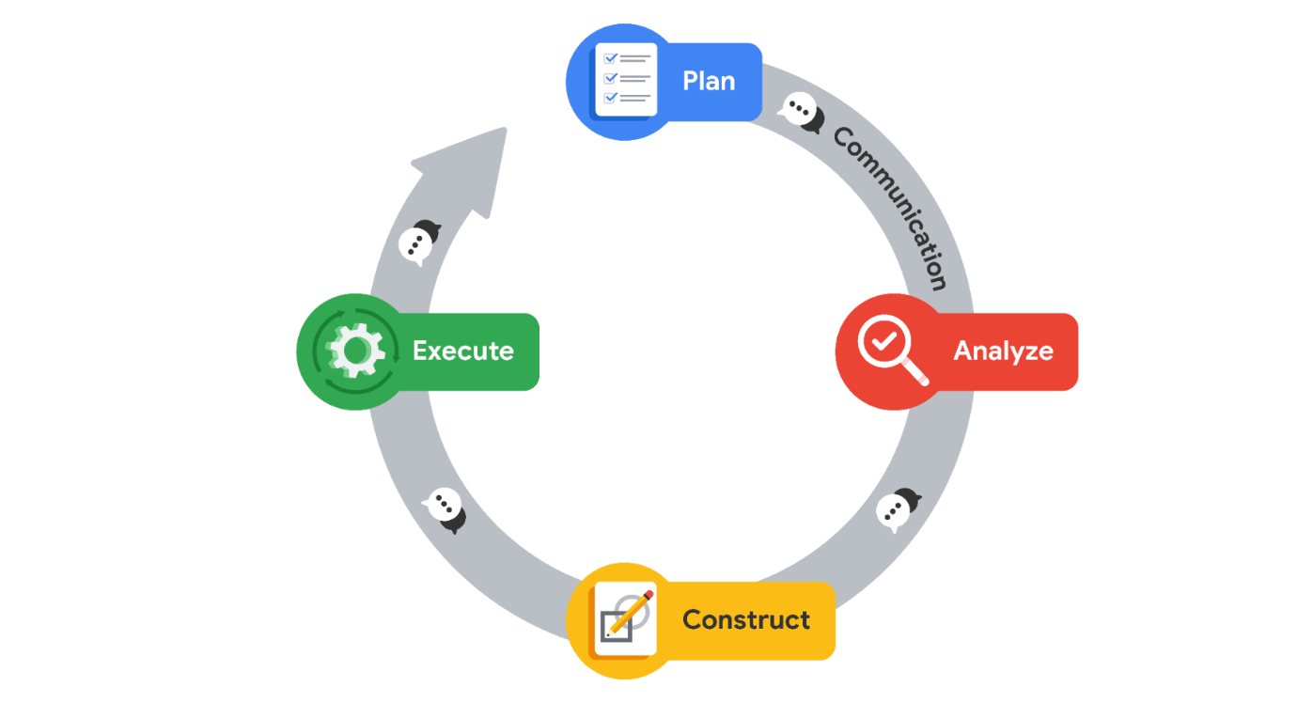

## Plan

To begin, Deloitte needed to meet with client stakeholders and help develop their vision for the future according to the three areas mentioned above: **Marketing leads, measuring marketing campaign performance,** and **personalizing data dashboards.**

They needed to understand the client’s business by learning its processes, objectives and key results (OKRs), and how it approached and used its customer and potential customer data.

Key project milestones were established early on, and adjusted according to any new knowledge acquired. Those milestones were:

* Alignment with client on the future vision of data architecture and dashboards
* Establishment of the new data architecture
* Launch of descriptive and diagnostic tooling
* Launch of predictive models
* Training the global sales team on new tooling

Deloitte determined that their project plan would begin with the discovering, structuring, and cleaning practices of EDA on the client’s company-wide performance data.

Deloitte quickly learned what OKRs the client wanted easy access to once the personalized dashboards were complete and set plans to achieve that outcome. Those OKRs came in the form of the following questions:

* How much revenue was earned from a particular marketing campaign?
* What industry, region, sector, and company size did the new customer fall into?
* How long did it take to finalize the sale after the initial point of contact?
* What was the success rate of different types of campaigns (i.e., in person events vs. online webinars)?
* What was the average cost of marketing per customer gained?

## Analyze

As part of the framing of their initial analysis of the client’s data, it became clear the client was unfamiliar with Deloitte’s product services offerings, including assets like easy-to-use Tableau dashboard tooling. Because of this, the client’s assumptions and requests for what was possible fell far below Deloitte’s actual capability. This represented an opportunity to not only meet, but actually exceed the client’s expectations of the project.

The first challenges of analysis were in understanding where the data was coming from and what each data variable meant. The client used non-standard naming conventions and definitions in their data, so Deloitte had to use discovering practices to learn their language to fully understand the client’s data and plan for how to help them use it.

Deloitte found that the client’s approach to tracking performance at the time was clunky and overbroad at best. The performance data they gathered consisted of the use of overall averages to determine value of strategic company-wide actions. Without specific performance data per region, the company had no simple way of tracking regional performance.

* As an example of the client’s overbroad data tracking at the time, this was the formula they used to derive the average revenue they gained per marketing campaign:

𝑎𝑣𝑒𝑟𝑎𝑔𝑒 𝑐𝑢𝑠𝑡𝑜𝑚𝑒𝑟 𝑐𝑜𝑛𝑡𝑟𝑎𝑐𝑡 𝑣𝑎𝑙𝑢𝑒𝑎𝑣𝑒𝑟𝑎𝑔𝑒 𝑐𝑜𝑠𝑡 𝑜𝑓 𝑚𝑎𝑟𝑘𝑒𝑡𝑖𝑛𝑔 𝑐𝑎𝑚𝑝𝑎𝑖𝑔𝑛𝑠=𝑎𝑣𝑒𝑟𝑎𝑔𝑒 𝑟𝑒𝑣𝑒𝑛𝑢𝑒 𝑔𝑎𝑖𝑛𝑒𝑑 𝑝𝑒𝑟 𝑐𝑎𝑚𝑝𝑎𝑖𝑔𝑛*average* *cost* *of* *marketing* *campaignsaverage* *customer* *contract* *value*​=*average* *revenue* *gained* *per* *campaign*

Deloitte learned that the client’s internal marketing and sales teams were organized according to geographic regions, industries, and customer account size. Regional leads had the authority and autonomy to conduct marketing research and campaigns on their own, but did take guidance and occasional instruction from the global team. Deloitte’s analysts began structuring the data in a consistent way company wide as part of their EDA of the client’s data.

In terms of customer life cycle, Deloitte learned that the client’s marketing leads would generate marketing campaigns and then inform sales partners in their regions. Field sales representatives would follow up on all leads generated from the campaigns, and they would also network outside of existing campaigns to find additional customers. This discovering part of EDA informed Deloitte’s team on more specific and plausible solutions that could meet the client’s needs.

The Deloitte team used discovering and structuring practices of EDA in spreadsheets to review all of the existing data from the client’s Salesforce and marketing campaigns. They began to identify and define every data variable that existed in their client’s sales system. Once an inventory of data variables was structured, cleaned, and validated, the Deloitte team brainstormed the type of insights they could glean from the information.

After the review, Deloitte utilized the presenting practice of EDA to share the information they had gathered with the client. They listened and asked questions to get a better understanding of how the client viewed their own business and what factors were important to them according to the data.

## Construct

From their analysis of the client’s systems and the discovering, structuring, and cleaning practices of EDA they did on the client’s performance data, Deloitte learned that the client needed a total overhaul of their analytical process; one that provided much greater detail and allowed them to identify and address bottlenecks, unprofitable campaigns, and unproductive customer segments.

With the client’s approval, Deloitte completely rebuilt the client’s data internal infrastructure from the ground up to make analysis more streamlined.

On top of the infrastructure overhaul, the most hands-on solution for the client was to build customized and dynamic dashboards for specific stakeholders.

* The Deloitte team worked with each client stakeholder group to understand their needs and their OKRs.
* They then helped develop tailored solutions for the client by creating supporting collateral resources, such as a data dictionary to define what each variable represents and how it should and should not be used.

Deloitte used the information they gathered from their client’s data to build automations and tools that performed predictive analysis on their OKRs. This allowed the client to establish feasible, but aggressive targets for the future.

## Execute

Deloitte’s overhaul of their client’s data infrastructure led to a streamlined, tiered approach to global data gathering. Where before the client was forced to rely on regionally gathered and inconsistently structured spreadsheets to formulate their performance metrics, they could now easily quantify everything from global, company-wide performance down to the performance of a regional team of sales team members on specific products and subset of clients.

After implementation of personalized dashboards, Senior VPs could filter the status and performance of the OKRs to the whole departments and regions for which they were responsible. Additionally, regional leads, marketing leads, and even local sales leads were able to view data filtered down to their applicable area.

As part of implementation, Deloitte team members created training sessions according to their client’s needs across the organization—everything from how to use the personalized dashboards to how to maintain the new data infrastructure.

The Deloitte-designed dashboards and data infrastructure instantly became valuable assets to multiple stakeholders across the client’s global team.

**Note**: In their work with the client,Deloitte was not following the PACE workflow as it is listed above; rather, while documenting the details of their work into this case study, Deloitte’s work for the client has been organized according to the PACE workflow to demonstrate the versatility of its application.

## Summarizing the results

When Deloitte started working with their new client, they were hesitant to trust the accuracy of the company’s existing data because of a lack of standardization between the marketing and sales teams. That lack of consistency made it difficult to associate any particular sale to a specific campaign. After a few weeks of studying the client’s sales and marketing processes and EDA of their data, Deloitte rebuilt the data infrastructure in a way that directly tied all sales to their applicable marketing campaigns. They tied these sales to marketing campaigns using primary keys aligned across a number of data tables that could be easily sorted. This gave the Deloitte analysts an idea of what was possible with the data and led them to building final products that exceeded what the client thought was initially possible.

Once the infrastructure was overhauled, Deloitte’s performance of EDA uncovered that the client was focusing too much effort on earning new clients, to the detriment of existing client relationships. While sales to new clients did increase because of the focus of OKRs, sales to their existing customers plummeted. This result was previously unknown to the client. As a result, the client was able to pivot their strategy by both sales region and product. The dynamic dashboards Deloitte created became the client’s most effective tool for measuring and tracking performance as well as setting strategy.

## Conclusion

Because of Deloitte’s focus on the client’s business problem in both their assessment of the client’s business practices and EDA of their data, they were able to uncover truths previously hidden in unstructured data. Deloitte built interactive, dynamic data dashboards designed to filter down to any sales region or product in the company so that the client could discover these truths on their own in the future. The greatest benefit of these solutions was the client’s leadership and marketing leads became a much more agile team. They were better able to make effective business decisions that directly improved revenue. The data infrastructure overhaul and data dashboard solutions also helped improve the work-life balance of their analysts. All of these outcomes were notable for not only the client but also Deloitte because the client was and is a key partner and account for the firm. Because of their focus on the data, Deloitte was able to offer a solution that exceeded the client’s expectations and, in turn, helped them better serve their customers around the world.

“Storytelling is the way that your insights make it to other people and really make change.”

“A really good way to tell a story with data is to think about categories of users, categories of devices, or categories of use cases.”

“It’s very important ethically to make sure that your data is working for everyone.”

# Test your knowledge: Tell stories with data

Question 1

Fill in the blank: The presenting stage of exploratory data analysis involves sharing \_\_\_\_\_, which can include graphs, charts, diagrams, or dashboards.

data visualizations

Question 2

During which exploratory data analysis practice might a data professional familiarize themself with the meaning of column headers in a dataset?

Discovering

Question 3

If sampled data is organized in such a way that it does not accurately represent its population as a whole, what problem will occur?

Biased data

## Question

When a data professional discusses a project plan and company goals with stakeholders, which element of the PACE model are they engaged in?

Plan

# Reference guide: The EDA process

## The six practices of EDA are iterative and non-sequential

Exploratory data analysis (EDA) is not like a cake recipe. It is ***not*** a step-by-step process you follow. Instead, the six practices of EDA are iterative and non-sequential.

* **Iterative**: Relating to or involving repetition of a process
* **Non-sequential**: Not arranged in or following an order or sequence.

Because of the varying nature of datasets, the approach to exploring that data will be different each time. That means that you will need to use your logic and experience throughout the EDA process to determine which of the six practices to utilize, how many times to apply them, and when in the process you should apply them.

## Save this course item

You may want to save a copy of this guide for future reference. You can use it as a resource for additional practice or in your future professional projects. To access a downloadable version of this course item, click the link below and select “Use Template.”

[Reference guide: The EDA process](https://docs.google.com/document/d/1LfewYbfeyQqky1Qx75PS7LOS3E_JsJDRQGthylWqX-k/template/preview)

OR

If you don’t have a Google account, you can download the item directly from the attachment below.

## **Visual example**

Imagine you are assigned a dataset that has only 200 rows and five columns of data about trees in a coniferous forest in Norway. You know that to complete your full analysis you’ll need more than 1,000 rows and at least two more columns. Even without much more detail than that, your entire EDA process might look something like this:

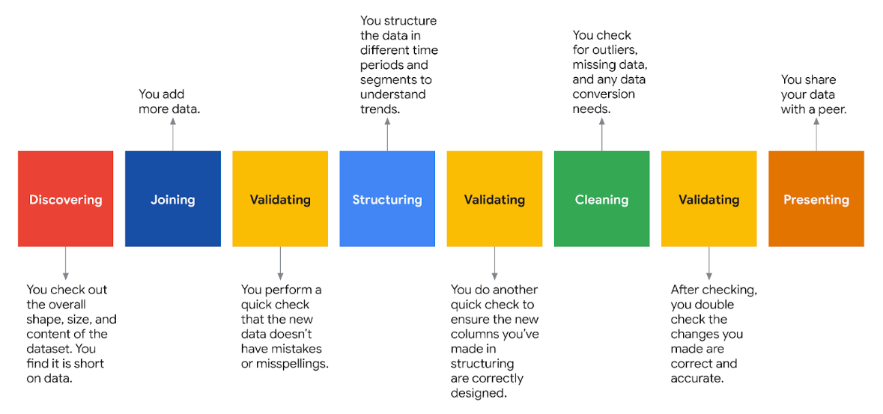

1. **Discovering**: You check out the overall shape, size, and content of the dataset. You find it is short on data.
2. **Joining**: You add more data.
3. **Validating**: You perform a quick check that the new data doesn’t have mistakes or misspellings.
4. **Structuring**: You structure the data in different time periods and segments to understand trends.
5. **Validating:** You do another quick check to ensure the new columns you’ve made in structuring are correctly designed.
6. **Cleaning**: You check for outliers, missing data, and needs for conversions or transformations.
7. **Validating**: After cleaning, you double check the changes you made are correct and accurate.
8. **Presenting**: You share your dataset with a peer.

Notice you performed the “validating” practice iteratively, or multiple times, to make sure your changes to the data did not unwittingly introduce errors. Also, because you recognized the need for more data up front, the practice of “joining” was performed immediately following the practice of “discovering.”

After you present your cleaned dataset to a peer, there is a good chance you will receive notes or ideas for more exploration and/or cleaning. Because of that, you will see even more iterations.

**Pro tip**: Data scientists expect to perform the practices of EDA multiple times on a dataset before they feel comfortable declaring it “clean” and ready for modeling or machine learning algorithms.

## The importance of EDA in ethical machine learning

As algorithms and machine learning networks begin to make more and more decisions on behalf of individuals, companies, and even governments, the discussion of ethics and regulation becomes more and more important. According to the [Institute for Ethical AI & Machine Learning](https://ethical.institute/principles.html), there are eight principles for developing machine learning systems in a responsible way.

**Key principles of the EDA process**

The following two principles are inherently part of the EDA process:

* **Human augmentation**: This principle ensures humans are inserted throughout the AI or machine learning algorithm systems for oversight. Thorough EDA, performed by data scientists, is perhaps one of the best ways to limit bias, imbalance, and inaccuracies being fed into an algorithm.
* **Bias evaluation**: Without human interference, bias is too easily injected and reproduced in machine learning models. Performing methodical EDA processes will lead data scientists to be aware of and act on biases and imbalances in the data.

**Pro tip**: The importance of assuring adherence to ethical standards cannot be overstated in the data career space. Data professionals need to continuously grow their capacities to recognize bias and discrimination by consistently applying an ethical mindset to their EDA work.

Beyond machine learning, EDA is applicable to nearly any important data-based decision. Moving forward, you will learn about many applications of EDA and the necessity of an iterative and non-sequential approach.

**Data visualization Python packages**

-Matplotlib

-Seaborn

-Plotly

# Test your knowledge: How PACE informs EDA and data visualizations

### 1.

Question 1

What are the primary drivers of a data-driven story? Select all that apply.

1 / 1 point

Project goals

Correct

Data insights and the stories they help create are driven by a project’s purpose and its goals.

Stakeholder theories

Project purpose

Correct

Data insights and the stories they help create are driven by a project’s purpose and its goals.

Sales predictions

### 2.

Question 2

Fill in the blank: In order to help avoid \_\_\_\_\_ in the workplace, data professionals share the PACE plan with stakeholders and team members.

1 / 1 point

miscommunication

Correct

In order to help avoid miscommunication in the workplace, data professionals share the PACE plan with stakeholders and team members. PACE helps users communicate, solve problems, and make judgments quickly and efficiently.

### 3.

Question 3

Why is it important to maintain proper scale of a graph’s axes in a data visualization?

1 / 1 point

To avoid misrepresenting the data

Correct

It is important to maintain proper scale of a graph’s axes in a data visualization to avoid skewing the data. Data visualizations with skewed data mislead the audience.

# Categorize: EDA best practices

**Deleting duplicate data entries is considered a “cleaning” practice of EDA**

**True**

**Data visualizations are only useful when presenting data to others**

**False**

**EDA must be performed using Python**

**False**

**Deleting duplicate data entries is considered a “cleaning” practice of EDA**

**True**

**Adding a new calculated column based on existing data is called “structuring”**

**True**

**Adding a new column from a different dataset is called “structuring”**

**False**

**Skipping the “cleaning” practice of EDA can lead to incorrect analysis outcomes**

**True**

**EDA is an iterative process**

**True**

**All six practices of EDA are to be done in strict order**

**False**

**Along with visualizations, making a clean dataset is also considered “presenting”**

**True**

**Review**

Practices of EDA

PACE workflow

Ethics of working with data

Data visualizations

# Glossary terms from module 1

# Terms and definitions from Course 3, Module 1

**Bias**: In data structuring, refers to organizing data results in groupings, categories, or variables that are misrepresentative of the whole dataset

**Cleaning**: The process of removing errors that might distort your data or make it less useful; one of the six practices of EDA

**Data visualization**: A graph, chart, diagram, or dashboard that is created as a representation of information

**Discovering**: The process data professionals use to familiarize themselves with the data so they can start conceptualizing how to use it; one of the six practices of EDA

**Exploratory data analysis (EDA)**: The process of investigating, organizing, and analyzing datasets and summarizing their main characteristics, often by employing data wrangling and visualization methods; the six main practices of EDA are: discovering, structuring, cleaning, joining, validating, and presenting

**Joining**: The process of augmenting data by adding values from other datasets; one of the six practices of EDA

**PACE**: A workflow data professionals can use to remain focused on the end goal of any given dataset; stands for plan, analyze, construct, and execute

**Presenting**: The process of making a cleaned dataset available to others for analysis or further modeling; one of the six practices of EDA

**Structuring**: The process of taking raw data and organizing or transforming it to be more easily visualized, explained, or modeled; one of the six practices of EDA

**Validating**: The process of verifying that the data is consistent and high quality; one of the six practices of EDA

# Module 1 challenge

### 1.

Question 1

Fill in the blank: Exploratory data analysis is the process of investigating, organizing, and analyzing datasets and \_\_\_\_\_ their main characteristics.

summarizing

### 2.

Question 2

A data team leader at a clothing manufacturer reviews a dataset that will be used to decide where to open new retail stores. They conceptualize how their analytics team can most effectively use the dataset. Which exploratory data analysis process does this scenario describe?

1 / 1 point

Discovering

### 3.

Question 3 (Answers not final)

What processes do data professionals perform during the structuring exploratory data analysis step? Select all that apply.

Categorize data into categories representing the dataset  
Transform raw data.

### 4.

Question 4

Which of the following statements correctly compare data cleaning to data validation during exploratory data analysis? Select all that apply.

1 / 1 point

When cleaning, a data professional looks for missing values, duplicate entries, and extreme outliers. When validating, a data professional uses digital tools to confirm the data types within a dataset.

Cleaning involves ensuring the data is useful. Validating involves verifying the data is of high quality.

### 5.

Question 5

Fill in the blank: In exploratory data analysis, \_\_\_\_\_ is the process of augmenting a dataset by adding values from other sources.

joining

### 6.

Question 6 (Answers not final)

What may be involved with visualizing data during exploratory data analysis? Select all that apply.

Making data visualizations available to team members for further analysis or modeling

Considering people with auditory impairments by providing captioned descriptions about the data

### 7.

Question 7

Fill in the blank: To avoid miscommunication in the workplace, data professionals can share \_\_\_\_\_ with a working group to get early feedback.

Initial data findings

### 8.

Question 8

A data professional works on a project that uses data from a study about mental health in Europe. They consider how to use the PACE framework to perform exploratory data analysis practices effectively. Which of the following objectives will this help them achieve? Select all that apply.

Confirm that the data represents an appropriate number of European geographical regions

Ensure ethical depictions of the mental health subjects represented in the study

Maintain focus on key priorities and project purpose

**Module 2:**

**What you’ll learn**

-Data types and data sources

-Discovering

-Structuring

-Formatting

“To understand and drive value in your organization, you have to really understand the underlying data.”

“I spend a lot of time trying to figure out what the right financial view is, so they can have the insights into their business to influence their decision making.”

**Examples of data source**

**-**Report from a computer system

-Selection from a large online database

-Data table that has been manually entered

**Data formats**

**-**Tabular files

-XML files

-CSV files

-Excel files

-DB files

-JSON files

pandas.read\_csv()

Import json

pandas.read\_json

pandas.df.to\_json()

**First-party data**

Data that was gathered from inside your own organization

**Third-party data**

Data gathered outside your organization and aggregated

## Question

Fill in the blank: \_\_\_\_\_ is data gathered from inside your own organization.

First-party

**Other types of data**

-Geographic

-Demographic

-Numeric

-Time-based

-Financial

-Qualitative

Given what you know of the data so far, does it align with the PLAN, as defined by your PACE workflow?

# Reference guide: Import datasets with Python

In your career as a data professional, you will come across various datasets that have different file types or are stored in various databases. As you’ve learned previously, it is critical for you to know what these data types are and how to import data using Python. Below you will find examples of importing both databases through connections and data files into Python.

Although you will use the Coursera platform for Python coding, you will need to know how to work with and import CSV files if you’d like to download and open them outside of Coursera.

## Save this course item

You may want to save a copy of this guide for future reference. You can use it as a resource for additional practice or in your future professional projects. To access a downloadable version of this course item, click the link below and select “Use Template.”

[Reference guide: Import datasets with Python](https://docs.google.com/document/d/14l3Veh2Z9n87GlD3Z1Qohjp0rqS2gx98Cxe8GRBwpys/template/preview)

OR

If you don’t have a Google account, you can download the item directly from the attachment below.

## How to import a dataset from a CSV file

For this example, find a CSV file on your computer. If you don't have one, you can use a dataset of unicorn companies (companies that reached a valuation of $1 billion USD) from this course's [Resources](https://www.coursera.org/learn/go-beyond-the-numbers-translate-data-into-insight/resources/9mSWv).

There are several different ways to import a CSV file into Python, but we will only review some of the more common ways. Start by using a **with** statement and **open()** function. Pass the **file name (or file path)** of the CSV file to the **open()** function along with an argument for the **mode** parameter of the function.

**with open("file path/file name", mode=)**

So the syntax so far is:

**Note:** The following code block is not interactive.

1

with open('file\_path/file\_name', mode=)

The mode is telling the Python library what to do with the file. When defining the **mode**, you use one of the following options:

* **'r'** – read
* **'w'** – write
* **'a'** – append
* **'+'** – create new file

Typically, you’ll be defining the mode inside the **with open()** argument field as **'r'** because you want Python to open and read the CSV file.

Next, we’ll add **as file** to the end, which is assigning the result to a variable name. In this case, we’ll name it **data**.

**Note:** The following code block is not interactive.

1

2

with open('example\_filepath/file', mode='r') as file:

    data = file.read()

### **Importing a CSV file using pandas**

Instead of using Python's standard library to read a file, you can use pandas to import the CSV file into a dataframe. First, of course, you’ll want to import the pandas library into your Python notebook.

**import pandas as pd**

Next, you’ll use the **read\_csv()** function to load the data into a dataframe. The file path then goes in the argument field.

**df = pd.read\_csv("file path/file name")**

**Note:** The following code block is not interactive.

1

2

import pandas as pd

df = pd.read\_csv('example\_filepath/file')

***Note:*** You can also use this same syntax for importing a CSV file that is stored on the internet. In the place of the filename, you would simply copy and paste the url.

## How to import data by connecting to a database

There are a number of database solutions that you can connect to with Python, such as BigQuery, MySQL, SQLite, and Oracle. Databases are a convenient way for companies and organizations to store huge amounts of data.

If the dataset is small enough, it can be downloaded and manipulated locally on your computer. However, often the datasets kept in databases are too large to access in their entirety on a personal computer. In this case you have a number of different options, most of which involve querying the database with SQL to obtain specific tables of interest. In other words, you extract select parts—usually specified rows and/or columns—from the whole dataset. The manner in which querying is done can vary with respect to systems, platforms, and interfaces. Because of this variability, this reference guide will only present a couple of different ways to query databases. Specifically, it will explore BigQuery, Google’s data warehouse that provides a wide range of tools and services to facilitate analysis.

### **Downloading data from BigQuery**

#### **Step 1: Access BigQuery**

BigQuery allows you to upload data for storage, and it also has a number of publicly available datasets to explore. You can access these public datasets for free using [BigQuery Sandbox](https://cloud.google.com/bigquery/docs/sandbox), which requires a free Google account. Sandbox gives you 10 GB of active storage and 1 TB of processed query data each month for free.

#### **Step 2: Perform a query**

Once you have authenticated your account and created a new project as indicated in the instructions linked in step one, you’re ready to query a database. Note that if it is your first time logging in, you may encounter a window asking “New to the BigQueryUI?” with a link to a quickstart guide.

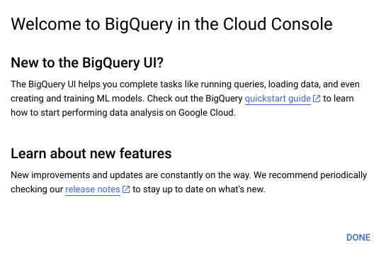

The quickstart guide will guide you through the same steps as those presented to you here.

From the “Welcome to your SQL Workspace!” page, click the “Compose a new query” button.

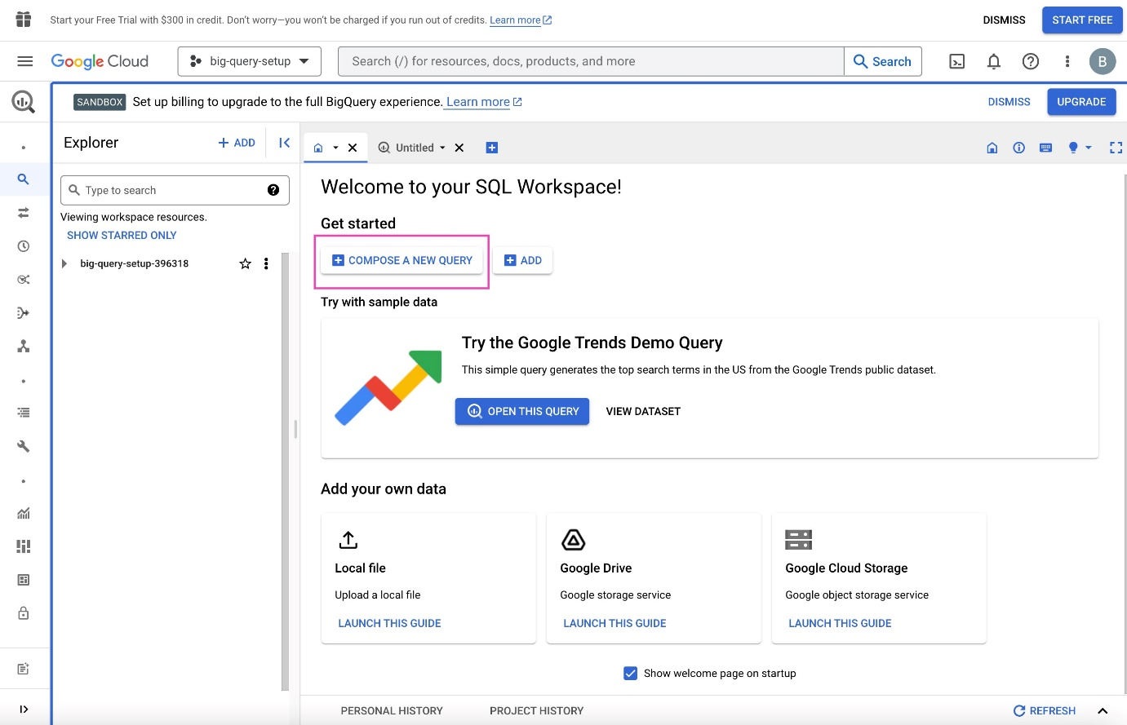

Click into the search bar in the Explorer on the left side of the page. For example, you can search for “trees.” Initially, this will return zero results. However, click “Search all projects” and it will return applicable datasets from the **bigquery-public-data** project and premade tables from those datasets.

Click the **street\_trees** table in the **san\_francisco** dataset. The metadata for this table will appear in a panel to the right. Then, click “Query” from the menu at the top of the metadata panel. You can opt to query in a new tab or in a split-pane of the current window.

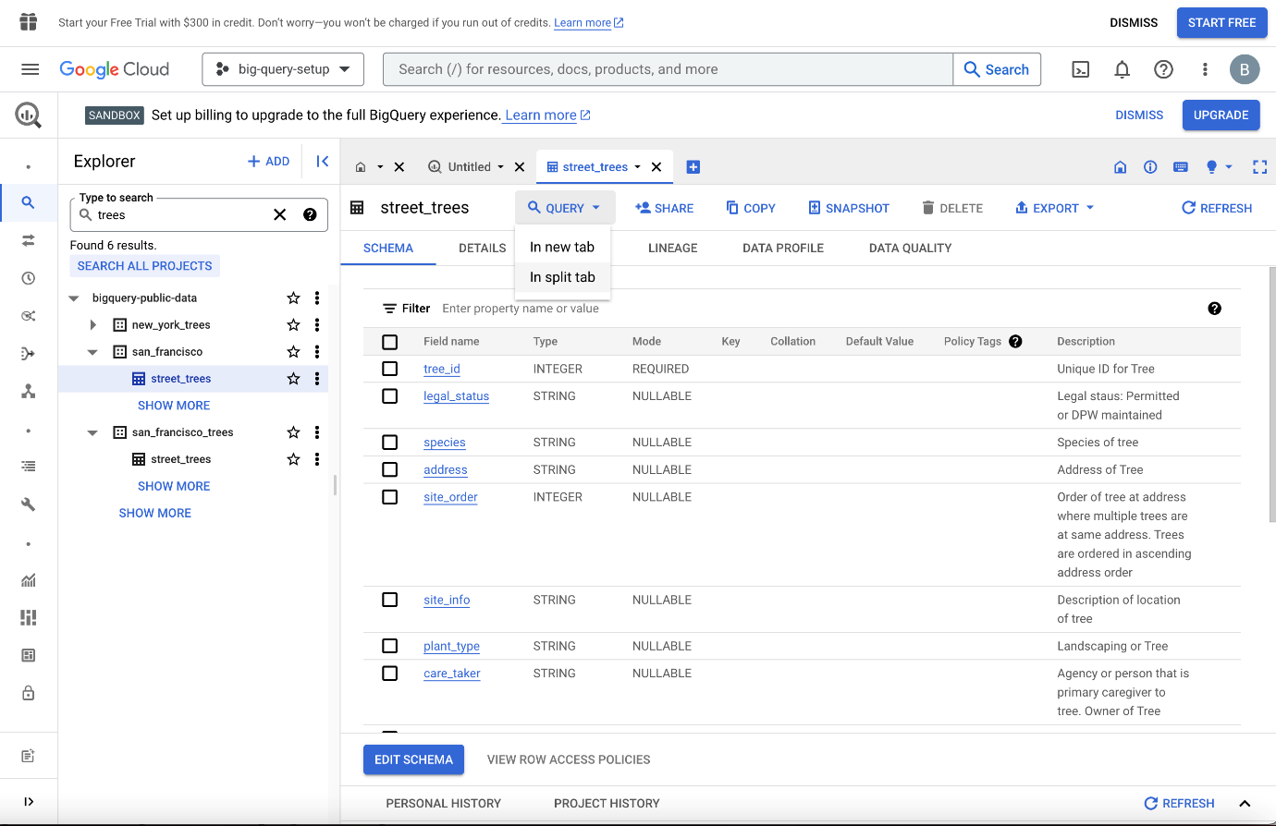

Now, you can query the table using SQL. For example, the query in the following screenshot selects 5,000 rows with columns of **tree\_id**, **plant\_type**, **species**, **plant\_date**, and **dbh** – defined as “depth, height.”

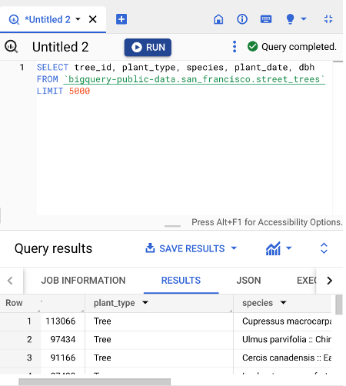

Once you are satisfied with your query, click the “Run” button at the top of the SQL query panel. The results will display below, and there is a button to “Save results,” which allows you to save the resulting table in different locations and formats. From there, you can read the data into your notebook.

### **Using notebooks within BigQuery**

Another way to access data on BigQuery is by using the tools within the BigQuery platform itself. This workflow more closely resembles what data professionals would use when working with very large datasets stored in the cloud. Essentially, you set up a virtual machine on BigQuery. A virtual machine is a computer that has its own CPU, memory, software, etc., just like any other computer, only it does not have its own dedicated hardware; they most often exist as a partition on a server. You can work in a Jupyter notebook on the virtual machine on the BigQuery platform, from which you can query and pull in data directly.

This process requires you to set up a payment method. However, new users get a $300 credit, and a ML instance is only a few cents per minute, so you’ll get approximately 2,000 hours of free usage before incurring any charges. There are a lot of great tutorials for setting this up. For instance, if you search for “How to use Jupyter notebook in Google Cloud AI,” you’ll find a number of useful videos and blogs on the topic.

### **Using notebooks outside of BigQuery**

It’s also possible to query data on BigQuery from notebooks that are not on the BigQuery platform. However, the details of this process are dependent on a number of factors, including the platform that is hosting the notebook, the operating environment, and the specific location of the data being accessed. Therefore, we will not go into depth on this method. Feel free to explore this on your own, though. You’ll find many helpful online resources that are just a search away.

## Key takeaways

There are lots of different kinds of data, which means there are numerous ways to import data. Learning several methods to import data, whether it be from a data file or a database, will build a solid foundation for your career as a data professional.

## Resources for more information

To learn more about importing data into Python, you can refer to the following links:

* [An overview of importing data in Python](https://towardsdatascience.com/an-overview-of-importing-data-in-python-ac6aa46e0889)
* [How to connect to BigQuery from a Colab](https://colab.sandbox.google.com/notebooks/bigquery.ipynb#scrollTo=fkhbyGaXKs_6)

# Reference guide: Pandas methods for the discovery of a dataset

## Python reference guide for EDA: Discovering

Use the following pandas methods and attributes to help you learn about a dataset when you encounter it for the first time.

### Save this course item

You may want to save a copy of this guide for future reference. You can use it as a resource for additional practice or in your future professional projects. To access a downloadable version of this course item, click the link below and select “Use Template.”

[Reference guide: Pandas methods for the discovery of a dataset](https://docs.google.com/document/d/1mCRJUC01dgk9MI_0QN7nmq_pJesdYWBIbJIi3-LOe_Q/template/preview#heading=h.azzt9john55t)

OR

If you don’t have a Google account, you can download the item directly from the attachment below.

**DataFrame.head()**

* The **head()** method will display the first n rows of the dataframe.
* In the argument field, input the number of rows you want displayed in a Python notebook. The default is 5 rows.
* Once executed, the **head()** method returns something like this:

**df.head(10)**

| **index** | **date** | **number of strikes** | **center point geom** |
| --- | --- | --- | --- |
| 0 | 2018-01-03 | 194 | POINT(-75 27) |
| 1 | 2018-01-03 | 41 | POINT(-78.4 29) |
| 2 | 2018-01-03 | 33 | POINT(-73.9 27) |
| 3 | 2018-01-03 | 38 | POINT(-73.8 27) |
| 4 | 2018-01-03 | 92 | POINT(-79 28) |
| 5 | 2018-01-03 | 119 | POINT(-78 28) |
| 6 | 2018-01-03 | 35 | POINT(-79.3 28) |
| 7 | 2018-01-03 | 60 | POINT(-79.1 28) |
| 8 | 2018-01-03 | 41 | POINT(-78.7 28) |
| 9 | 2018-01-03 | 119 | POINT(-78.6 28) |

**Note**: In a Python notebook, the results of **head()** will not include a table with visible grid lines.

### **DataFrame.info(X)**

* The **info()** method will display a summary of the dataframe, including the range index, dtypes, column headers, and memory usage.
* Leaving the argument field blank will return a full summary. As an option, in the argument field you can type in **show\_counts=True**, which will return the count of non-null values for each column.
* Once executed, the **info()** method returns something like this:

**Note:** The following code block is not interactive.

1

2

3

4

5

6

7

8

9

10

11

df.info()

<class ‘pandas.core.frame.DataFrame’>

RangeIndex:3401012 entries, 0 to 3401011

Data columns (total 3 columns):

#     Column                   Dtype

--    ----                     -----

0     date                     object

1     number\_of\_strikes        int64

2     center\_point\_geom        object

Dtypes: int64(1), object(2)

Memory usage 77.8+ MB

### **DataFrame.describe()**

* The **describe()** method will return descriptive statistics of the entire dataset, including total count, mean, minimum, maximum, dispersion, and distribution.
* Leaving the argument field blank will default to returning a summary of the data frame’s statistics. As an option, you can use “include=[X]” and “exclude=[X]” which will limit the results to specific data types, depending on what you input in the brackets.
* Once executed, the **describe()** method returns something like this:

**df\_joined.describe()**

| **N/A** | **longitude** | **latitude** | **number\_of\_strikes\_x** | **number\_of\_strikes\_y** |
| --- | --- | --- | --- | --- |
| count | 717530.00 | 717530.00 | 717530.00 | 323700.00000 |
| mean | -90.875445 | 33.328572 | 21.637081 | 25.410587 |
| std | 13.648429 | 7.938831 | 48.02952 | 57.421824 |
| min | -133.9000 | 16.600000 | 1.00000 | 1.000000 |
| 25% | -102.80000 | 26.900000 | 3.00000 | 3.000000 |
| 50% | -90.300000 | 33.200000 | 6.00000 | 8.000000 |
| 75% | -80.900000 | 39.400000 | 21.00000 | 24.000000 |
| max | -43.800000 | 51.700000 | 2211.00000 | 2211.000000 |

**Note**: In a Python notebook, the results of **describe()** will not include a table with visible grid lines.

### **DataFrame.shape**

* **shape** is an attribute that returns a tuple representing the dimensions of the dataframe by number of rows and columns. Remember that attributes are not followed by parentheses. The code will look something like this:

**Note:** The following code block is not interactive.

1

2

df.shape

(3401012, 3)

## Key takeaways

**head()**, **info()**, **describe()**, and **shape** are pandas tools that data scientists can use to understand a dataset at a high level. The information learned from using these tools will serve to inform the remainder of your EDA work when you use pandas to analyze data throughout your career.

## Resources for more information

For more information on the EDA discovering functions above and others like it, you can use the online Pandas reference guide:

* [A list of Pandas dataframe functions](https://pandas.pydata.org/docs/reference/frame.html)

# Instructions

All of the instructional videos with onscreen coding demonstrations have a corresponding follow-along guide that is available to you. The follow-along guide is an annotated Jupyter notebook organized to match the content from each module. It contains the same code shown in the videos for that module. This guide is provided for your reference; you do not need to add any text or run the code yourself. If you would like to run the code, you will need to run each cell sequentially for the code to function as intended.

In addition to content that is identical to what is covered in the videos, you’ll often find additional information throughout the guide to explain the purpose of each concept covered, why the code is written in a certain way, and tips for running the code.

The landing page for each follow-along notebook also provides information about data sources (when relevant) and tips on how to access and use these guides.

# Data dictionary

This notebook uses a file called **eda\_using\_basic\_data\_functions\_in\_python\_dataset1.csv**, which comes from the **bigquery-public-data.noaa\_lightning.lightning\_strikes** public data table. It contains cloud-to-ground lightning strike information collected by Vaisala's National Lightning Detection Network (NLDN) and aggregated into 0.1° tiles by the National Centers for Environmental Information. This means that all the daily strikes within 0.1° latitude x 0.1° longitude are summed and assigned to a set of geographic coordinates that represents the center of the 0.1° “square” area.

One thing to keep in mind as you explore this data is that, because circles of latitude become shorter the farther they are from the equator, the area encompassed by the tiles becomes smaller the farther north the tiles are located. For example, tiles at 50°N are approximately 7 km x 11 km, while tiles at 20°N are approximately 10 km x 11 km—nearly 43% larger in area.

More information about this data can be found in the [linked documentation](https://ghrc.nsstc.nasa.gov/uso/ds_docs/nldn/gai_dataset.html).

Remember, you can access and download the data for any Jupyter notebook activity from within the notebook itself by navigating to the **Lab Files** dropdown menu at the top of the page, clicking into the **/home/jovyan/work** folder, selecting the relevant data file, and clicking **Download**.

Each row of the data used in this lesson represents a total lightning strike count on the specified date for a particular location. Refer to the column information in the table below. **Note that some lessons in this course use subsets of the data.**

| **Column name** | **Type** | **Description** |
| --- | --- | --- |
| number\_of\_strikes | int64 | The total count of lightning strikes in that geographic tile on a given date |
| center\_point\_geom | str | String of characters representing the geographic center point of the strikes based on the latitude and longitude given |
| longitude | float64 | Longitudinal point extracted from center\_point\_geom |
| latitude | float64 | Latitudinal point extracted from center\_point\_geom |
| date | str | The recorded date (format: YYYY/MM/DD) |
| zip\_code | float64 | United States postal code where given center point is located |
| city | str | U.S. city where given center point is located |
| state | str | U.S. state where given center point is located |
| state\_code | str | Two-letter abbreviation for the U.S. state where the center point is located |

## Set up a split screen

While watching the videos that follow this notebook, you may find it helpful to track the instructor’s progress by following along in your own Jupyter Notebook. It can be helpful to review the code notebook alongside the video, especially if you’re new to coding in Python.

To do so:

1. Open the video in one browser window.
2. Then, open the annotated follow-along guide in a separate window.
3. Arrange your screen so that the video and the follow-along guide are both visible.

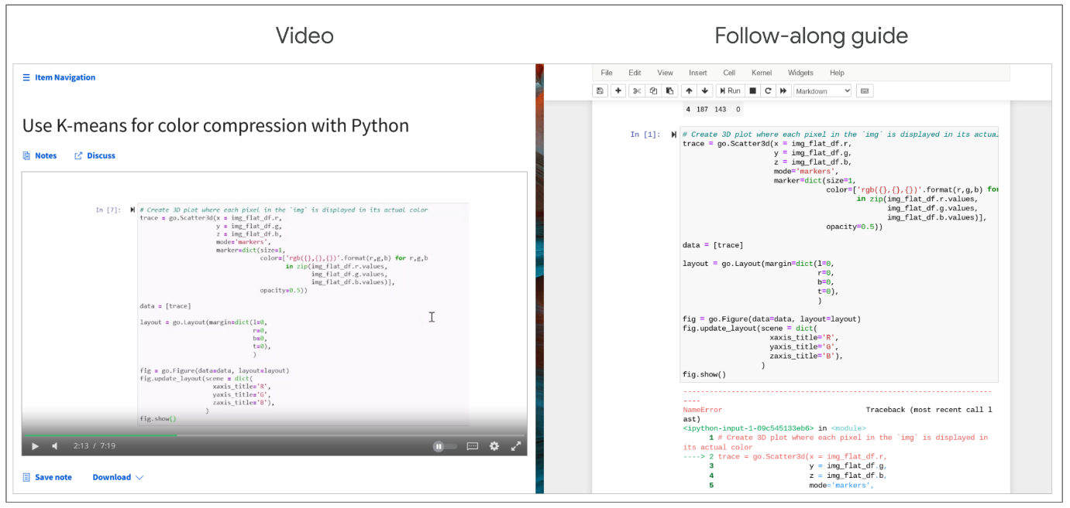

## Tips for working with the follow-along guide

Follow these suggestions to enhance your learning experience:

* Reference the [Jupyter notebooks reading](https://www.coursera.org/learn/get-started-with-python/supplement/2poER/create-upload-and-edit-jupyter-notebooks) before starting if you need more information on working with the Jupyter notebooks.
* Go to the section of the follow-along guide for the current module's content. The follow-along guide has different sections for each video included in the module's content. The in-video message will direct you to the relevant section in the guide for the specific video you are viewing.
* Follow along in the notebook as the instructor discusses the code.

**Type:**

**Control + Enter**

**OR**

**Command + Enter**

**Python libraries used for this dataset**

Pandas

Numpy

**Helpful Python methods for ‘discovering’**

.describe()

.sample()

.size

.shape

## Question

Why does a data professional use the Python methods **describe()**, **sample()**, **size**, and **shape**?

To learn about a dataset

# **Instructions**

In this lab, you will use basic discovering Python functions to get characteristics of a provided dataset associated with a business scenario. You will practice applying these Python functions and simple visualizations to analyze and understand data.

# **Data Dictionary**

This activity uses a dataset called [Unicorn\_Companies.csv](https://www.coursera.org/learn/go-beyond-the-numbers-translate-data-into-insight/resources/9mSWv). It represents a list of private companies with a value of over $1 billion as of March 2022. The data includes the name of the country where the company was founded, its current valuation, funding, industry, top investors, year it was founded, and the year it reached a $1 billion valuation.

The dataset contains:

**1,074 rows** – each row is a different company

**10 columns**

| **Column name** | **Type** | **Description** |
| --- | --- | --- |
| Company | str | Company name |
| Valuation | str | Company valuation in billions (B) of dollars |
| Date Joined | datetime | The date in which the company reached $1 billion in valuation |
| Industry | str | Company industry |
| City | str | City the company was founded in |
| Country/Region | str | Country the company was founded in |
| Continent | str | Continent the company was founded in |
| Year Founded | int | Year the company was founded |
| Funding | str | Total amount raised across all funding rounds in billions (B) or millions (M) of dollars |
| Select Investors | str | Top 4 investing firms or individual investors (some have less than 4) |

The data was taken from [Kaggle](https://www.kaggle.com/datasets/mysarahmadbhat/unicorn-companies).

Remember, you can access and download the data for any Jupyter notebook activity from within the notebook itself by navigating to the **Lab Files** dropdown menu at the top of the page, clicking into the **/home/jovyan/work** folder, selecting the relevant data file, and clicking **Download**.

# Tips

To complete this lab, you will open a Jupyter notebook and follow instructions to enter code and written responses where prompted.

The Jupyter notebook will autosave as you work, or you can manually save it by clicking the **Save and Checkpoint** button or by selecting **Save and Checkpoint** from the **File** menu.

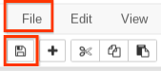

As you complete the lab, note the following features:

* **Sections:** Step-by-step instructions in each section lead you through the lab.
* **Code blocks:** Code blocks allow you to practice key Python coding concepts. Add code where prompted and then click the **Run** button to execute your code and view any possible output.

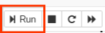

* **Questions:** Thought questions offer moments to pause and think about concepts and your output as you move through the lab.
* **Hints:** Hidden hints provide suggestions you can use to complete your work.

To review how to work in Jupyter notebooks, refer to the reading [Create, upload, and edit Jupyter notebooks](https://www.coursera.org/learn/get-started-with-python/supplement/2poER/create-upload-and-edit-jupyter-notebooks).

Be sure to complete this lab before moving on. To get started, click **Open Lab**.

The next course item will provide an exemplar of a completed lab for you to compare to your own work. To access the exemplar, return to the main course menu and click **Next**.



# Test your knowledge: Discovering is the beginning of an investigation

### 1.

Question 1

Fill in the blank: Tabular, XML, CSV, and JSON files are all types of \_\_\_\_\_.

1 / 1 point

data formats

### 2.

Question 2

It is a data professional’s responsibility to understand data sources because the data’s origin affects its reliability.

1 / 1 point

True

It is a data professional’s responsibility to understand data sources because the data’s origin affects its reliability. Understanding data sources involves determining how and when to contact the people who either generated the data or are in charge of delivering it in order to inform data discovery.

### 3.

Question 3

Which Python method returns the total number of entries and the data types of individual data entries in a dataset?

1 / 1 point

**Info()**

Correct

**Info()** returns the total number of entries and the data types of individual data entries in a dataset.

**Hypothesis**

A theory or an explanation, based on evidence, that is not yet proved true

**Questions during the discovering process**

How can I break this data into smaller groups so I can understand it better?

How can I prove my hypothesis?

In its current form, can this data give me the answers I need?

**Questions to ask**

Which months have the most passenger traffic?

Which weeks, dates, or known holidays have the highest number of passengers?

When are tickets typically purchased?

**Test hypothesis**

Analyze the data to understand whether the airline would attract more customers by lowering prices on those specific flights

**Organize or alter data**

-Regroup entries into months/years or age ranges

-Group customer ages into age ranges

-Combine or split data columns

-Change date formats or time zones

# Reference guide: Datetime manipulation

The following tables can serve as reference guides to remind you of the shorthand code for manipulating datetime strings into individual objects.

## Save this course item

You may want to save a copy of this guide for future reference. You can use it as a resource for additional practice or in your future professional projects. To access a downloadable version of this course item, click the link below and select “Use Template.”

[Reference guide: Datetime manipulation](https://docs.google.com/document/d/1R-YhTtylVinN4q09jymGE648ViVebMsBla-scs3Nb4s/template/preview)

OR

If you don’t have a Google account, you can download the item directly from the attachment below.

## Manipulating datetime strings in Python

Below, you will find a table with the datetime functions you can use to help you manipulate datetime objects in different ways.

| **Code** | **Format** | **Example** |
| --- | --- | --- |
| **%a** | Abbreviated weekday | Sun |
| **%A** | Weekday | Sunday |
| **%b** | Abbreviated month | Jan |
| **%B** | Month name | January |
| **%c** | Date and time | Sun Jan 1 00:00:00 2021 |
| **%d** | Day (leading zeros) | 01 to 31 |
| **%H** | 24 hours | 00 to 23 |
| **%I** | 12 hours | 01 to 12 |
| **%j** | Day of year | 001 to 366 |
| **%m** | Month | 01 to 12 |
| **%M** | Minute | 00 to 59 |
| **%p** | AM or PM | AM/PM |
| **%S** | Seconds | 00 to 61 |
| **%U** | Week number (Sun) | 00 to 53 |
| **%W** | Week number (Mon) | 00 to 53 |
| **%w** | Weekday | 0 to 6 |
| **%x** | Locale’s appropriate date representation | 08/16/88 (None);  08/16/1988 (en\_US);  16.08.1988 (de\_DE) |
| **%X** | A locale’s appropriate time representation | 21:30:00 (en\_US);  21:30:00 (de\_DE) |
| **%y** | Year without century | 00 to 99 |
| **%Y** | Year | 2022 |
| **%z** | Offset | +0900 |
| **%Z** | Time zone | EDT/JST/WET etc (GMT) |

## Datetime functions to remember

All of the following date string manipulations require the datetime package to be imported first.

**(from datetime import datetime)**

| **Code** | **Input Type** | **Input Example** | **Output Type** | **Output Example** |
| --- | --- | --- | --- | --- |
| **datetime.strptime(“25/11/2022”, “%d/%m/%Y”)** | string | “25/11/2022” | DateTime | “2022-11-25  00:00:00” |
| **datetime.strftime(dt\_object, “%d/%m/%Y”)** | DateTime | “2022-11-25  00:00:00” | string | “25/11/2022” |
| **dt\_object = datetime.strptime(“25/11/2022”, “%d/%m/%Y”)**  **datetime.timestamp(dt\_object)** | string | “25/11/2022” | float (UTC timestamp in seconds) | 1617836400.0 |
| **datetime.strptime(“25/11/2022”, “%d/%m/%Y”).strftime(“%Y-%m-%d”)** | string | “25/11/2022” | string | “2022-11-25” |
| **datetime.fromtimestamp(1617836400.0)** | float (UTC timestamp in seconds) | 1617836400.0 | DateTime | datetime.datetime(2021, 4, 7, 23, 0) |
| **datetime.fromtimestamp(1617836400.0).strftime(“%d/%m/%Y”)** | float (UTC timestamp in seconds) | 1617836400.0 | string | “'07/04/2021'” |
| **from pytz import timezone**  **ny\_time = datetime.strptime(“25-11-2022  09:34:00-0700”,**  **“%d-%m-%Y  %H:%M:%S%z”)**  **Tokyo\_time = ny\_time.astimezone(timezone(‘Asia/Tokyo’))** | string | NewYork timezone “25-11-2022  09:34:00-0700” | DateTime | Tokyo timezone 2022, 11, 26, 1, 34, JST+9:00:00 STD> |
| **datetime.strptime(“20:00”, “%H:%M”).strftime(“%I:%M %p”)** | string | “20:00” | string | “08:00 PM” |
| **datetime.strptime(“08:00 PM”, “%I:%M  %p”).strftime(“%H:%M”)** | string | “08:00 PM” | string | “20:00” |

## Datetime in NumPy and pandas

A preface regarding terminology in the following section: **datetime** refers to the specific module of that name in the Python standard library or to the specific class within that module. Datetime (or uncapitalized, datetime) refers to any date/time-related object from any library or language.

You’ve learned that the **datetime** [module in Python’s standard library](https://docs.python.org/3/library/datetime.html) contains a number of classes used to work with time data, including **date**, **time**, **datetime**, **timedelta**, **timezone**, and **tzinfo**. Remember, modules are similar to libraries, in that they are groups of related classes and functions, but they are generally subcomponents of libraries. Classes are  data types that bundle data and functionality together.

NumPy and pandas have their own datetime classes that offer significant performance boosts when working with large datasets. Pandas datetime classes, like the rest of the pandas library, are built on NumPy. These classes have very similar (and in many cases identical) functionality to Python’s native datetime classes, but they run more efficiently due to NumPy and pandas’ vectorization capabilities. Therefore, although you can use **datetime** data in pandas, it’s generally better to use NumPy or pandas datetime objects when working in pandas, if possible.

[NumPy’s datetime classes](https://numpy.org/doc/stable/reference/arrays.datetime.html) include, most notably, **datetime64** and **timedelta64**. Like **datetime** objects, **datetime64** objects contain date and time information in a single data structure; and, like **timedelta** objects, **timedelta64** objects contain information pertaining to spans of time.

[Pandas’ datetime classes](https://pandas.pydata.org/docs/user_guide/timeseries.html) include **Timestamp**, **Timedelta**, **Period**, and **DateOffset**.

Because these classes are efficient and dynamic in their capabilities, you often don’t need to import the **datetime** module when working with datetime data in pandas. Also, pandas will automatically recognize datetime-like data and convert it to the appropriate class when possible. Here’s an example:

1

2

3

4

import pandas as pd

data = ['2023-01-20', '2023-04-27', '2023-06-15']

my\_series = pd.Series(data)

my\_series

RunReset

This series contains string data, but it can be converted to **datetime64** data using the **pd.to\_datetime()** function:

1

2

my\_series = pd.to\_datetime(my\_series)

my\_series

RunReset

Refer to the [pandas to\_datetime() documentation](https://pandas.pydata.org/docs/reference/api/pandas.to_datetime.html) for more information about this function.

When a **Series** object contains datetime data, you can use **dt** to access various properties of the data. For example:

1

2

3

print(my\_series.dt.year)

print(my\_series.dt.month)

print(my\_series.dt.day)

RunReset

Note that it’s not uncommon to import the **datetime** module from Python’s standard library as **dt**. You may have encountered this yourself. In such case, **dt** is being used as an alias. The pandas **dt** **Series** accessor (as demonstrated in the last example) is a different thing entirely. Refer to the [pandas dt accessor documentation](https://pandas.pydata.org/pandas-docs/stable/user_guide/basics.html#dt-accessor) for more information.

## Key takeaways

Use reference guides like the tables above throughout your career to help remind you of the different ways to manipulate datetime objects. Even experts in the field use reference guides, rather than memorizing all this information. Getting familiar with guides like these will be beneficial because you will be using them throughout your career as a data professional.

# Instructions

All of the instructional videos with onscreen coding demonstrations have a corresponding follow-along guide that is available to you. The follow-along guide is an annotated Jupyter notebook organized to match the content from each module. It contains the same code shown in the videos for that module. This guide is provided for your reference; you do not need to add any text or run the code yourself. If you would like to run the code, you will need to run each cell sequentially for the code to function as intended.

In addition to content that is identical to what is covered in the videos, you’ll often find additional information throughout the guide to explain the purpose of each concept covered, why the code is written in a certain way, and tips for running the code.

The landing page for each follow-along notebook also provides information about data sources (when relevant) and tips on how to access and use these guides.

# Data dictionary

This notebook uses a file called **eda\_manipulate\_date\_strings\_with\_python.csv**, which comes from the **bigquery-public-data.noaa\_lightning.lightning\_strikes** public data table. It contains cloud-to-ground lightning strike information collected by Vaisala's National Lightning Detection Network (NLDN) and aggregated into 0.1° tiles by the National Centers for Environmental Information. This means that all the daily strikes within 0.1° latitude x 0.1° longitude are summed and assigned to a set of geographic coordinates that represents the center of the 0.1° “square” area.

One thing to keep in mind as you explore this data is that, because circles of latitude become shorter the farther they are from the equator, the area encompassed by the tiles becomes smaller the farther north the tiles are located. For example, tiles at 50°N are approximately 7 km x 11 km, while tiles at 20°N are approximately 10 km x 11 km—nearly 43% larger in area.

More information about this data can be found in the [linked documentation](https://ghrc.nsstc.nasa.gov/uso/ds_docs/nldn/gai_dataset.html).

Remember, you can access and download the data for any Jupyter notebook activity from within the notebook itself by navigating to the **Lab Files** dropdown menu at the top of the page, clicking into the **/home/jovyan/work** folder, selecting the relevant data file, and clicking **Download**.

Each row of the data used in this lesson represents a total lightning strike count on the specified date for a particular location. Refer to the column information in the table below. Note that some lessons in this course use subsets of the data.

| **Column name** | **Type** | **Description** |
| --- | --- | --- |
| number\_of\_strikes | int64 | The total count of lightning strikes in that geographic tile on a given date |
| center\_point\_geom | str | String of characters representing the geographic center point of the strikes based on the latitude and longitude given |
| longitude | float64 | Longitudinal point extracted from center\_point\_geom |
| latitude | float64 | Latitudinal point extracted from center\_point\_geom |
| date | str | The recorded date (format: YYYY/MM/DD) |
| zip\_code | float64 | United States postal code where given center point is located |
| city | str | U.S. city where given center point is located |
| state | str | U.S. state where given center point is located |
| state\_code | str | Two-letter abbreviation for the U.S. state where the center point is located |

## Set up a split screen

While watching the videos that follow this notebook, you may find it helpful to track the instructor’s progress by following along in your own Jupyter Notebook. It can be helpful to review the code notebook alongside the video, especially if you’re new to coding in Python.

To do so:

1. Open the video in one browser window.
2. Then, open the annotated follow-along guide in a separate window.
3. Arrange your screen so that the video and the follow-along guide are both visible.



## Tips for working with the follow-along guide

Follow these suggestions to enhance your learning experience:

* Reference the [Jupyter notebooks reading](https://www.coursera.org/learn/get-started-with-python/supplement/2poER/create-upload-and-edit-jupyter-notebooks) before starting if you need more information on working with the Jupyter notebooks.
* Go to the section of the follow-along guide for the current module's content. The follow-along guide has different sections for each video included in the module's content. The in-video message will direct you to the relevant section in the guide for the specific video you are viewing.
* Follow along in the notebook as the instructor discusses the code.

**Current data format**

2016-06-13

## Question

In the statement **df['date'].dt.strftime('%Y-W%V')**, which element states that the year should be included in the new column format?

**%Y**

# Test your knowledge: Understand data format

### 1.

Question 1

Which of the following statements will convert the **'time'** column into a datetime data type?

**df['time'] = pd.to\_datetime(df['time'])**

Correct

The statement **df['time'] = pd.to\_datetime(df['time'])**will convert the **'time'**column into a datetime data type.

### 2.

Question 2

What Python method formats data into a new string representing date and time using a date, time, or datetime object?

**Strftime()**

Correct

**Strftime()** formats data into a new string representing date and time using a date, time, or datetime object.

### 3.

Question 3

A data professional is creating a bar chart in Python. To label the y-axis Sales to Date, a data professional could use the following statements: **plt.ylabel('Sales to Date')**.

Correct

A data professional is creating a bar chart in Python. To label the y-axis Sales to Date, a data professional could use the following statements: **plt.ylabel('Sales to Date')**.

**Sorting**

The process of arranging data into meaningful order for analysis

**Extracting**

The process of retrieving data from a dataset or source for further processing

**Filtering**

The process of selecting a smaller part of your dataset based on specific parameters and using it for viewing or analysis.

**Grouping**

Aggregating individual observations of a variable into groups.

**Merging**

Method to combine two different data frames along a specified starting column

## Question

What structuring method enables data professionals to divide information into smaller parts in order to facilitate efficient examination and analysis from different viewpoints?

Slicing

# Reference guide: Pandas tools for structuring a dataset

As you’ve learned, there are far too many Python functions to memorize all of them. That’s why, as every data professional will tell you, you’ll be using reference sheets and coding libraries nearly every day in your data analysis work.

The following reference guide will help you identify the most common Pandas tools used for structuring data. Note that this is just for reference. For detailed information on how each method works, including explanations of every parameter and examples, refer to the linked documentation.

## Save this course item

You may want to save a copy of this guide for future reference. You can use it as a resource for additional practice or in your future professional projects. To access a downloadable version of this course item, click the link below and select “Use Template.”

[Reference guide: Pandas tools for structuring a dataset](https://docs.google.com/document/d/1g2lJKS_4bSkPLf6zzB2J2VfW26VylwPvzPDRde-21oA/template/preview)

OR

If you don’t have a Google account, you can download the item directly from the attachment below.

## **Combine data**

Note that for many situations that require combining data, you can use a number of different functions, methods, or approaches. Usually you’re not limited to a single “correct” function. So if these functions and methods seem very similar, don’t worry! It’s because they are! The best way to learn them, determine what works best for you, and understand them is to use them!

[**df.merge()**](https://pandas.pydata.org/docs/reference/api/pandas.DataFrame.merge.html)

* A method available to the **DataFrame** class.
* Use **df.merge()** to take columns or indices from other dataframes and combine them with the one to which you’re applying the method.
* Example:
* **Note**: The following code block is not interactive.

1

df1.merge(df2, how=‘inner’, on=[‘month’,’year’])

[**pd.concat()**](https://pandas.pydata.org/docs/reference/api/pandas.concat.html)

* A pandas function to combine series and/or dataframes
* Use **pd.concat()** to join columns, rows, or dataframes along a particular axis
* Example:
* **Note**: The following code block is not interactive.

1

df3 = pd.concat([df1.drop(['column\_1','column\_2'], axis=1), df2])

[**df.join()**](https://pandas.pydata.org/docs/reference/api/pandas.DataFrame.join.html)

* A method available to the **DataFrame** class.
* Use **df.join()** to combine columns with another dataframe either on an index or on a key column. Efficiently join multiple **DataFrame** objects by index at once by passing a list.
* Example:
* **Note**: The following code block is not interactive.

1

df1.set\_index('key').join(df2.set\_index('key'))

Visual representation of a combination:



## Extract or select data

**df[[columns]]**

* Use **df[[columns]]** to extract/select columns from a dataframe. Example:

1

2

3

print(df)

print()

df[['animal', 'legs']]

RunReset

[**df.select\_dtypes()**](https://pandas.pydata.org/docs/reference/api/pandas.DataFrame.select_dtypes.html)

* A method available to the **DataFrame** class.
* Use **df.select\_dtypes()** to return a subset of the dataframe’s columns based on the column dtypes (e.g., **float64**, **int64**, **bool**, **object**, etc.). Example:

1

2

3

4

print(df)

print()

df2 = df.select\_dtypes(include=['int64'])

df2

RunReset

Visual representation of extraction:



## Filter data

Recall from Course 2 that Boolean masks are used to filter dataframes.

**df[condition]**

* Use **df[condition]** to create a Boolean mask, then apply the mask to the dataframe to filter according to selected condition.
* Example:

1

2

3

print(df)

print()

df[df['class']=='Aves']

RunReset

Visual representation of filtering:

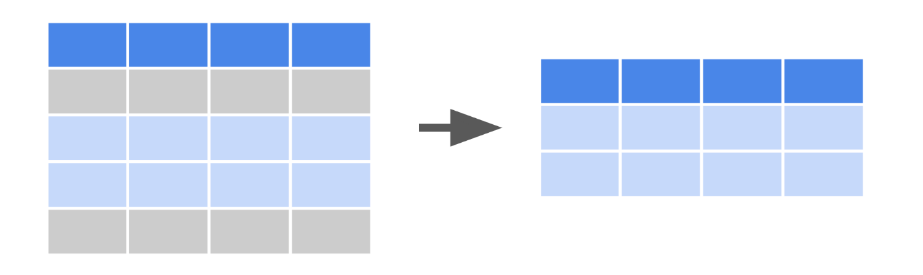

## Sort data

[**df.sort\_values()**](https://pandas.pydata.org/docs/reference/api/pandas.DataFrame.sort_values.html)

* A method available to the **DataFrame** class.
* Use **df.sort\_values()** to sort data according to selected parameters.
* Example:

1

2

3

print(df)

print()

df.sort\_values(by=['legs'], ascending=False)

RunReset

Visual representation of sorting:

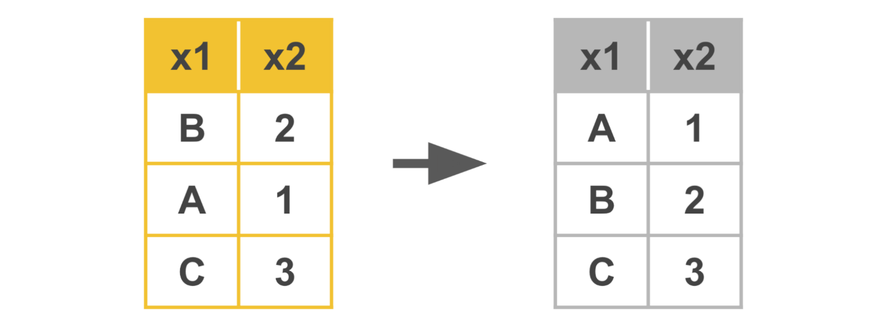

## Slice data

[**df.iloc[]**](https://pandas.pydata.org/docs/reference/api/pandas.DataFrame.iloc.html)

* Use **df.iloc[]** to slice a dataframe based on an integer index location.
* Examples:

**df.iloc[5:10, 2:]** → selects only rows 5 through 9, at columns 2+

**df.iloc[5:10]** → selects only rows 5 through 9, all columns **df.iloc[1, 2]** → selects value at row 1, column 2 **df.iloc[[0, 2], [2, 4]]** → selects only rows 0 and 2, at columns 2 and 4

[**df.loc[]**](https://pandas.pydata.org/docs/reference/api/pandas.DataFrame.loc.html)

* Use **df.loc[]** to slice a dataframe based on a label or Boolean array.
* Example:

1

2

3

print(df)

print()

df.loc[:, ['color', 'class']]

RunReset

## Key takeaways

The tools in this reference guide are foundational to structuring data, including filtering, sorting, merging, and slicing. You will find yourself using them throughout your career as a data professional.

## Resources for more information

Refer to these links for more details on Python functions and their various parameters.

* [Pandas documentation to describe parameters in Python functions](https://pandas.pydata.org/docs/index.html)
* [W3schools provides explanations for Python functions in an easy-to-understand way](https://www.w3schools.com/)

# Instructions

All of the instructional videos with onscreen coding demonstrations have a corresponding follow-along guide that is available to you. The follow-along guide is an annotated Jupyter notebook organized to match the content from each module. It contains the same code shown in the videos for that module. This guide is provided for your reference; you do not need to add any text or run the code yourself. If you would like to run the code, you will need to run each cell sequentially for the code to function as intended.

In addition to content that is identical to what is covered in the videos, you’ll often find additional information throughout the guide to explain the purpose of each concept covered, why the code is written in a certain way, and tips for running the code.

The landing page for each follow-along notebook also provides information about data sources (when relevant) and tips on how to access and use these guides.

# Data dictionary

This notebook uses two .csv files:

**eda\_structuring\_with\_python\_dataset1.csv**

**eda\_structuring\_with\_python\_dataset2.csv**

Both files come from the **bigquery-public-data.noaa\_lightning.lightning\_strikes** public data table. The data contains cloud-to-ground lightning strike information collected by Vaisala's National Lightning Detection Network (NLDN) and aggregated into 0.1° tiles by the National Centers for Environmental Information. This means that all the daily strikes within 0.1° latitude x 0.1° longitude are summed and assigned to a set of geographic coordinates that represents the center of the 0.1° “square” area.

One thing to keep in mind as you explore this data is that, because circles of latitude become shorter the farther they are from the equator, the area encompassed by the tiles becomes smaller the farther north the tiles are located. For example, tiles at 50°N are approximately 7 km x 11 km, while tiles at 20°N are approximately 10 km x 11 km—nearly 43% larger in area.

More information about this data can be found in the [linked documentation](https://ghrc.nsstc.nasa.gov/uso/ds_docs/nldn/gai_dataset.html).

Remember, you can access and download the data for any Jupyter notebook activity from within the notebook itself by navigating to the **Lab Files** dropdown menu at the top of the page, clicking into the **/home/jovyan/work** folder, selecting the relevant data file, and clicking **Download**.

Each row of the data used in this lesson represents a total lightning strike count on the specified date for a particular location. Refer to the column information in the table below. Note that some lessons in this course use subsets of the data.

| **Column name** | **Type** | **Description** |
| --- | --- | --- |
| number\_of\_strikes | int64 | The total count of lightning strikes in that geographic tile on a given date |
| center\_point\_geom | str | String of characters representing the geographic center point of the strikes based on the latitude and longitude given |
| longitude | float64 | Longitudinal point extracted from center\_point\_geom |
| latitude | float64 | Latitudinal point extracted from center\_point\_geom |
| date | str | The recorded date (format: YYYY/MM/DD) |
| zip\_code | float64 | United States postal code where given center point is located |
| city | str | U.S. city where given center point is located |
| state | str | U.S. state where given center point is located |
| state\_code | str | Two-letter abbreviation for the U.S. state where the center point is located |

## Set up a split screen

While watching the videos that follow this notebook, you may find it helpful to track the instructor’s progress by following along in your own Jupyter Notebook. It can be helpful to review the code notebook alongside the video, especially if you’re new to coding in Python.

To do so:

1. Open the video in one browser window.
2. Then, open the annotated follow-along guide in a separate window.
3. Arrange your screen so that the video and the follow-along guide are both visible.

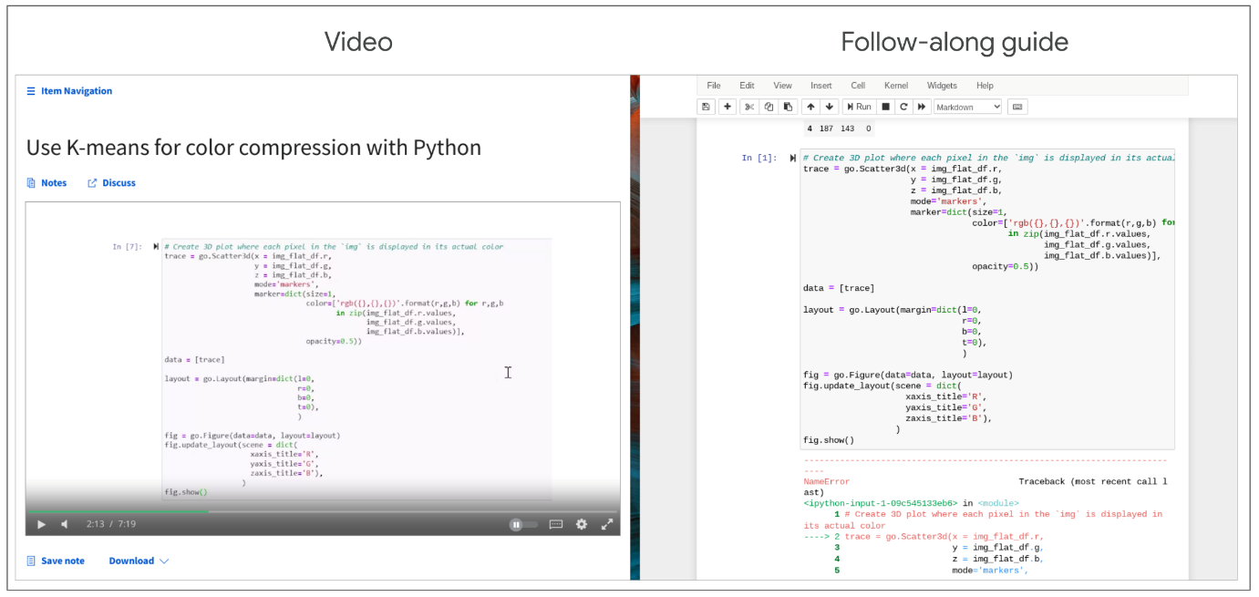

## Tips for working with the follow-along guide

Follow these suggestions to enhance your learning experience:

* Reference the [Jupyter notebooks reading](https://www.coursera.org/learn/get-started-with-python/supplement/2poER/create-upload-and-edit-jupyter-notebooks) before starting if you need more information on working with the Jupyter notebooks.
* Go to the section of the follow-along guide for the current module's content. The follow-along guide has different sections for each video included in the module's content. The in-video message will direct you to the relevant section in the guide for the specific video you are viewing.
* Follow along in the notebook as the instructor discusses the code.

## Question

Fill in the blank: A box plot is a data visualization that depicts the locality, spread, and \_\_\_\_\_ of groups of values within quartiles.

Skew

# Histograms

As you’ve been learning, the purpose of exploratory data analysis (EDA) is just what its name says: explore and analyze the data. As a data professional, you’ll almost always begin with a guiding question or objective, such as, “Where are the highest emitters of carbon dioxide located?” or “Determine the characteristics of people most likely to buy product X.” Reflecting on this often throughout your process creates a driving force that keeps you on track.

One of the most important tools at your disposal when exploring data is the **histogram**. A histogram is a graphical representation of a frequency distribution, which shows how frequently each value in a dataset or variable occurs. It’s essential for data professionals to understand the distributions of their data, because this knowledge drives many downstream decisions around experiment design, modeling, and further analysis. In this reading, you’ll learn about histograms, what they are, how to make them, and how to interpret them.

## **Introduction to histograms**

Histograms are commonly used to illustrate the shape of a distribution, including the presence of any outliers, the center of the distribution, and the spread of the data. Histograms are typically represented by a series of bars, where each bar represents a range of values. Bar height represents the frequency or count of the data points within that range.

The following example is a histogram of the number of seconds between eruptions of the Old Faithful geyser in Yellowstone National Park, Wyoming, USA.

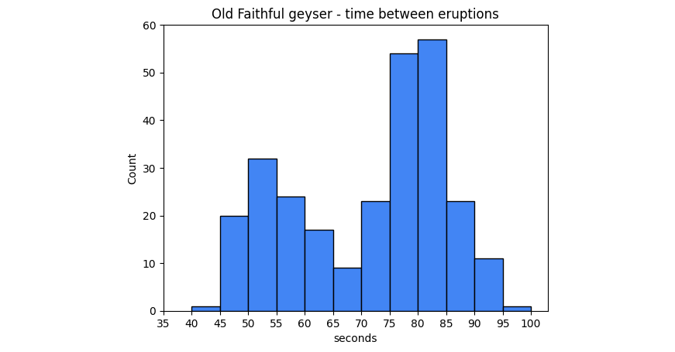

The x-axis represents the number of seconds between eruptions. The y-axis represents the eruption count. So, as indicated by the second bar in the graph, there are 20 eruptions that occurred after a wait time of 45-49 seconds.

## **The importance of histograms**

Histograms are an essential tool for understanding the characteristics of a dataset. They provide a visual representation of the data’s distribution and enable data professionals to identify patterns, trends, or outliers within the data. Histograms can also help data professionals choose appropriate statistical tests and models for the data and determine whether the data meets any assumptions required for the analysis. Histograms are widely used in any field and any situation that requires any kind of data analysis, including finance, health care, engineering, and social sciences.

## **How to interpret histograms**

Interpreting histograms involves understanding the shape, center, and spread of the distribution. There are several common shapes of histograms, including:

1.Symmetric: A symmetric histogram has a bell-shaped curve with a peak in the middle, indicating that the data is evenly distributed around the mean. This is also known as a normal, or Gaussian, distribution.

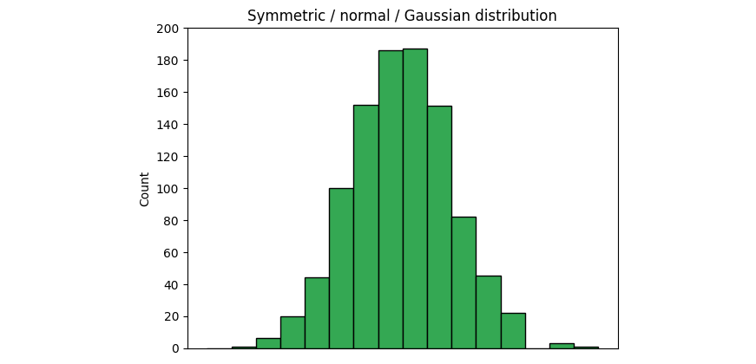

2. Skewed: A skewed histogram has a longer tail on one side than the other. A right-skewed histogram has a longer tail on the right side, indicating that there are more data points on the left side of the histogram.

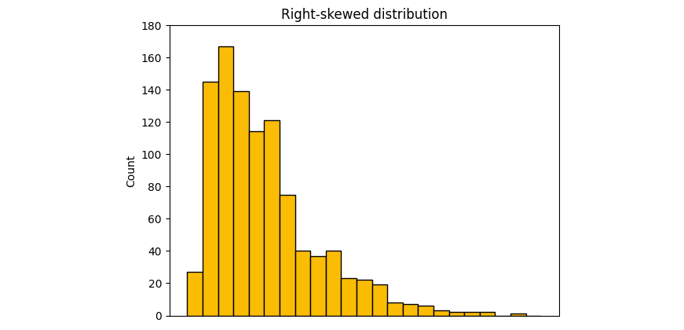

A left-skewed distribution has a longer tail on the left side, indicating more data points on the right side.

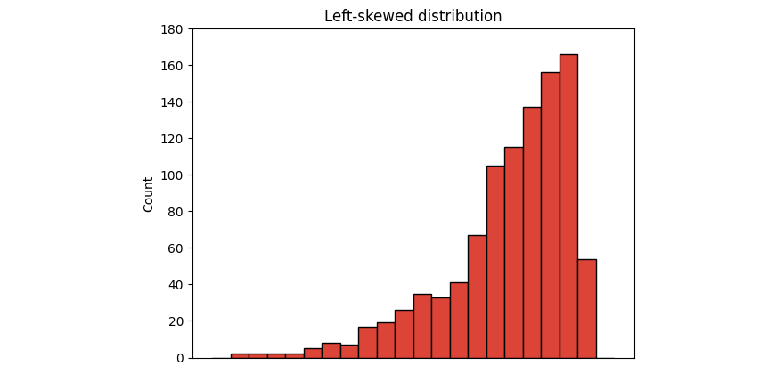

3. Bimodal: A bimodal histogram has two distinct peaks, indicating that the data has two modes.

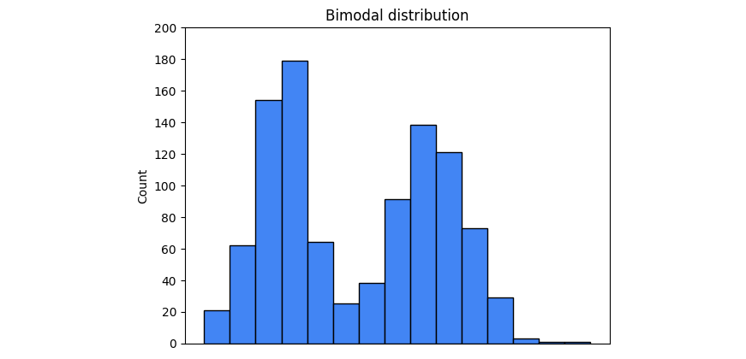

4.Uniform: A uniform histogram has a flat distribution, indicating that all data points are evenly distributed.

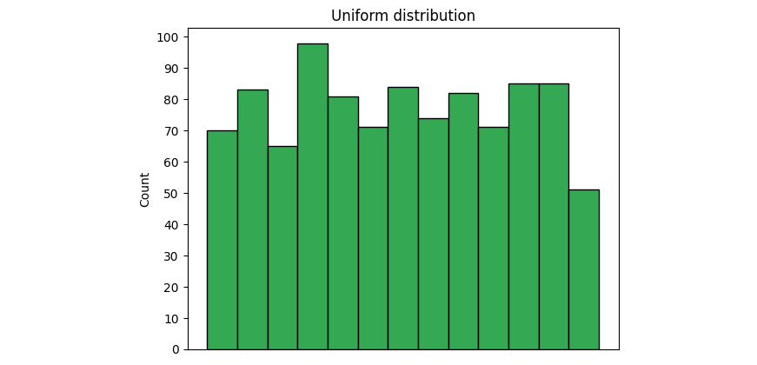

The examples provided are not the only distributions you’ll encounter, but they are some of the most common. Soon, you will learn more about distributions.

Now, return to the Old Faithful geyser histogram at the beginning of this reading. Ask yourself: what type of distribution is represented by that graph? In addition to the shape, it’s important to understand the center and spread. The center of the distribution is typically represented by the mean or median, while the spread is represented by the standard deviation or range of the data. The center and spread can provide insights into data concentration and variability.

## **How to create histograms**

Python’s seaborn and matplotlib libraries provide simple and powerful options to create histograms.

### [plt.hist(x, bins=10, …)](https://matplotlib.org/stable/api/_as_gen/matplotlib.pyplot.hist.html#matplotlib-pyplot-hist)

To generate a histogram in matplotlib, use the **hist()** function in the pyplot module. The function can take many different arguments, but the primary ones are:

* x: A sequence of values representing the data you want to plot. It can be a list, tuple, NumPy array, pandas series, and so on.
* bins: The number of bins you want to sort your data into. The default value is 10, but this parameter can be an int, sequence, or string. If you use a sequence, it defines the bin edges, including the left edge of the first bin and the right edge of the last bin. In other words, if bins = [1, 3, 5, 7], then the first bin is [1–3) (including 1, but excluding 3) and the second [3–5). The last bin, however, is [5–7], which includes 7. A string refers to a predefined binning strategy supported by numpy. Refer to the documentation for more information.

The following example demonstrates how to generate the Old Faithful geyser histogram from the beginning of this reading using the **plt.hist()** function.

1

2

3

4

5

6

7

8

# Plot histogram with matplotlib pyplot

plt.hist(df['seconds'], bins=range(40, 101, 5))

plt.xticks(range(35, 101, 5))

plt.yticks(range(0, 61, 10))

plt.xlabel('seconds')

plt.ylabel('count')

plt.title('Old Faithful geyser - time between eruptions')

plt.show();

RunReset

In this case, the data being plotted is the seconds column of the dataframe. The bins begin at 40 seconds and go to 100 seconds in steps of five, for a total of 12 bins.

### [sns.histplot(x, bins, binrange, binwidth …)](https://seaborn.pydata.org/generated/seaborn.histplot.html)

One way to generate a histogram in seaborn is to use the **sns.histplot()** function. Like the matplotlib function, **sns.histplot()** can take many arguments. Here are some important ones:

* x: The data sequence. Same as **plt.hist()**
* bins: Same as **plt.hist()**
* binrange: Lowest and highest value for bin edges; can be used either with **bins** or **binwidth**; defaults to data extremes
* binwidth:Width of each bin, overrides **bins** but can be used with **binrange**

The following example is the code used to generate the Old Faithful geyser histogram using the seaborn **histplot()** function. It uses all of the previously mentioned parameters. Run this code block to generate a histogram.

Notice in this case that **binrange** is defined from 40 to 100 and **binwidth** is set to 5. This produces the same results as setting **bins=range(40, 101, 5)**. This example also makes use of a couple of style parameters by specifying a particular color using hex code notation and setting the color saturation level to 100%, as indicated by the **alpha** parameter.

**Note:** The following code block is not interactive.

1

2

3

4

5

6

# Plot histogram with seaborn

ax = sns.histplot(df['seconds'], binrange=(40, 100), binwidth=5, color='#4285F4', alpha=1)

ax.set\_xticks(range(35, 101, 5))

ax.set\_yticks(range(0, 61, 10))

plt.title('Old Faithful geyser - time between eruptions')

plt.show();



## **Key takeaways**

Histograms help data professionals understand the frequency distributions of their dataset and variables. Knowledge of the shape and type of data distribution will affect important downstream decisions, such as statistical tests and model architecture selection. Additionally, knowing the shape of your data gives valuable insights into the story that your data is telling you by helping you understand its distributional trends.

In this lab, you will practice structuring, an integral step in exploratory data analysis that helps you find and use the right tools to adjust and filter datasets and problem-solve. You will be presented with a business scenario and a dataset to use as you explore structuring. You will practice applying data structuring and using visualizations to analyze data and develop your knowledge of functions that allow you to structure data.

# **Data Dictionary**

This activity uses a dataset called [Unicorn\_Companies.csv](https://www.coursera.org/learn/go-beyond-the-numbers-translate-data-into-insight/resources/9mSWv). It represents a list of private companies with a value of over $1 billion as of March 2022. The data includes the name of the country where the company was founded, its current valuation, funding, industry, top investors, year it was founded, and the year it reached a $1 billion valuation.

The dataset contains:

**1,074 rows** – each row is a different company

**10 columns**

| **Column name** | **Type** | **Description** |
| --- | --- | --- |
| Company | str | Company name |
| Valuation | str | Company valuation in billions (B) of dollars |
| Date Joined | datetime | The date in which the company reached $1 billion in valuation |
| Industry | str | Company industry |
| City | str | City the company was founded in |
| Country/Region | str | Country the company was founded in |
| Continent | str | Continent the company was founded in |
| Year Founded | int | Year the company was founded |
| Funding | str | Total amount raised across all funding rounds in billions (B) or millions (M) of dollars |
| Select Investors | str | Top 4 investing firms or individual investors (some have less than 4) |

The data was taken from [Kaggle](https://www.kaggle.com/datasets/mysarahmadbhat/unicorn-companies).

Remember, you can access and download the data for any Jupyter notebook activity from within the notebook itself by navigating to the **Lab Files** dropdown menu at the top of the page, clicking into the **/home/jovyan/work** folder, selecting the relevant data file, and clicking **Download**.

# Tips

To complete this lab, you will open a Jupyter notebook and follow instructions to enter code and written responses where prompted.

The Jupyter notebook will autosave as you work, or you can manually save it by clicking the **Save and Checkpoint** button or by selecting **Save and Checkpoint** from the **File** menu.



As you complete the lab, note the following features:

* **Sections:** Step-by-step instructions in each section lead you through the lab.
* **Code blocks:** Code blocks allow you to practice key Python coding concepts. Add code where prompted and then click the **Run** button to execute your code and view any possible output.



* **Questions:** Thought questions offer moments to pause and think about concepts and your output as you move through the lab.
* **Hints:** Hidden hints provide suggestions you can use to complete your work.

To review how to work in Jupyter notebooks, refer to the reading [Create, upload, and edit Jupyter notebooks](https://www.coursera.org/learn/get-started-with-python/supplement/2poER/create-upload-and-edit-jupyter-notebooks).

Be sure to complete this lab before moving on. To get started, click **Open Lab**.

The next course item will provide an exemplar of a completed lab for you to compare to your own work. To access the exemplar, return to the main course menu and click **Next**.



# Categorize: Structuring methods

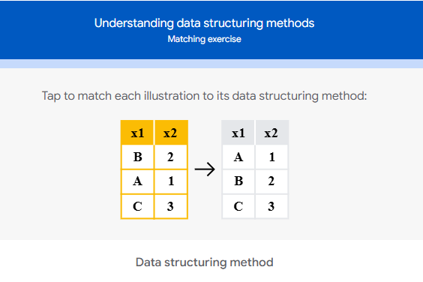

Sorting

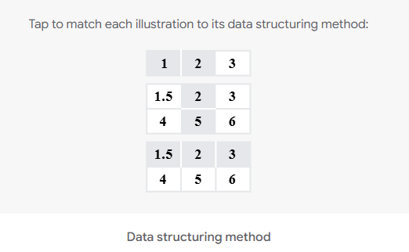

Slicing

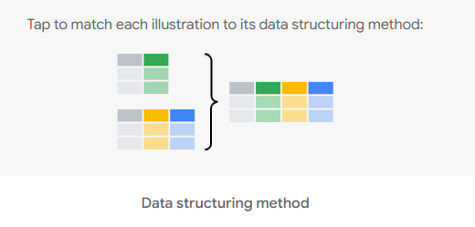

Joining

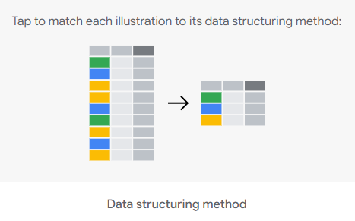

Grouping

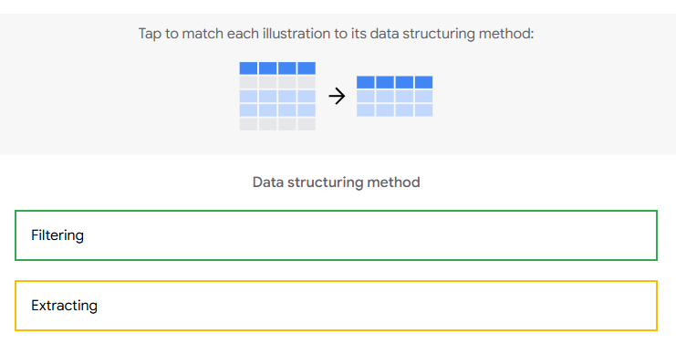

Filtering

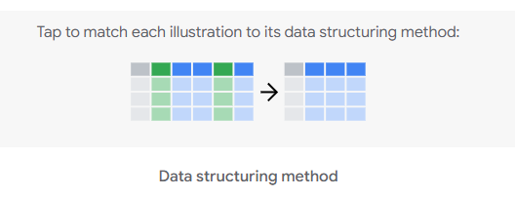

Extracting

# Test your knowledge: Create structure from raw data

### 1.

Question 1

Fill in the blank: Grouping is a structuring method that enables data professionals to \_\_\_\_\_ individual observations of a variable into different categories or classes.

Aggregate

Correct

Grouping is a structuring method that enables data professionals to aggregate individual observations of a variable into different categories or classes

### 2.

Question 2

Which of the following Python statements will create a list called **grade\_order** that starts with **Preschool**?

**grade\_order = ['Preschool', 'Kindergarten', 'Elementary School', 'Middle School', 'High School']**

Correct

The statement **grade\_order = ['Preschool', 'Kindergarten', 'Elementary School', 'Middle School', 'High School']** will set the *grade* order to start with *Preschool.*

### 3.

Question 3

A data professional can use the concat function to join two or more dataframes.

1 / 1 point

True

Correct

A data professional can use the concat function to join two or more dataframes. In pandas, it’s written as **pd.concat()**.

**Review (Discovering techniques)**

-Data sources

-Data types

-Data formats

-How to use Python to uncover big picture understandings

-Date and time transformations in Python

**Review (Data structuring techniques)**

-Sorting

-Extracting

-Filtering

-Slicing

-Joining

-Merging

-Grouping

**Review (Workspace skills)**

-Timing for communicating updates

-Posing questions to project stakeholders, managers, and subject matter experts

**Review (Techniques for gathering data-driven insights)**

-Making and testing hypothesis on your datasets

# Glossary terms from module 2

# Terms and definitions from Course 3, Module 2

**Box plot:** A data visualization that depicts the locality, spread, and skew of groups of values within quartiles

**CSV file**: A simple text file that can be easy to import or store in other softwares, platforms, and databases

**Database (DB) file**: A file type used to store data, often in tables, indexes, or fields

**Data source:** The location where data originates

**Extracting:** The process of retrieving data out of data sources for further data processing or storage

**Filtering:** The process of selecting a smaller part of a dataset based on specified values and using it for viewing or analysis

**First-party data:** Data that was gathered from inside your own organization

**Grouping**: The process of aggregating individual observations of a variable into groups

**Hypothesis:** A theory or an explanation, based on evidence, that has not yet been refuted

**Info():** Gives the total number of entries, along with the data types—called Dtypes in pandas—of the individual entries

**Int64:** A standard integer data type, representing numbers somewhere between negative nine quintillion and positive nine quintillion

**JSON file:** A data storage file that is saved in a JavaScript format

**Merging:** A method to combine two (or more) different data frames along a specified starting column(s)

**Second-party data:** Data that was gathered outside your organization but directly from the original source

**Slicing:** A method for breaking information down into smaller parts to facilitate efficient examination and analysis from different viewpoints

**Sorting:** The process of arranging data into a meaningful order for analysis

**String:** A sequence of characters and punctuation that contains textual information

**Third-party data:** Data gathered outside your organization and aggregated

# Terms and definitions from previous modules

## B

**Bias**: In data structuring, bias refers to organizing data results into groupings, categories, or variables that are misrepresentative of the whole dataset

## C

**Cleaning**: The process of removing errors that may distort your data or make it less useful; one of the six practices of Exploratory Data Analysis (EDA)

## D

**Data visualization**: A graph, chart, diagram, or dashboard that is created as a representation of information

**Discovering**: The process data professionals use to familiarize themselves with the data so they can start conceptualizing how to use it; one of the six practices of EDA

## E

**Exploratory data analysis (EDA)**: The process of investigating, organizing, and analyzing datasets and summarizing their main characteristics, often by employing data wrangling and visualization methods; the six main practices of EDA are: discovering, structuring, cleaning, joining, validating, and presenting

## J

**Joining**: The process of augmenting data by adding values from other datasets; one of the six practices of EDA

## P

**PACE**: A workflow data professionals can use to remain focused on the end goal of any given dataset; stands for plan, analyze, construct, and execute

**Presenting**: The process of making a cleaned dataset available to others for analysis or further modeling; one of the six practices of EDA

## S

**Structuring**: The process of taking raw data and organizing or transforming it to be more easily visualized, explained, or modeled; one of the six practices of EDA

## V

**Validating**: The process of verifying that the data is consistent and high quality; one of the six practices of EDA

# Module 2 challenge (Not all listed are here!)

### 1.

Question 1

What are some strategies data professionals use to understand the source of a dataset? Select all that apply.

1 / 1 point

Investigate whether the data originator has any financial stake in the dataset.

Request relevant information from the data owners.

Confirm the data owners have experience collecting data.

### 2.

Question 2

What is the data storage file format for JavaScript?

J-SON

### 3.

Question 3

What type of data is gathered outside of an organization and aggregated?

1 / 1 point

Third-party

### 4

Question 4

Which of the following statements correctly uses the **head()** function to return the first 10 rows of a dataset?

1 / 1 point

**df.head(10)**

### 5.

Question 5

Which of the following statements will assign the name **Kuwait Museums** to a bar graph in Python?

1 / 1 point

**plt.title("Kuwait Museums")**

### 6.

Question 6

A data professional types the following partial code:

**locationmode ='Indonesia'**

**fig.update\_layout(title\_text = 'Languages',**

**geo\_scope='Indonesia', )**

**fig.show()**

Which element of the code is used to render a graphic of the plot?

**fig.show()**

### 7.

Question 7

Which structuring method selects a smaller part of a dataset based on specified parameters, then uses it for analysis?

1 / 1 point

Filtering

### 8.

Question 8

Fill in the blank: A box plot is a data visualization that depicts the spread, skew, and \_\_\_\_\_ of groups of values within quartiles.

1 / 1 point

locality

**Module 3:**

**What you’ll learn**

-Missing values

-Outliers

-Transforming categorical into numerical data

-Input validation

**Workplace skills**

-When to communicate with stakeholders and engineers about missing or outliner values

-Ethical implications you must consider when dealing with missing and outlier data values

**Missing data are often encoded as**

-N/A

-NaN (‘Not a number’)

-[blank]

**Missing data (or null values)**

A value that is not stored for a variable in a set of data

## Question

Data encoded as N/A, NaN, or a blank is defined as zero.

Correct

Data encoded as N/A, NaN, or a blank is defined as a value that is not stored for a variable in a dataset. This is different from a data point of zero, which may be a missing value or a legitimate data point.

A zero (0) could be considered a missing value, but in other datasets could be a legitimate data point.

**What to do with missing data**

-Request the missing values to be filled in by the owner of the data

-Delete the missing column(s),row(s),or value(s)

-Create a NaN category

-Derive new representative value(s)

**Derive new representative value(s) strategy**

-Forward filling

-Backward filling (backfilling)

-Derving mean values

-Derving median values

# Data deduplication with Python

As you’ve learned, the data cleaning and validating practices include several different steps, including handling missing data, outliers, and label encoding; checking for misspellings; and, handling duplicates. As a data professional, it will be your task to know how best to handle data values in those categories. In this reading, you'll learn more about handling duplicates. You will also learn to identify and decide whether deduplication is the right strategy for a dataset. In addition, you will learn some common Python functions for handling duplicates.

## Identifying duplicates

Before we make any decisions on whether to remove duplicate values or not, we should first determine if duplicate values are present in our dataset.

A simple way to identify duplicates is to use the **duplicated()** function from Pandas. **duplicated()** is a method of the **DataFrame** class.

This function returns a series of “true/false” outputs, with “true” indicating the data value is a duplicate, and “false” indicating it is a unique value.

Here’s an example of a five-row dataframe:

1

2

3

df

RunReset

Using the **duplicated()** function, the result is that one has been marked “True,” indicating it is a duplicate.

1

2

3

print(df)

print()

print(df.duplicated())

RunReset

Identifying duplicates for an entire dataframe will be different than a single column or index. Be sure when you use the **duplicated()** function for an entire dataframe. The **duplicated()** function will only return entire rows that have exactly matching values, not just individual matching values found within a column.If you wish to identify duplicates for only one column or a series of columns within a dataframe, you will need to include that in the “subset” portion of the argument field of the **duplicated()** function. Going further, if you’d like to specify which of the duplicates to keep as the “original” as opposed to the duplicate, you can specify that in the **keep** portion of the argument field.

Below is an example of identifying duplicates in only one column (subset) of values and labeling the last duplicates as “false,” so that they are “kept”:

1

2

3

print(df)

print()

print(df.duplicated(subset=['type'], keep='last'))

RunReset

## Decision time: To drop or not to drop?

As you’ve learned, every dataset is unique and you cannot treat every dataset the same. When you are making the decision on whether to eliminate duplicate values or not, think deeply about the **dataset itself** and about **the objective you wish to achieve**. What impact will dropping duplicates have on your dataset and your objective?

**1. Deciding to drop**

You should **drop or eliminate** duplicate values if duplicate values are clearly mistakes or will misrepresent the remaining unique values in the dataset.

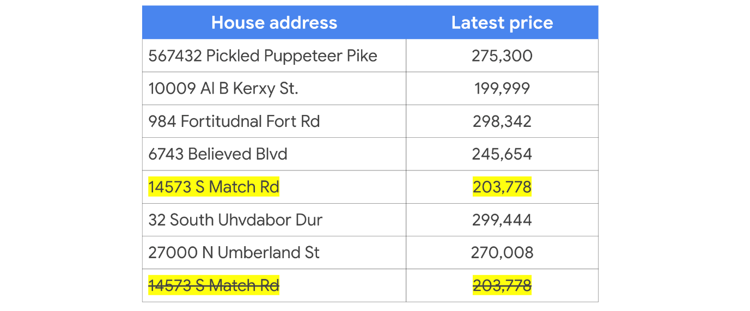

For example, you can be reasonably sure that a data professional will (in most cases) eliminate duplicate values of a dataset containing house addresses and house prices. Counting the same house twice will (in most cases) misrepresent any conclusions drawn from the dataset as a whole, such as average house price, total house price, or even total number of houses. In a case like this, a data professional would almost certainly eliminate the duplicate data so as to fairly represent the remaining data during analysis and visualization.

**2. Deciding to NOT drop**

You should **keep** duplicated data in your dataset if the duplicate values are clearly **not** mistakes and should be taken into account when representing the dataset as a whole.

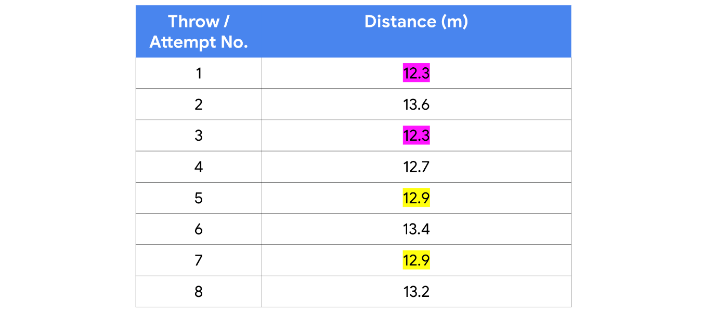

For example, a dataset marking the number of throws and distances of an Olympic shot-put athlete in training will likely include several duplicate distances; just by nature of number of attempts and the limits a person can have a weighted ball, there will be duplicate values—particularly if the distance measurements are labeled to only 1 or 2 decimal places. In a case like this, a data professional would almost certainly keep all of the data to fairly represent it as a whole during analysis and visualization.

## Don’t be duped — How to do deduplication

Before we get back into Python and learn how to eliminate duplicates, let’s first define the term “deduplication”:

* **Deduplication:**  The elimination or removal of matching data values in a dataset.

There are a number of different libraries, functions, and methods in Python you could use to remove matching data values.

One of the more common functions to use is in Pandas: **drop\_duplicates()**

**drop\_duplicates()** is another **DataFrame** method. It's used to create a new dataframe with all of the duplicate rows removed.

For example, use a dataframe from earlier in this reading:

1

2

df

RunReset

Now apply the drop duplicates function:

1

2

df.drop\_duplicates()

RunReset

You’ll notice in the resulting output that the duplicate row of data was removed, leaving the remaining unique values intact.

**Note:** Keep in mind that the **drop\_duplicates()** function as written above will only drop duplicates of exact matches of **entire rows of data**. If you wish to drop duplicates within a single column, you will need to specify which columns to check for duplicates using the **subset** keyword argument.

This example drops all rows that have duplicate values in the **style** column (except for the first occurrence):

1

2

3

4

5

print(df)

df = df.drop\_duplicates(subset='style')

print()

print(df)

RunReset

And this example drops all rows (except the first occurrence) that have duplicate values in both the **style** and **rating** columns:

1

2

3

4

5

print(df)

df = df.drop\_duplicates(subset=['style', 'rating'])

print()

print(df)

RunReset

## Key Takeaways

Identifying duplicate data values in a dataset is an important part of EDA (or “Exploratory Data Analysis”) practices, specifically cleaning and validating. After identifying duplicates, think about the impact to the dataset and your analysis objective when choosing to eliminate duplicates or not eliminate duplicates.

## Additional Resources

Want to learn more about duplicates and deduplication? Check out the following additional links.

* [Look at Pandas documentation to learn more about the parameters of the argument field](https://pandas.pydata.org/docs/reference/api/pandas.DataFrame.drop_duplicates.html)
* [W3 Schools: Pandas - removing duplicates](https://www.w3schools.com/python/pandas/pandas_cleaning_duplicates.asp)

# Instructions

All of the instructional videos with onscreen coding demonstrations have a corresponding follow-along guide that is available to you. The follow-along guide is an annotated Jupyter notebook organized to match the content from each module. It contains the same code shown in the videos for that module. This guide is provided for your reference; you do not need to add any text or run the code yourself. If you would like to run the code, you will need to run each cell sequentially for the code to function as intended.

In addition to content that is identical to what is covered in the videos, you’ll often find additional information throughout the guide to explain the purpose of each concept covered, why the code is written in a certain way, and tips for running the code.

The landing page for each follow-along notebook also provides information about data sources (when relevant) and tips on how to access and use these guides.

# Data dictionary

This notebook uses two .csv files:

**eda\_missing\_data\_dataset1.csv**

**eda\_missing\_data\_dataset2.csv**

Both files come from the **bigquery-public-data.noaa\_lightning.lightning\_strikes** public data table. The data contains cloud-to-ground lightning strike information collected by Vaisala's National Lightning Detection Network (NLDN) and aggregated into 0.1° tiles by the National Centers for Environmental Information. This means that all the daily strikes within 0.1° latitude x 0.1° longitude are summed and assigned to a set of geographic coordinates that represents the center of the 0.1° “square” area.

One thing to keep in mind as you explore this data is that, because circles of latitude become shorter the farther they are from the equator, the area encompassed by the tiles becomes smaller the farther north the tiles are located. For example, tiles at 50°N are approximately 7 km x 11 km, while tiles at 20°N are approximately 10 km x 11 km—nearly 43% larger in area.

More information about this data can be found in the [linked documentation](https://ghrc.nsstc.nasa.gov/uso/ds_docs/nldn/gai_dataset.html).

Remember, you can access and download the data for any Jupyter notebook activity from within the notebook itself by navigating to the **Lab Files** dropdown menu at the top of the page, clicking into the **/home/jovyan/work** folder, selecting the relevant data file, and clicking **Download**.

Each row of the data used in this lesson represents a total lightning strike count on the specified date for a particular location. Refer to the column information in the table below. Note that some lessons in this course use subsets of the data.

| **Column name** | **Type** | **Description** |
| --- | --- | --- |
| number\_of\_strikes | int64 | The total count of lightning strikes in that geographic tile on a given date |
| center\_point\_geom | str | String of characters representing the geographic center point of the strikes based on the latitude and longitude given |
| longitude | float64 | Longitudinal point extracted from center\_point\_geom |
| latitude | float64 | Latitudinal point extracted from center\_point\_geom |
| date | str | The recorded date (format: YYYY/MM/DD) |
| zip\_code | float64 | United States postal code where given center point is located |
| city | str | U.S. city where given center point is located |
| state | str | U.S. state where given center point is located |
| state\_code | str | Two-letter abbreviation for the U.S. state where the center point is located |

## Set up a split screen

While watching the videos that follow this notebook, you may find it helpful to track the instructor’s progress by following along in your own Jupyter Notebook. It can be helpful to review the code notebook alongside the video, especially if you’re new to coding in Python.

To do so:

1. Open the video in one browser window.
2. Then, open the annotated follow-along guide in a separate window.
3. Arrange your screen so that the video and the follow-along guide are both visible.



## Tips for working with the follow-along guide

Follow these suggestions to enhance your learning experience:

* Reference the [Jupyter notebooks reading](https://www.coursera.org/learn/get-started-with-python/supplement/2poER/create-upload-and-edit-jupyter-notebooks) before starting if you need more information on working with the Jupyter notebooks.
* Go to the section of the follow-along guide for the current module's content. The follow-along guide has different sections for each video included in the module's content. The in-video message will direct you to the relevant section in the guide for the specific video you are viewing.
* Follow along in the notebook as the instructor discusses the code.

## Question

What is indicated by the term null?

The data is missing.

The term null indicates that the data is missing.

**“There’s a lot of informational emails about new features, products, or techniques. I have to read those and learn about them because it’s my job to be the person who knows about all of these things for our customers.”**

**“The best thing you can do is pick a software, pick a language, maybe a specific area, and just focus on that.”**

# Test your knowledge: The challenge of missing or duplicate data

### 1.

Question 1

Fill in the blank: Missing data has a value that is not stored for a \_\_\_\_\_ in a dataset.

variable

### 2.

Question 2

A data professional requests additional information from a dataset’s original owner. Unfortunately, they are not able to provide the information. Therefore, the data professional creates a NaN category in the dataset. What concept does this scenario describe?

Solving the problem of missing data

### 3.

Question 3

When merging data, a data professional uses the following code:

**df\_joined = df.merge(df\_zip, how='left', on=['date','center\_point\_geom'])**

What is the function of the parameters **how** and **on** in this code?

To tell Python which way to join the data and which column to join from

### 4.

Question 4

Non-null count is the total number of blank data entries within a data column.

False

**Outliers**

Observations that are an abnormal distance from other values or an overall pattern in a data population.

## Question

Fill in the blank: Outliers are observations that are an \_\_\_\_\_ distance from other values.

abnormal

**3 types of outliers**

Global outliers: Values that are completely different from the overall data group and have no association with any other outliers.

Contextual outliers: Normal data points under certain conditions but become anomalies under most other conditions.

Collective outliers: A group of abnormal points that follow similar patterns and are isolated from the rest of the population.

**Documentation string or Docstring**

A line of text following a method or function that is used to explain to others, using your code, what this method or function does. A docstring represents good documentation practice in Python.

## Question

Docstrings are useful within a line of Python code, but they cannot be exported to create library documentation.

False

# Protect the people behind the data

## We’ve all been there…

Whether at work or at school, there’s a moment of realization about an essay or a project you’ve been working on—you suddenly realize you’ve made a mistake, and it needs to be fixed.

“But think of all of the trouble that will cause,” you think. “It will make the project late, and everyone will find out I made a mistake.”

Is it really worth the time and effort to stop the process and fix it?

For data professionals, the answer needs to always be ***YES***.

## The big picture

Even seasoned data professionals can fail to see the big picture. As intuitive as our brains can be, we often fail to see how a small error, a tiny change, or a seemingly insignificant choice about data analysis can have significant implications on a process, a business, or even a whole population.

To help illustrate this, imagine a grid of alternating orange and blue circles. Now, imagine there is a person who can only see a small section of six circles. What if this person decides that it makes more sense for the circles to be arranged by groups, with orange circles on top and blue on bottom? You’ll find that even though the circles within the rectangle may be perceived as orderly, the reality is the change has actually disrupted the larger pattern. Now imagine the rectangle of six circles is a department and the bigger grid is an entire company.

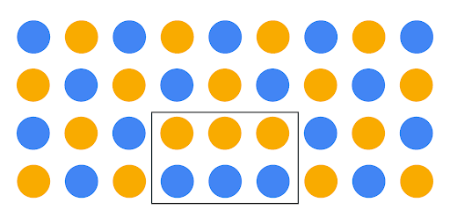

## An ethical mindset

Hopefully, this illustration helps you understand the importance of context and scope when dealing with data. One principle that can help data professionals keep data in context is ethics and developing an ethical mindset.

Here are three important concepts to help you foster an ethical mindset as you seek to tell stories with data:

* Models have lives beyond code blocks and data strings.
* Data science needs regulatory compliance.
* Customers should choose how their data is used.

### **Models have lives beyond the code blocks and data strings**

There can be a tendency to think of data as strictly numbers and math. The reality is that data consists of people-driven inputs. Data professionals should never lose sight of the fact that analysis in all forms—visualizations, models, decisions, and strategies—impacts people.

The end goal of all data analysis and data science work should be to improve the lives of individuals and groups. Next time you are designing a data dashboard or coding a complex algorithm, take a moment to consider how the data might impact human beings, and whether the decisions you make alter that impact for the better. Remember that your own biases may prevent you from being able to anticipate many impacts, so gathering input from a diverse group of team members helps you mitigate your personal biases.



Here is a hypothetical data career example to help you see how this concept may someday impact your work:

* Imagine a data professional is analyzing traffic flow data in order to help a city planner for a major metropolitan area decide where to focus on expanding roads. At first glance, using data for road construction appears to be a purely financial decision between a city and a road construction company. The professional’s analysis first led them to select a more hilly, uneven terrain as the most cost-effective place for the expansion of roads. But after analyzing the data with concern for the citizens and families who will be driving on those roads in all seasons, the data professional’s analysis determined the hilly area to have a higher accident risk, and decided to recommend a flatter location for road expansion.

### **Data science needs regulatory compliance**

If you are unfamiliar with the laws and regulations of the industry you work in, your job will not only be much more difficult, but also could land you in legal trouble. A data professional should always remain up to date and in compliance with all regulations in their particular field. As an example, when you begin a new job in the data career space, you can do the following:

* Ask your manager for compliance guidance.
* Take time to research the data governance policies.
* Take time to research the regulatory body of your particular industry and its relevant policy documents.

Keep in mind that the data governance field is quite young and that regulations can and will change at a quick pace. Be sure to keep up with the changes!

It's important to follow the rules … but not ***just*** for rules’ sake. Here are a few important benefits of remaining compliant with regulatory bodies and data governance policies:

* Keeps client and company data safe from security threats
* Bolsters trust with clients, peer groups, companies, and public
* Lessens likelihood of lost or mismanaged data
* Ensures business critical data remains usable, accessible, and available

### **Customers should choose how their data is used**

With each passing day, technology gets more advanced and capable. As data becomes increasingly involved in our day-to-day lives, it stands to reason the data itself becomes more and more important and valuable. Because of this, data privacy and security is critical to a company’s clients and a government’s citizens.

As data professionals, it is our ethical responsibility to treat client and customer data with respect and dignity. Companies that store, analyze, and utilize data as part of their business processes should make sure those processes are transparent and compliant. Customers who divulge confidential information in order to procure a service should be able to trust that the data will remain confidential and not compromised due to breaches or cyber security threats.

You’ll find that many companies have begun to treat customer data with more internal care and security. More companies are providing extensive employee training regarding the handling and securing of customer data. Many are adding multi-factor authentication systems and auditing their third-party vendors, requiring high levels of digital security systems and platforms.

As an example, because data breaches like Home Depot in 2014, Uber in 2017, and Instagram in 2020 have been commonplace for decades, corporations are increasingly ramping up cybersecurity, employee and vendor training, and transparency to customers and the public regarding data gathering and data use methods. Specifically, Home Depot has added data security into its risk management plan, and built a data security web page that describes what data they gather and how they use it.

Data transparency is not only good for business, it is the right thing to do—the ethical thing to do. Data professionals need to understand that more than anyone.

## Key Takeaways

Data ethics is an expanding field and remains an integral part of a data professional’s daily work. While manipulating, analyzing, or using data in any capacity, remember that data models have lives beyond code blocks and data strings. Data science needs regulatory compliance and customers should always get to choose how their data is used.

### Resources for more information

Data governance and data ethics are a growing field of work and study. Here are some resources should you like to learn more:

* [Harvard Business School: 5 principles of Data Ethics for Business](https://online.hbs.edu/blog/post/data-ethics)
* [Dataversity: Data Governance and Data Quality](https://www.dataversity.net/category/data-topics/data-governance/)

# Reference guide: How to handle outliers

You might want to save a copy of this guide for future reference. You can use it as a resource for additional practice or in your future professional projects. To access a downloadable version of this course item, click the link below and select “Use Template.”

[Reference guide: How to handle outliers](https://docs.google.com/document/d/1jWNz_HzON9CfwqpMYu2dqwwIkl2CyCodYoXACNWkstI/template/preview)

OR

If you don’t have a Google account, you can download the item directly from the attachment below.

Previously, you watched two videos about how to detect outliers and why handling outliers can be an important part of data cleaning. At this point, you likely have a good understanding of this. It is important to not only detect outliers, but also to have a plan for them.

That is precisely what you will review in this reading. Once you’ve detected outliers in your dataset—whether global, contextual, or collective—how do you handle them? When it comes to exploratory data analysis, or EDA, there are essentially three main ways to handle outliers: delete, reassign, or leave them in.

Whether you keep outliers as they are, delete them, or reassign values is a decision that you make on a dataset-by-dataset basis. To help you make the decision, you can start with these general guidelines:

* **Delete them**: If you are sure the outliers are mistakes, typos, or errors and the dataset will be used for modeling or machine learning, then you are more likely to decide to delete outliers. Of the three choices, you’ll use this one the least.
* **Reassign them**: If the dataset is small and/or the data will be used for modeling or machine learning, you are more likely to choose a path of deriving new values to replace the outlier values.
* **Leave them**: For a dataset that you plan to do EDA/analysis on and nothing else, or for a dataset you are preparing for a model that is resistant to outliers, it is most likely that you are going to leave them in.

The videos discussing outliers went into detail on how to handle outliers when youleave them in the dataset. In this reading, you will learn about some techniques for deleting and reassigning outliers.

## **1. Delete them.**

For one way to delete outlier values, recall the coding you saw in the walkthrough video on outliers. In that video, the instructor coded a box plot to help you visualize two different outliers, as shown here:

**Note:** The following code block is not interactive.

1

2

3

4

5

box = sns.boxplot(x=df['number\_of\_strikes'])

g = plt.gca()

box.set\_xticklabels(np.array([readable\_numbers(x) for x in g.get\_xticks()]))

plt.xlabel('Number of strikes')

plt.title('Yearly number of lightning strikes');

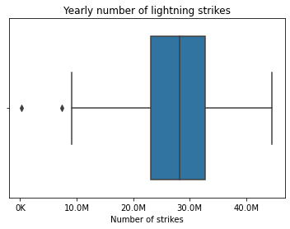

The instructor then used the following code to find the lower limit—8.6M.

1

2

3

4

5

6

7

8

9

10

11

12

13

14

# Calculate 25th percentile of annual strikes

percentile25 = df['number\_of\_strikes'].quantile(0.25)

# Calculate 75th percentile of annual strikes

percentile75 = df['number\_of\_strikes'].quantile(0.75)

# Calculate interquartile range

iqr = percentile75 - percentile25

# Calculate upper and lower thresholds for outliers

upper\_limit = percentile75 + 1.5 \* iqr

lower\_limit = percentile25 - 1.5 \* iqr

print('Lower limit is: ', lower\_limit)

RunReset

Next, a Boolean mask was used to filter the dataframe so it only contained rows where the number of strikes was less than the lower limit.

1

print(df[df['number\_of\_strikes'] < lower\_limit])

RunReset

Once you know the cutoff points for outliers, if you want to delete them, you can use a Boolean mask to select all rows such that: lower limit ≤ values ≤ upper limit.

1

2

3

4

5

mask = (df['number\_of\_strikes'] >= lower\_limit) & (df['number\_of\_strikes'] <=

upper\_limit)

df = df[mask].copy()

print(df)

RunReset

Next, you’ll consider reassigning outliers by deriving new values that are a better fit for the dataset.

## **2. Reassigning them.**

Instead of deleting outliers, you can always reassign them, that is, change the values to ones that fit within the general distribution of the dataset. There are two common ways to do this, but many different ways can be used, depending on your use case:

**1. Create a floor and ceiling at a quantile:** For example, you could place walls at the 90th and 10th percentile of the distribution of data values. Any value above the 90% mark or below the 10% mark are changed to fit within the walls you set. Here is an example of what that code might look like:

1

2

3

4

5

6

7

8

9

10

11

# Calculate 10th percentile

tenth\_percentile = np.percentile(df['number\_of\_strikes'], 10)

# Calculate 90th percentile

ninetieth\_percentile = np.percentile(df['number\_of\_strikes'], 90)

# Apply lambda function to replace outliers with thresholds defined above

df['number\_of\_strikes'] = df['number\_of\_strikes'].apply(lambda x: (

    tenth\_percentile if x < tenth\_percentile

    else ninetieth\_percentile if x > ninetieth\_percentile

    else x))

RunReset

**2. Impute the average:** In some cases, it might be best to reassign all outlier values to match the median or mean value. This will ensure that your median and distribution are based solely on the non-outlier values, leaving the original outliers excluded. The actual imputation or reassigning of values can be pretty simple if you’ve already found the outliers. The following code block calculates the median of the values greater than the lower limit. Then it imputes the median where values are lower than the lower limit.

1

2

3

4

5

# Calculate median of all NON-OUTLIER values

median = np.median(df['number\_of\_strikes'][df['number\_of\_strikes'] >= lower\_limit])

# Impute the median for all values < lower\_limit

df['number\_of\_strikes'] = np.where(df['number\_of\_strikes'] < lower\_limit, median, df['number\_of\_strikes'] )

RunReset

**Note:** Outside of EDA, machine learning and regression modeling have more complex variations on dealing with outliers. You will learn more about those topics later.

## Key Takeaways

After detecting the outliers in a dataset, it is essential that you determine a strategy for how to handle them. Because every dataset and data-based problem is different, your strategy will vary. For the most part, you will be choosing between deleting, reassigning, or leaving outliers.

# Test your knowledge: The ins and outs of data outliers

Question 1

What type of outlier is a normal data point under certain conditions, but becomes an anomaly under most other conditions?

Contextual outlier

Question 2

What is the term for a line of text that follows a method or function, which is used to explain the purpose of that method or function to others using the same code?

Docstring

Question 3

A data professional is using a box plot to identify suspected high outliers in a dataset, according to the interquartile rule. To do that, they search for data points greater than the third quartile plus what standard of the interquartile range?

1.5 times

**Categorical data**

Data that is divided into a limited number of qualitative groups.

## Question

Categorical data can be grouped on its qualities, thus enabling data professionals to store and identify it based on its category.

True

**Dummy variables**

Variables with values of 0 or 1, which indicate the presence or absence of something.

**Heatmap**

A type of data visualization that depicts the magnitude of an instance or set of values based on two colors.

## Question

Fill in the blank: A heat map uses \_\_\_\_\_ to depict the magnitude of an instance or set of values.

colors

# Other approaches to data transformation

As you know, data comes to us in many different forms. For categorical or qualitative data types, data professionals often need to transform (or encode) this type of data into numeric digits to complete their analysis, design their data visualization, or build their machine learning algorithm. In this reading, you will learn about the two main types of categorical data encoding and when to use each type.

## Label encoding

You’ve already learned about **label encoding,** which is one type of data transformation technique where each data value is assigned a distinct number instead of a qualitative value.

If you remember from the [video](https://www.coursera.org/learn/go-beyond-the-numbers-translate-data-into-insight/lecture/BrCPD/sort-numbers-versus-names), the example provided was label encoding mushroom types:

| **Mushroom Type** | **Code** |
| --- | --- |
| Black truffle | 0 |
| Button | 1 |
| Cremini | 2 |
| Hedgehog | 3 |
| King Trumpet | 4 |
| Morel | 5 |
| Portobello | 6 |
| Shiitake | 7 |
| Toadstool | 8 |

As you can tell, for this hypothetical data set about mushrooms, each mushroom type was assigned its own number, starting with zero.

## Some potential problems with label encoding

Imagine you’re analyzing a dataset with categories of music genres. You label encode “Blues,” “Electronic Dance Music (EDM),” “Hip Hop,” “Jazz,” “K-Pop,” “Metal,” “ and “Rock,” with the following numeric values, “1, 2, 3, 4, 5, 6, and 7.”

With this label encoding, the resulting machine learning model **could** derive not only a ranking, but also a closer connection between Blues (1) and EDM (2) because of how close they are numerically than, say, Blues(1) and Jazz(4). In addition to these presumed relationships (which you may or may not want in your analysis) you should also notice that each code is equidistant from the other in the numeric sequence, as in 1 to 2 is the same distance as 5 to 6, etc. The question is, does that equidistant relationship accurately represent the relationships between the music genres in your dataset? To ask another question, after encoding, will the visualization or model you build treat the encoded labels as a ranking?

The same could be said for the mushroom example above. After label encoding mushroom types, are you satisfied with the fact that the mushrooms are now in a presumed ranked order with button mushrooms ranked first and toadstool ranked eighth?

In summary, label encoding **may** introduce unintended relationships between the categorical data in your dataset. When you are making decisions about label encoding, consider the algorithm you’ll apply to the data and how it may or may not impact label encoded categorical data.

Fortunately, there is another method for categorical encoding that may help with these potential problems.

## One-hot encoding

As you learned in a previous [video](https://www.coursera.org/learn/go-beyond-the-numbers-translate-data-into-insight/lecture/BrCPD/sort-numbers-versus-names), you can create dummy variables in Python. If you remember, a dummy variable is a variable with values of 0 or 1, which indicate the presence or absence of something. The idea is to create a new column for each category type, then for each value indicate a 0 or a 1 — 0 meaning, no, and 1 meaning, yes.

This creation of dummies is called **one-hot encoding.** As a reminder, a table with one-hot encoding ends up like this:

| **N/A** | **Mild** | **Scattered** | **Heavy** | **Severe** |
| --- | --- | --- | --- | --- |
| **0** | 1 | 0 | 0 | 0 |
| **1** | 1 | 0 | 0 | 0 |
| **2** | 0 | 1 | 0 | 0 |
| **3** | 0 | 0 | 1 | 0 |
| **4** | 0 | 0 | 0 | 1 |
| **5** | 0 | 0 | 0 | 1 |
| **6** | 0 | 0 | 0 | 1 |
| **7** | 0 | 0 | 0 | 1 |
| **8** | 0 | 0 | 1 | 0 |
| **9** | 0 | 1 | 0 | 0 |
| **10** | 1 | 0 | 0 | 0 |
| **11** | 1 | 0 | 0 | 0 |
| **12** | 0 | 1 | 0 | 0 |

You’ll find the values from the lightning strike dataset covered in the [video](https://www.coursera.org/learn/go-beyond-the-numbers-translate-data-into-insight/lecture/BrCPD/sort-numbers-versus-names) are labeled as “mild” and have a “1.” “Mild” refers to the lowest quartile of lightning counts in the dataset. For any other value in the “mild” column that is NOT mild, there is a zero in that cell. With this method, we solve the problem of the unintended and problematic relationships that label encoding presented.

But one-hot encoding does present its own set of problems, particularly when it comes to logistic and linear regression. You will learn more about that in a future course.

## **Label encoding or one-hot encoding: How to decide?**

There is no simple answer to whether you should use label encoding or one-hot encoding. The decision needs to be made on a case-by-case, or dataset-by-dataset basis. But there are some guidelines to help you.

Use label encoding when:

* There are a large number of different categorical variables — because label encoding uses far less data than one-hot encoding
* The categorical values have a particular order to them (for example, age groups can be grouped as youngest to oldest or oldest to youngest)
* You plan to use a decision tree or random forest machine learning model

Use one-hot encoding when:

* There is a relatively small amount of categorical variables — because one-hot encoding uses much more data than label encoding.
* The categorical variables have no particular order
* You use a machine learning model in combination with dimensionality reduction (like Principal Component Analysis (PCA))

## Key takeaways

Label encoding and one-hot encoding are techniques for transforming categorical data to numeric data. Label encoding is best for large numbers of different categorical variables and for categories that have an inherent order to them. One-hot encoding is best for smaller amounts of categorical variables and for categories that have no order.

# Reference guide: Data cleaning in Python

This reference guide contains common functions and methods that data professionals use to clean data. The reference guide contains three different tables of useful tools, each grouped by cleaning category: missing data, outliers, and label encoding.

## Save this course item

You may want to save a copy of this guide for future reference. You can use it as a resource for additional practice or in your future professional projects. To access a downloadable version of this course item, click the link below and select “Use Template.”

Reference guide: [Data cleaning in Python](https://docs.google.com/document/d/1NZytstU3au3WlXdQvgE5wMnzlFyxnrL8L0Yqdij_Q50/template/preview#heading=h.ip6x7rxqiv0o)

OR

If you don’t have a Google account, you can download the item directly from the attachment below.

[Reference guide\_ Data cleaning in Python](https://d3c33hcgiwev3.cloudfront.net/CrVS3Dv5Tt-GW11DSYoWhA_054ff731aea34dd5a0ad2e1d836835f1_Reference-guide_-Data-cleaning-in-Python.docx?Expires=1720656000&Signature=UHiF2pQGhazoJd0zXFSt8GjNMpPCJMfAmB2vuXJ8kNqhauuY1-KCi5Pvos-r13hes2G5bf-LlXdXImYoCVjArkPIzowaENTnSHGabc6AE185~lUDylQXhNKRK9~e2YsJHmNtvQTNueeTN3sy94-N6UuFivZuGGuxzUZ8-DZYGsk_&Key-Pair-Id=APKAJLTNE6QMUY6HBC5A" \t "_blank)

[DOCX File](https://d3c33hcgiwev3.cloudfront.net/CrVS3Dv5Tt-GW11DSYoWhA_054ff731aea34dd5a0ad2e1d836835f1_Reference-guide_-Data-cleaning-in-Python.docx?Expires=1720656000&Signature=UHiF2pQGhazoJd0zXFSt8GjNMpPCJMfAmB2vuXJ8kNqhauuY1-KCi5Pvos-r13hes2G5bf-LlXdXImYoCVjArkPIzowaENTnSHGabc6AE185~lUDylQXhNKRK9~e2YsJHmNtvQTNueeTN3sy94-N6UuFivZuGGuxzUZ8-DZYGsk_&Key-Pair-Id=APKAJLTNE6QMUY6HBC5A" \t "_blank)

## Missing data

The following pandas functions and methods are helpful when dealing with missing data.

### [df.info()](https://pandas.pydata.org/docs/reference/api/pandas.DataFrame.info.html#pandas.DataFrame.info)

* **Description:**  A **DataFrame** method that returns a concise summary of the dataframe, including a ‘non-null count,’ which helps you know the number of missing values

**Example:**

1

2

3

print(df)

print()

df.info()

RunReset

[**pd.isna() / pd.isnull()**](https://pandas.pydata.org/docs/reference/api/pandas.isna.html)

* **Description: pd.isna()** is a pandas function that returns a same-sized Boolean array indicating whether each value is null (you can also use **pd.isnull()** as an alias). Note that this function also exists as a **DataFrame** method. **Example:**

1

2

3

4

print(df)

print('\n After pd.isnull(): \n')

pd.isnull(df)

RunReset

### [**pd.notna() / pd.notnull()**](https://pandas.pydata.org/docs/reference/api/pandas.notna.html)

* **Description:** A pandas function that returns a same-sized Boolean array indicating whether each value is NOT null (you can also use **pd.notnull()** as an alias). Note that this function also exists as a **DataFrame** method.

**Example:**

1

2

3

print(df)

print('\n After notnull(): \n')

pd.notnull(df)

RunReset

### [**df.fillna()**](https://pandas.pydata.org/docs/reference/api/pandas.DataFrame.fillna.html)

* **Description:** A **DataFrame** method that fills in missing values using specified method **Example:**

1

2

3

4

print(df)

print('\n After fillna(): \n')

df.fillna(2)

RunReset



### [**df.replace()**](https://pandas.pydata.org/docs/reference/api/pandas.DataFrame.replace.html)

* **Description:** A **DataFrame** method that replaces specified values with other specified values. Can also be applied to pandas **Series**. **Example:**

1

2

3

4

print(df)

print('\n After replace(): \n')

df.replace('Aves', 'bird')

RunReset

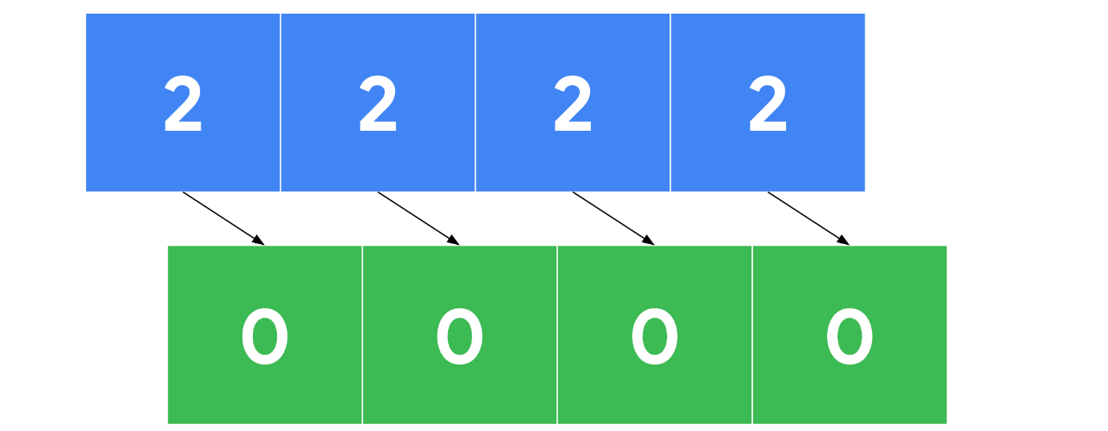

### [**df.dropna()**](https://pandas.pydata.org/docs/reference/api/pandas.DataFrame.dropna.html)

* **Description:** A **DataFrame** method that removes rows or columns that contain missing values, depending on the axis you specify. **Example:**

1

2

3

4

5

6

print('Original df: \n \n', df)

print('\n After dropna(axis=0): \n')

print(df.dropna(axis=0))

print('\n After dropna(axis=1): \n')

print(df.dropna(axis=1))

RunReset

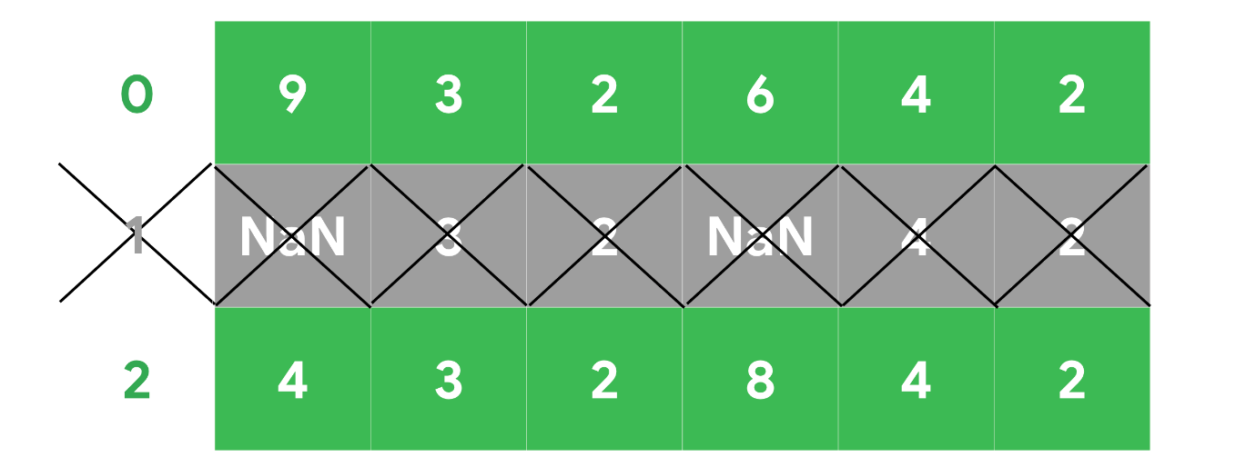

## Outliers

The following tools are helpful when dealing with outliers in a dataset.

### [**df.describe()**](https://pandas.pydata.org/docs/reference/api/pandas.DataFrame.describe.html)

* **Description:** A **DataFrame** method that returns general statistics about the dataframe which can help determine outliers **Example:**

1

2

3

print(df)

print()

df.describe()

RunReset

### [**sns.boxplot()**](https://seaborn.pydata.org/generated/seaborn.boxplot.html)

* **Description:** A seaborn function that generates a box plot. Data points beyond 1.5x the interquartile range are considered outliers. **Example:**

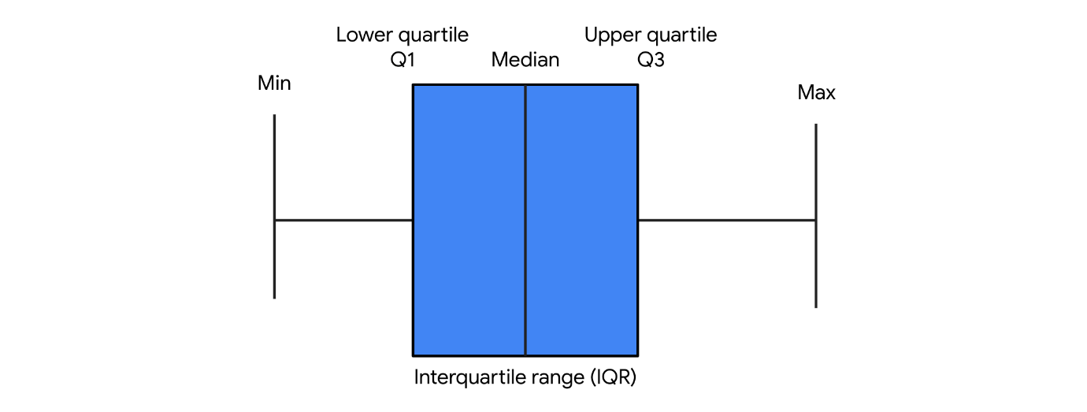

## Label encoding

The following tools are helpful when performing label encoding.

### [df.astype()](https://pandas.pydata.org/docs/reference/api/pandas.DataFrame.astype.html)

* **Description:** A **DataFrame** method that allows you to encode its data as a specified dtype. Note that this method can also be used on **Series** objects. **Example:**

1

2

3

4

5

6

7

8

9

10

print(df)

print('\n Original dtypes of df: \n')

print(df.dtypes)

print('\n dtypes after casting \'class\' column as categorical: \n')

df['class'] = df['class'].astype('category')

print(df.dtypes)

RunReset

### [**Series.cat.codes**](https://pandas.pydata.org/docs/reference/api/pandas.Series.cat.codes.html)

* **Description:** A **Series** attribute that returns the numeric category codes of the series.

**Example:**

1

2

3

4

5

6

7

8

9

# Cast 'class' column as categorical

df['class'] = df['class'].astype('category')

print('\n \'class\' column: \n')

print(df['class'])

print('\n Category codes of \'class\' column: \n')

df['class'].cat.codes

RunReset

### [**pd.get\_dummies()**](https://pandas.pydata.org/docs/reference/api/pandas.get_dummies.html)

* **Description:** A function that converts categorical values into new binary columns—one for each different category **Example:**

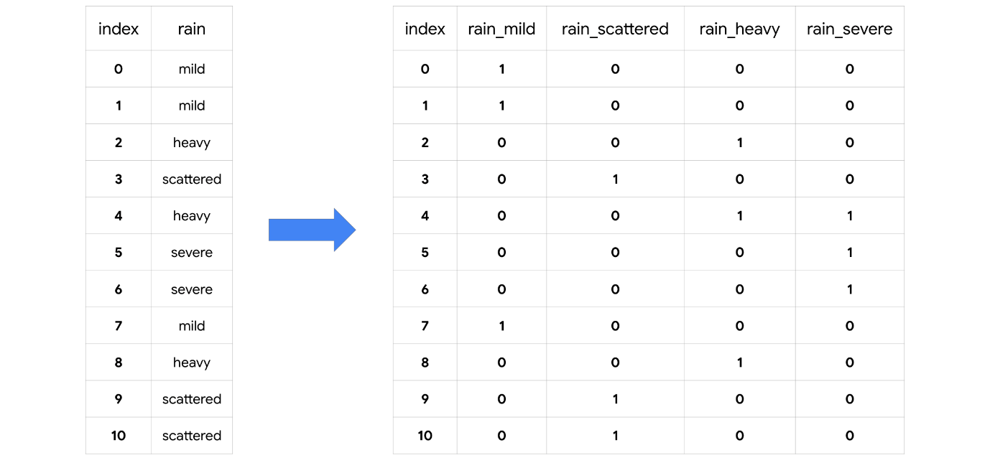

### [**LabelEncoder()**](https://scikit-learn.org/stable/modules/generated/sklearn.preprocessing.LabelEncoder.html)

* **Description:** A transformer from **scikit-learn.preprocessing** that encodes specified categories or labels with numeric codes. Note that when building predictive models it should only be used on target variables (i.e., y data). **Example:  It can be used to normalize labels:**

1

2

3

4

5

6

7

8

9

10

11

12

13

14

15

16

17

18

19

20

21

from sklearn.preprocessing import LabelEncoder

# Instantiate LabelEncoder()

encoder = LabelEncoder()

data = [1, 2, 2, 6]

# Fit to the data

encoder.fit(data)

# Transform the data

transformed = encoder.transform(data)

# Reverse the transformation

inverse = encoder.inverse\_transform(transformed)

print('Data =', data)

print('\n Classes: \n', encoder.classes\_)

print('\n Encoded (normalized) classes: \n', transformed)

print('\n Reverse from encoded classes to original: \n', inverse)

RunReset

**It can be used to convert categorical labels into numeric:**

1

2

3

4

5

6

7

8

9

10

11

12

13

14

15

16

17

18

19

20

21

22

23

24

from sklearn.preprocessing import LabelEncoder

# Instantiate LabelEncoder()

encoder = LabelEncoder()

data = ['paris', 'paris', 'tokyo', 'amsterdam']

# Fit to the data

encoder.fit(data)

# Transform the data

transformed = encoder.transform(data)

# New data

new\_data = [0, 2, 1, 1, 2]

# Get classes of new data

inverse = encoder.inverse\_transform(new\_data)

print('Data =', data)

print('\n Classes: \n', list(encoder.classes\_))

print('\n Encoded classes: \n', transformed)

print('\n New data =', new\_data)

print('\n Convert new\_data to original classes: \n', list(inverse))

RunReset

## Key takeaways

There are many tools that data professionals can use to perform data cleaning on a wide range of data. The information you learn from missing data, outliers, and transforming categorical to numeric data will help you prepare datasets for further analysis throughout your career.

# Test your knowledge: Changing categorical data to numerical data

### 1.

Question 1

Fill in the blank: Label encoding assigns each category a unique \_\_\_\_\_ instead of a qualitative value

number

### 2.

Question 2

When working with dummy variables, data professionals may assign the variables an infinite number of values.

False

### 3.

Question 3

Which pandas function does a data professional use to convert categorical variables into dummy variables?

get\_dummies()

**Why validate data?**

Make more accurate business decisions

Improve model complex performance

Prevent future system crashes, coding issues, or wrong predictions

**Questions to ask while validating data**

Are all entries in the same format?

Are all entries in the same range?

Are the applicable data entries expressed in the same data type?

**Joining**

The process of augmenting data by adding values form other datasets

**Input validation**

The practice of thoroughly analysing and double-checking to make sure data is complete, error-free, and high-quality.

# Identify: Python functions for cleaning data

df.isnull().sum()

Missing data

df['water\_level\_numerical'] = df['water\_level'].cat.codes

Label encoding

df.dtypes

Input validation

percentile25 =  
df['number\_of\_strikes'].quantile(0.25)  
percentile75 =  
df['number\_of\_strikes'].quantile(0.75)  
  
iqr = percentile75 - percentile25  
upper\_limit = percentile75 + 1.5 \* iqr  
lower\_limit = percentile25 - 1.5 \* iqr  
  
df[df['number\_of\_strikes'] > upper\_limit  
| df['number\_of\_strikes'] < lower\_limit]

Outliers

# Activity: Validate and clean your data

# **Instructions**

In this lab, you will analyze and interpret a dataset by applying input validation and label encoding. These are both fundamental techniques used in all types of data analysis, from simple linear regression to complex neural networks. You will be presented with a business scenario and a dataset to use as you explore structuring. You will practice applying input validation and label encoding to prepare a dataset for analysis.

# **Data Dictionary**

This activity uses a dataset called [Modified\_Unicorn\_Companies.csv](https://www.coursera.org/learn/go-beyond-the-numbers-translate-data-into-insight/resources/9mSWv). For teaching purposes, some of the data has been changed from the **Unicorn\_Companies.csv** data that you have been working with so far.

The original **Unicorn\_Companies.csv** data represents a list of private companies with a value of over $1 billion as of March 2022. The data includes the name of the country where the company was founded, its current valuation, funding, industry, top investors, year it was founded, and the year it reached a $1 billion valuation.

The dataset contains:

**1,074 rows** – each row is a different company

**10 columns**

| **Column name** | **Type** | **Description** |
| --- | --- | --- |
| Company | str | Company name |
| Valuation | str | Company valuation in billions (B) of dollars |
| Date Joined | datetime | The date in which the company reached $1 billion in valuation |
| Industry | str | Company industry |
| City | str | City the company was founded in |
| Country/Region | str | Country the company was founded in |
| Continent | str | Continent the company was founded in |
| Year Founded | int | Year the company was founded |
| Funding | str | Total amount raised across all funding rounds in billions (B) or millions (M) of dollars |
| Select Investors | str | Top 4 investing firms or individual investors (some have less than 4) |

The data was taken from [Kaggle](https://www.kaggle.com/datasets/mysarahmadbhat/unicorn-companies).

Remember, you can access and download the data for any Jupyter notebook activity from within the notebook itself by navigating to the **Lab Files** dropdown menu at the top of the page, clicking into the **/home/jovyan/work** folder, selecting the relevant data file, and clicking **Download**.

# Tips

To complete this lab, you will open a Jupyter notebook and follow instructions to enter code and written responses where prompted.

The Jupyter notebook will autosave as you work, or you can manually save it by clicking the **Save and Checkpoint** button or by selecting **Save and Checkpoint** from the **File** menu.



As you complete the lab, note the following features:

* **Sections:** Step-by-step instructions in each section lead you through the lab.
* **Code blocks:** Code blocks allow you to practice key Python coding concepts. Add code where prompted and then click the **Run** button to execute your code and view any possible output.



* **Questions:** Thought questions offer moments to pause and think about concepts and your output as you move through the lab.
* **Hints:** Hidden hints provide suggestions you can use to complete your work.

To review how to work in Jupyter notebooks, refer to the reading [Create, upload, and edit Jupyter notebooks](https://www.coursera.org/learn/get-started-with-python/supplement/2poER/create-upload-and-edit-jupyter-notebooks).

Be sure to complete this lab before moving on. To get started, click **Open Lab**.

The next course item will provide an exemplar of a completed lab for you to compare to your own work. To access the exemplar, return to the main course menu and click **Next**.



# Test your knowledge: Input validation

### 1.

Question 1

Data professionals use input validation to ensure data is complete, error-free, and of high-quality.

True

### 2.

Question 2

Fill in the blank: If a dataset lacks sufficient information to answer a business question, the process of \_\_\_\_\_ makes it possible to augment that data by adding values from other datasets.

joining

### 3.

Question 3

In which phase of the PACE workflow would a data professional perform the majority of the data-validation process?

Analyze

# The importance of validating a dataset

You work for a company that helps maintain the data of an international organization that manages and hosts long-distance running competitions.

Your manager has just assigned you to validate the data input gathered from the entrants for a recent marathon held in Cyprus. Runners from all over the world traveled to compete in the race. Your manager tells you that the data has already been cleaned, and it is now ready for final input validation.

When you take a look at the data in Python, you find the following columns titles:

|  |  |  |  |  |  |
| --- | --- | --- | --- | --- | --- |
| Entrant Name | Sign-Up Date | Age Group | Completion Time | Home Country | Entry Fee Amount Paid |

  To complete this discussion prompt:

1. Select two of the data columns above (other than “entrant name,” which has examples provided below).
2. Write what you would validate in the two data columns you selected. For example, for “entrant name”:
   * Format: first name, last name, plus initials
   * Script: names in English or other languages/scripts
   * Duplicates: check that no one entered twice or more
   * Missing/fake names: search for only first or last names, or fake entries
3. List three to four things to validate for each column (60-80 words).
4. Using what you've learned, comment on at least two other learners' posts in the [discussion forums](https://www.coursera.org/learn/go-beyond-the-numbers-translate-data-into-insight/discussions).

Participation is optional

**Response:**

### Data Column: Sign-Up Date

1. **Date Format:** Ensure the dates follow a consistent format, such as YYYY-MM-DD.
2. **Valid Dates:** Check that the dates fall within a reasonable range, e.g., the year of the marathon.
3. **Future Dates:** Verify that no sign-up dates are set in the future relative to the marathon date.
4. **Missing Dates:** Identify and handle any missing or null values in the sign-up date column.

### Data Column: Completion Time

1. **Time Format:** Ensure the completion times follow a standard format, such as HH:MM

.

1. **Reasonable Times:** Validate that the completion times are within a realistic range for a marathon, typically between 2 to 8 hours.
2. **Missing Times:** Identify and address any missing or null values in the completion time column.
3. **Consistent Units:** Verify that all times are recorded in the same unit of measure (e.g., hours, minutes, seconds) and not mixed with other units.

### Example Comments on Learners' Posts

**Comment on Learner 1:** Your points on validating the "Home Country" column are excellent. Ensuring the country names are standardized and consistent is crucial for accurate data analysis. Another aspect you might consider is cross-referencing country names with an official list of countries to catch any typos or unrecognized entries.

**Comment on Learner 2:** I appreciate your thorough approach to validating the "Age Group" column. It's important to ensure age groups are not only accurately defined but also consistently applied across the dataset. Additionally, you might want to check for any outliers or unrealistic age groups that could indicate data entry errors.

**Review**

EDA practises

Missing data and outliers

Categorical and numerical data

Input validation

Workplace skills

Ethical considerations

# Glossary terms from module 3

# Terms and definitions from Course 3, Module 3

**Categorical data:** Data that is divided into a limited number of qualitative groups

**Collective outliers:** A group of abnormal points, following similar patterns and isolated from the rest of the population

**Contextual outliers:** Normal data points under certain conditions but become anomalies under most other conditions

**Data ethics**: Well-founded standards of right and wrong that dictate how data is collected, shared, and used

**Data governance**: A process for ensuring the formal management of a company’s data assets

**Deduplication:** The elimination or removal of matching data values in a dataset

**Docstring:** (Refer to **documentation string**)

**Documentation string:** A group of text that explains what a method or function does; also referred to as a “docstring”

**Dummy variables:** Variables with values of 0 or 1 that indicate the presence or absence of something

**Global outliers:** Values that are completely different from the overall data group and have no association with any other outliers

**Heatmap:** A type of data visualization that depicts the magnitude of an instance or set of values based on two colors

**Input validation:** The practice of thoroughly analyzing and double-checking to make sure data is complete, error-free, and high quality

**Joining:** The process of augmenting data by adding values from other datasets; one of the six practices of EDA

**Label encoding:** Data transformation technique where each category is assigned a unique number instead of a qualitative value

**Missing data:** A data value that is not stored for a variable in the observation of interest

**Non-null count:** The total number of data entries for a data column that are not blank

**One-hot encoding**: A data transformation technique that turns one categorical variable into several binary variables

**Outliers:** Observations that are an abnormal distance from other values or an overall pattern in a data population

# Terms and definitions from previous modules

## B

**Bias**: In data structuring, bias refers to organizing data results in groupings, categories, or variables that are misrepresentative of the whole dataset

**Box plot:** A data visualization that depicts the locality, spread, and skew of groups of values within quartiles

## C

**Cleaning**: The process of removing errors that may distort your data or make it less useful; one of the six practices of Exploratory Data Analysis (EDA)

**CSV file**: A simple text file that can be easy to import or store in other softwares, platforms, and databases

## D

**Database (DB) file**: A file type used to store data, often in tables, indexes, or fields

**Data source:** The location where data originates

**Data visualization**: A graph, chart, diagram, or dashboard that is created as a representation of information

**Discovering**: The process data professionals use to familiarize themselves with the data so they can start conceptualizing how to use it; one of the six practices of EDA

## E

**Exploratory data analysis (EDA)**: The process of investigating, organizing, and analyzing datasets and summarizing their main characteristics, often by employing data wrangling and visualization methods; the six main practices of EDA are: discovering, structuring, cleaning, joining, validating, and presenting

**Extracting:** The process of retrieving data out of data sources for further data processing or storage

## F

**Filtering:** The process of selecting a smaller part of a dataset based on specified values and using it for viewing or analysis

**First-party data:** Data that was gathered from inside your own organization

## G

**Grouping**: The process of aggregating individual observations of a variable into groups

## H

**Hypothesis:** A theory or an explanation, based on evidence, that is not yet proven true

## I

**Info():** Gives the total number of entries, along with the data types—called Dtypes in pandas—of the individual entries

**Int64:** A standard integer data type, representing numbers somewhere between negative nine quintillion and positive nine quintillion

## J

**Joining**: The process of augmenting data by adding values from other datasets; one of the six practices of EDA

**JSON file:** A data storage file that is saved in a JavaScript format

## M

**Merging:** A method to combine two (or more) different data frames along a specified starting column(s)

## P

**PACE**: A workflow data professionals can use to remain focused on the end goal of any given dataset; stands for plan, analyze, construct, and execute

**Presenting**: The process of making a cleaned dataset available to others for analysis or further modeling; one of the six practices of EDA

## S

**Second-party data:** Data that was gathered outside your organization but directly from the original source

**Slicing:** A method for breaking information down into smaller parts to facilitate efficient examination and analysis from different viewpoints

**Sorting:** The process of arranging data into a meaningful order for analysis

**String:** A sequence of characters and punctuation that contains textual information

**Structuring**: The process of taking raw data and organizing or transforming it to be more easily visualized, explained, or modeled; one of the six practices of EDA

## T

**Third-party data:** Data gathered outside your organization and aggregated

## V

**Validating**: The process of verifying that the data is consistent and high quality; one of the six practices of EDA

# Module 3 challenge

Question 1

Fill in the blank: N/A and NaN are terms used to describe \_\_\_\_\_ data.

missing

Question 2 (NOT FINAL)

Stakeholders at a film studio hire a data analytics firm to provide insights about the best locations for film shoots. However, the film studio’s datasets contain missing data. Which of the following strategies can help the data analytics firm solve this problem? Select all that apply.

- Create a NaN category.

- Add in the missing values by taking the average values from the existing data.

Question 3

A data professional writes the following code:

**df.merge(df\_zip, how='left',**

**on=['date','center\_point\_geom'])**

Which section of the code refers to the dataframe to be merged with **df**?

**df\_zip**

Question 4

What pandas function is used to identify when a value is missing from a data frame?

**pd.isnull()**

Question 5

What type of outliers are a group of abnormal points that follow similar patterns and are isolated from the rest of a population?

Collective outliers

Question 6

A data team works for a stereo installation company. To gain insights into what products people are most likely to purchase in the coming year, they review categorical data about 20 of the most popular stereos. Rather than using brand names, they assign a different number to each stereo to make the data simpler to join. What does this scenario describe?

Label encoding

Question 7

What type of data visualization shows the concentration of values between two data points by illustrating their magnitude with two colors?

Heat map

Question 8 (NOT FINAL)

What does the pandas function **pd.duplicated()** return to indicate that a data value is a duplicate of another value within the same dataset?

True

Question 9

Fill in the blank: The pandas function \_\_\_\_\_ enables data professionals to create a new dataframe with all duplicate rows removed.

**drop\_duplicates()**

**Module 4:**

**What you’ll learn**

Improve your data visualizations skills

Accurate representation aspects and techniques

Techniques for making al your data visualizations accessible

**What you’ll learn (Working with Tableau)**

How to create data visualizations in Tableau

Explain technical concepts to non-technical audiences

Create dynamic visualizations with interactive and motion elements

Alter your visualizations based on different audiences’ needs

# Tableau Public overview

As you have been learning, Tableau is a powerful data visualization tool used by data professionals around the world. If you have taken the Google Data Analytics Professional Certificate, then you should already be familiar with Tableau. If you haven’t completed the Data Analytics Certificate, you can review resource materials below and linked in other videos. The Tableau software is available for free through its browser version, which allows learners like you to test out the capabilities of the software in a limited capacity. In this reading, you will be given an overview of Tableau Public, the free use, basic version of this visualization software.

## Reviewing the fundamentals of Tableau Public

In this reading, you will learn about the basic structure of the **data source** and **design** screens featured in Tableau Public. The data source page is used for inputting or connecting to the data, and the design page is used for plotting and creating data visualizations. Both are needed to successfully design impactful and compelling data visualizations.

**Note:** To review the Tableau Public setup process, refer to the reading about [how to sign on to Tableau Public](https://www.coursera.org/learn/go-beyond-the-numbers-translate-data-into-insight/supplement/muYtK/how-to-sign-on-to-tableau-public).

### **Data source page**

Before you can start designing visualizations, you’ll first need to upload your data. Since you’ve already set up your Tableau Public profile, all you need to do is log in and select **Web Authoring** under **Create** in the navigation bar.

**Note:** Everything required for Tableau in this course can be completed with Web Authoring; you are not required to download the Tableau software.

#### **Tableau Public Web Authoring**

Web authoring allows you to create visualizations directly from a web browser. Can you create a viz without downloading any software? Yes! Since you’ve already [set up your Tableau Public profile](https://www.tableau.com/community/blog/2022/9/beginners-guide-tableau-public), all you need to do is log in and select **Web Authoring** under **Create** in the navigation bar. For the purposes of this certificate program, you can perform everything you need in Tableau Public. The instructions in the following resources refer to Tableau Public.

#### **Tableau Desktop Public Edition**

You can also [download](https://www.tableau.com/products/public/download) the software directly to your Mac or PC. Select **Tableau Desktop Public Edition** under **Create** in the navigation bar on Public’s website.

***Reminder: Tableau Public should only be used for analyzing and sharing public data.*** All workbooks and datasets published will be freely accessible to anyone.

 After you upload your dataset, you can perform the following steps outlined to match the circled numbers in the following image:

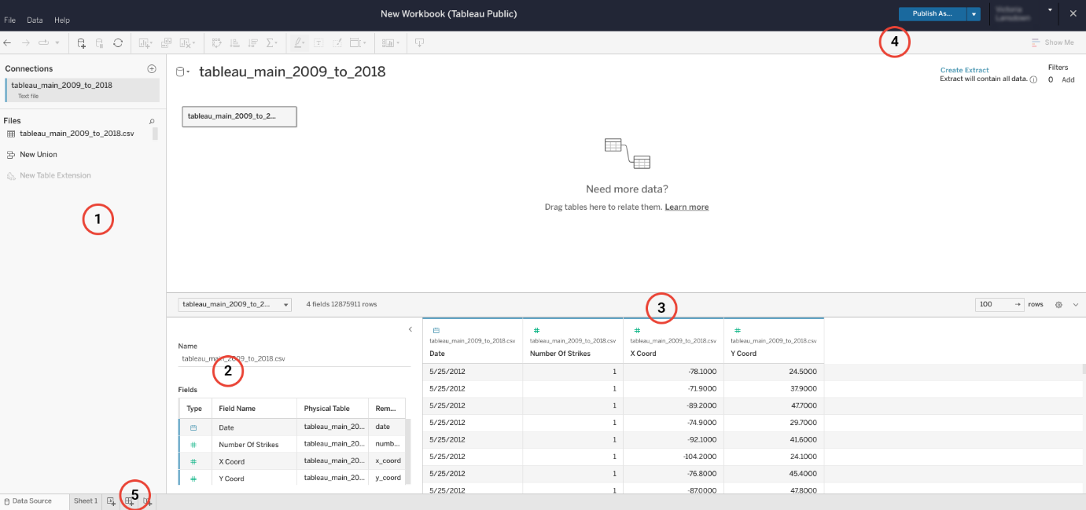

The following descriptions correspond to the image above.

1. This left-hand pane includes your data connections and files. Here you will find all the files you upload in a list so that you can keep track of multiple files and/or multiple connections to different databases.
2. Just to the right of the data connections window is a list of all of the fields that Tableau Public has detected in a particular file. If you have multiple files uploaded, you can select the file from a dropdown to access each file’s fields. As you’ll learn in an upcoming video, Tableau’s fields are acquired from the data columns in your file. Tableau automatically sorts these fields into dimensions or measures and discrete or continuous variables.
3. The biggest pane on the page, on the middle right, allows you to access all of the columns of your file as Tableau fields, including several rows of data. Unlike the pane to the left, this pane allows you to create new fields based on those already present, such as new calculation fields, groups, sets, or parameters (you will learn more about these features in upcoming videos). You may be prompted to select “update now” or “update automatically” in order to populate this pane with your data. If that’s the case, it is good practice to update automatically to ensure you’re consistently working with recent data. (For reference -- review the following image, after #5.)
4. The blue button “Publish” in the upper right of the screen acts as your “save” button. Because Tableau Public is a browser-based platform, anything you create and want to save will be published to your public account. There are ways to password lock or hide data sources and data visualizations if desired, but Tableau Public only offers the Publish field for saving your work. When you click on the ‘Publish’ button, you may automatically be navigated to your data design page, which may be blank depending on your design progress. Do not be alarmed. Your latest dataset uploads or data designs were still saved; just navigate back to where you were last and continue editing your visualization.
5. Lastly, you will use the collection of buttons at the bottom left of the page to navigate to your data design page.  You’ll find button options for creating a new worksheet, a new dashboard, and a new story. These elements will be introduced in the next section.

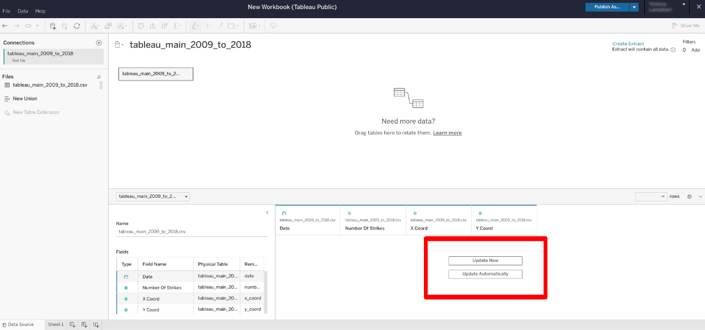

### **Data design page**

The data design page is where your data visualizations will be built. To navigate to the data design page, click on ‘Sheet 1’ or create a new sheet as instructed in #5 on the previous corresponding image. When you first click to open a data design page, you may be prompted that Tableau is ‘Creating Extract’. That means that Tableau is extracting the providing data to be used in visualizations. This process may take several minutes. Here you will move your data source fields to appropriate shelves to build the type of visualization you want. You can build data visualizations or entire interactive dashboards from this page.

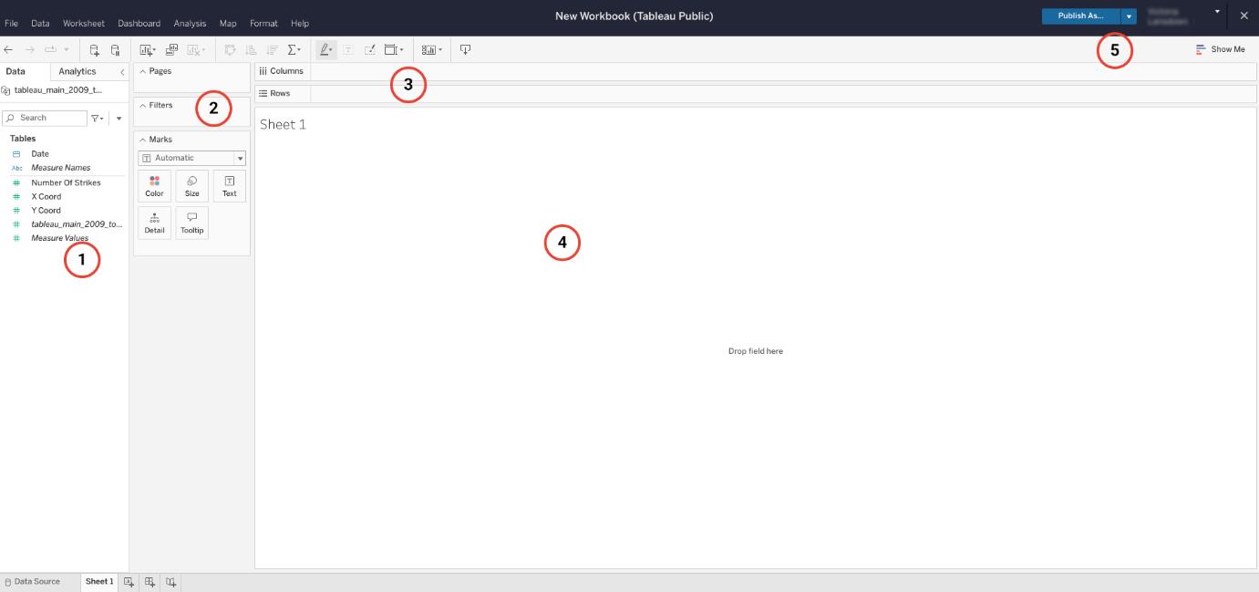

The following numbered items correspond to the numbers displayed in the Tableau workbook image above.

1. In this pane on the far left, you will find your list of discrete and continuous dimensions and measures. You will move these variables to different panes on this page to build visualizations. You will learn more about these variables later.
2. In the next pane just to the right, you’ll find “Pages,” “Filters,” and “Marks.” You can move any dimension or measure to these different fields to manipulate the data visualization. You will learn how to use these features in upcoming videos.
3. At the top of the page, just under the menu bar, there are two empty rows that act as your main two shelves for moving your variable fields. The “Columns” and “Rows” shelves help you position your data visualization as desired. You’ll also notice above these rows a toolbar and menu full of other options for manipulating your data visualization.
4. In the middle of the screen is the main viewing panel for your visualization. As you add elements and drag your dimensions and measures to different fields, you will notice the impact they have on your data visualization in this panel. In the upper right corner you will find your “Publish” button, which acts as the save button, and the “Show Me” dropdown. Under the “Show Me” dropdown, you will find a selection of data visualization types and guides for building each of them.
5. When you’re ready to [save and share your work](https://help.tableau.com/current/pro/desktop/en-us/publish_workbooks_tableaupublic.htm), publish it to your Tableau Public profile. View the options for publishing your work by clicking on the down arrow next to the “Publish” button on the top navigation bar.

## Other ways to review Tableau tools

### **Google Data Analytics Professional Certificate**

As mentioned earlier, if you have taken the [Google Data Analytics Professional Certificate](https://www.coursera.org/professional-certificates/google-data-analytics) program, you are already familiar with Tableau and Tableau Public. Go to the [Get started with Tableau](https://www.coursera.org/learn/visualize-data/lecture/sLxV4/data-visualizations-with-tableau) lesson in that program to review what you have learned.

### **Tableau.com**

By visiting [Tableau.com](https://www.tableau.com/), you’ll notice multiple product offerings, everything from Tableau Public (which is free) to Tableau Desktop, Tableau Mobile, and Tableau Server. Each product has its own use and specialization, but the main elements for data visualization are the same. You can search through the [Tableau Help page](https://www.tableau.com/support/help?_ga=2.3466357.45238129.1654614666-316280037.1654614666) to find specific articles on just about any topic regarding data visualizations. There are a variety of training resources available from Tableau to help users learn the different features of their products. Tableau offers a variety of training resources for helping to learn their different products.

## Key takeaways

Tableau is a powerful data visualization tool, but that means it takes a lot of practice and experience to use it proficiently. The two main pages you’ll use are the data source and data design pages. There are also a large number of resources available to help you in each step of the process, including Tableau Help and Grow With Google Data Analytics Certificate Program.

## Resources for more information

To help you troubleshoot or to learn more, you can use  the following links:

* Use Tableau resource page to set up your data for success: [Set up data sources](https://help.tableau.com/current/pro/desktop/en-us/datasource_prepare.htm)
* Tableau Tools and Web Authoring Help: [Design charts and analyze data](https://help.tableau.com/current/pro/desktop/en-us/design_and_analyze.htm)
* The Tableau Public “Discover” page, which includes “Viz of the Day” and other beautiful vizzes designed on the platform: [Welcome to Tableau Public](https://public.tableau.com/app/discover)
* Beginner's guide to using Tableau Public: [A step-by-step guide to get you started on your own data viz journey](https://www.google.com/url?q=https://www.tableau.com/blog/beginners-guide-tableau-public?_gl%3D1*uv0ojo*_ga*MjU5NjUyMzcuMTY1NDMwMDM4MQ..*_ga_8YLN0SNXVS*MTY5MTE4NzA1Mi4xMC4xLjE2OTExODcwNzcuMC4wLjA&sa=D&source=docs&ust=1691485449789685&usg=AOvVaw267xvonfqL2uCc_x_yXcip)
* Getting Ready to Publish Your First Data Visualization: [A step-by-step guide for analyzing data and publishing a viz to your Tableau Public profile](https://www.tableau.com/blog/getting-ready-publish-your-first-data-visualization)

# How to sign on to Tableau Public

As you have been learning, Tableau is a powerful data visualization tool used by data professionals around the world. Tableau offers a free browser version of its software, Tableau Public, which allows learners like yourself to test out its capability in a limited capacity. Tableau Public is the software you will use throughout this course on data visualization. In this reading, you will be guided on how to sign up for Tableau Public, and you will be given troubleshooting resources for potential obstacles you may experience.

## How to sign in to Tableau Public

**Signing in with an existing Tableau.com account**

If you already have a Tableau.com account, you can use your existing [login credentials](https://identity.idp.tableau.com/login?state=hKFo2SBKOEgxYllud014VHFFakVpMzlnNFdhRUNKVXJ6ZVBnTaFupWxvZ2luo3RpZNkgLXBtWHRBWUhuNFFqNWZVVjRadnU4clhBNEtDVGNTeWOjY2lk2SBFeVRaSXdmbjlTM2ViTk15RHU1TjRmcTkxMVJsSW9hdA&client=EyTZIwfn9S3ebNMyDu5N4fq911RlIoat&protocol=oauth2&prompt=login&response_type=token%20id_token&redirect_uri=https%3A%2F%2Fid.tableau.com%2Fcallback&scope=openid%20email&audience=https%3A%2F%2Fid.tableau.com%2Fapi%2Fv4%2F&nonce=yZmF9e77cuq0mA8Aq..3zZF1SFh84Kni&auth0Client=eyJuYW1lIjoiYXV0aDAuanMiLCJ2ZXJzaW9uIjoiOS4xOS4xIn0%3D) to sign into Tableau Public. Click [here](https://community.tableau.com/s/tableau-public-faq#subhead6) to learn more. If this is your first time signing in to Tableau Public with your Tableau.com account, you can set your account password by resetting your password. To do so, click “[reset password](https://id.tableau.com/resetPassword).”

**Signing in for the first time**

The following instructions show you how to sign up for Tableau Public for the first time, without a pre-existing Tableau.com or Tableau Public account. First, go to the [Tableau Public home page](https://public.tableau.com/). If [this link](https://public.tableau.com/) does not open to Tableau’s homepage, type public.tableau.com in your browser’s address bar.

***Note:*** Tableau Public works best on Chrome (Windows, Mac, Android), Edge (Windows), Firefox (Windows and Mac), Safari (Mac and IOS).

Next, at the top right of the page, click the “Sign Up” button.

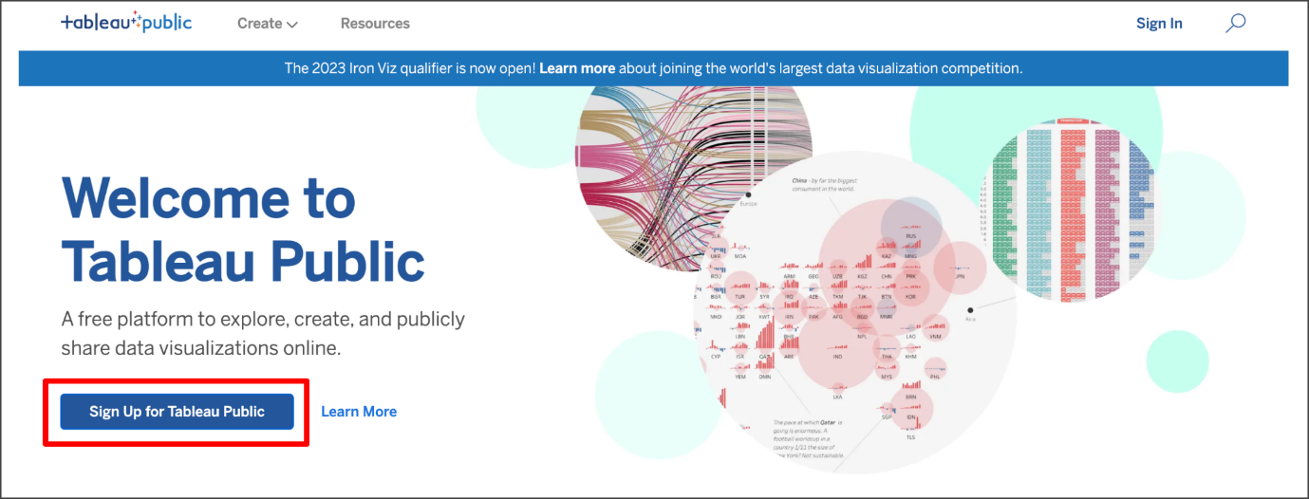

Fill in all the required fields and click “Create My Account.”

### **Navigating Tableau Public**

The home page for Tableau Public contains resources and guides for helping data professionals learn more about and get inspired by data visualizations. You can explore any and all of the links on this landing page to help enhance your knowledge of Tableau. The most helpful place to start if you are new to Tableau is the [Resources page](https://public.tableau.com/en-us/s/resources), which has how-to videos, community resources and user forums.

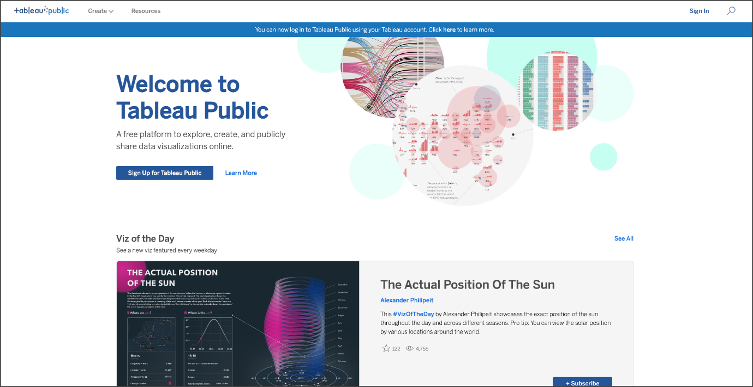

## How to start creating your own visualizations

During the instruction videos, the instructor will ask you to log in to Public Tableau and follow along in the creation of a data visualization. Once you’ve set up your Tableau Public profile, all you need to do is log in and select Web Authoring under Create in the navigation bar.

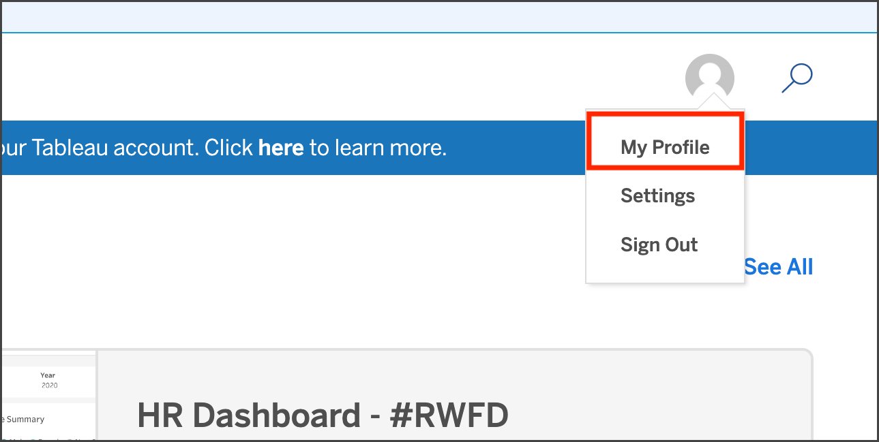

### **Get Started**

Within your Tableau Public profile, you’ll find tabs for Vizzes, Favorites, Following, and Followers. At the instructor's prompt, click  Create a Viz.



## Key takeaways

Accessing Tableau Public and creating a profile will be your first step to learning how to design data visualizations like a data professional.

## Resources for more information

To help you troubleshoot or to learn more, explore take a look at the following links:

* Tableau Public not working? Check out these [Technical speculations and storage requirements](https://www.tableau.com/products/techspecs#public)
* [The Tableau Public Discover page](https://public.tableau.com/app/discover) includes ‘Viz of the Day’ and other beautiful vizzes designed on the platform
* [The Tableau Public Blog](https://public.tableau.com/en-us/s/blog) offers regular dispatches from the Tableau Public Team

**Your analysis criteria**

* The locations of rental units where the owners have 40 or more properly listings.
* Properties with many good reviews
* Price between 90 and 250 Euros

(From the video: The visualization life cycle)

# Choose a data visualization type

Consider the following scenario: You are a data consultant contracted by a landowner organization in Greece. They are asking you to analyze the publicly-available AirBnB data in Athens, Greece, as part of a land development strategy meeting.

They aren’t interested in a deep analysis yet. What they would like is data visualizations portraying some important aspects of the data.

They would like you to create data visualizations of the following:

* The listings with more than 100 reviews, with the dates of each listing’s most recent customer review
* The prices of the top 20 listings with the highest reviews per month
* The locations of the top 50 most expensive AirBnB listings in Athens, Greece

To complete this discussion prompt:

1. Use the graphics below to help you decide which type(s) of data visualizations are best suited to visualize each requested data extraction.
2. Write the data visualization type.
3. Write two sentences describing why you selected each data visualization type (60–80 words per bullet point).
4. Visit the [discussion forums](https://www.coursera.org/learn/go-beyond-the-numbers-translate-data-into-insight/discussions) to read what other learners have written, and respond to at least two posts with your own thoughts.

### Comparison: Compare different data values

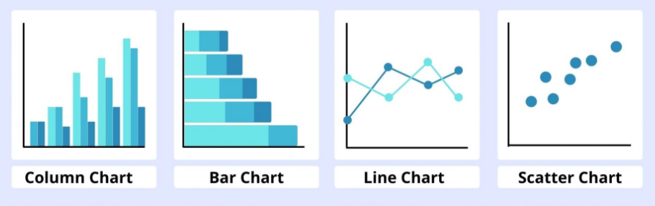

### Distribution: Show how data values are distributed

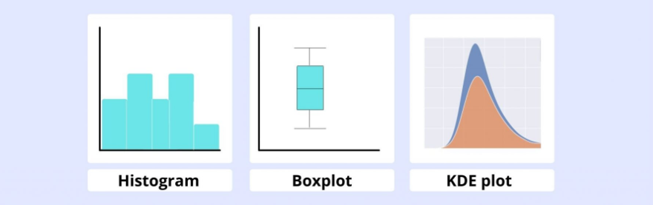

### Segmentation: Break data into parts

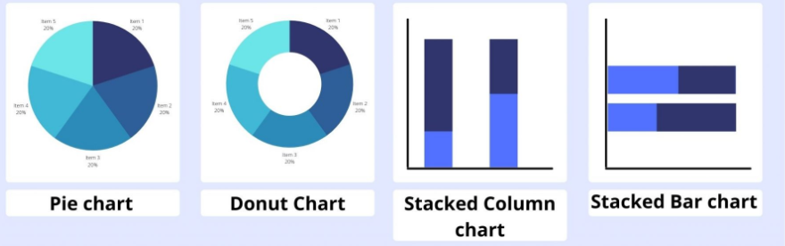

### Relationship: Show how data variables relate

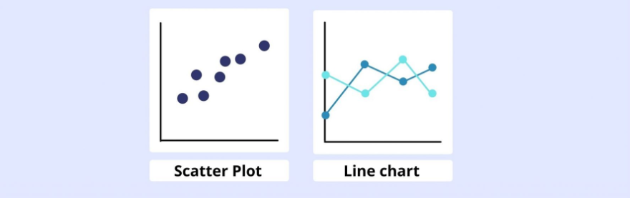

### Time series: Show changes in data over time

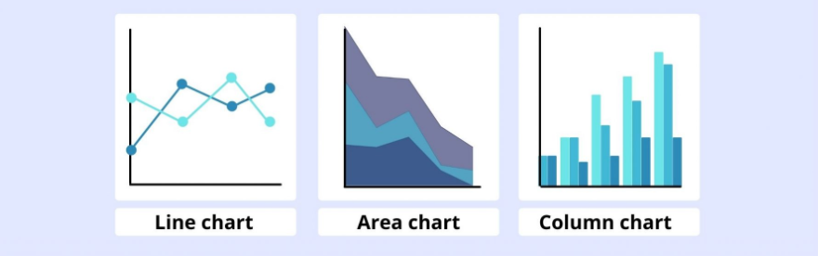

# Download your datasets and begin presenting with Tableau

## Accessing and utilizing resources in this section

To help your learning in this part of the course, follow along with the instructor as they go through Tableau in each video.

Steps to complete:

1. Open [Tableau Public](https://public.tableau.com/app/discover).
2. Since you’ve already set up your Tableau Public profile, just  log in and select Web Authoring under Create in the navigation bar.
3. Download the dataset files attached below and then upload them to Tableau. **\*See additional instructions below.**
4. Open the Tableau follow-along guides linked below. These guides are labeled to correspond to video titles and concepts.

* [Tableau follow-along guide: Work with Tableau, Part 1](https://www.coursera.org/learn/go-beyond-the-numbers-translate-data-into-insight/supplement/PJNUB/follow-along-guide-work-with-tableau-part-1)
* [Tableau follow-along guide: Work with Tableau, Part 2](https://www.coursera.org/learn/go-beyond-the-numbers-translate-data-into-insight/supplement/EnfzQ/follow-along-guide-work-with-tableau-part-2)
* [Tableau follow-along guide: Craft compelling stories with Tableau](https://www.coursera.org/learn/go-beyond-the-numbers-translate-data-into-insight/supplement/iJKtd/follow-along-guide-craft-compelling-stories-with-tableau)
* [Tableau follow-along guide: Present like a pro with Tableau](https://www.coursera.org/learn/go-beyond-the-numbers-translate-data-into-insight/supplement/pvIZR/follow-along-guide-present-like-a-pro-with-tableau)

4. Follow along with the instructor in each video as they show the creation of the data visualizations in Tableau.

In this lesson’s videos, you will need access to these datasets:

**\*Instructions for downloading the dataset files and uploading them to Tableau:**

You will need to download the provided .csv files and upload them to Tableau Public to follow along with the instructor in subsequent videos and interact with Tableau.To do so, follow these steps:

1. Download the attached .csv zip file to your device.
2. Extract the contents of the zip file once the download is finished.
   1. You'll need to upload the specific dataset files to Tableau. Do not upload the entire .zip folder.
   2. When you download the zip folder from this page, your computer will automatically download a .zip file folder. The .zip folder is automatically named with a series of letters and numbers.
   3. Open up that .zip folder, then save the individual dataset files. The two files are: tableau\_main\_2009\_to\_2018.csv and tableau\_dataset.csv.
   4. Once you can see the individual dataset files, proceed to upload those to Tableau Public.
3. Upload the extracted .csv files to Tableau.
   1. Review the provided [Tableau follow-along guide: Work with Tableau, Part 1](https://www.coursera.org/learn/go-beyond-the-numbers-translate-data-into-insight/supplement/PJNUB/follow-along-guide-work-with-tableau-part-1), and/or follow along with the instructor in the video [Work with Tableau, Part 1](https://www.coursera.org/learn/go-beyond-the-numbers-translate-data-into-insight/lecture/RpCfi/work-with-tableau-part-1) for further instructions about uploading files to Tableau.
   2. There are two Tableau datasets: tableau\_main\_2009\_to\_2018.csv and tableau\_dataset.csv. Be sure to check the dataset name shown on screen in the instructional video.
   3. When following along, make sure you've uploaded the same file so you can create the same visualizations.

## Data dictionary

The datasets above represent lightning strike counts in the United States. They include four columns of data: latitude, longitude, date, and lightning strike counts. Each row represents a total lightning strike count on the specified date for a particular location.

| **Column name** | **Type** | **Description** |
| --- | --- | --- |
| number of strikes | int64 | The total count of lightning strikes on a given day |
| X Coor | obj | Longitude |
| Y Coor | obj | Latitude |
| date | str | The recorded date (format: DD/MM/YYYY) |

# Follow-along guide: Work with Tableau, Part 1

## This document includes detailed instructions for how to perform the data visualizations described in the video “Work with Tableau, Part 1.”

### The following guide points out areas of the video that may require adjustment. These reference guides can also serve as a set of usability reminders for you to recall when using Tableau in your future career.

**Instructions**

* Since you’ve already [set up your Tableau Public profile](https://www.tableau.com/community/blog/2022/9/beginners-guide-tableau-public), all you need to do is log in and select **Web Authoring** under **Create** in the navigation bar.
* **Upload your dataset from your computer**. Select the appropriate CSV file provided in the [instructions](https://www.coursera.org/learn/go-beyond-the-numbers-translate-data-into-insight/supplement/hSNPT/follow-along-instructions-data-visualizations-and-presentations-with-tableau). The dataset you’ll use with this instructional video is: tableau\_main\_2009\_to\_2018.csv.

(**Note:** Please allow several minutes for data upload into Tableau Public.)

Before you can start designing visualizations, you’ll first need to upload your data. You'll need to upload the specific dataset files to Tableau. Do not upload the entire .zip folder. When you download the zip folder from this page, your computer will automatically download a .zip file folder. The .zip folder is automatically named with a series of letters and numbers. Open up that .zip folder, then save the individual dataset files. The two files are: tableau\_main\_2009\_to\_2018.csv and tableau\_dataset.csv. Once you can see the individual dataset files, proceed to upload your dataset for this video to Tableau Public.

Notice on the data source tab that you can see all of your column headers and Tableau icons that help you determine data types. In this case, you’ll see a calendar icon and pound signs indicating numbers or integers.

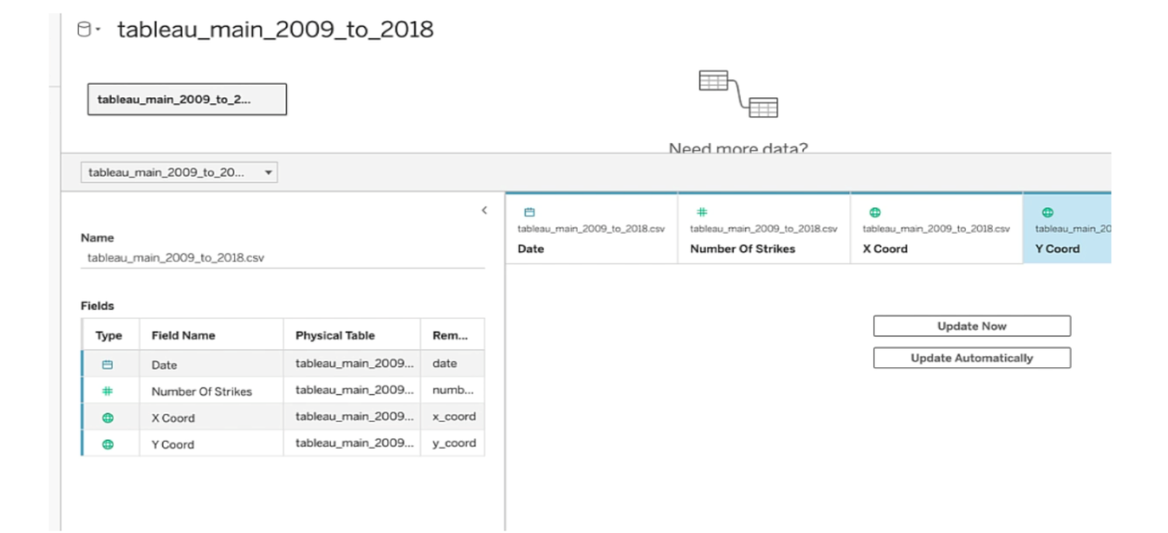

* Click on **New Worksheet**.

(**Note:** Please allow several minutes for data to import into a new worksheet.)

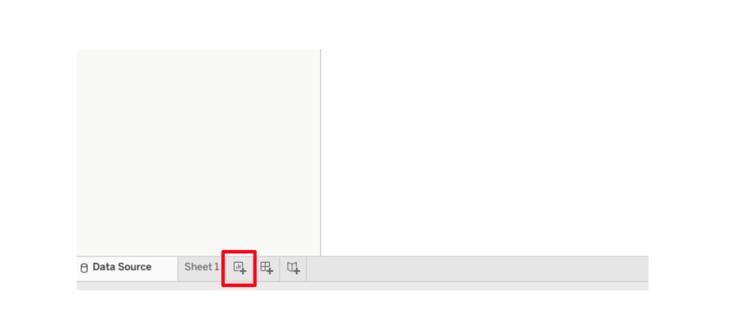

Notice the green and blue fields and the gray line dividing them. As you’ll remember from the video, blue indicates a discrete field and green indicates a continuous field. The gray line divides the dimensions from the measures, with dimensions above and measures below the line.

* Drag **Date** into Columns shelf.

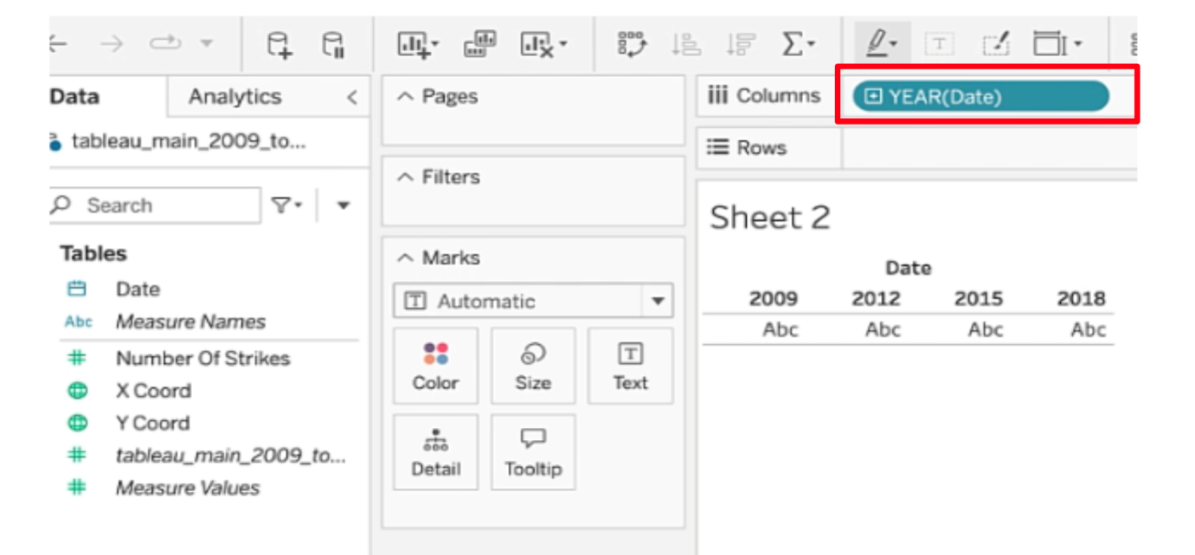

* Click on the drop down menu of the date field. Ensure there is a checkmark next to **Year**.

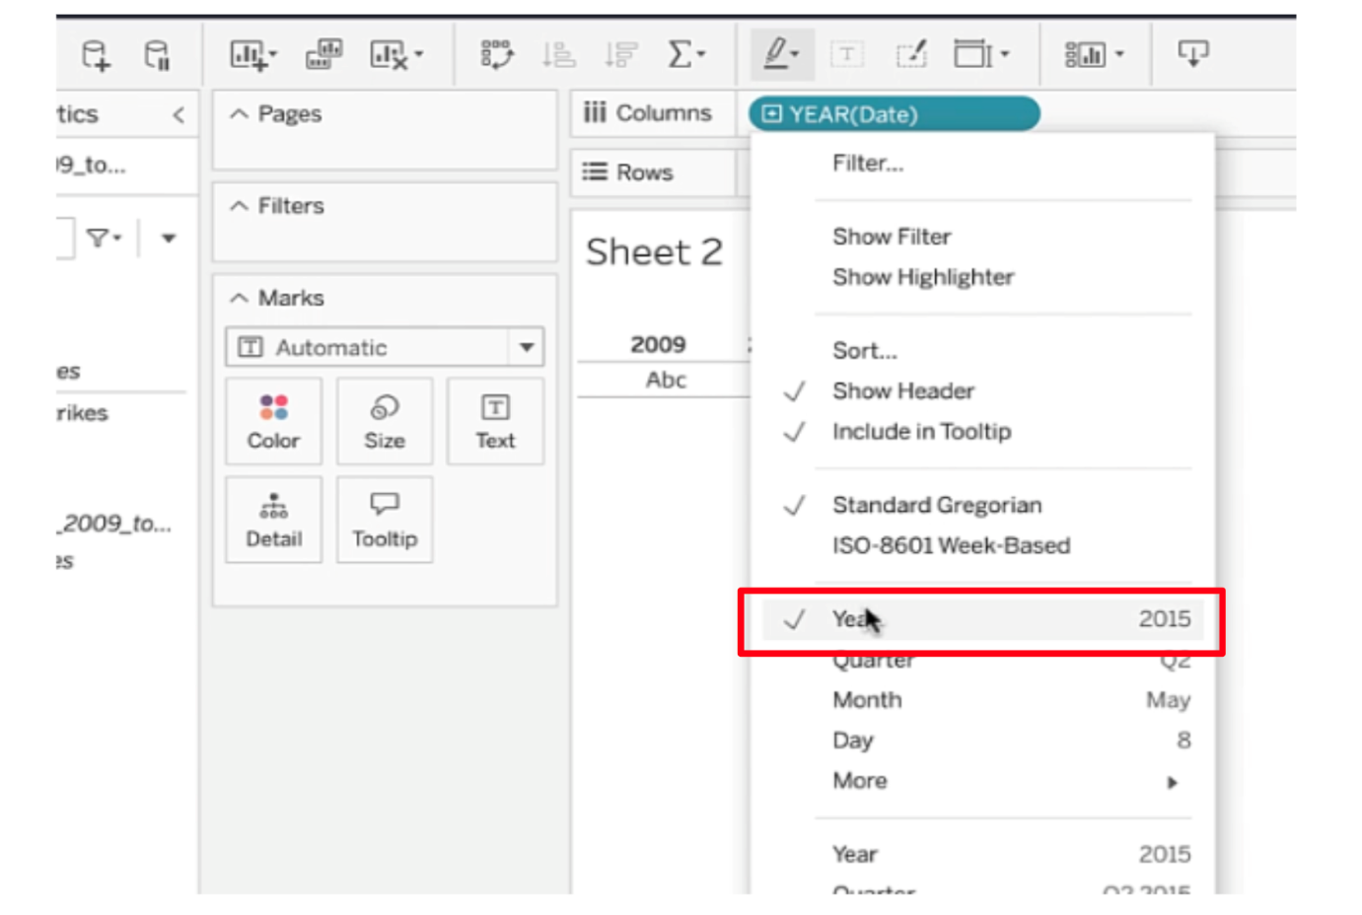

* Drag **Number Of Strikes** to the Row shelf. You’ve created a line graph.

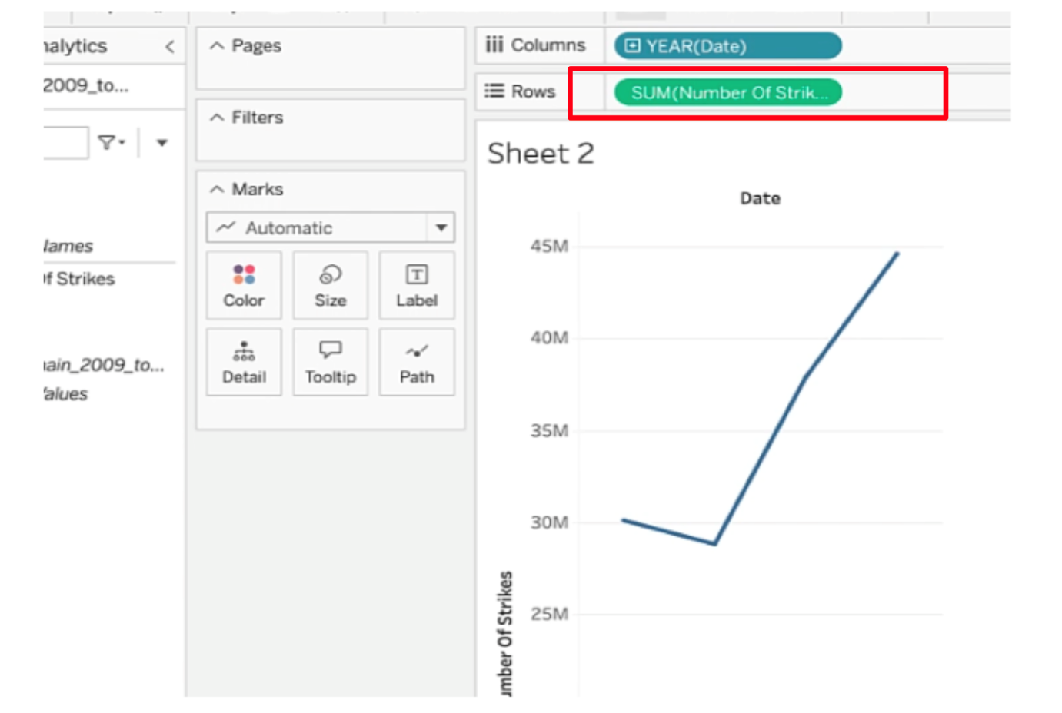

* Click on **Duplicate** worksheet in the toolbar menu.
* Click on the dropdown menu in the **Marks** field. Select **Bar**.

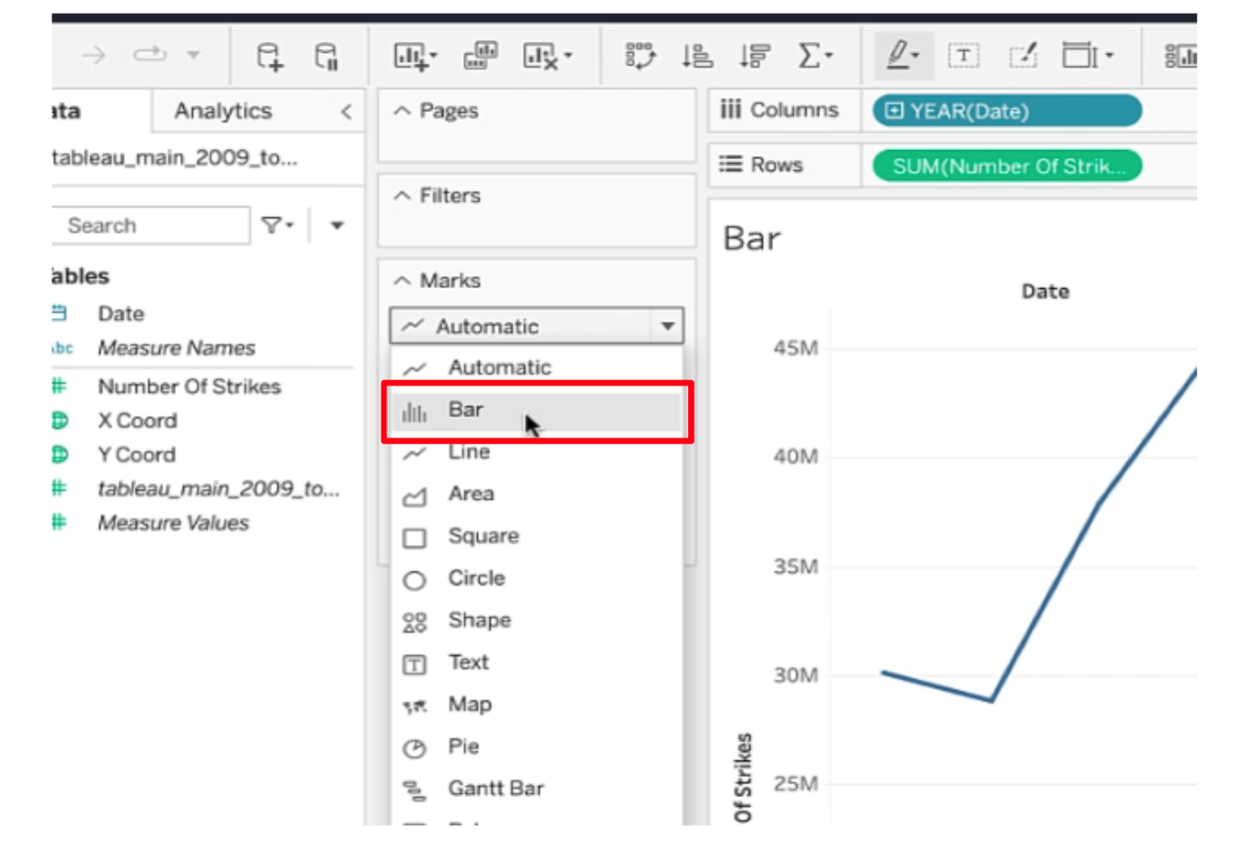

* Click **Filters**.
* Select **Years** when the pop-up window appears.
* Click **Next**.

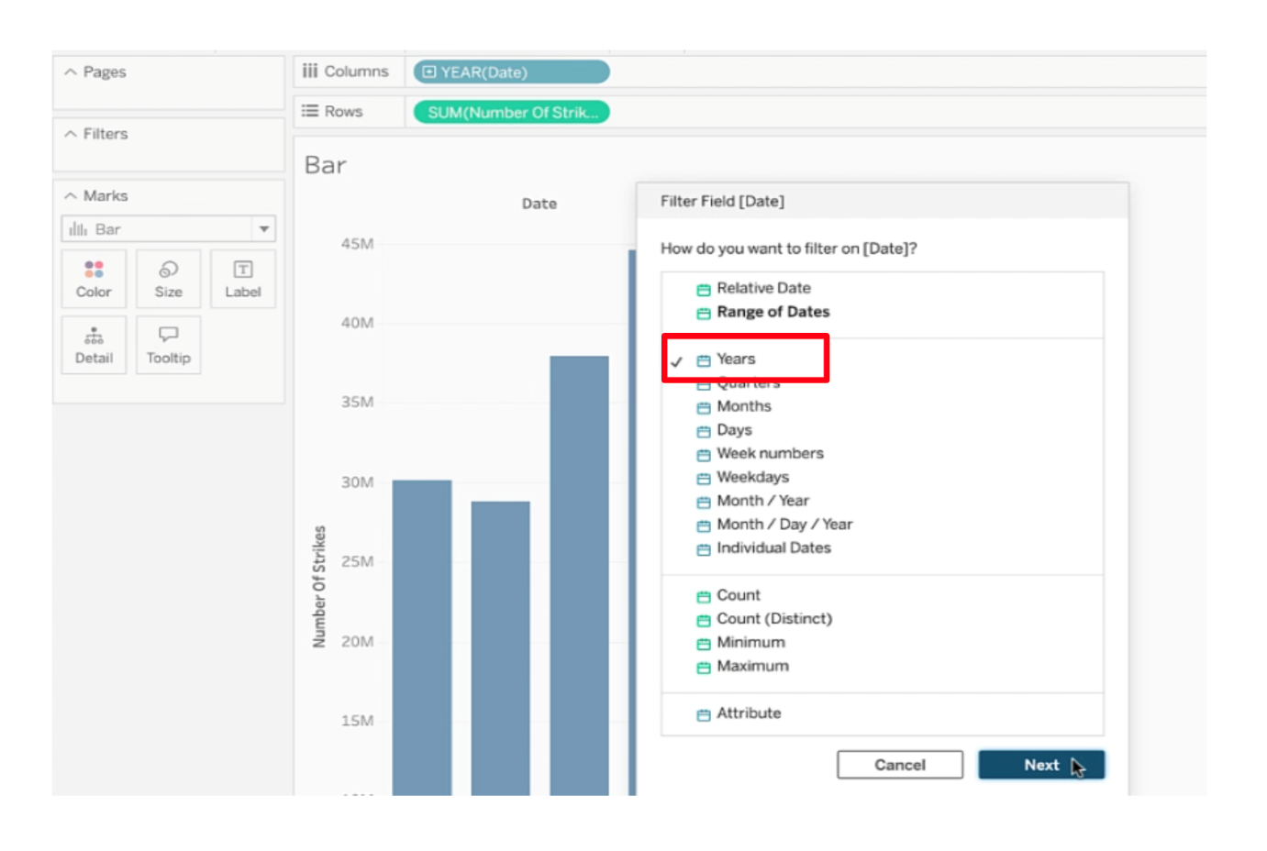

* Select only **2009** and **2018** in the next pop-up window.
* Click **OK**.

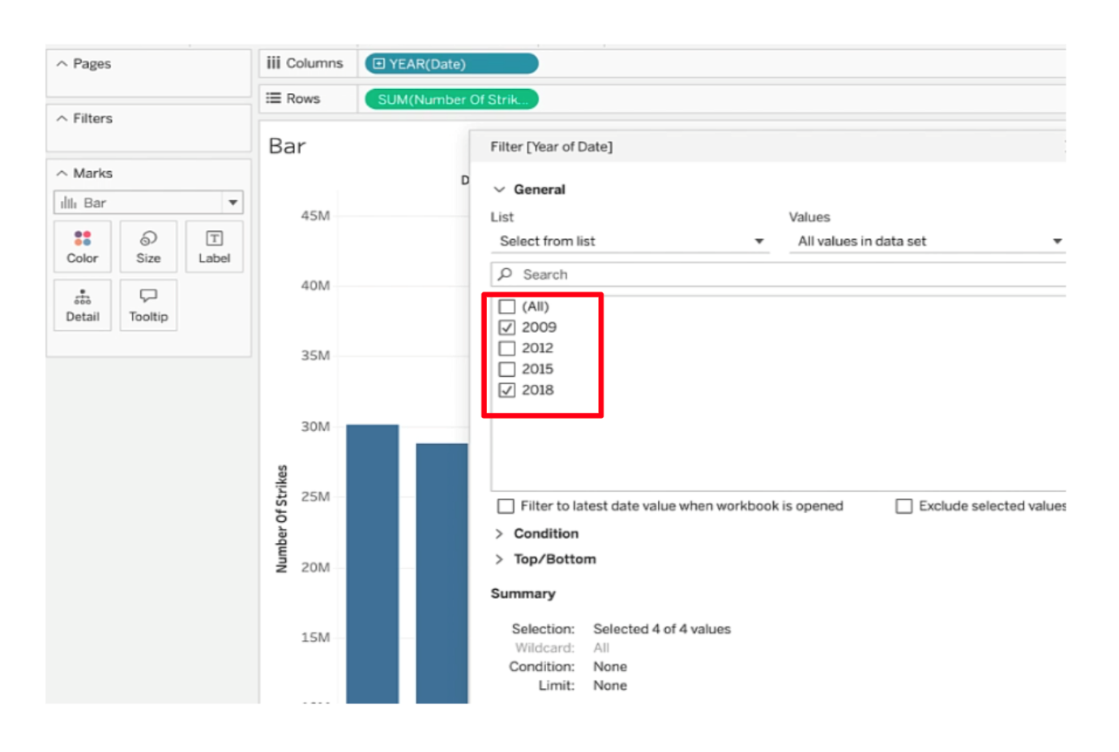

* Add labels to the bars by dragging **Number Of Strikes** to the **Label** field.

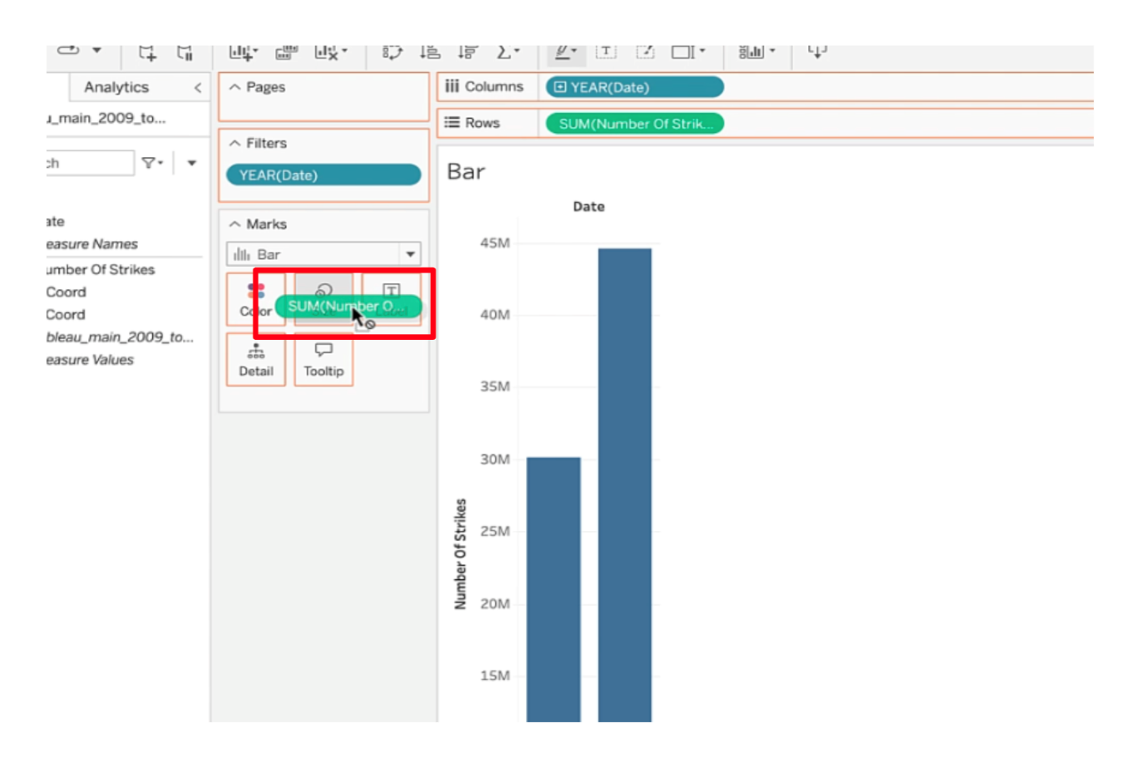

Notice the bars are labeled at the top with total number of strikes for 2009 and 2018.

* Click **Duplicate** worksheet in the toolbar menu.
* Drag **Date** to column shelf. This will automatically divide the number of strikes into quarters.

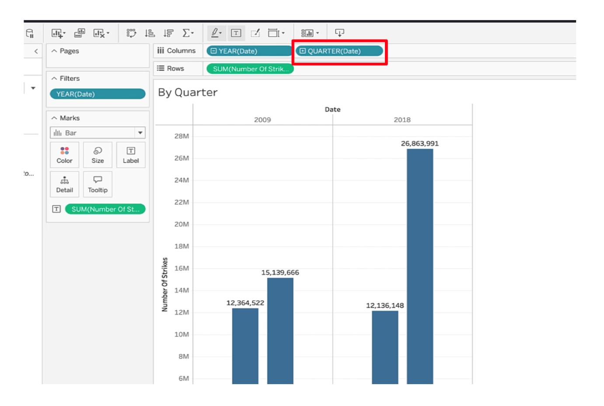

* Drag **Date** to **Color** square.

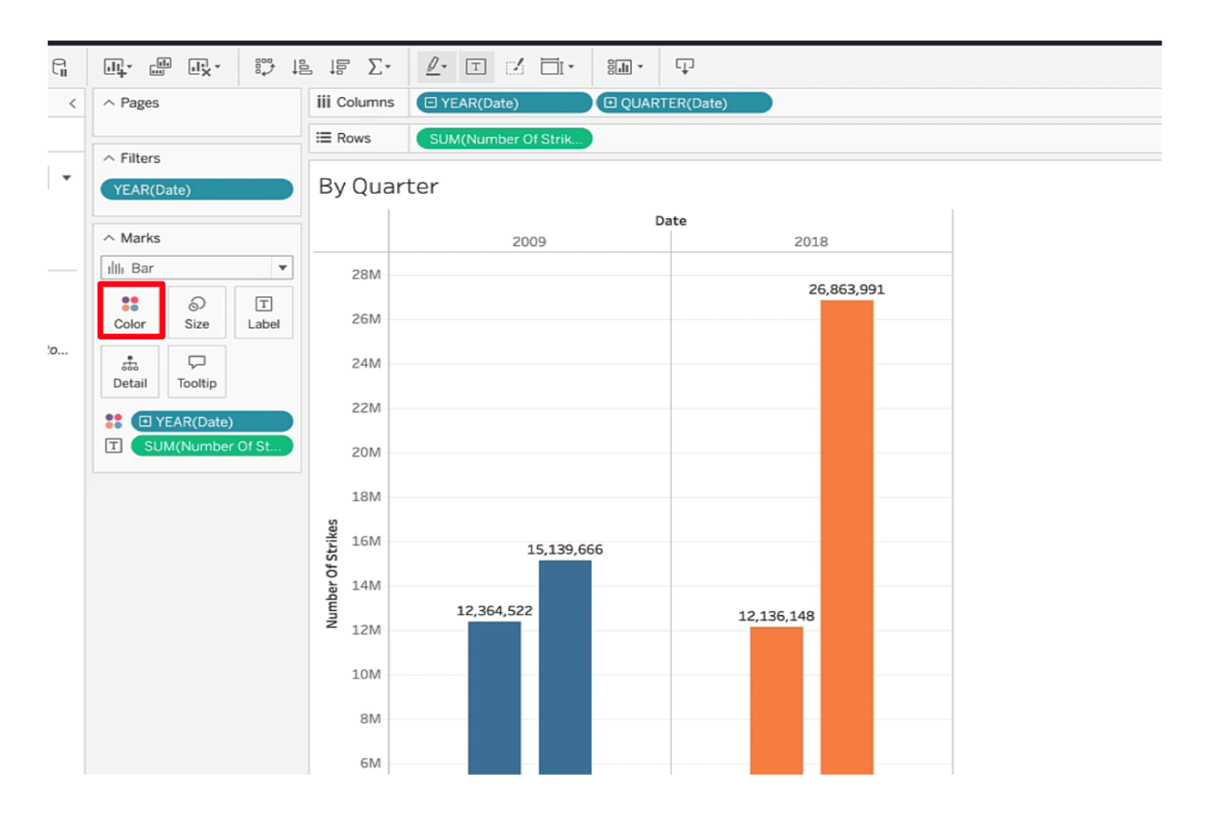

* Click on the blue drop down arrow of **YEAR(Date)** in the **Color** field and select **Quarter**.

You’re done!

(**Note:** Be sure to save your work to your Tableau Public profile by clicking on “Publish.”)

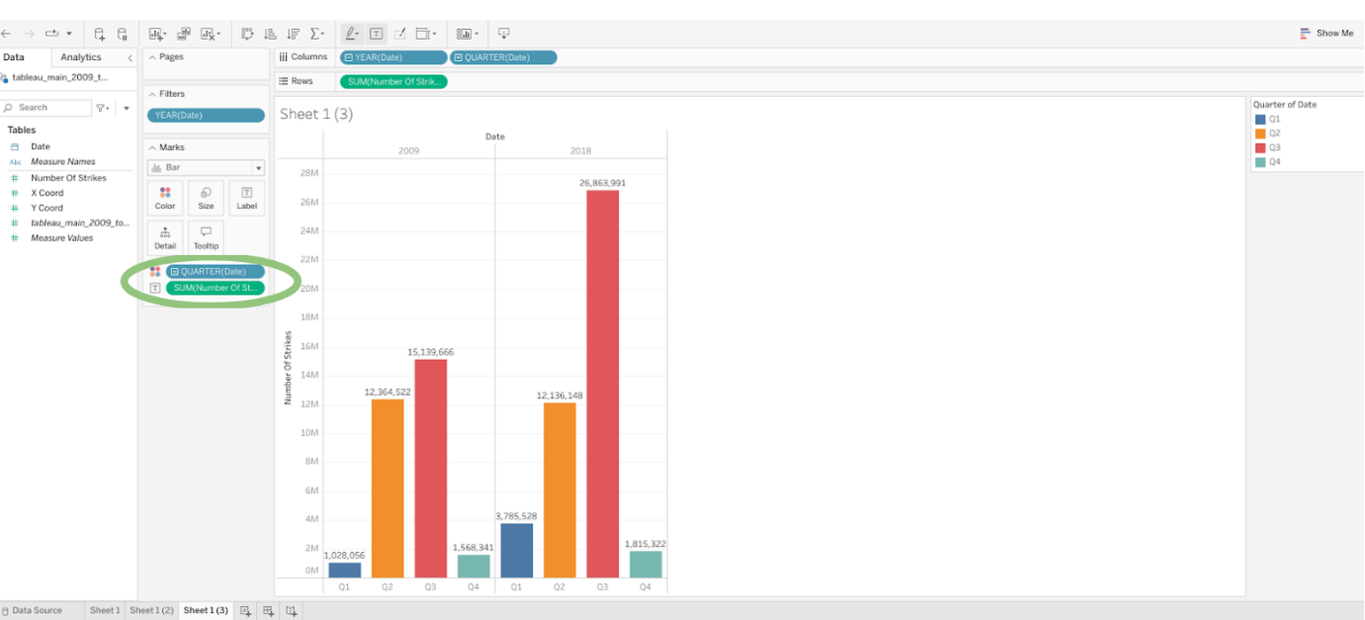

**Dimensions**

Qualitative data values, used to categorize and group data to reveal details about it.

**Measures**

Numeric values that can be aggregated or placed in calculations.

**Continuous**

A measure or dimension has an infinite and uncountable number of outcomes.

**Discrete**

A measure or dimension has a finite and countable number of outcomes

# Test your knowledge: Present a story

### 1.

Question 1

Fill in the blank: In Tableau, qualitative data values called \_\_\_\_\_ are used to categorize and group data to reveal details about it.

1 / 1 point

dimensions

### 2.

Question 2

What does the term continuous indicate in data analytics?

A measure or dimension has an infinite and uncountable number of outcomes.

# Follow-along guide: Work with Tableau, Part 2

## This document includes detailed instructions for how to perform the data visualizations described in the video “Work with Tableau, Part 2.”

### The following guide points out areas of the video that may require adjustment. These reference guides can also serve as a set of usability reminders for you to recall when using Tableau in your future career.

**Instructions**

* Go to  <https://public.tableau.com/s/>
* Since you’ve already [set up your Tableau Public profile](https://www.tableau.com/community/blog/2022/9/beginners-guide-tableau-public), all you need to do is log in and select **Web Authoring** under **Create** in the navigation bar.
* Select the appropriate CSV file provided in the [instructions](https://www.coursera.org/learn/go-beyond-the-numbers-translate-data-into-insight/supplement/hSNPT/follow-along-instructions-data-visualizations-and-presentations-with-tableau). The dataset you’ll use with this instructional video is: tableau\_dataset.csv.
  + Please be aware that when you download the zip file folder provided, the computer automatically names that zip file folder with a long string of numbers and letters. You have to open that folder and then upload the individual files that are named correctly and match what's shown in the video.

(**Note:** Please allow several  minutes for dataset upload.)

Before you can start designing visualizations, you’ll first need to upload your data. You'll need to upload the specific dataset files to Tableau. Do not upload the entire .zip folder. When you download the zip folder from this page, your computer will automatically download a .zip file folder. The .zip folder is automatically named with a series of letters and numbers. Open that .zip folder, then save the individual dataset files. The two files are: tableau\_main\_2009\_to\_2018.csv and tableau\_dataset.csv. Once you can see the individual dataset files, proceed to upload your dataset for this video to Tableau Public.

Notice on the data source tab that you can see all of your column headers and Tableau icons that help you determine data types. In this case, you’ll see a calendar icon, globe icons, and pound signs.

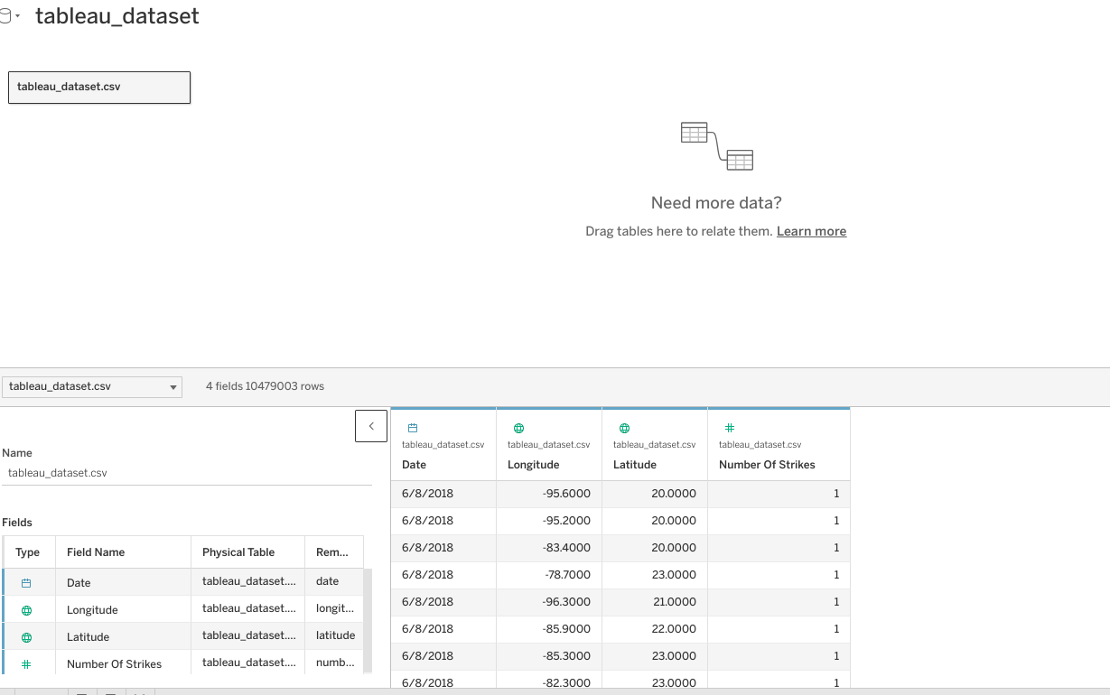

* Click on NEW WORKSHEET.

**(Note:** Please allow several minutes for data import into a new worksheet)

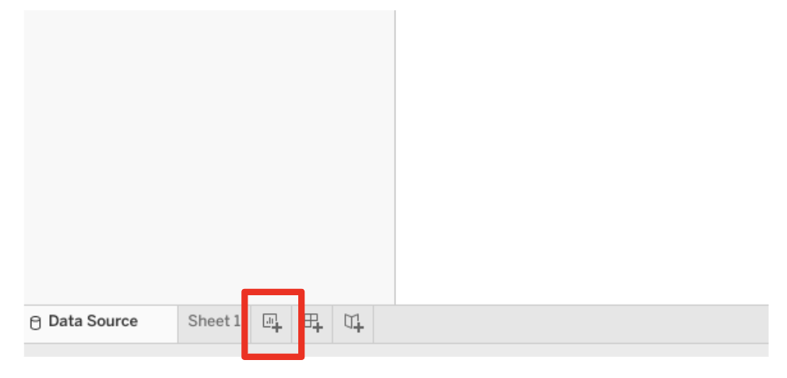

* Drag LONGITUDE into the column field. Drag LATITUDE into the rows field.

(**Note:** Make sure the latitude and longitude fields are set to continuous dimensions)

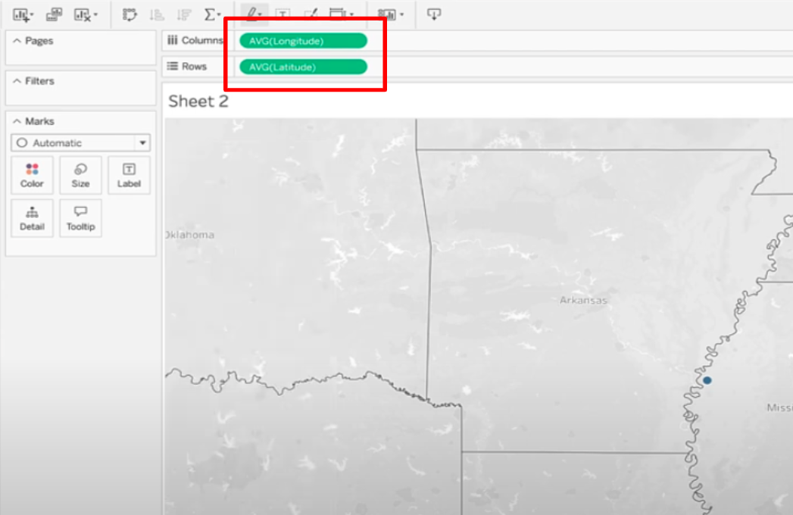

* Drag DATE into Filters field. Filter to only 2018.

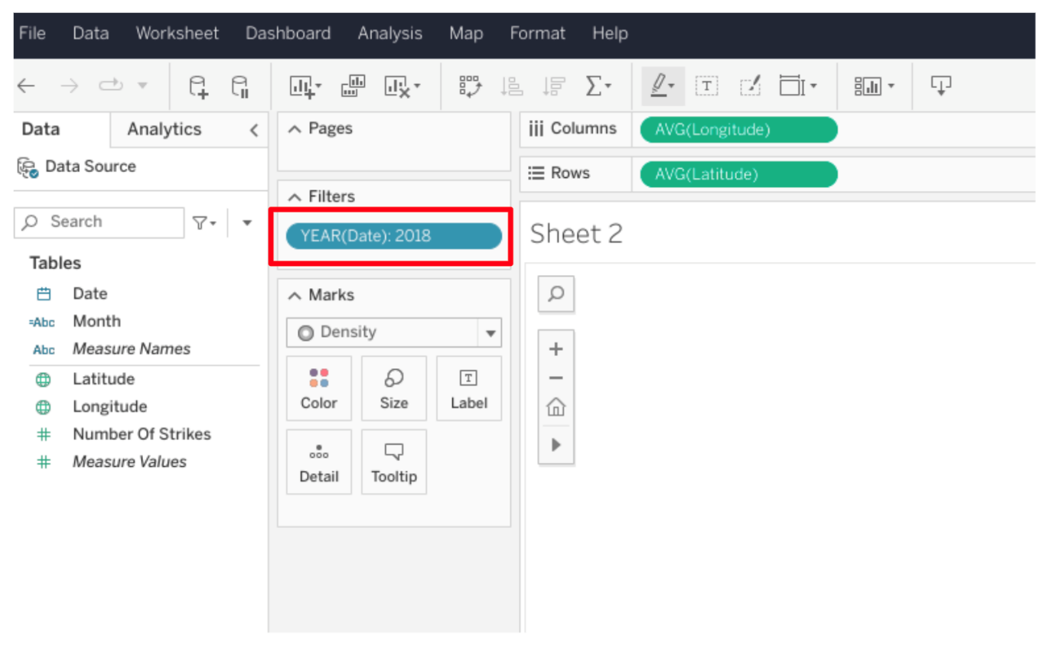

* Click on NUMBER OF STRIKES dropdown.
* Select “Convert to Dimension.”

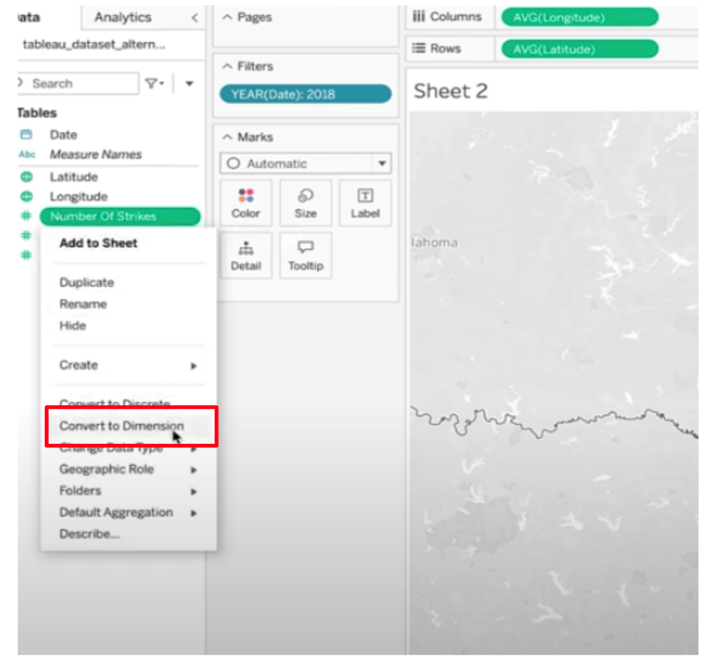

* Drag NUMBER of STRIKES to the box labeled COLOR.

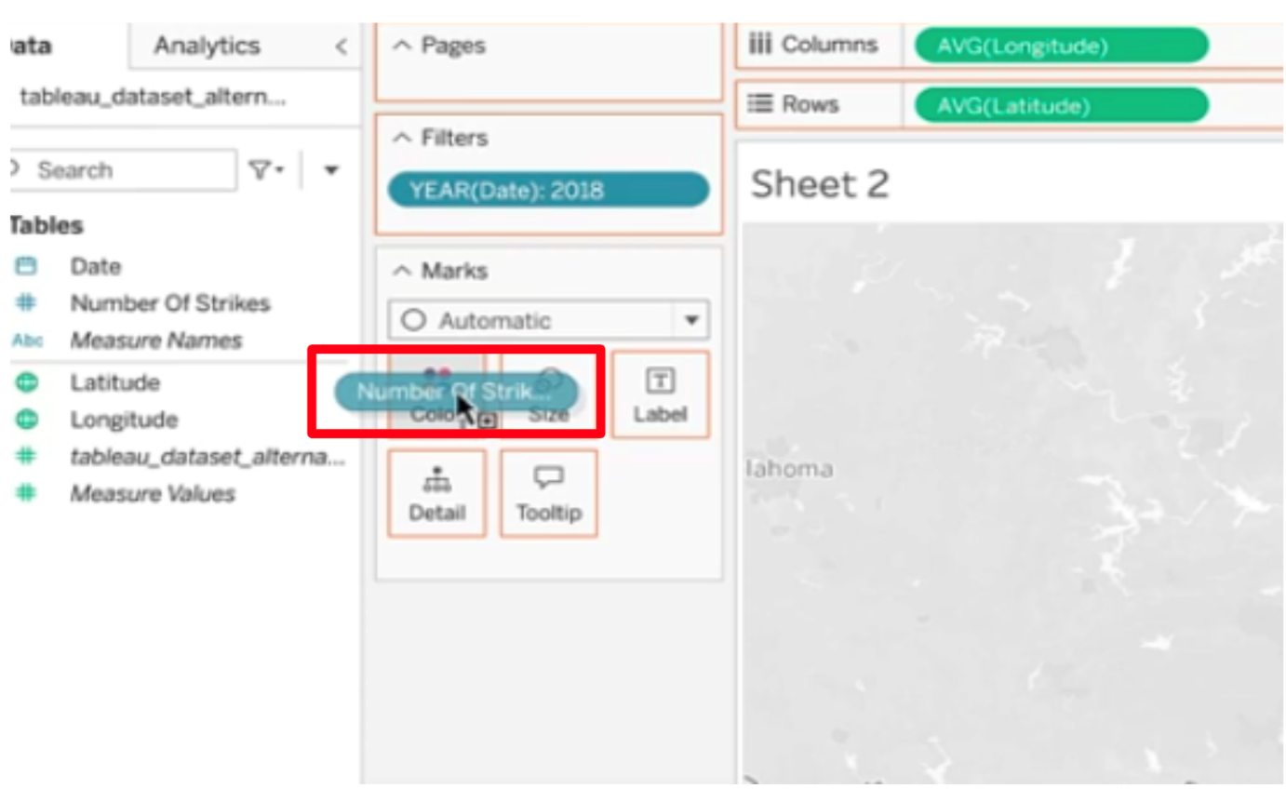

* Select Density in MARKS dropdown.

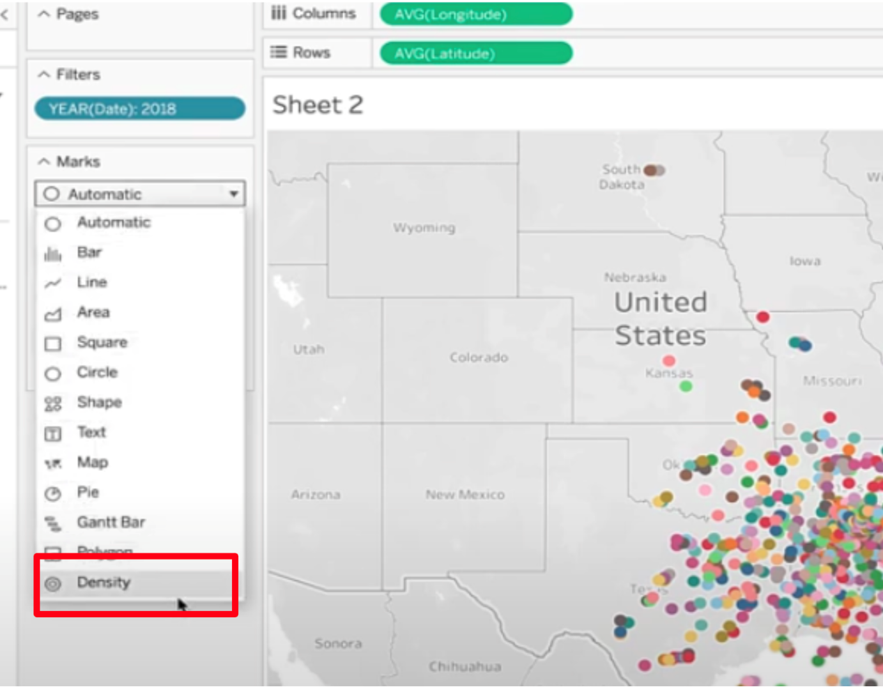

* Click on color and show the dropdown. Select any color you’d like.

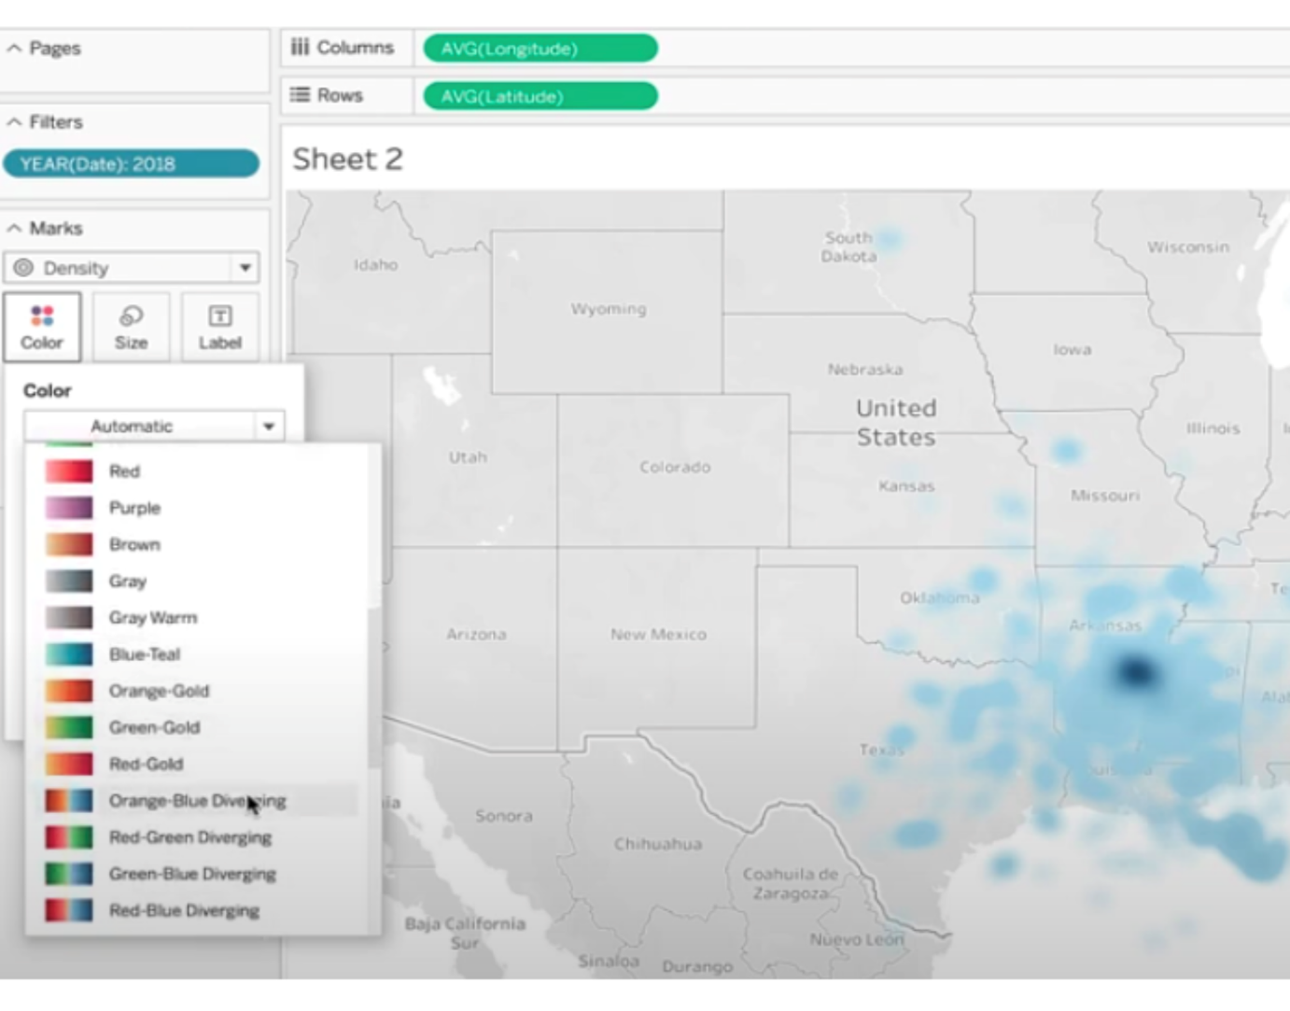

* And here is your geographic map of the location of lightning strikes in the U.S. in 2018.

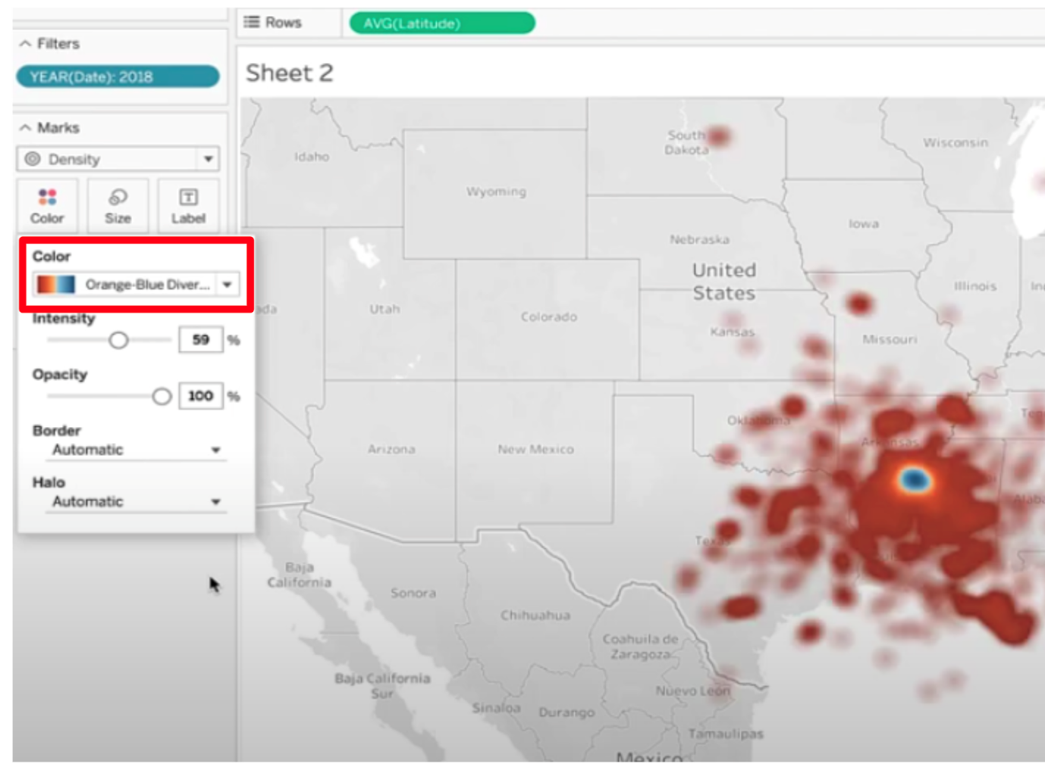

* Click on “new worksheet.”
* Drag DATE to the ROW field and select YEAR.

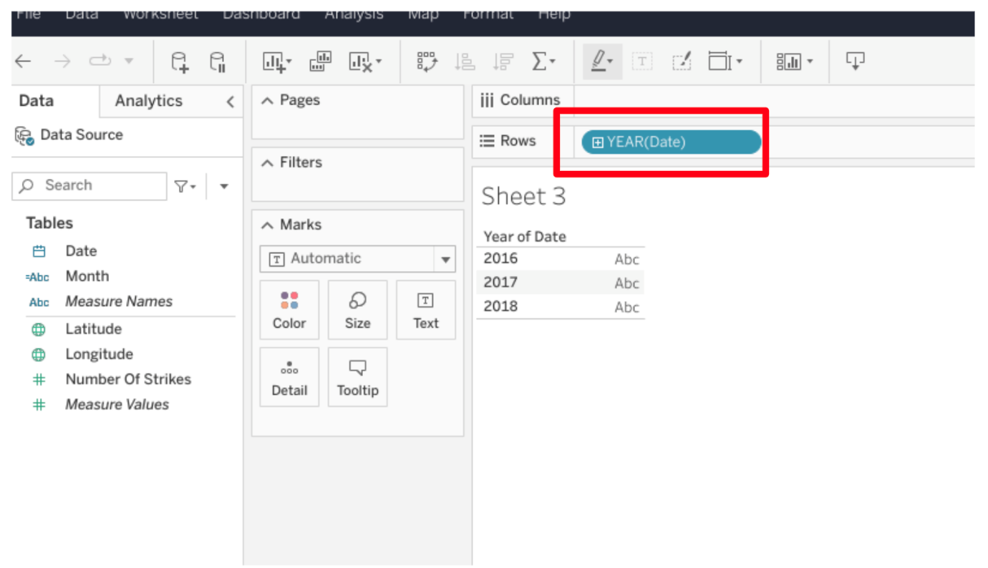

* Click on DATE dropdown in the “Tables” menu. Click CREATE and select Calculated Field.

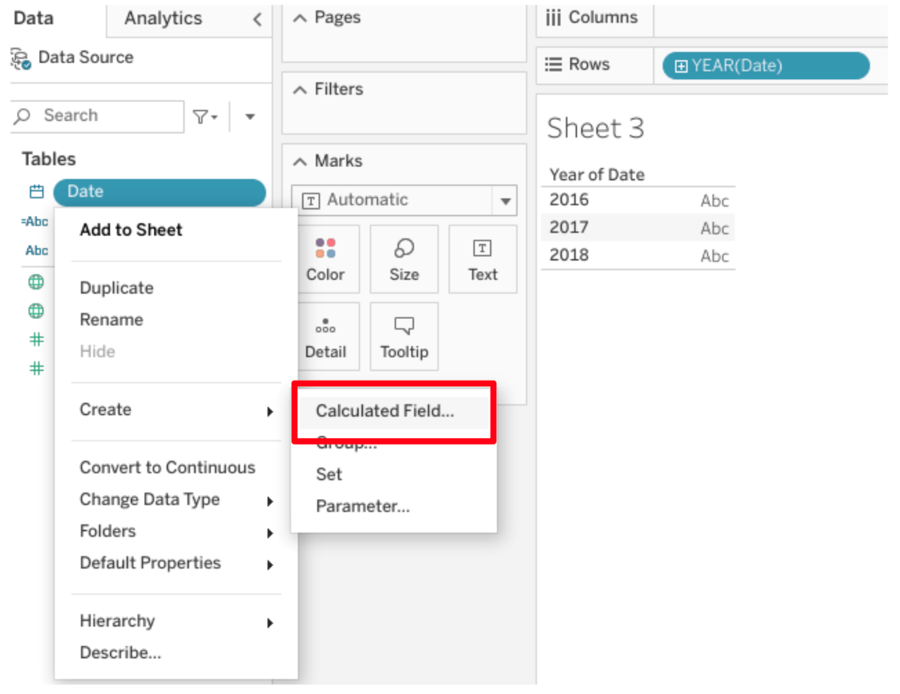

* Type in Month for Calculated Field name.
* Type into field:
  + **LEFT(DATENAME('month',[date]),3)**
  + Click Apply.
  + Click OK.
* Drag month to column field.

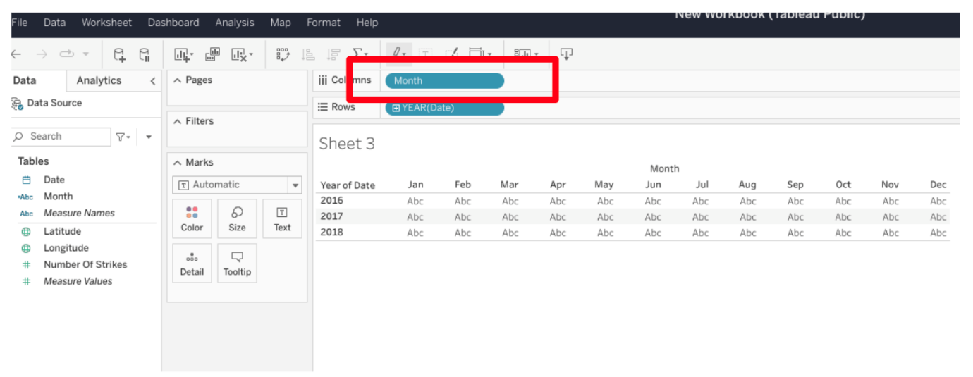

* Drag NUMBER of STRIKES to the color square under the MARKS field.
* Make sure NUMBER of STRIKES is converted to Measure. To do so, right click on Number of Strikes field and select ‘Convert to Measure.’

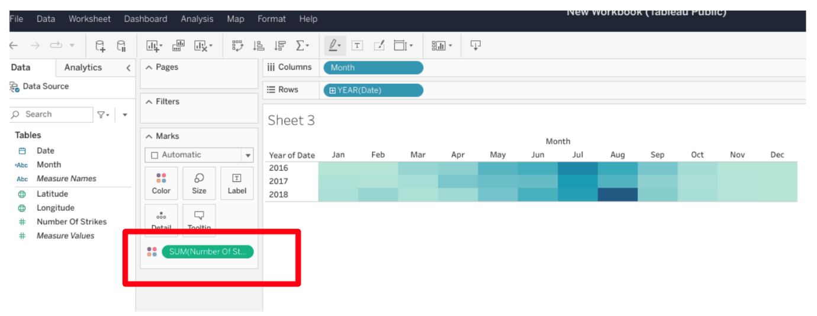

* In Marks dropdown, select SQUARE.

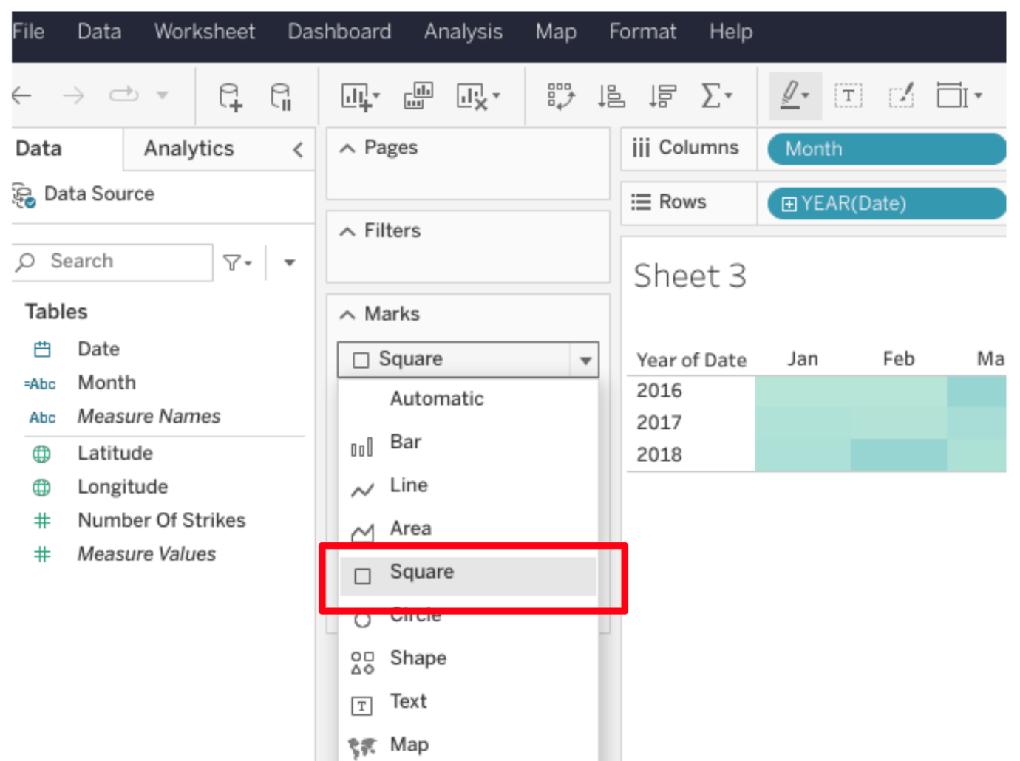

* Feel free to change the color. You’ve completed a heatmap.
* Click on NEW WORKSHEET.
* Drag NUMBER OF STRIKES to the rows field.

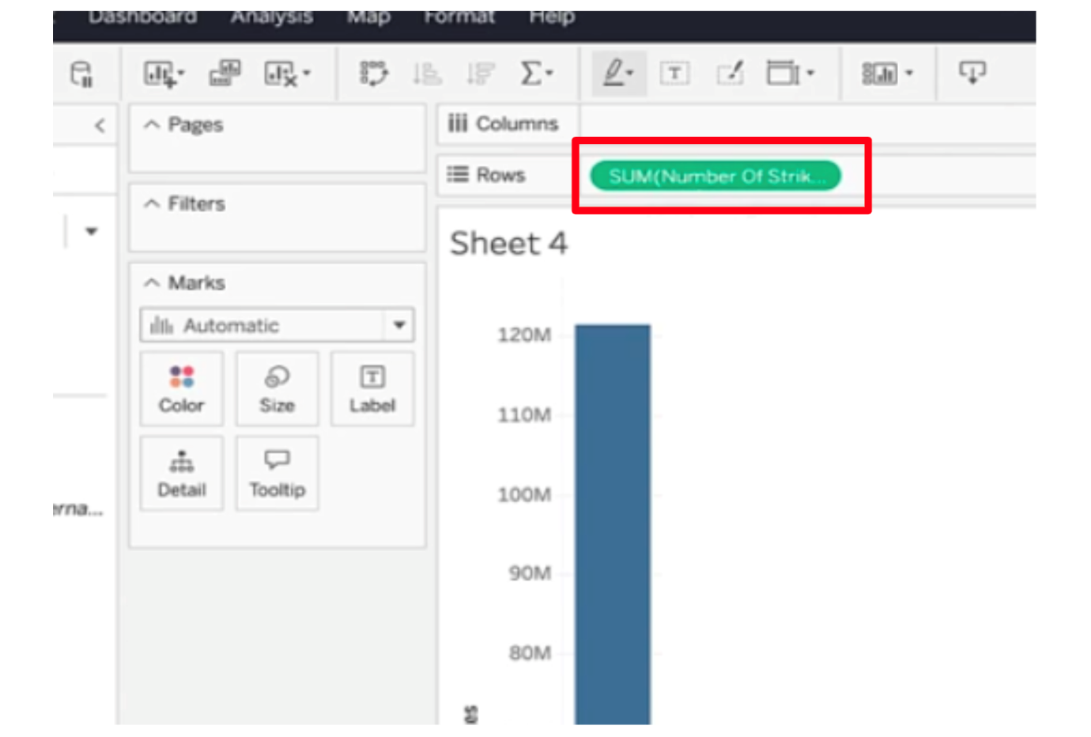

* Drag DATE to the column field and select YEAR.

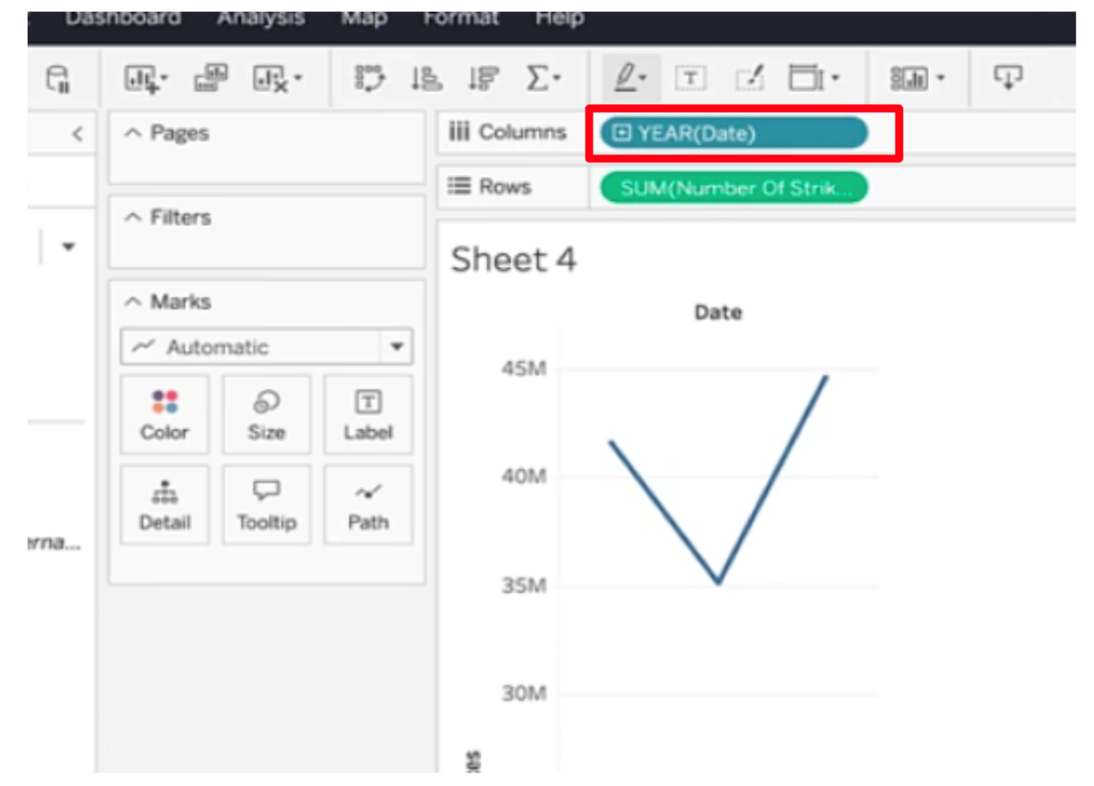

* **Note:** If nothing is shown in the Columns field, drag YEAR back to the Columns filter again.
* Select CIRCLE from MARKS dropdown.

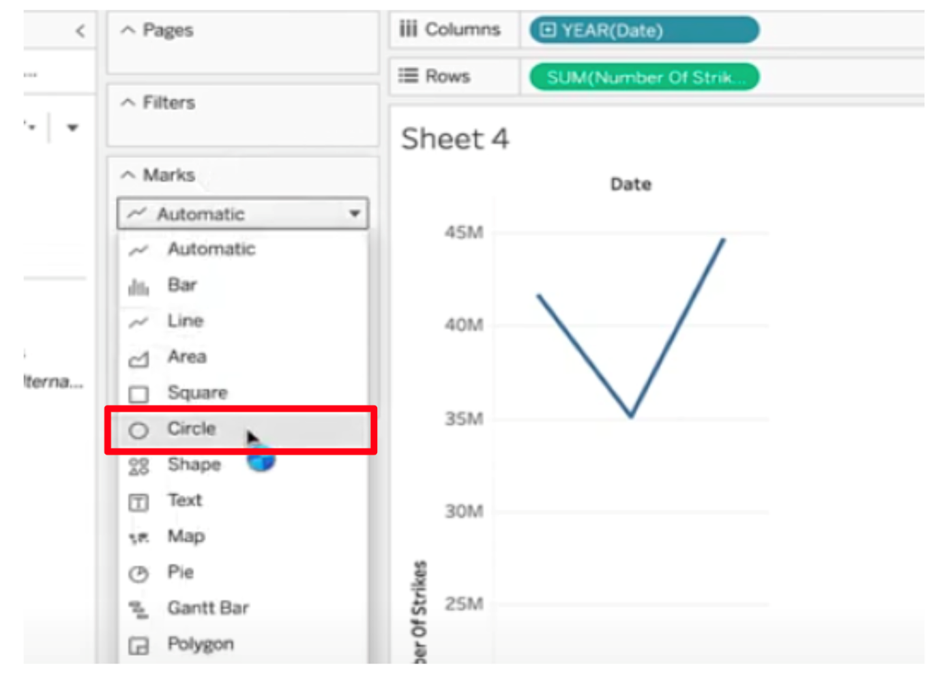

* **Note**: If box plot isn’t the default, select the BOX and WHISKER PLOT from the SHOW ME dropdown.
* Drag Date to the column field again, if that has been removed.

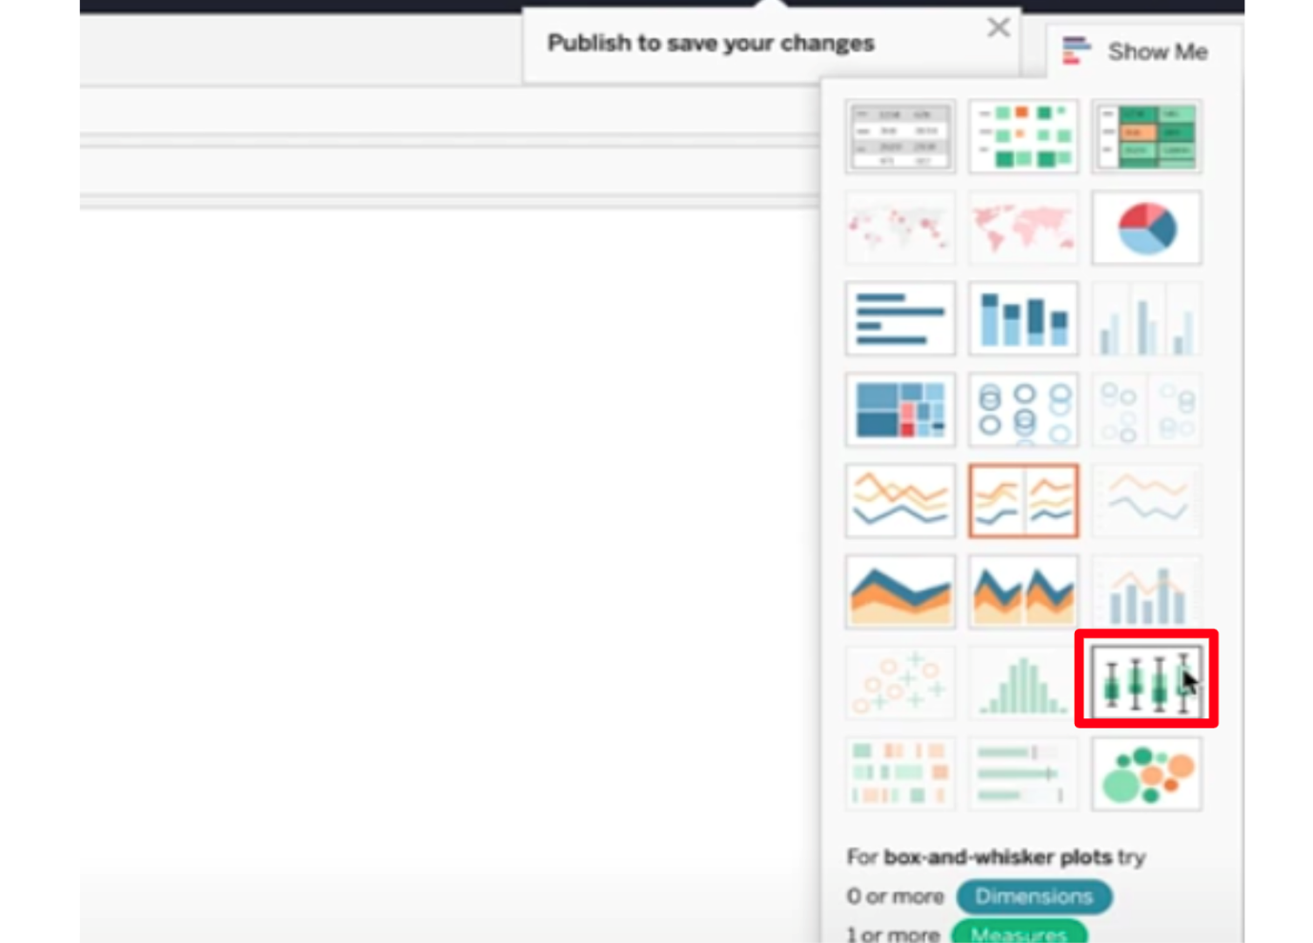

* Drag DATE into the detail square under the MARKS field, and select DAY. **Note:** When you do this, you’ll see that Tableau changes your YEAR(Date) filter to QUARTER(Date) to show an additional level of detail. That change is shown in the instructional video, so please proceed.
* Now you've completed a boxplot.
* Click on NEW WORKSHEET.
* Click on the dropdown of NUMBER of STRIKES in Table menu, and select CREATE and then BINS.

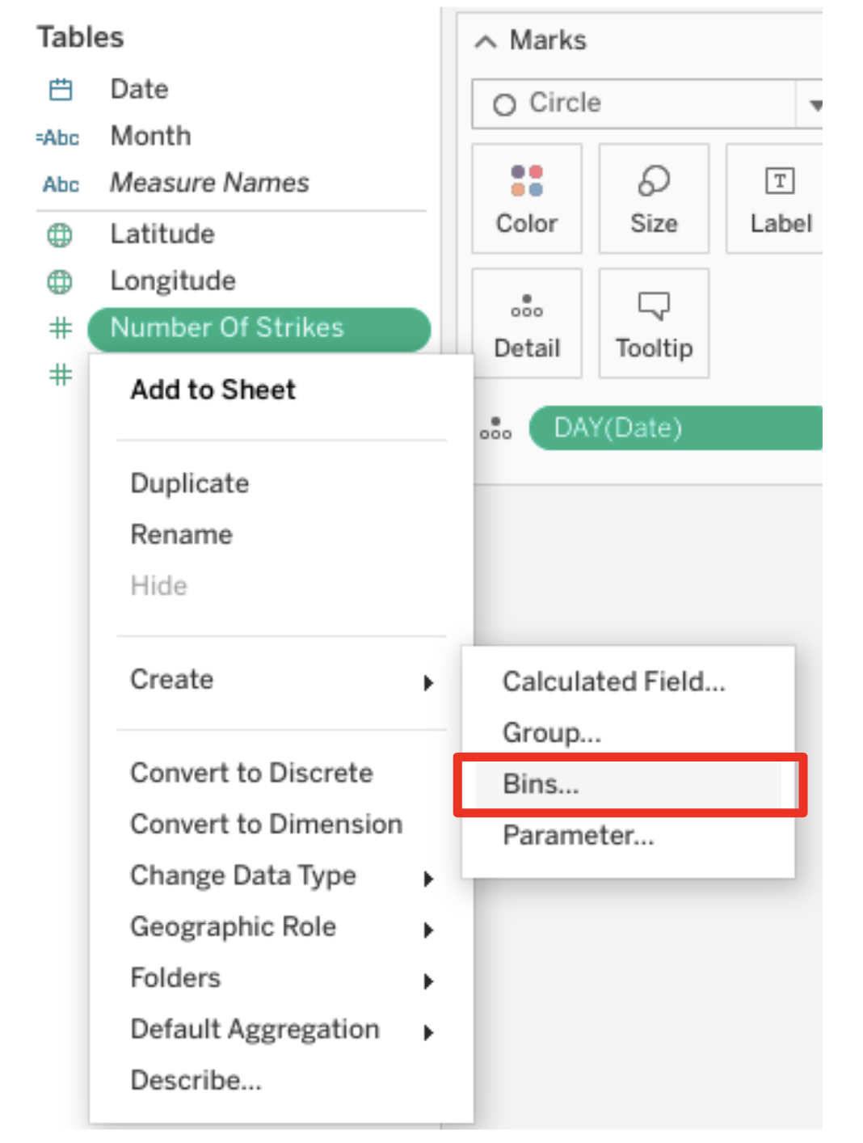

* Give bin a name: BIN STRIKES.
* Select a number between 5 and 10 for “Size of Bins” field.
* Drag BIN STRIKES to columns field.

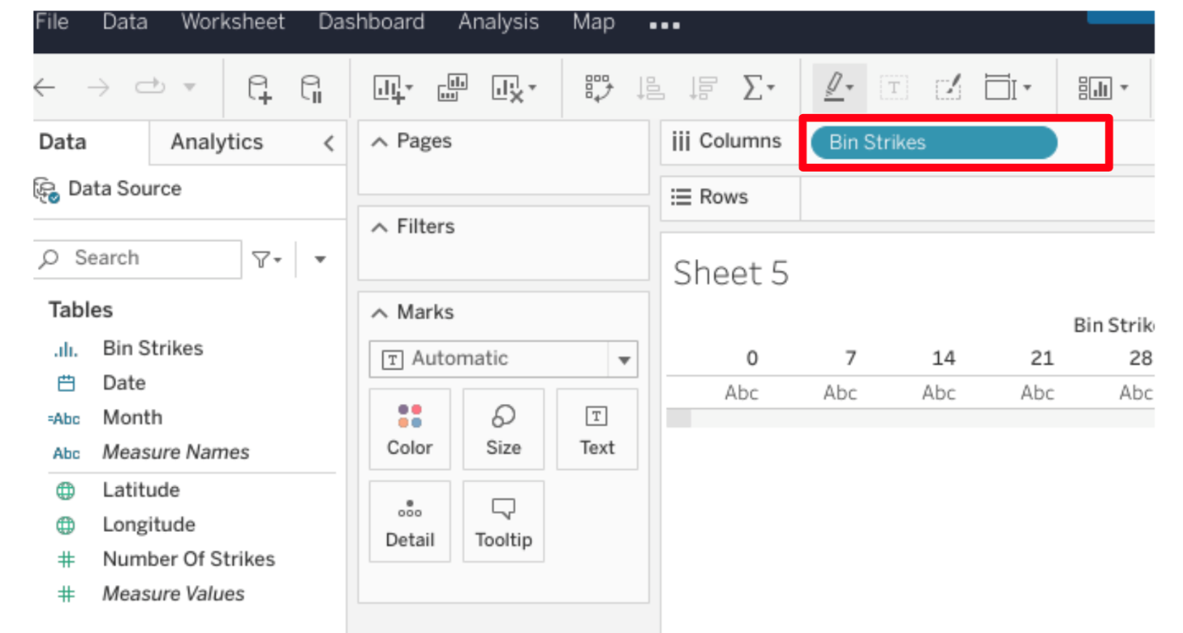

* Drag NUMBER OF STRIKES to Row Field.
* In NUMBER of STRIKES dropdown, make sure COUNT is selected.

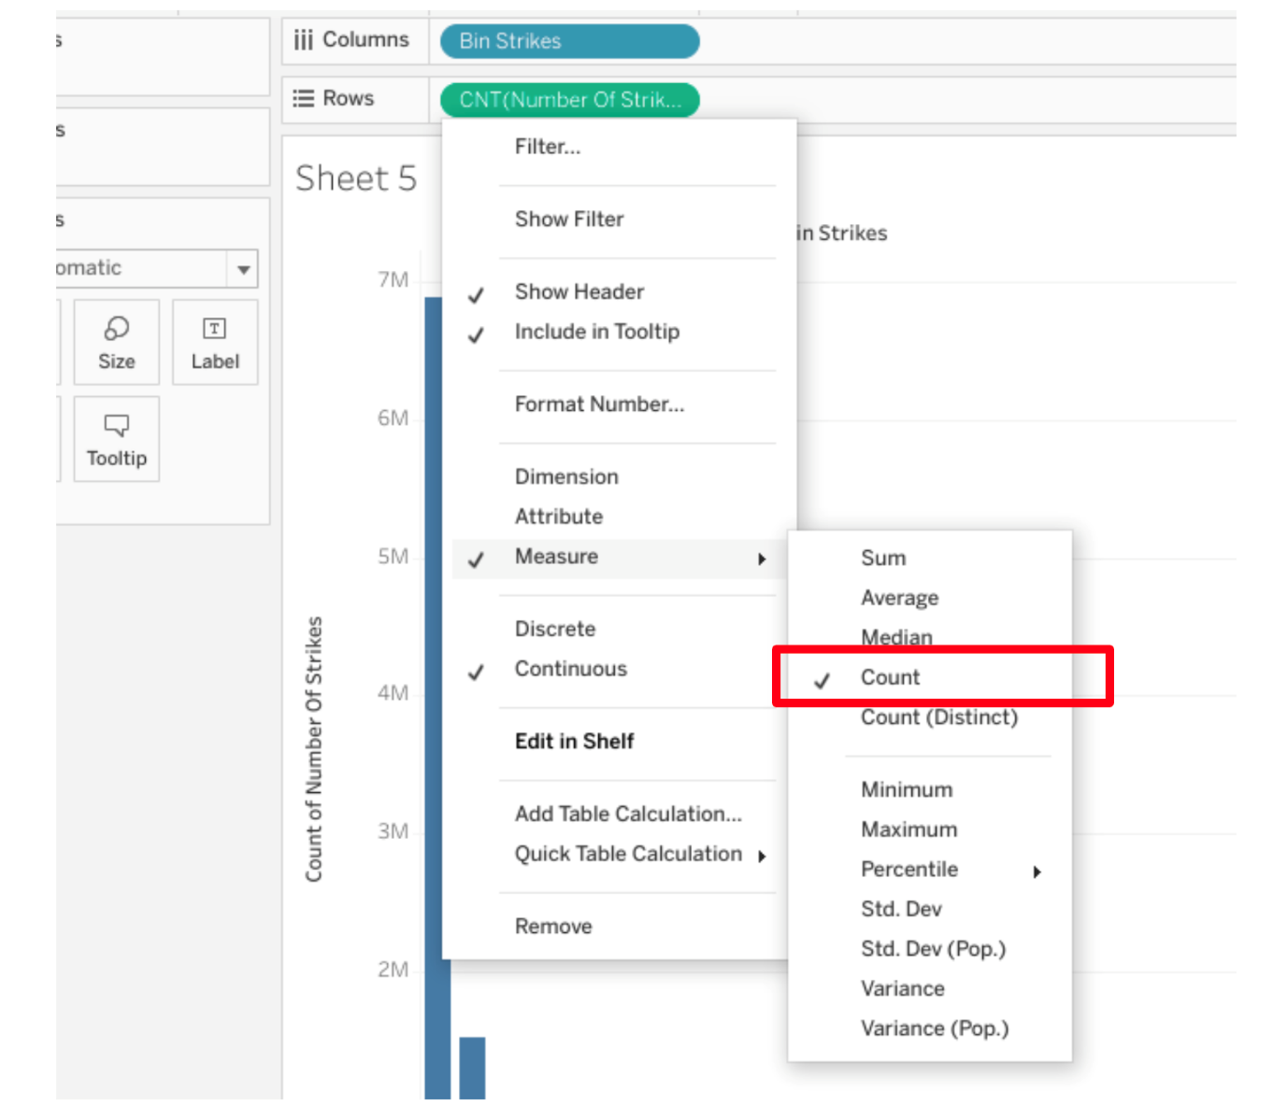

* Drag NUMBER of STRIKES to filter field.
* Limit the field numbers between 1 and 200.
* Drag NUMBER of STRIKES to the LABEL.
* Select COUNT.
* Change color as desired.
* Now you know how to create a histogram!

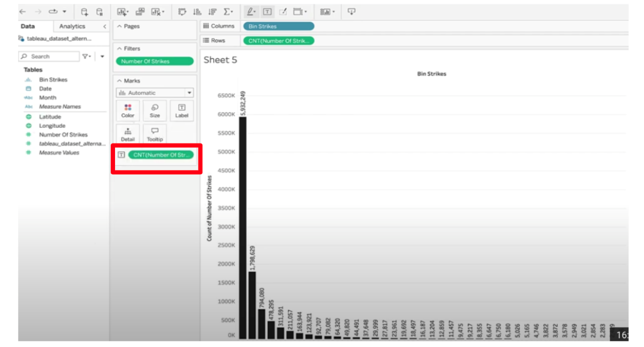

**Heatmap**

A type of data visualization that depicts the magnitude of an instance or set of values based on two colors.

**Box plot**

Data visualization that depicts the locality, spread and skew of groups of values within quartiles.

**Histogram**

A data visualization that depicts an approximate representation of the distribution of values in a dataset.

**Bins**

A Tableau term that describes the custom segments of data that values can be grouped into.

# Identify: Compelling visualizations

### **Review the question and compare similar data graphics to determine which visualization meets the goal of the scenario.**

### **Example**

Which visualization is more useful for a manager who asked for data on the total distance traveled for each of the first 50 years of the Tour de France?

Line Chart

## Which visualization illustrates the story?

### **Review the question and compare similar data graphics to determine which visualization meets the goal of the scenario.**

### **Example**

Which visualization tells the most complete story about the top speed by country at the Tour de France?

Bar/Column Chart

## Which visualization illustrates the story?

### **Review the question and compare similar data graphics to determine which visualization meets the goal of the scenario.**

### **Example**

Which graph is more useful to someone trying to find the location of the most highly rated tea shop in San Francisco?

Focus carefully on the labels, specially the legends (it has a 1-3 star rating).

## Which visualization illustrates the story?

### **Review the question and compare similar data graphics to determine which visualization meets the goal of the scenario.**

### **Example**

Which graph’s color scheme better meets accessibility standards?

Choose the one that has more accessibly to visualise in case some of the audience may be colorblind.

“Exploratory data analysis is everything. You can’t do anything without understanding the data first.”

“When delivering news about data, it’s important to shift from a data mindset to a client mindset.”

# Activity: Design a bar graph that tells a story in Tableau

To pass this practice quiz, you must receive 100%, or 1 out of 1 point, by completing the following activity. You can learn more about graded and practice items in the [course overview](https://www.coursera.org/learn/go-beyond-the-numbers-translate-data-into-insight/supplement/2wUrM/course-3-overview).



## Activity Overview



In this activity, you will design a professional and accessible bar graph data visualization in Tableau Public. Your bar graph will share a story and will help a business manager make a data-driven decision for their business needs.

The structure of this activity is designed to emulate the proposals you will likely be assigned in your career as a data professional. Completing this activity will help prepare you for those career moments.

Be sure to complete this activity before moving on. At the end of this activity, you will be provided a completed exemplar to compare to your own work. You will not be able to access the exemplar until you have completed this activity.

## Scenario



Review the following scenario. Then complete the step-by-step instructions.

Imagine you are a data professional consulting for the transportation department in Seoul, South Korea. Your client contact is the director of the department. For your next project, the director asks you to analyze the rented bicycle data they've gathered in 2018 in order to learn the best time of day to have their maintenance teams repair bikes. The director wants the maintenance work to occur during lower traffic times, when bicycle rental numbers are minimal, but still during standard working hours (8 a.m. to 5 p.m).

Your task is to use Tableau to design a data visualization that illustrates the low-traffic times of standard workdays in order to remove bicycles from circulation for maintenance. The director wants the visualization to include gradients of orange to represent the company colors. Be sure your data visualization is clear, accessible, and ethical.

## Step-By-Step Instructions



Follow the instructions to complete each step of the activity. Then, answer the three questions at the end of the activity before going to the next course item to compare your work to a completed exemplar.

### **Step 1: Access supporting materials**

The following supporting materials will help you complete this activity. Keep them open as you proceed to the next steps.

To use the supporting materials for this course item, click the following link and select Use Template.

Link to supporting materials: [Seoul bicycle rental dataset](https://docs.google.com/spreadsheets/d/1t0tOZJrhQihibYFnJ6lF2baXfDYrU-A4HvWqNrgMUtE/template/preview?resourcekey=0-1Ox-ENKPQN5-dVjFXq5P5Q#gid=2106842449)

OR

If you don’t have a Google account, you can download the supporting materials directly from the following attachment.

[Seoul bicycle rental dataset](https://d3c33hcgiwev3.cloudfront.net/_JqBwOEaS_a37dYNVftzmw_0b1c1cafa639423e9342b5f2640999f1_Seoul-bicycle-rental-dataset.xlsx?Expires=1720915200&Signature=AImEQMgFWJ56GgyNl5vK~W-oX4-KP~ALDQUs6GHIta2aGpPnKYOP5g0UpoV7VZJPLw3x84PfCmlnuueZZDn~y72r4U84aoLo6RZ9dkeawgz4JXlGXqDFASxw9zWyF5NotEQvvXhhU3Hp9MWLqWpAo8-hoHm9ogz-uEeW8dWJnOM_&Key-Pair-Id=APKAJLTNE6QMUY6HBC5A" \t "_blank)

[XLSX File](https://d3c33hcgiwev3.cloudfront.net/_JqBwOEaS_a37dYNVftzmw_0b1c1cafa639423e9342b5f2640999f1_Seoul-bicycle-rental-dataset.xlsx?Expires=1720915200&Signature=AImEQMgFWJ56GgyNl5vK~W-oX4-KP~ALDQUs6GHIta2aGpPnKYOP5g0UpoV7VZJPLw3x84PfCmlnuueZZDn~y72r4U84aoLo6RZ9dkeawgz4JXlGXqDFASxw9zWyF5NotEQvvXhhU3Hp9MWLqWpAo8-hoHm9ogz-uEeW8dWJnOM_&Key-Pair-Id=APKAJLTNE6QMUY6HBC5A" \t "_blank)

### **Step 2: Create a Tableau Public account or log in**

You will need a [Tableau Public](https://public.tableau.com/s/) account to complete this activity. If you haven’t created an account yet or need to review how to connect to data, review the reading about [how to sign on to Tableau Public](https://www.coursera.org/learn/go-beyond-the-numbers-translate-data-into-insight/supplement/muYtK/how-to-sign-on-to-tableau-public).

If you already have a Tableau Public account, log in to your account.

### **Step 3: Upload your dataset**

In your Tableau Public account, go to your profile and select Create a Viz. You will be directed to a screen that asks you to connect to data. When prompted, upload the **Seoul bicycle rental dataset**.

### **Step 4: Decide which columns are applicable**

Check the Data Source page on Tableau Public to get a sense of the size, shape, and makeup of the dataset. You’ll notice more than 10 columns of data values. Determine which columns are most applicable for the scenario. To do this, refer back to the department request. The director is asking you to determine the hour bike rentals are minimal during weekdays. With that target in mind, identify the columns of data that will help you derive that answer. One way to start is to set aside the irrelevant columns and narrow your selection. Once identified, you should have four columns of relevant data and six irrelevant columns.

### **Step 5: Assess whether the dimensions and measures are correct**

Check the data types for the applicable columns you selected in the previous step. You should pay particular attention to the dimensions and measures to assure they are correctly designated as continuous or discrete.

* Confirm that the “Date” and “Rented Bike Count” columns are correctly designated as dimension and measure, respectively.
* Convert ‘Hour’ to a dimension (to match the “Date” column) rather than a measure (like “Rented Bike Count”) because “Hour” acts as a time quantifier and should be treated like a datetime string, rather than a numeric measure.

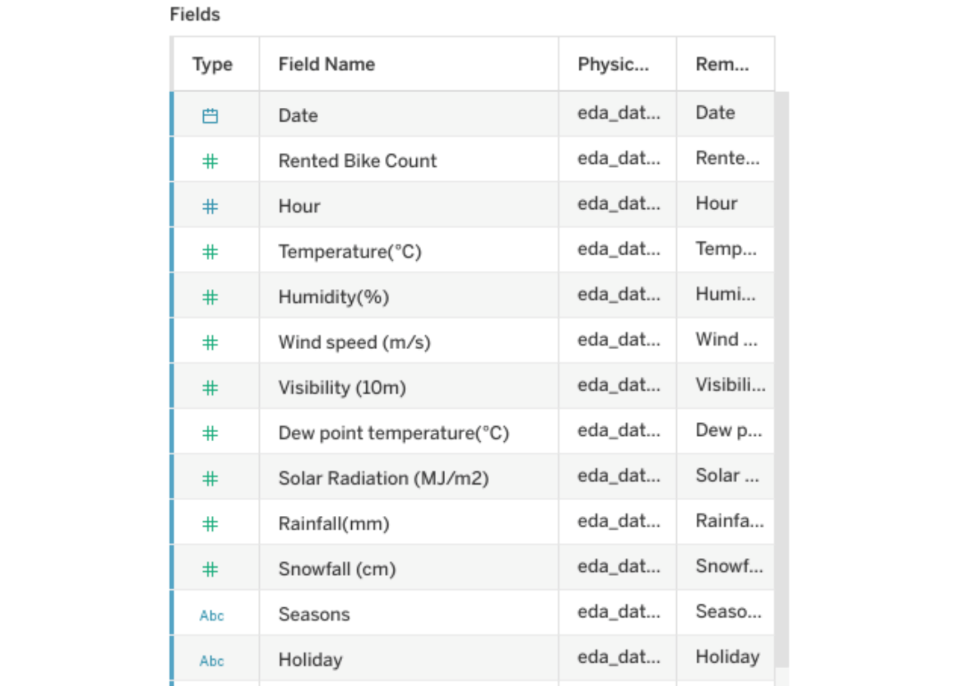

### **Step 6: Plot your data**

You’ve assessed your data and decided on which data variables are most applicable. Now it’s time to plot the bar graph. Start by placing the two most important data variables in the “Column” and “Row” shelves.

Next, drag “Date” to the columns shelf and “Bike Rental Count” to the rows shelf to show the average number of bike rentals every hour of the workday of the course of the entire year.

**Note:** Tableau will default to a line chart to start. That’s expected. You can convert it to a bar graph later.

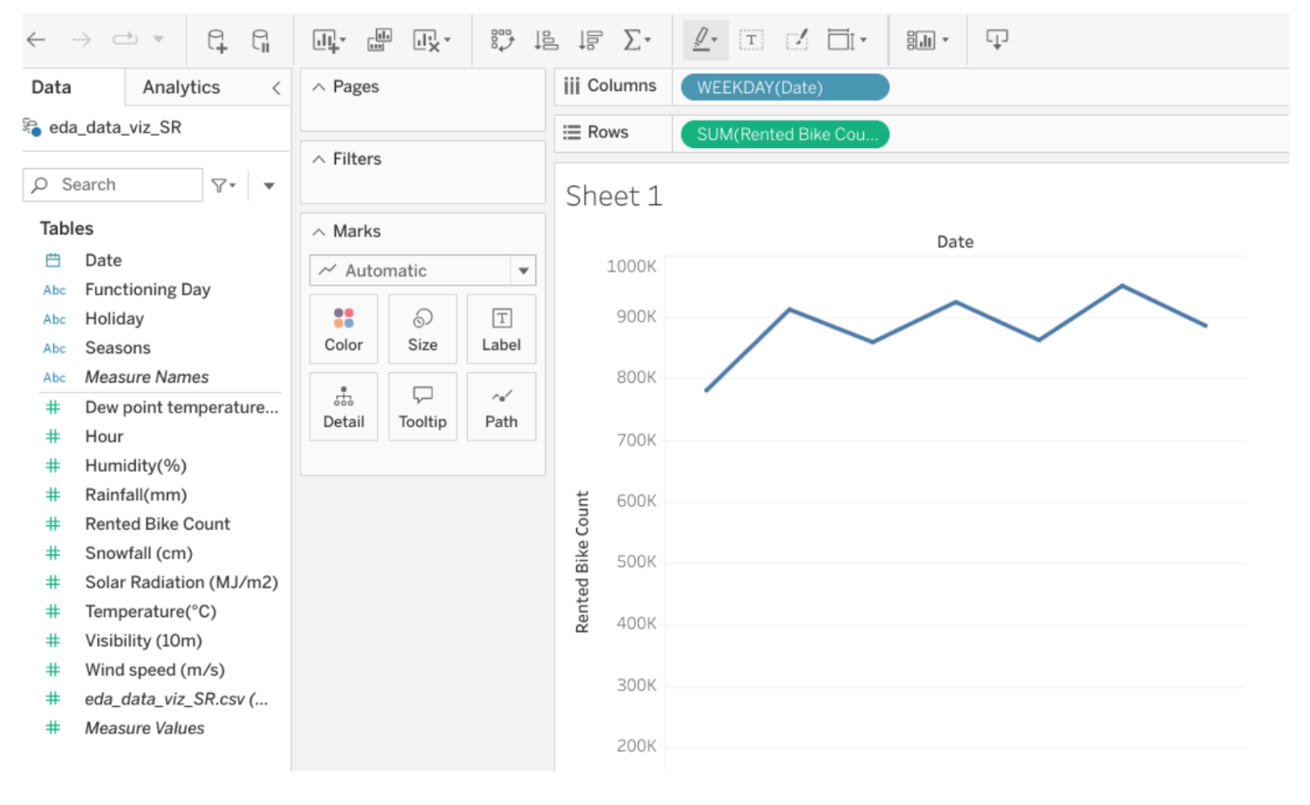

### **Step 7: Add the “Hour” data**

Select “Weekday” in the “Date” variable dropdown to order the data by day of the week.Then, convert the “Hour” variable to a dimension by selecting the option in the “Hour” variable dropdown.

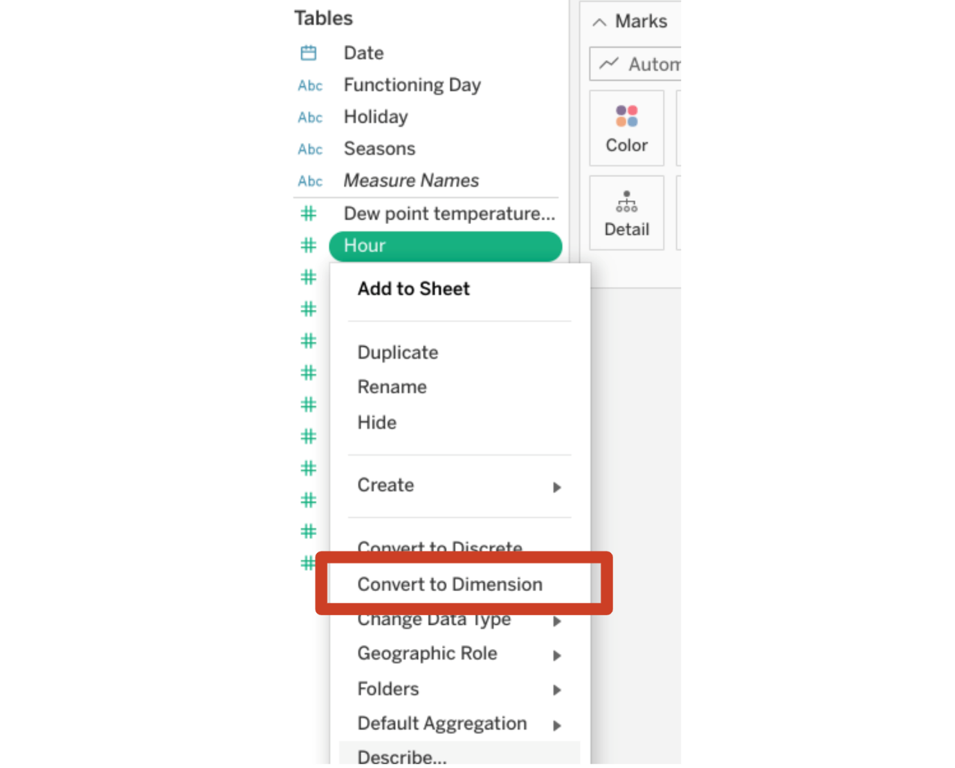

Next, organize the “Rented Bike Count” variable by “Hour” along with the “WEEKDAY(Date)” variable that is already there. Place the “Hour” variable in the “Column” shelf, next to the “WEEKDAY (Date)” variable.

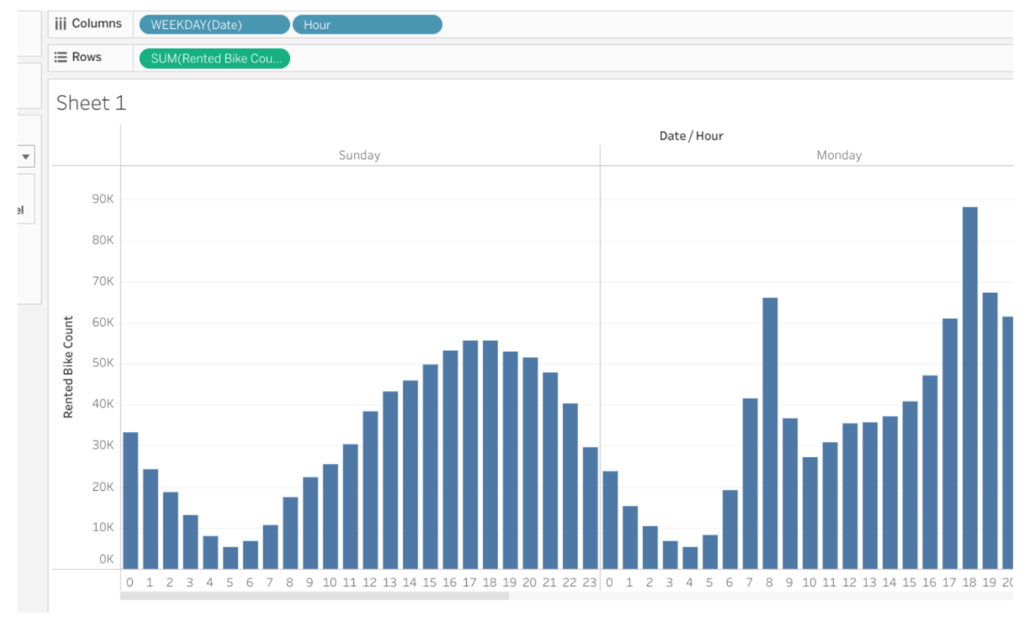

### **Step 8: Filter the data**

Now structure the data to show only the most relevant details based on the business need.

Drag “Date” to the “Filters” field.

* Tableau will default the “Date” variable to be formatted in years.
* In the popup window that opens, uncheck the box for “2017.”

Drag “Date” to the “Filters” field.

* Click on the “Date” dropdown menu.
* Select “Weekday.”
* Uncheck the boxes for “Saturday” and “Sunday.”

Drag “Hour” to the “Filters” field.

* A popup window will appear.
* Check only boxes 8 to 17 (representing 8 a.m. to 5 p.m.).
* Uncheck all other boxes.

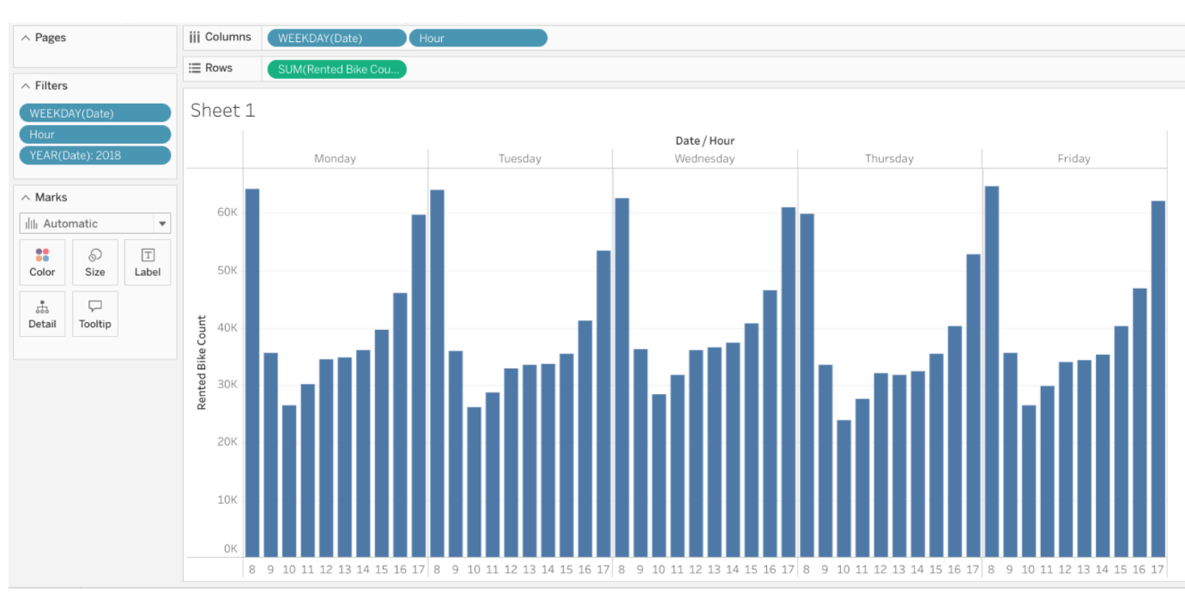

### **Step 9: Add color and contrast**

You have visualized the data you need to share with the director now. The bar graph you created confirms that the 9 a.m. to 3 p.m. time frame is the best block for pulling bicycles for maintenance.

Before you present the data to the director, you should clean up the data visualization to highlight your findings. Remember, the goal of a data visualization is for the audience to get the important information on the chart.

When it comes to color and contrast, there is not one correct approach. The goal is to ensure that all members of the audience, including , including people with color blindness, can still clearly perceive the difference in the bars’ contrast.

The following picture includes gradients of orange, the colors of the company requesting the visualization. The contrast in this chart also meets accessibility standards.

To change the color, click on the “color” square dropdown and select “edit colors.”

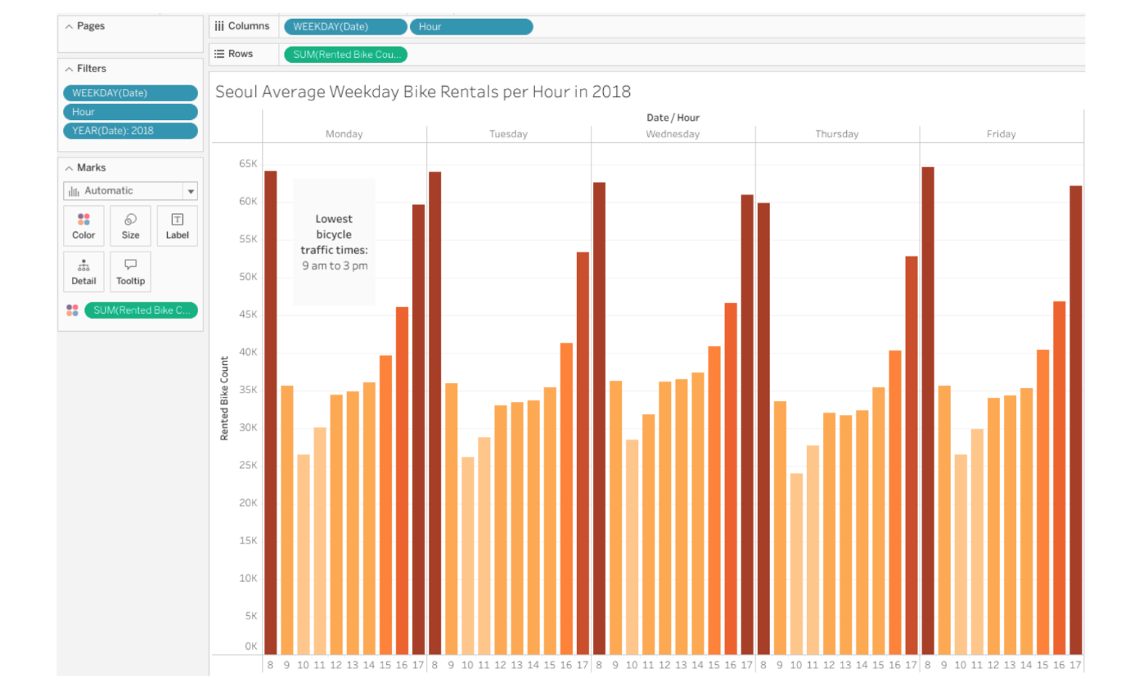

### **Step 10: Annotate and title the chart**

Right click on the data visualization and select “Annotate Area.” This will open a text box. Fill that text box with “Lowest bicycle traffic times: 9 a.m. to 3 p.m."

Then, add a title to the data visualization: “Seoul Average Bike Rentals per Hour on Weekdays in 2018.”

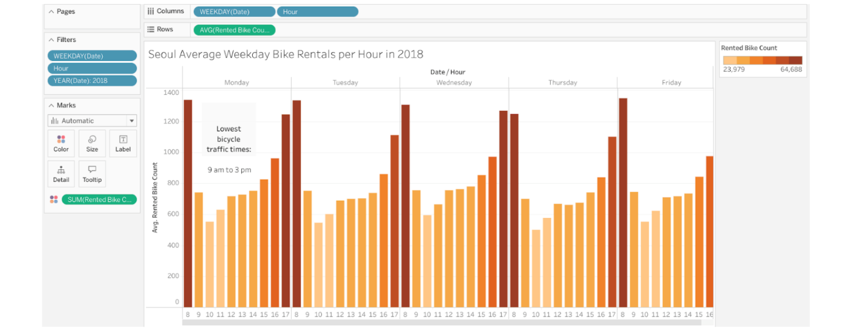

### **Step 11: Visualize the data by season**

What you have already created is a valuable data visualization that can help the department of transportation identify the best times to perform maintenance on rental bicycles. But your findings can also help provide answers to questions that stakeholders didn’t even consider. For example, do these hours change when you divide the bike rentals by season?

You can test that by adding the “Seasons” variable to the rows shelf.

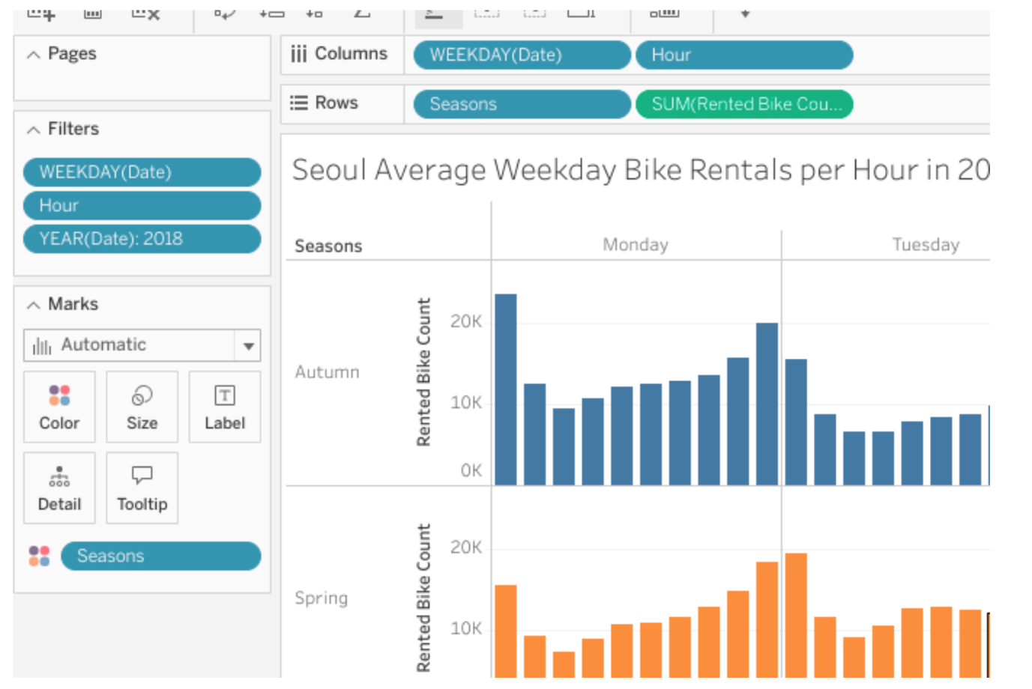

If you click on the 10 a.m. hour block in Tableau, you can emphasize to the department of transportation that no matter the season, 10 a.m. is the hour with the lowest number of bike rentals on a given weekday.

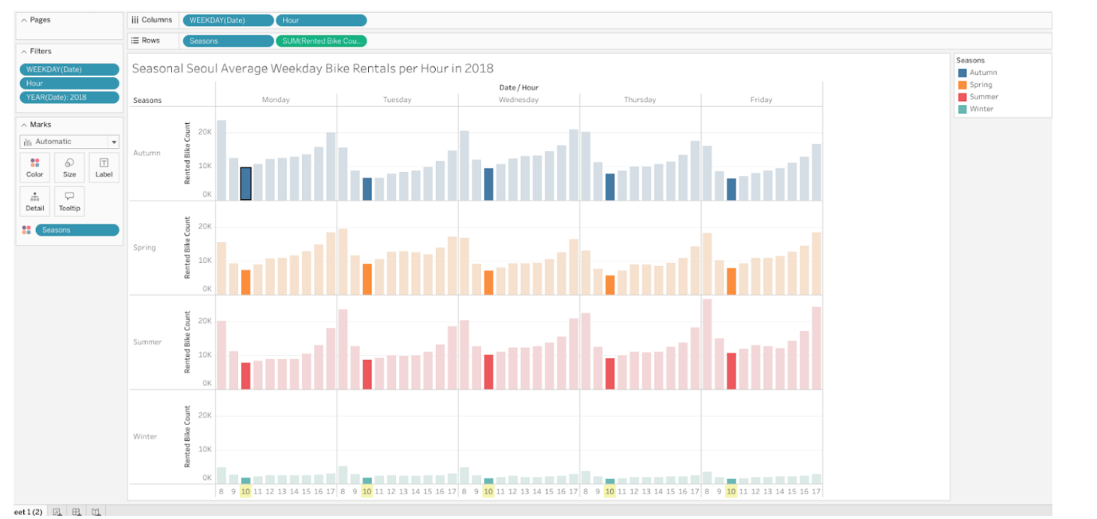

What you have now provided is a comprehensive, data-driven answer to a stakeholder’s request. This is the way a data professional provides an answer.

Be sure to save your visualization as a reference for later work in Tableau by clicking “Publish.”

## What to Include in Your Data Visualization



Be sure to address the following elements in your completed activity:

* The data visualization includes only data from 2018.
* The data visualization includes only weekdays, Monday to Friday.
* The data visualization type makes sense for the data shown and includes color, contrast, labeling, and emphasis elements that draw attention to the most relevant data.
* The data visualization can be observed without scrolling out or zooming in.
* The data visualization depicts an answer to the question, “Which hour of the day is best for bicycle maintenance?”

### 1.

Question 1

## Did you complete this activity?

1 / 1 point

Yes

No

Correct

Thank you for completing this activity! Plotting data visualizations is a valuable skill for data professionals because it is the most impactful and engaging way to tell the story of data. Review the quiz question feedback to find out how you did. Then go to the next course item to compare your work to a completed exemplar.

### 2.

Question 2

In order to structure the data to show only the most relevant details based on the business need, which of the following should your visualization include? Select all that apply.

1 / 1 point

Data for the year 2018

Correct

The director asked you to analyze the rented bicycle data they gathered in 2018. They also wanted to analyze data during the hours of 8 a.m. to 5 p.m. on weekdays.

 Data for all weekdays

Correct

The director asked you to determine the hour bike rentals are lowest during the hours of 8 a.m. to 5 p.m. on weekdays in 2018.

Data for the hours of 8:00 a.m. to 5:00 p.m.

Correct

The director asked you to determine the hour bike rentals are lowest during the hours of 8 a.m. to 5 p.m. on weekdays in 2018.

Data for the hours of 5:00 p.m. to 8:00 a.m.

### 3.

Question 3

What are some goals of how you use color, contrast, labeling, and emphasis elements in the data visualization? Select all that apply.

1 / 1 point

Meet accessibility standards.

Correct

Color and contrast should be used to ensure that all members of the audience, including people with color blindness, can still perceive the difference in the bars’ contrast. The visualization should also include the colors the company requested and help the audience understand the data.

Help the audience understand important information on the chart.

Correct

The data visualization should include color, contrast, labeling, and emphasis elements that draw attention to the most relevant data. The visualization should also meet accessibility standards and include the colors the company requested.

Include the colors of the company requested for the visualization.

Correct

The visualization should include gradients of orange, which are the colors the company requested for the visualization. The visualization should also meet accessibility standards and help the audience understand the data.

Present all of the available data.

# Activity Exemplar: Design a bar graph that tells a story in Tableau Public

Here is a completed exemplar along with an explanation of how the exemplar fulfills the expectations for the activity.

## Completed Exemplar



To review the exemplar for this course item, click the link below.

Link to exemplar: [Seasonal Seoul Average Bike Rentals on Weekdays in 2018](https://public.tableau.com/app/profile/grow.with.google/viz/SeoulAverageBikeRentalsperHouronWeekdaysin2018/Sheet12)

## Assessment of Exemplar



Compare the exemplar to your completed activity. Review your work using each of the criteria in the exemplar. What did you do well? Where can you improve? Use your answers to these questions to guide you as you continue to progress through the course.

***Note:*** The exemplar represents one possible way to complete the data visualization. Yours will likely differ in certain ways. What’s important is that your data visualization meets the business scenario criteria.



### How the exemplar meets the criteria

Notice how the exemplar posted to Tableau Public uses the detail from the given scenario to adhere to the following guidelines:

The data visualization includes only data from 2018.

* The “YEAR(Date)” variable is in the filter field and is check marked for 2018 only.

The data visualization includes only weekdays, Monday to Friday.

* The “WEEKDAY(Date)” variable is in the filter field and is check marked for Monday through Friday only.
* The “Hour” variable in the filter field is check marked on the hours 8 to 17.

The data visualization type makes sense for the data shown and includes color, contrast, labeling, and emphasis elements that focus on  the most relevant data.

* The chart selected was a bar chart. A scatter plot and box plot could be helpful, but would likely be too complex for the purpose of the visualization. A geographic map would not be helpful at all since there is no geographic data.
* The blue color bars represent viable times of day and dark orange are times in which bike rental traffic is too high for maintenance to be viable.
* Annotations are added to highlight the relevant information.
* A title was added.
* The “Seasons” variable was added to provide a more thorough answer.

The data visualization can be observed without scrolling out or zooming in.

* Because of the filtering mentioned above (2018 data, excluding weekends and non-business hours), the visualization fits on one screen or a printout.

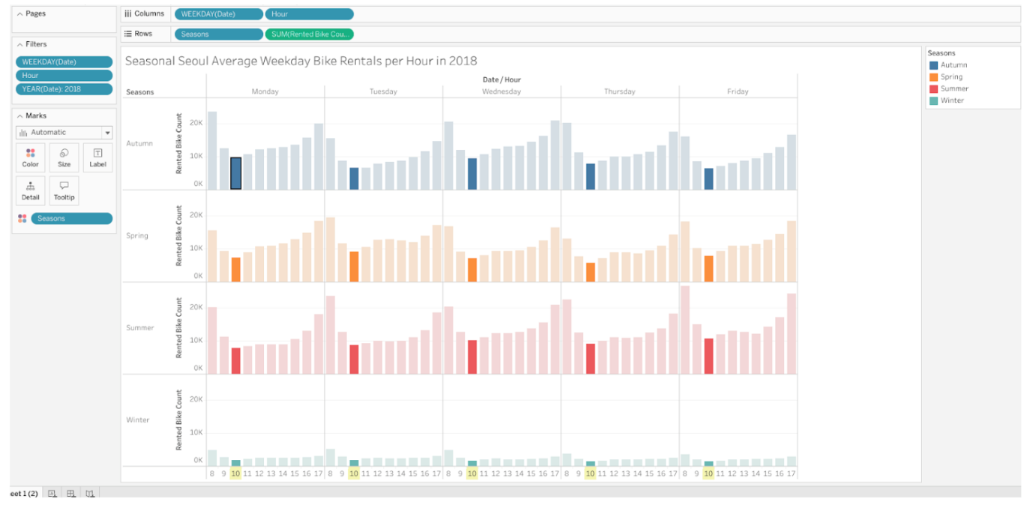

# Follow-along guide: Craft compelling stories with Tableau

## This document includes detailed instructions for how to perform the data visualizations described in the video “Craft compelling stories with Tableau.”

### The following guide points out areas of the video that may require adjustment. These resource guides can also serve as a set of usability reminders for you to recall when using Tableau in your future career.

**Instructions**

* Go to  <https://public.tableau.com/s/>
* Since you’ve already [set up your Tableau Public profile](https://www.tableau.com/community/blog/2022/9/beginners-guide-tableau-public), all you need to do is log in and select **Web Authoring** under **Create** in the navigation bar.
* Select the appropriate CSV file provided in the [instructions](https://www.coursera.org/learn/go-beyond-the-numbers-translate-data-into-insight/supplement/hSNPT/follow-along-instructions-data-visualizations-and-presentations-with-tableau).  The dataset you’ll use with this instructional video is: tableau\_main\_2009\_to\_2018.csv.
  + Please be aware that when you download the zip file folder provided, the computer automatically names that zip file folder with a long string of numbers and letters. You have to open that folder and then upload the individual files that are named correctly and match what's shown in the video.
* Click on NEW WORKSHEET.

**Note:** Please allow several minutes for data import into a new worksheet.

* Move the blue Date field to the column field.
* Select YEAR from dropdown.
* Move NUMBER OF STRIKES to the row field.

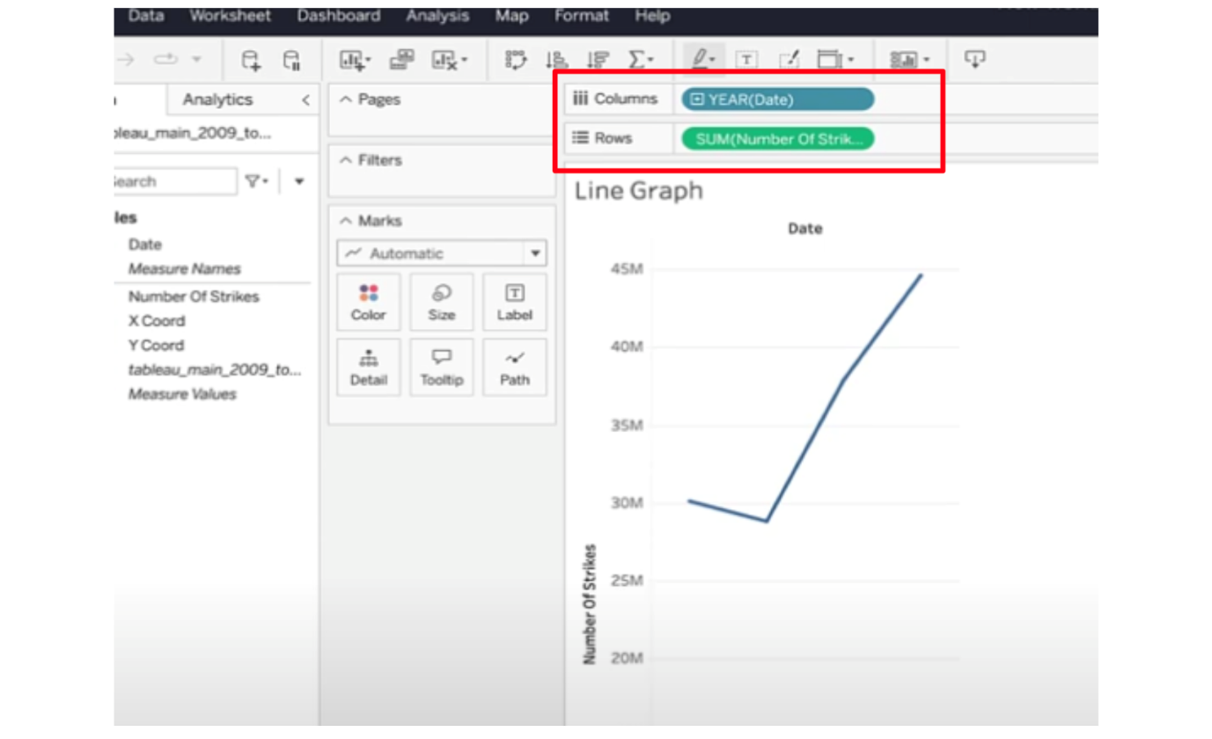

* If your visualization doesn’t default to a line graph, click on “SHOW ME” in the upper right of the screen and select Lines (discrete).
* Create annotation by **right clicking** on each end of the line and selecting “Annotate mark.”
* Type in “30.1M” for the Number of Strikes.
* Create annotation on the final mark in the same way.
* Type “45M” for number of strikes in 2018.

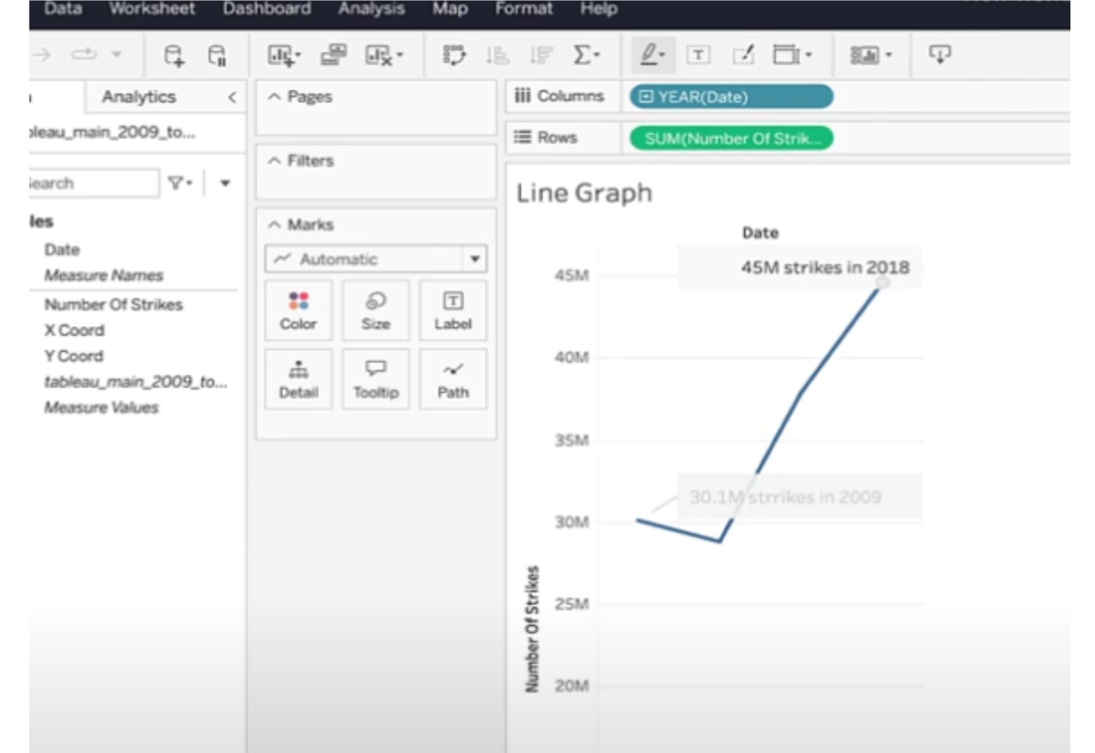

* Click on NEW WORKSHEET.
* Drag the X-coord to the column field. Drag the Y-coord to the Row field.

**Note**: Make sure the X and Y coordinates are continuous dimensions with Y coord geographic role set to latitude and X coord geographic role set to longitude.

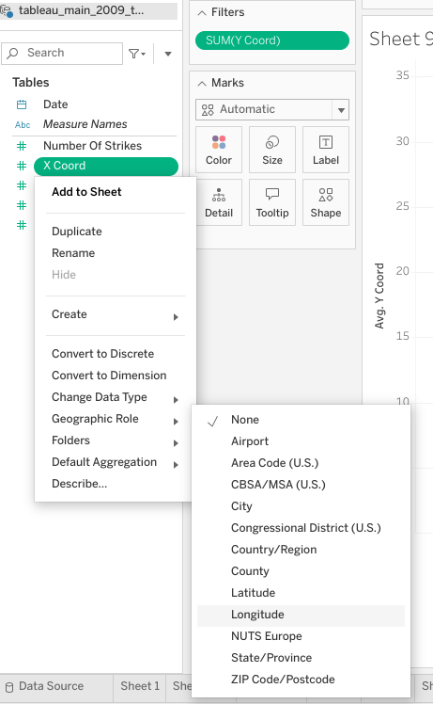

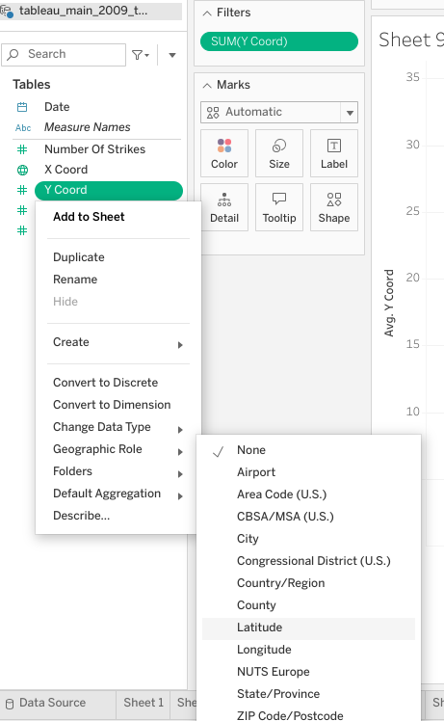

* Click on the dropdown for both the X and Y coordinates.
* Select MEASURE then AVERAGE.

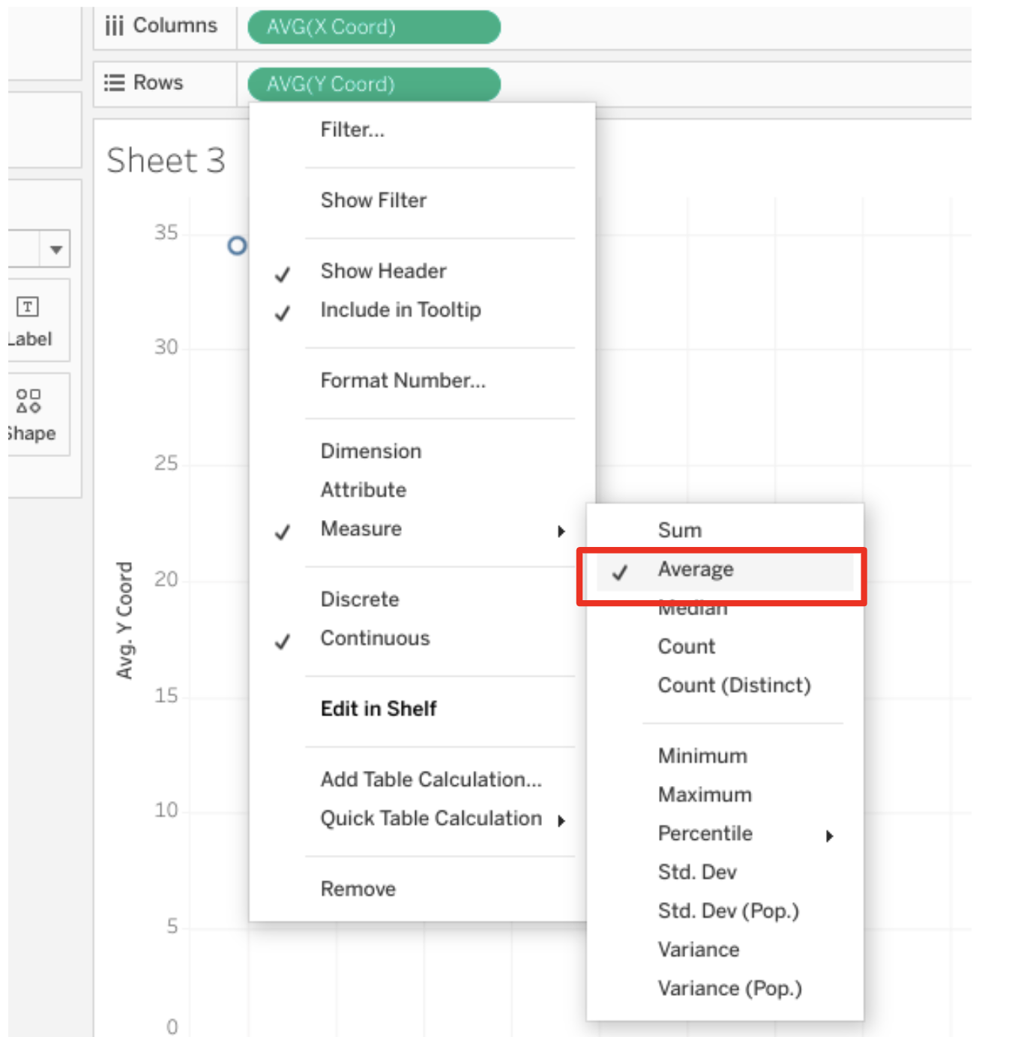

* Drag DATE to filter field.

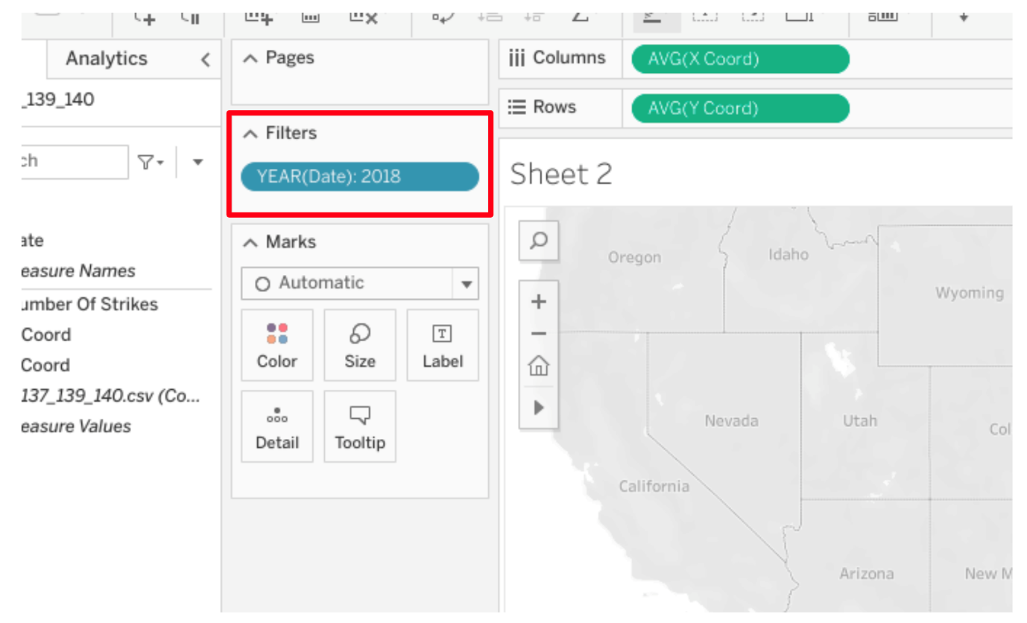

* Drag DATE to pages field, select year from dropdown.

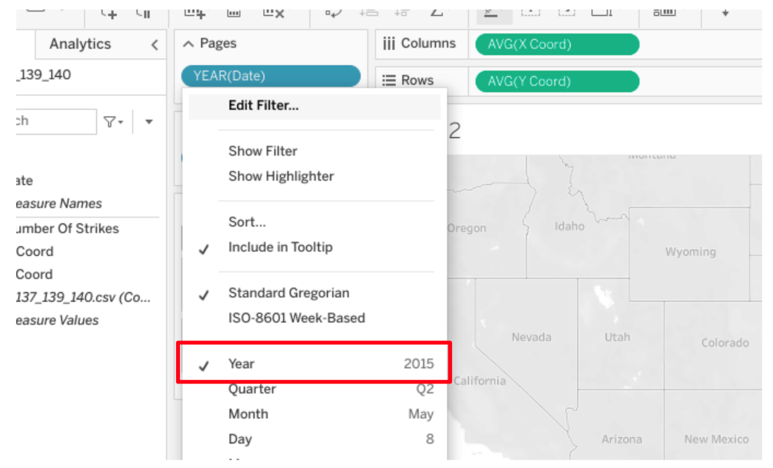

* Drag NUMBER of STRIKES to the detail field.

**Note:**  Be sure to click the dropdown on “Number of Strikes” and convert it to a dimension.

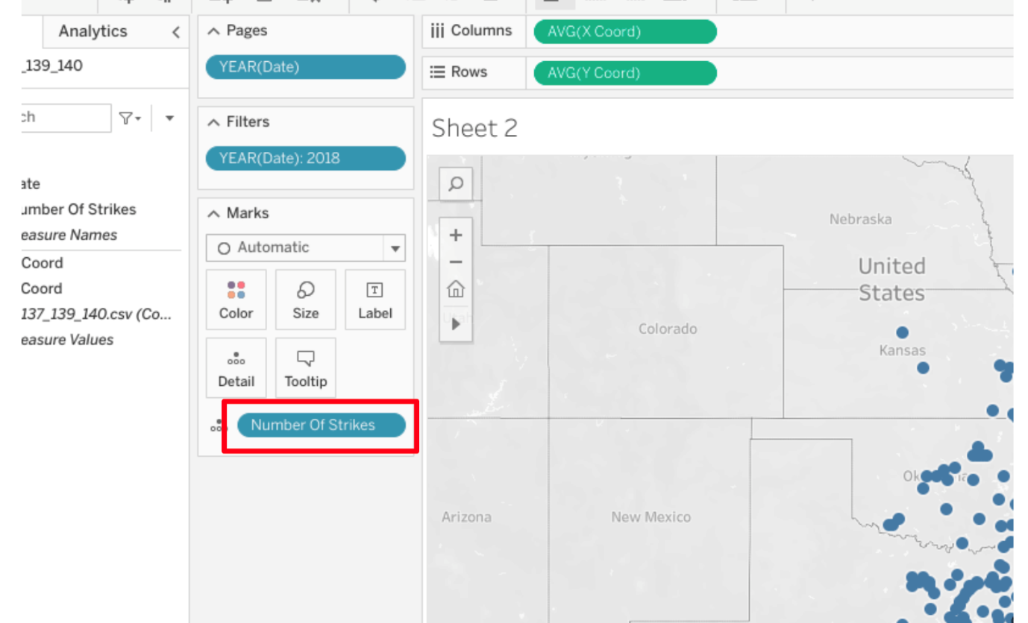

* Click on NEW WORKSHEET.
* Drag the X-coord to the column field. Drag the Y-coord to the Row field.
* Drag the Number of Strikes measure to the detail field.
* **Note:** Make sure the Number of Strikes measure is Discrete. To do so, right click Number of Strikes measure and click “Convert to Discrete.”
* Add Number of Strikes to the color field and make the color coincide with the number of strikes. Select Red-Gold under “Automatic” drop down.

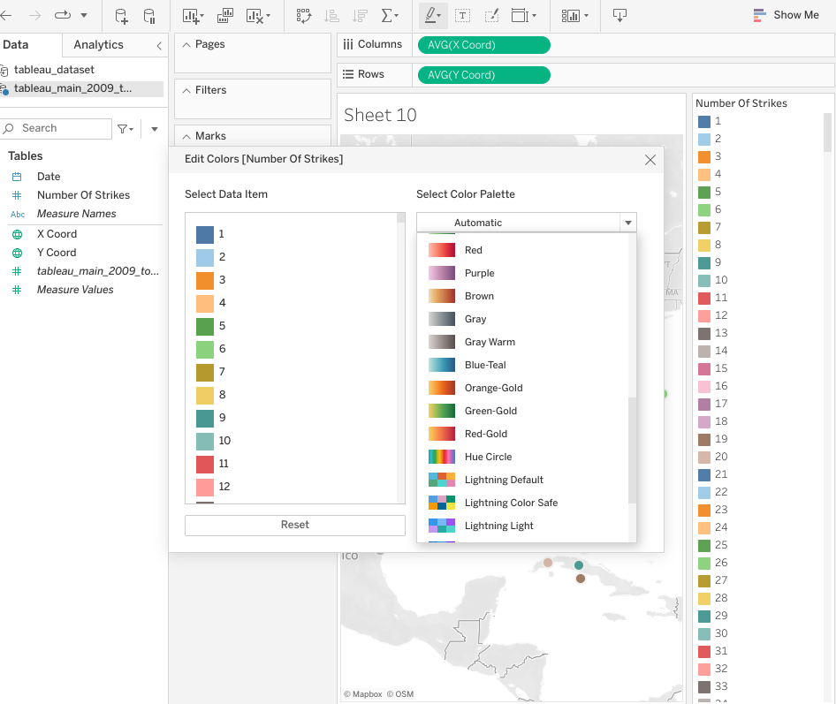

* Drop Date into the Filters field and select Year.

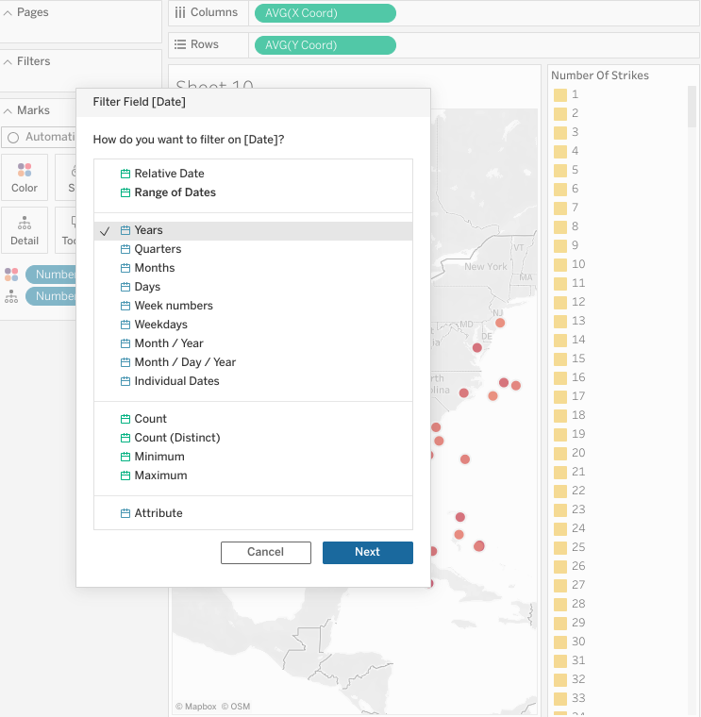

* Use the lasso tool. To do so, hover your cursor over your geographic map visualization and a small line of graphics will appear on the left side. Hover over the right arrow then click on the lasso image.

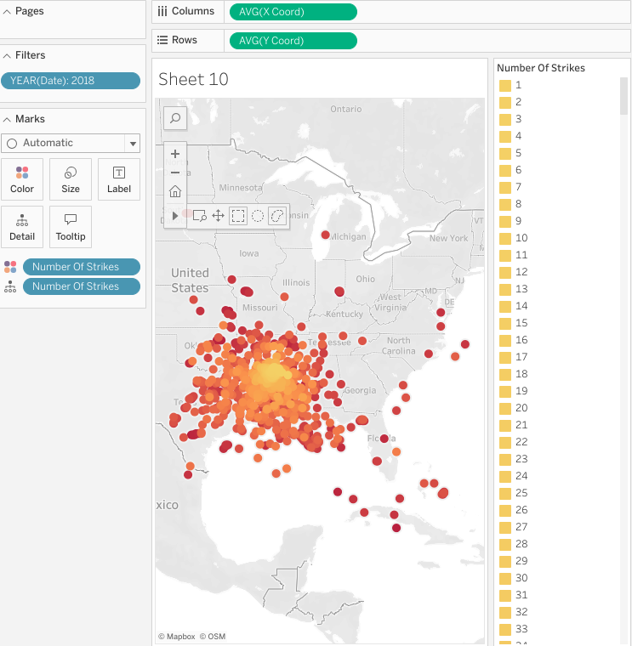

* Drag your cursor over the Texas state border, select Keep Only then click Create Set.
* Drag your new set to the Filters field and select ‘In’ from  Filter.

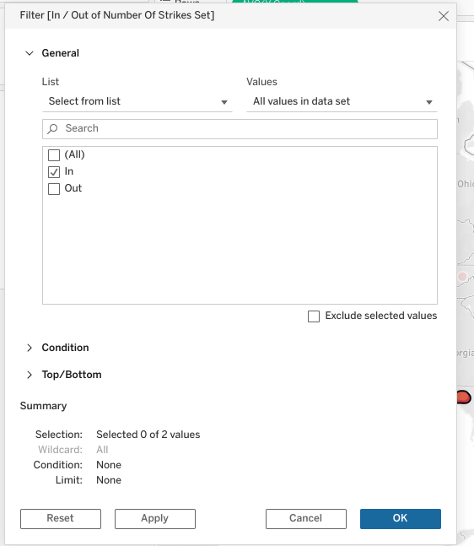

* **Note:** The dashboards section shown in the final part of this instructional video should be completed on your own. It is up to you to design the Oklahoma and Kansas visualizations by following the same steps as performed for Texas in the video. For detailed instructions to create the on-screen visuals shown in the remainder of this video, please follow the proceeding steps.
* Create two duplicates of this sheet and redo the same tracing of states process, but for Oklahoma and Kansas.

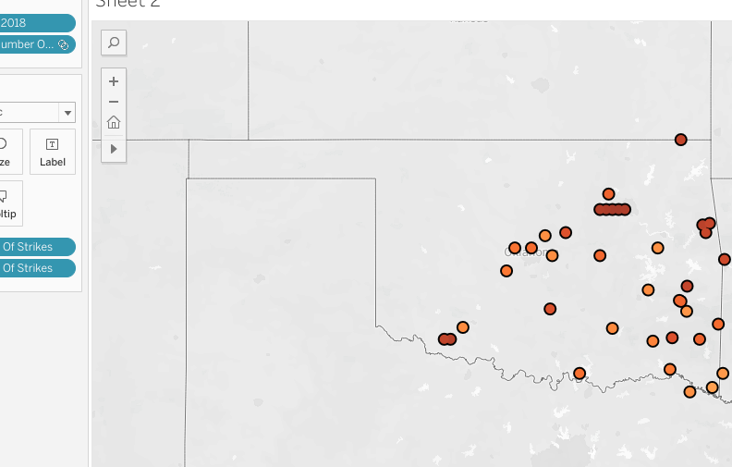

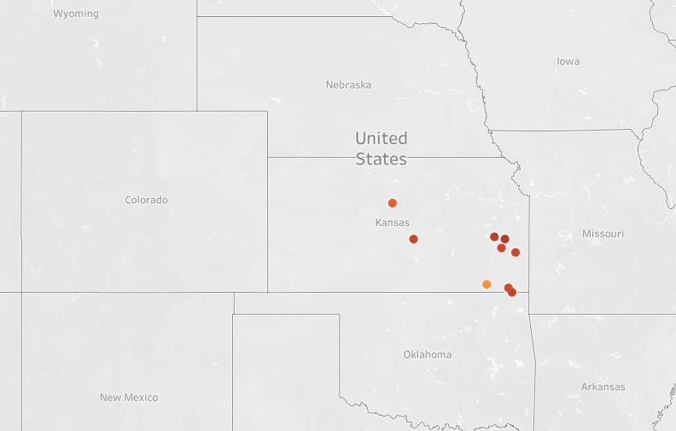

* Click on “New Dashboard” at bottom of page.
* In the dashboard, embed the three state worksheets.

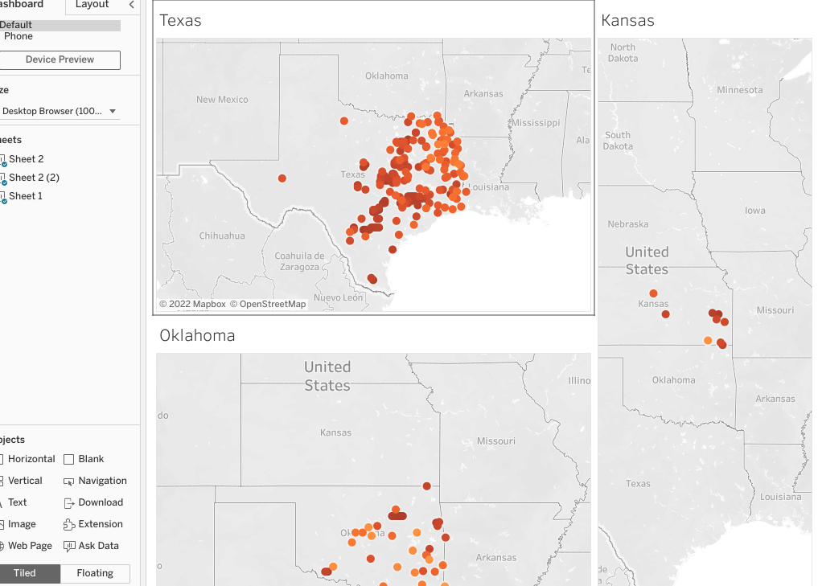

* Create another dashboard.
* Place USA map in it.

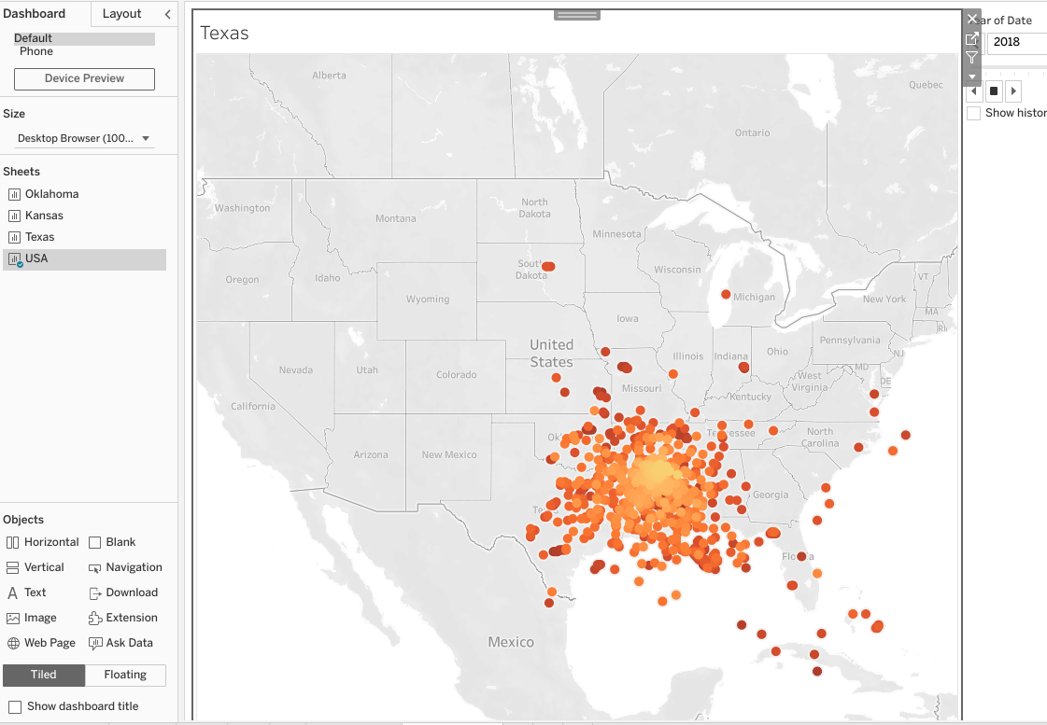

* Create a new STORY at the bottom of the Tableau page.

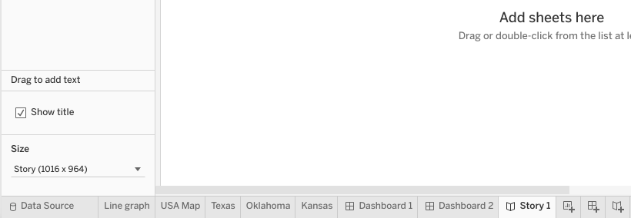

* On the first page, select the line graph dashboard.
* Fill in the caption with “Lightning strikes in the U.S. have increased 50% over the last decade.”
* Go to page 2 of the story.
* Select USA dashboard for Page 2.
* In caption type, “Lightning strikes have moved from the East Coast to the Central Mainlands over the last decade.”

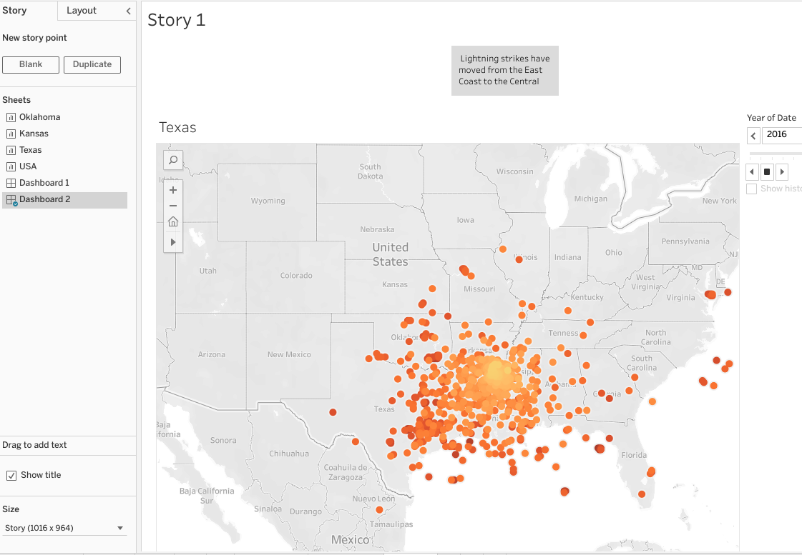

* Go to page 3 of Story.
* Select the last dashboard with three states on it.
* In caption type, “Most number of lightning strikes in 2018 happened in densely populated household areas.”
* And now you’ve created a story using dashboards and worksheets as building blocks!

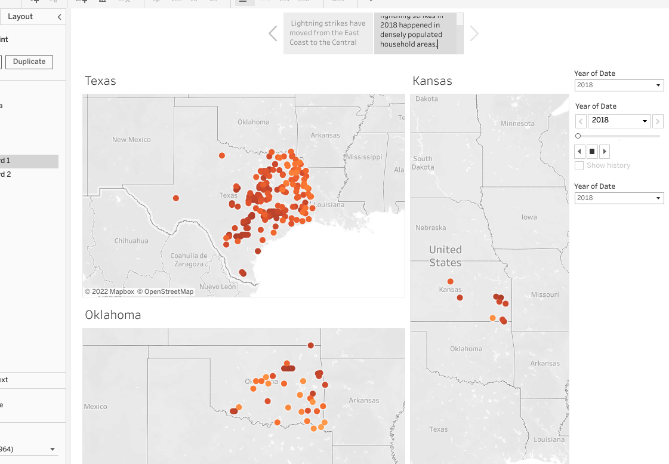

**Basic organizing strategies for a presentation**

* Chronological
* Generic-to-specific
* Specific-to-generic

A chronological approach to data visualizations is useful for data that is best understood in a time series

A generic-to-specific approach helps an audience consider an issue before describing how it affects them

A specific-to-generic approach is useful to highlight impacts the data can have on a broader scale.

**Story**

A Tableau term for a group of dashboards or worksheets assembled into a presentation

**Set**

A Tableau term for a custom field of data created form a larger dataset based on custom conditions.

# The top five data visualization resources

## Top five data visualization resources for data professionals

You’ve gotten a lot of experience in data visualization by now, which will be instrumental in your career as a data professional. As you step into new roles in the data industry, it is important to keep up with data visualization trends by participating in visualization (“viz”) communities and accessing viz resources.

Below you’ll find the top five data viz resources for data professionals. At each site you’ll find amazing training resources and bustling data viz communities ready to help you maintain and improve on the skills you’ve already acquired. Along with improving your skills, these sites and communities can be a useful resource for maintaining a working knowledge of data viz ethics and accessibility.

Take time to explore each resource. In particular, learn what they offer for training, education, and community engagement.

**\_\_\_\_\_\_\_\_\_\_\_\_\_\_\_\_\_\_\_\_\_\_\_\_\_\_\_\_\_\_\_\_\_\_\_\_\_\_\_\_\_\_\_\_\_\_\_\_\_\_\_\_\_\_\_\_\_\_\_\_\_\_\_\_\_\_\_\_\_\_\_\_\_\_\_\_\_\_\_\_\_\_\_\_\_\_\_\_\_\_\_\_\_\_**

"Where can I find training material and sample visualizations to help me with my own data visualizations?"

**Tableau**

You’re already quite familiar with Tableau’s free browser software: [**Tableau Public**](https://public.tableau.com/app/discover). Of course, they offer a variety of software packages that appeal to every data professional, from the daily power user to the occasional presenter.

But did you know that Tableaualso offers a comprehensive education and tutorial platform focused on training both software users and class leaders? In their [Resources](https://www.tableau.com/resources) tab, Tableau offers video tutorials, e-learning courses, and webinars to help every level of user improve their data visualizations. Along with articles, blogs, and white papers, Tableau has a huge collection of sample visualizations (including [Viz of the Day](https://public.tableau.com/app/discover/viz-of-the-day), which showcases some of the best Tableau vizzes) that is meant to encourage and empower data pros at every level to turn their dull datasets into effective storytelling tools.

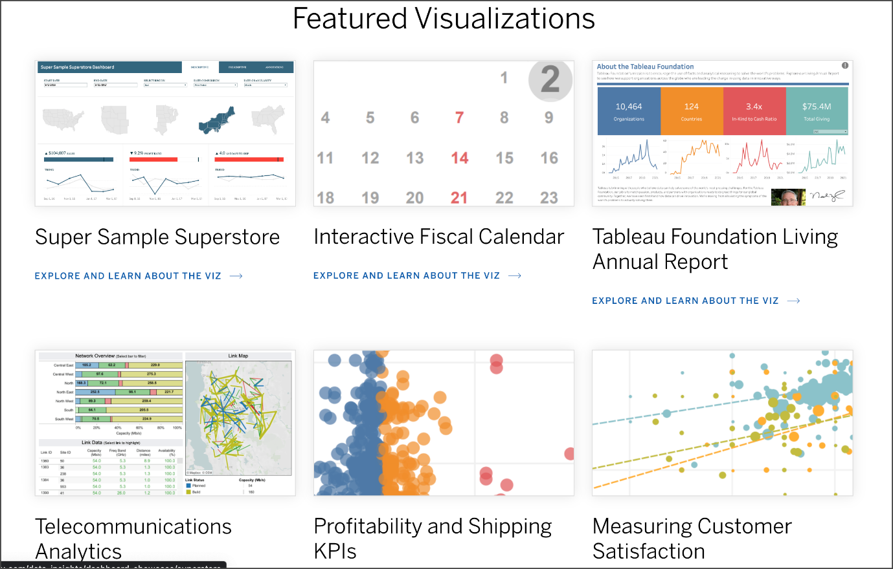

**\_\_\_\_\_\_\_\_\_\_\_\_\_\_\_\_\_\_\_\_\_\_\_\_\_\_\_\_\_\_\_\_\_\_\_\_\_\_\_\_\_\_\_\_\_\_\_\_\_\_\_\_\_\_\_\_\_\_\_\_\_\_\_\_\_\_\_\_\_\_\_\_\_\_\_\_\_\_\_\_\_\_\_\_\_\_\_\_\_\_\_\_\_\_**

"Where can I find a community of data professionals dedicated to building intelligent data visualizations for businesses? "

**PowerBI**

What [PowerBI](https://powerbi.microsoft.com/en-us/)is probably best known for is its popular software product used by businesses and corporations worldwide for data visualization. Not only do they offer a free online version of their premium product,PowerBI, they also provide comprehensive [guided learning](https://docs.microsoft.com/en-us/learn/powerplatform/power-bi?WT.mc_id=sitertzn_learntab_guidedlearning-card-powerbi) and [online workshops](https://www.microsoft.com/en-us/store/workshops-training-and-events/) for teaching users of its products to create powerful data visualizations.

A growing number of data pros are also part of their [PowerBIdata visualization community](https://community.powerbi.com/). Here, users collaborate and share insight about the most effective ways to build data visualizations for businesses and organizations of every kind all over the world, like The Associated Press, Nokia, Real Madrid Football Club, Toyota, UNICEF, Galadari Brothers, and Eurobank, to name a few.

**\_\_\_\_\_\_\_\_\_\_\_\_\_\_\_\_\_\_\_\_\_\_\_\_\_\_\_\_\_\_\_\_\_\_\_\_\_\_\_\_\_\_\_\_\_\_\_\_\_\_\_\_\_\_\_\_\_\_\_\_\_\_\_\_\_\_\_\_\_\_\_\_\_\_\_\_\_\_\_\_\_\_\_\_\_\_\_\_\_\_\_\_\_\_**

"Where can I find data visualizations paired with the datasets they are built from? "

**Information is Beautiful**

Founded by author and data visualization expert David McCandless, the [Information is Beautiful](https://informationisbeautiful.net/) platform is a gathering place for data pros who want to help people make clearer, more informed decisions in the world.

The site is a treasure trove of data visualizations on a host of topics. The Information is Beautiful team also has blogs, newsletters, and live and [online workshops](https://informationisbeautiful.net/workshops/), which aim to help data professionals improve their craft. Beyond the powerful visualizations and graphs on their website, Information is Beautiful focuses on transparency by sharing all of the datasets on which they base their vizzes.

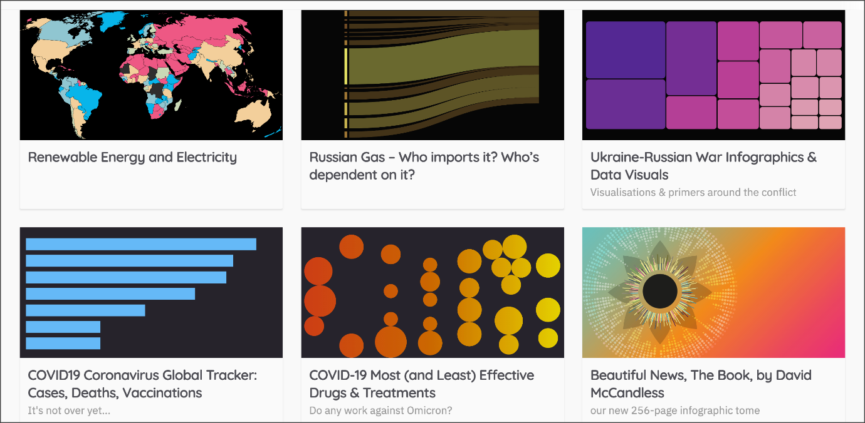

**\_\_\_\_\_\_\_\_\_\_\_\_\_\_\_\_\_\_\_\_\_\_\_\_\_\_\_\_\_\_\_\_\_\_\_\_\_\_\_\_\_\_\_\_\_\_\_\_\_\_\_\_\_\_\_\_\_\_\_\_\_\_\_\_\_\_\_\_\_\_\_\_\_\_**

"Where can I go to learn more about communicating my data visualizations effectively?"

**Storytelling with Data**

As evidenced by their name, [Storytelling with Data](https://www.storytellingwithdata.com/) is an organization focused on communicating with concise data that informs change. They provide training, workshops, and tools for the craft that combines both data visualization and storytelling.

Storytelling with Data has a particularly engaged [community](https://community.storytellingwithdata.com/), where data pros gather to learn, practice, ask for feedback, and help others. Though they don’t have their own dedicated software for designing vizzes, they have a myriad of tiered resources for training, office hours, and consulting.



**\_\_\_\_\_\_\_\_\_\_\_\_\_\_\_\_\_\_\_\_\_\_\_\_\_\_\_\_\_\_\_\_\_\_\_\_\_\_\_\_\_\_\_\_\_\_\_\_\_\_\_\_\_\_\_\_\_\_\_\_\_\_\_\_\_\_\_\_\_\_\_\_\_\_**

"Where can I go to find out more about data visualizations created in Python?"

**Python Graph Gallery**

If you are looking to improve your skill in plotting data visualizations in Python, the [Python Graph Gallery](https://www.python-graph-gallery.com/) is a fantastic website to visit. This site created by [Yan Holtz](https://www.yan-holtz.com/) includes a wide range of different types of visualization plots, like bar graphs, line charts, times series charts, geographic maps, and many more. Along with each visualization, you will also find the accompanying Python code used to plot the viz.

The site is organized first by plot type, but can also be sorted by the visualization Python package used, seaborn, matplotlib, or plotly. There is also a space for general knowledge tips and tricks, and a section titled [Dataviz Inspiration](https://www.dataviz-inspiration.com/), which can help you understand what Python is capable of.

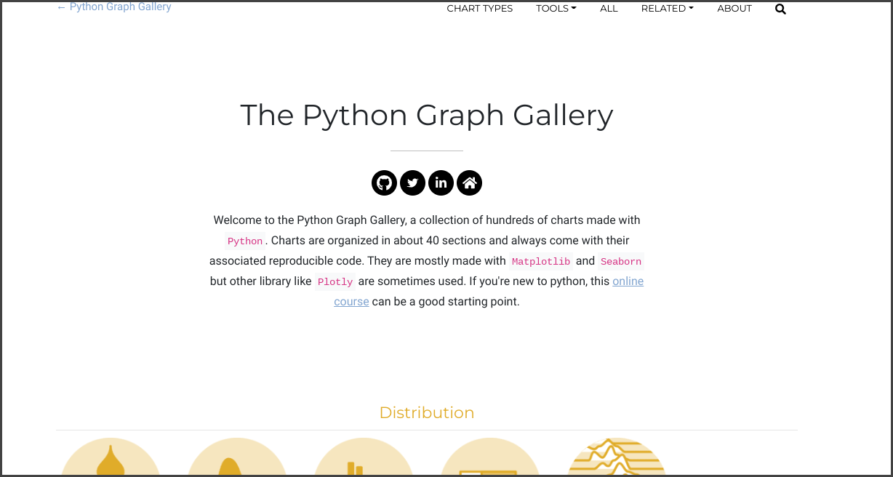

## Key Takeaways

Your data visualization education doesn’t end when you complete this program. There are amazing resources available that are consistently being updated with the latest trends and most up-to-date principles regarding the design, ethics, accessibility,  and communication of data visualizations.

# Follow-along guide: Present like a pro with Tableau

## This document includes detailed instructions for how to perform the data visualizations described in the video “Present like a pro with Tableau.”

### The following guide points out areas of the video that may require adjustment. These resource guides can also serve as a set of usability reminders for you to recall when using Tableau in your future career.

**Instructions**

* Go to  <https://public.tableau.com/s/>
* Since you’ve already [set up your Tableau Public profile](https://www.tableau.com/community/blog/2022/9/beginners-guide-tableau-public), all you need to do is log in and select **Web Authoring** under **Create** in the navigation bar.
* Select the appropriate CSV file provided in the [instructions](https://www.coursera.org/learn/go-beyond-the-numbers-translate-data-into-insight/supplement/hSNPT/follow-along-instructions-data-visualizations-and-presentations-with-tableau).  Use the same data source as the previous video. The dataset you’ll use with this instructional video is: tableau\_main\_2009\_to\_2018.csv
  + Please be aware that when you download the zip file folder provided, the computer automatically names that zip file folder with a long string of numbers and letters. You have to open that folder and then upload the individual files that are named correctly and match what's shown in the video
* Click on NEW WORKSHEET.

**Note**: Please allow several minutes for data import into a new worksheet.

## Sheet 1- Map

* Set the geographic role of the X coord to Longitude
* Set the geographic role of the Y coord to Latitude

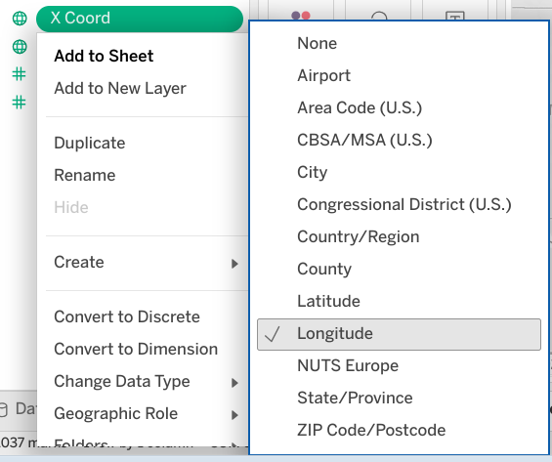

* Drag X coord to Column field. Drag Y coord to Row field.
* Drag DATE to FILTERS.

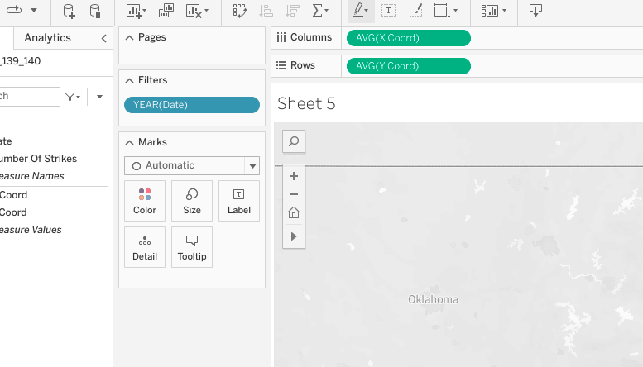

* Select **Years**. This will be a filter. Select All.

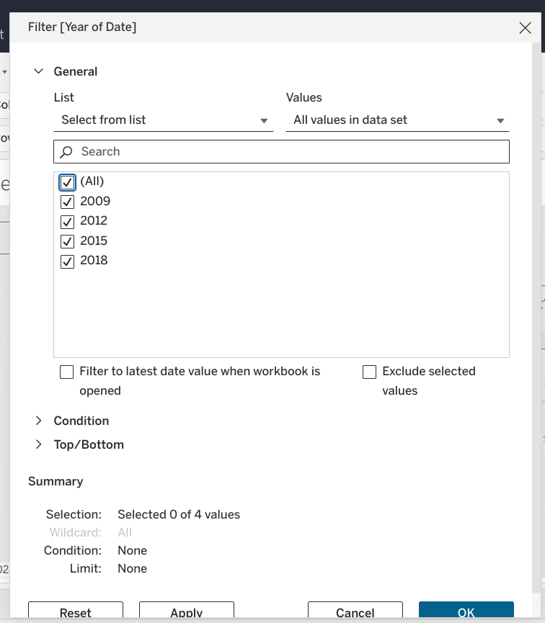

* Click on DATE dropdown, select SHOW FILTER.

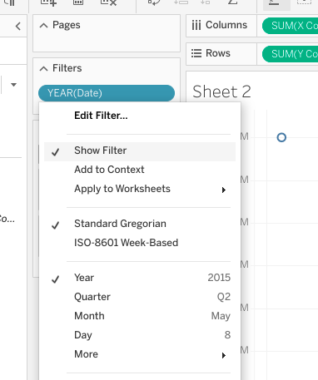

* Click on NUMBER of STRIKES and select CONVERT to DIMENSION

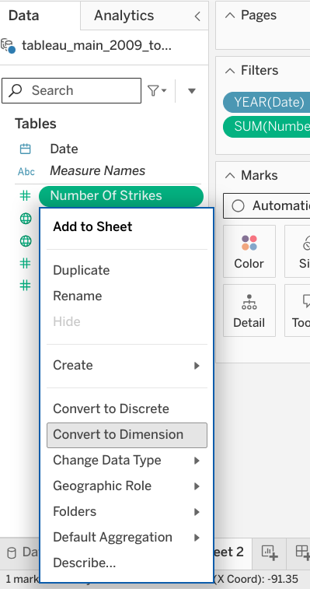

* Drag NUMBER of STRIKES into both the COLOR square and DETAIL square inside the MARKS box.

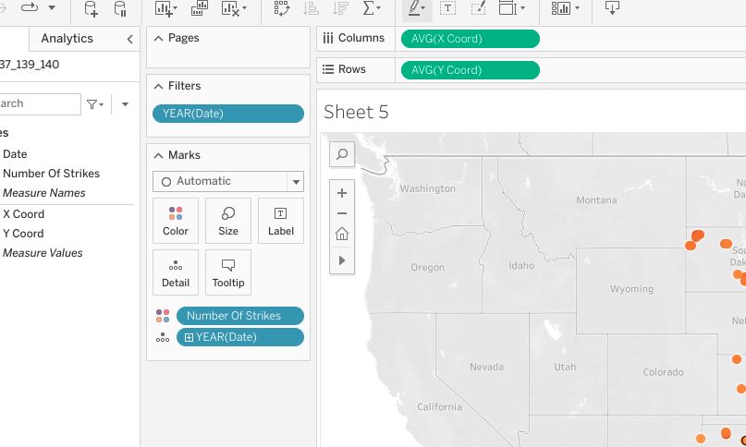

* Click on dropdown of NUMBER OF STRIKES, select CONTINUOUS.

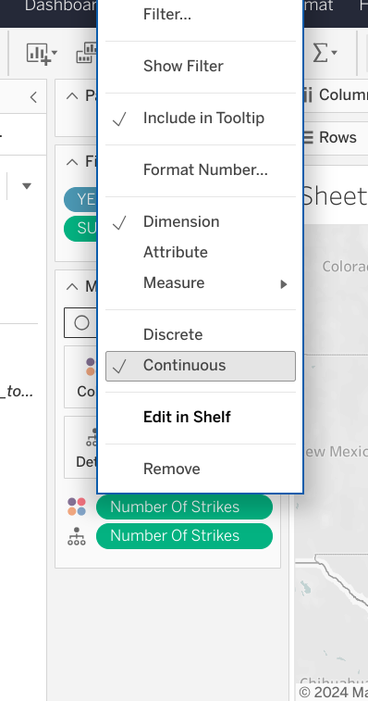

* Before moving on to the next Sheet, title Sheet 1 Map. You can do this under Rows between <> by clicking in that space.

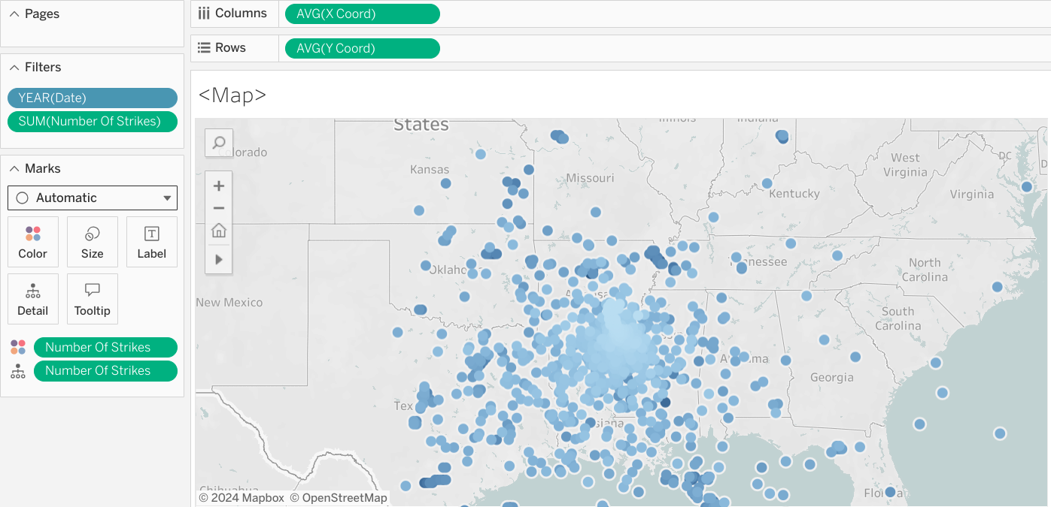

## Sheet 2

* In the same Tableau Workbook, Click on NEW WORKSHEET.
* Click dropdown of NUMBER of STRIKES field.
* Select CREATE and CALCULATED FIELD.
* TYPE “Strikes” for the title.
* Click OK.
* Drag calculation into TOOLTIP field.

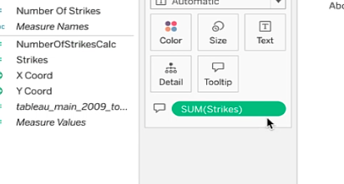

* In the Strikes drop down, Select MEASURE, then AVERAGE.

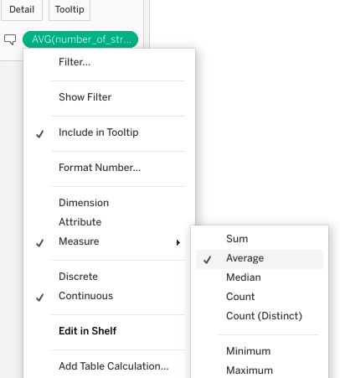

* Drag calculation field  to TOOLTIP again. Select MEASURE, then MAXIMUM.

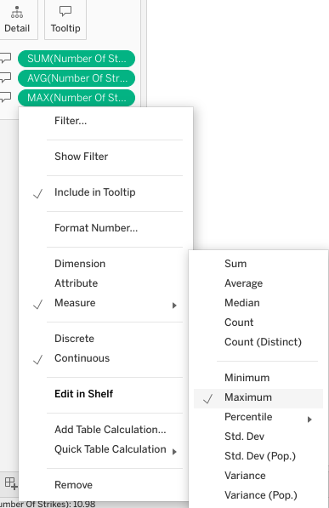

* Drag calculation to TOOLTIP, select MEASURE, then SUM.

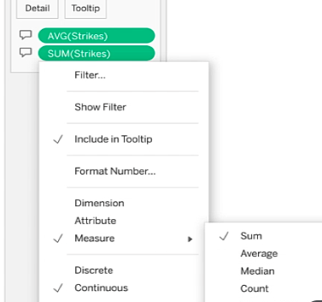

* Click on WORKSHEET and select SHOW TITLE.

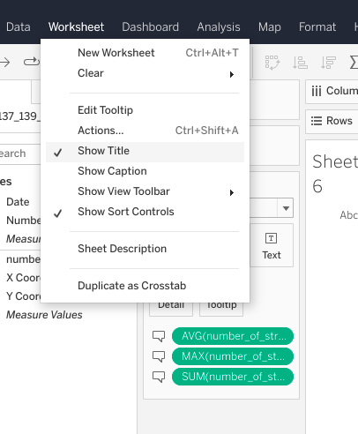

* Type in ‘Metrics for the Year’ in title field.
* Then add the following beneath it:

\*Total: <SUM(Strikes)>

\* Average: <AVG(Strikes)>

\* Maximum: <MAX(Strikes)>’.

* Click OK.

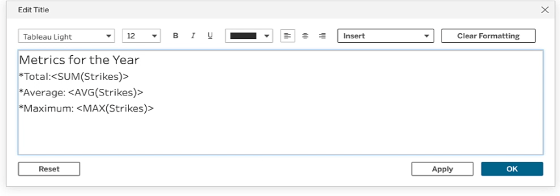

## Sheet 3

* Click on NEW WORKSHEET.
* Drag NUMBER of STRIKES to the TEXT square in the MARKS field.

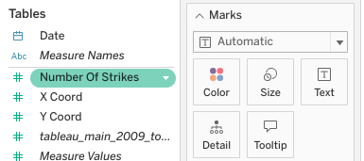

* From dropdown, select MEASURE and AVERAGE.

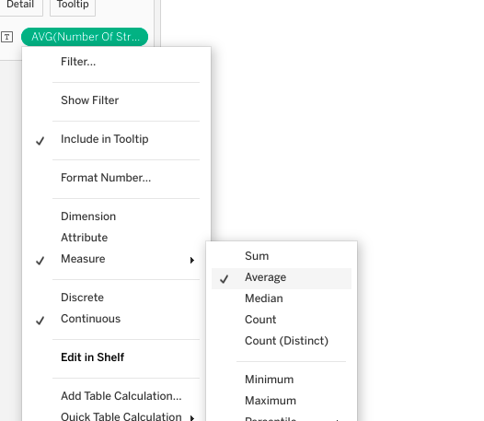

* Click on NEW DASHBOARD.
* Drag USA map worksheet to empty dashboard.

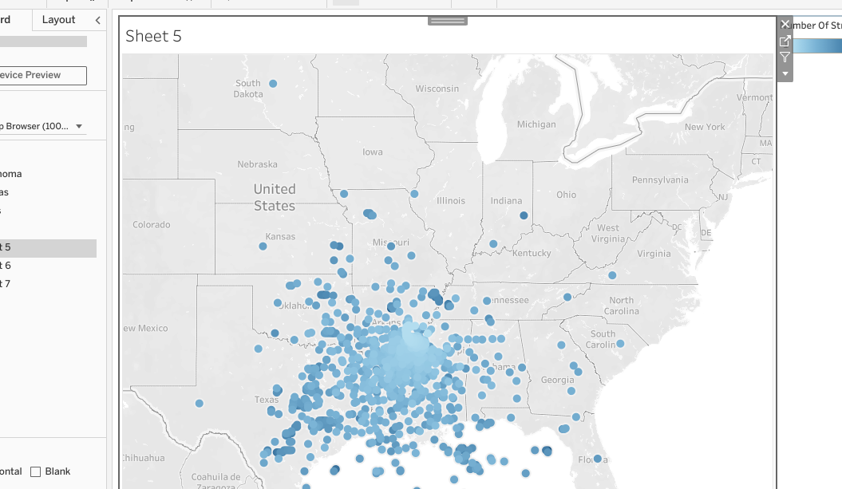

* Drag your other two worksheets to the dashboard.

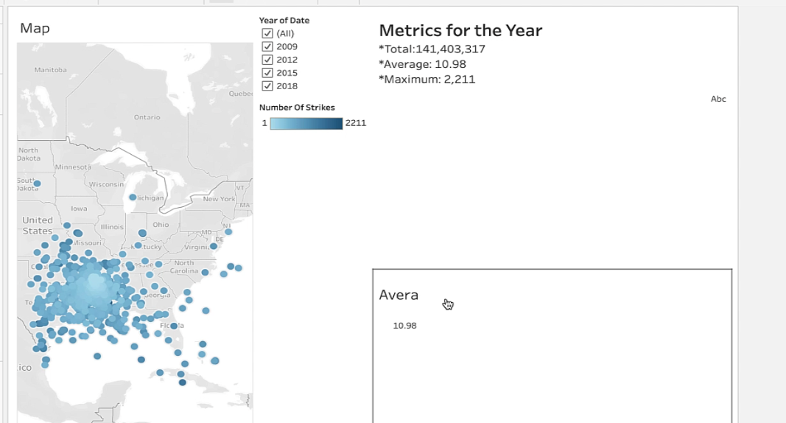

* Click map, then select WORKSHEET and ACTIONS.

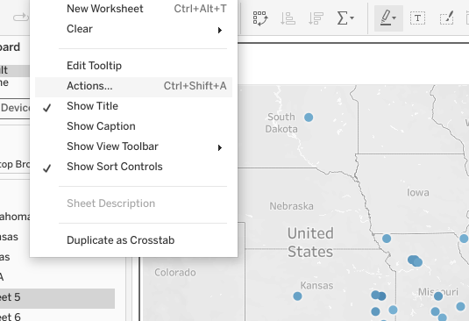

* Select ADD ACTION and FILTER.

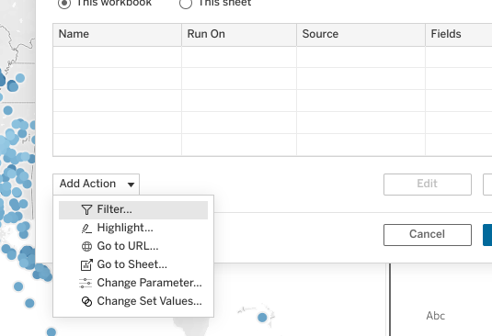

* Under SOURCE SHEETS, select the dashboard you created from the dropdown.
* Check the box for the map worksheet, and then choose SELECT under the RUN ACTION ON list.

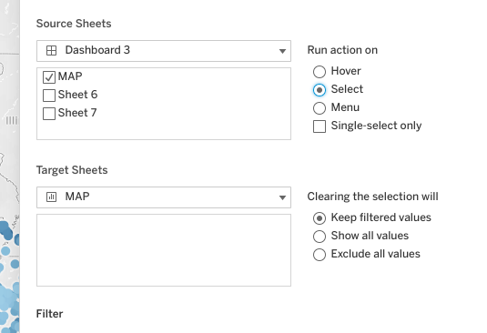

* Next, under the TARGET SHEETS list, select dashboard from the drop down, then check box for the other two worksheets you created.
* Select SHOW ALL VALUES.
* Select ALL FIELDS, under Filter.
* Click OK.

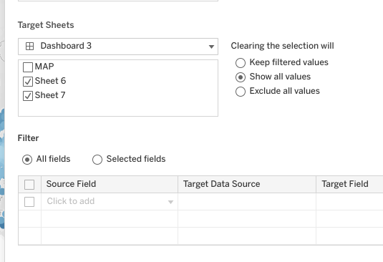

* Type in ‘Interactive Filter’ in Legend title field.
* Type in ‘Location Metrics’ in title field.
* Now you’ve created an interactive geographic dashboard that adjusts metrics each time a year or location is changed or selected. Well done!

**Three worksheets for you interactive dashboard**

* Interactive U.S. map
* Dynamic statsheet
* Lightning strike metrics for the individual location

**Three metrics for your interactive dashboard**

* Total number of strikes
* Average number of strikes
* Maximum number of strikes

## Reflect

Before you drag the X and Y coords to the Column and Row field. You will need to set the geographic data using their drop down menus.

* Set the geographic role of the X coord to Longitude.
* Set the geographic role of the Y coord to Latitude.



**Action**

A Tableau tool to help a user interact with a visualization or dashboard by allowing control of a selection

# Activity Exemplar: Build an interactive dashboard in Tableau Public

Here is a completed exemplar along with an explanation of how the exemplar fulfills the expectations for the activity.

## Completed Exemplar

To review the exemplar for this course item, click the following link .

Link to exemplar: [Impact of Holidays on Seoul Bike Rentals in 2017 - 2018](https://public.tableau.com/app/profile/grow.with.google/viz/ImpactofHolidaysonSeoulBikeRentalsin2017-2018/Dashboard1)

## Assessment of Exemplar



Compare the exemplar to your completed activity. Review your work using each of the criteria in the exemplar. What did you do well? Where can you improve? Use your answers to these questions to guide you as you continue to progress through the course.

***Note:*** The exemplar represents one possible way to complete the data visualization. Yours will likely differ in certain ways. What’s important is that your data visualization meets the business scenario criteria.



### How the exemplar meets the criteria

Notice how the exemplar posted to Tableau Public uses the detail from the given scenario to adhere to the following guidelines:

* The data dashboard includes two dynamic worksheets.
* The dashboard has divided the data into two different bar graphs: by Weekday and by Adjacent Day.
* One worksheet divides data into dates and months
* This worksheet is the “By Adjacent Day” worksheet.
* Another worksheet is divided into dates for each day of the week. This worksheet is the “By Weekday” worksheet.
* The dashboard, worksheets, and filters are properly labeled.
* Holidays are shown in a clearly contrasting color. Holiday data is in orange, while non-holiday data is in blue.
* The filters on the dashboard sidebar filter the desired data.
* There are two filters shown and one legend.
* One filter connects to the “By Adjacent Day” data and allows the data to be filtered by month.
* Another filter connects to the “By Weekday” data and allows the data to filter by day of the week.
* The legend shows that holidays are orange and non-holidays are blue.

**Review (Working with Tableau)**

* Use Tableau to tell your data’s stories
* Adjust content depending on audience
* Share technical concepts with non-technical audiences
* Use Tableau at a high level
* Applied techniques data professionals use to create
* Ensure visualizations accurately represent data
* Make data visualizations accessible for people who have

# Glossary terms from module 4

# Terms and definitions from Course 3, Module 4

**Action:** A Tableau tool to help an audience interact with a visualization or dashboard by allowing control of selection

**Bin:** A segment of data that groups values into categories

**Box plot:** A data visualization that depicts the locality, spread, and skew of groups of values within quartiles

**Continuous:** A mathematical concept indicating that a measure or dimension has an infinite and uncountable number of outcomes

**Dimensions:** Qualitative data values used to categorize and group data to reveal details about it

**Discrete:** A mathematical concept indicating that a measure or dimension has a finite and countable number of outcomes

**Heatmap:** A type of data visualization that depicts the magnitude of an instance or set of values based on two colors

**Histogram:** A data visualization that depicts an approximate representation of the distribution of values in a dataset

**Measures:** Numeric values that can be aggregated or placed in calculations

**Set:**A Tableau term for a custom field of data created from a larger dataset based on custom conditions

**Story:** A Tableau term for a group of dashboards or worksheets assembled into a presentation

**Tableau**: A data visualization software primarily used for presenting data to inform and improve businesses

# Terms and definitions from previous modules

## B

**Bias**: In data structuring, refers to organizing data results in groupings, categories, or variables that are misrepresentative of the whole dataset

**Box plot:** A data visualization that depicts the locality, spread, and skew of groups of values within quartiles

## C

**Categorical data:** Data that is divided into a limited number of qualitative groups

**Cleaning**: The process of removing errors that may distort your data or make it less useful; one of the six practices of EDA

**Collective outliers:** A group of abnormal points, following similar patterns and isolated from the rest of the population

**Contextual outliers:** Normal data points under certain conditions but become anomalies under most other conditions

**CSV file**: A simple text file that can be easy to import or store in other softwares, platforms, and databases

## D

**Database (DB) file**: A file type used to store data, often in tables, indexes, or fields

**Data ethics**: Well-founded standards of right and wrong that dictate how data is collected, shared, and used

**Data governance**: A process for ensuring the formal management of a company’s data assets

**Data source:** The location where data originates

**Data visualization**: A graph, chart, diagram, or dashboard that is created as a representation of information

**Deduplication:** The elimination or removal of matching data values in a dataset

**Discovering**: The process data professionals use to familiarize themselves with the data so they can start conceptualizing how to use it; one of the six practices of EDA

**Docstring:** (Refer to **documentation string**)

**Documentation string**: A group of text that explains what a method or function does; also referred to as a “docstring”

**Dummy variables:** Variables with values of 0 or 1 that indicate the presence or absence of something

## E

**Exploratory data analysis (EDA)**: The process of investigating, organizing, and analyzing datasets and summarizing their main characteristics, often by employing data wrangling and visualization methods; the six main practices of EDA are: discovering, structuring, cleaning, joining, validating, and presenting

**Extracting:** The process of retrieving data out of data sources for further data processing

## F

**Filtering:** The process of selecting a smaller part of a dataset based on specified values and using it for viewing or analysis

**First-party data:** Data that was gathered from inside your own organization

## G

**Global outliers:** Values that are completely different from the overall data group and have no association with any other outliers

**Grouping**: The process of aggregating individual observations of a variable into groups

## H

**Heatmap:** A type of data visualization that depicts the magnitude of an instance or set of values based on two colors

**Hypothesis:** A theory or an explanation, based on evidence, that is not yet proven true

## I

**Info():** Gives the total number of entries, along with the data types—called Dtypes in pandas—of the individual entries

**Input validation:** The practice of thoroughly analyzing and double-checking to make sure data is complete, error-free, and high quality

**Int64:** A standard integer data type, representing numbers somewhere between negative nine quintillion and positive nine quintillion

## J

**Joining**: The process of augmenting data by adding values from other datasets; one of the six practices of EDA

**JSON file:** A data storage file that is saved in a JavaScript format

## L

**Label encoding:** Data transformation technique where each category is assigned a unique number instead of a qualitative value

## M

**Merging:** A method to combine two (or more) different data frames along a specified starting column(s)

**Missing data:** A data value that is not stored for a variable in the observation of interest

## N

**Non-null count:** The total number of data entries for a data column that are not blank

## O

**One-hot encoding**: A data transformation technique that turns one categorical variable into several binary variables

**Outliers:** Observations that are an abnormal distance from other values or an overall pattern in a data population

## P

**PACE**: A workflow data professionals can use to remain focused on the end goal of any given dataset; stands for plan, analyze, construct, and execute

**Presenting**: The process of making a cleaned dataset available to others for analysis or further modeling; one of the six practices of EDA

## S

**Second-party data:** Data that was gathered outside your organization but directly from the original source

**Slicing:** A method for breaking information down into smaller parts to facilitate efficient examination and analysis from different viewpoints

**Sorting:** The process of arranging data into a meaningful order for analysis

**String:** A sequence of characters and punctuation that contains textual information

**Structuring**: The process of taking raw data and organizing or transforming it to be more easily visualized, explained, or modeled; one of the six practices of EDA

## T

**Third-party data:** Data gathered outside your organization and aggregated

## V

**Validating**: The process of verifying that the data is consistent and high quality; one of the six practices of EDA

# Activity: Build an interactive dashboard in Tableau Public

## Activity Overview



In a previous activity, you built a bar graph data visualization in Tableau Public.

In this activity, you will use Tableau Public to design an interactive dashboard. This dashboard will tell a multitude of compelling stories about the data it represents by allowing end users to compare critical data variables in real time. Your interactive dashboard will also help a stakeholder make business decisions based on a business need.

The structure of this activity is designed to emulate the proposals you will likely be assigned in your career as a data professional. Completing this activity will help prepare you for those career moments.

Be sure to complete this activity before moving on. At the end of this activity, you will be provided a completed exemplar to compare to your own work. You will not be able to access the exemplar until you have completed this activity.

## Scenario



Review the following scenario. Then complete the step-by-step instructions.

Imagine you are again consulting for the transportation department in Seoul, Korea. The director of transportation is curious about the impact of national holidays on bicycle rentals in 2017 and 2018. The director’s instinct is that the total number of bicycles rented on holidays decreased.

The transportation department has sent you a screenshot of an initial data visualization, but they would like you to provide a more dynamic way of presenting the data. In particular, they would like to compare total bike rentals on holidays with adjacent non-holiday days and matching weekdays.

Your task is to create a dynamic dashboard that compares the impacts of a holiday on bike rentals by weekday or adjacent day.

## Step-By-Step Instructions



Follow the instructions to complete each step of the activity. Then, answer the three questions at the end of the activity before going to the next course item to compare your work to a completed exemplar.

**Step 1: Access supporting materials**

To download the data for this course item, click the following link and select Use Template.

Link to data:[Seoul bicycle rental dataset](https://docs.google.com/spreadsheets/d/1t0tOZJrhQihibYFnJ6lF2baXfDYrU-A4HvWqNrgMUtE/template/preview?resourcekey=0-1Ox-ENKPQN5-dVjFXq5P5Q#gid=2106842449)

OR

If you don’t have a Google account, you can download the data directly from the following attachment.

[Seoul bicycle rental dataset](https://d3c33hcgiwev3.cloudfront.net/_JqBwOEaS_a37dYNVftzmw_0b1c1cafa639423e9342b5f2640999f1_Seoul-bicycle-rental-dataset.xlsx?Expires=1721606400&Signature=Ye0o6ALWfv5YcHHIOL6vmBqxJ5vpjezGTgy8-VTNqd3HyMnI9HvRZwBK~INRlQ5YOyGMjKrCqP3VNOGlS8HfjyiXwPwcCsMj-pL0GHYICUw4Wv-4-BMb0Tt6Of89dBGbw5SOI-YEs-ZuuzYzq0mnNbDy9cV6sZaWfwpyiAs9gvo_&Key-Pair-Id=APKAJLTNE6QMUY6HBC5A" \t "_blank)

[XLSX File](https://d3c33hcgiwev3.cloudfront.net/_JqBwOEaS_a37dYNVftzmw_0b1c1cafa639423e9342b5f2640999f1_Seoul-bicycle-rental-dataset.xlsx?Expires=1721606400&Signature=Ye0o6ALWfv5YcHHIOL6vmBqxJ5vpjezGTgy8-VTNqd3HyMnI9HvRZwBK~INRlQ5YOyGMjKrCqP3VNOGlS8HfjyiXwPwcCsMj-pL0GHYICUw4Wv-4-BMb0Tt6Of89dBGbw5SOI-YEs-ZuuzYzq0mnNbDy9cV6sZaWfwpyiAs9gvo_&Key-Pair-Id=APKAJLTNE6QMUY6HBC5A" \t "_blank)

### **Step 2: Go to Tableau Public**

You will need a [Tableau Public](https://public.tableau.com/s/) account to complete this activity. If you haven’t created an account yet or need to review how to connect to data, review the reading [How to sign on to Public Tableau](https://www.coursera.org/learn/go-beyond-the-numbers-translate-data-into-insight/supplement/muYtK/how-to-sign-on-to-tableau-public)**.**

If you already have a Tableau Public account, log in to your account.

### **Step 3: Upload your dataset**

### **Step 4: Assess the current data**

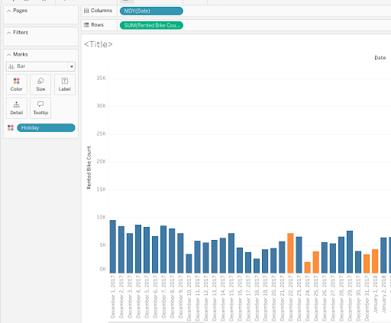

### **Step 5: Create an adjacent-day worksheet**

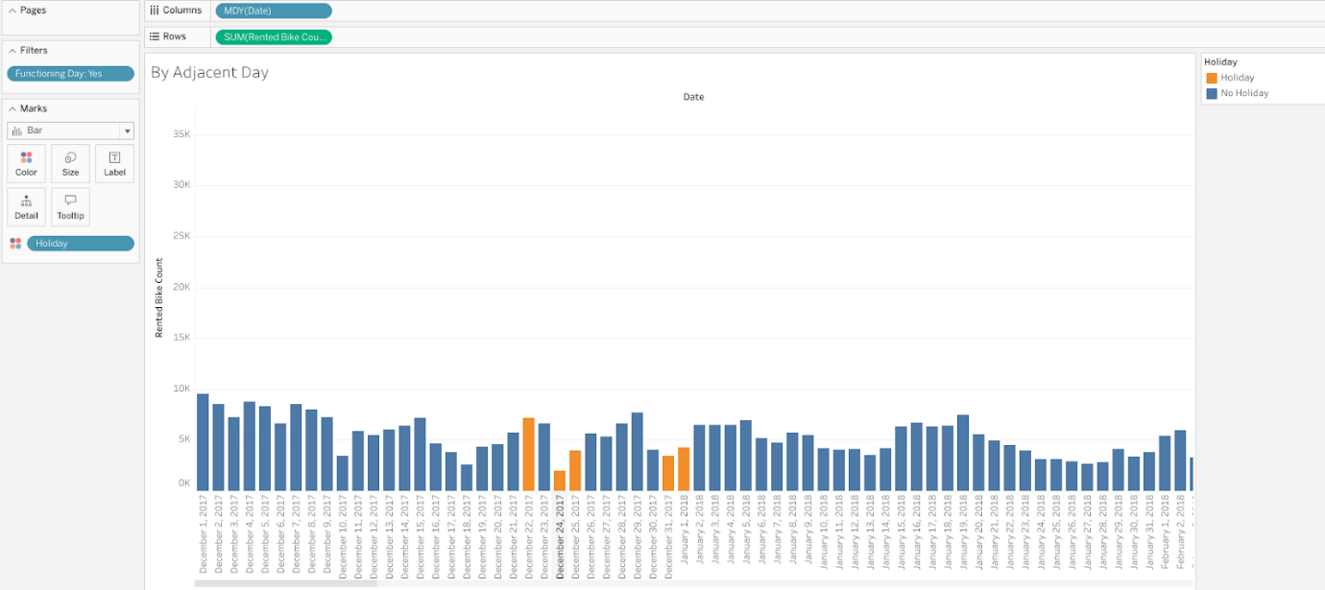

### **Step 6: Update pages and filters for adjacent-day worksheet**

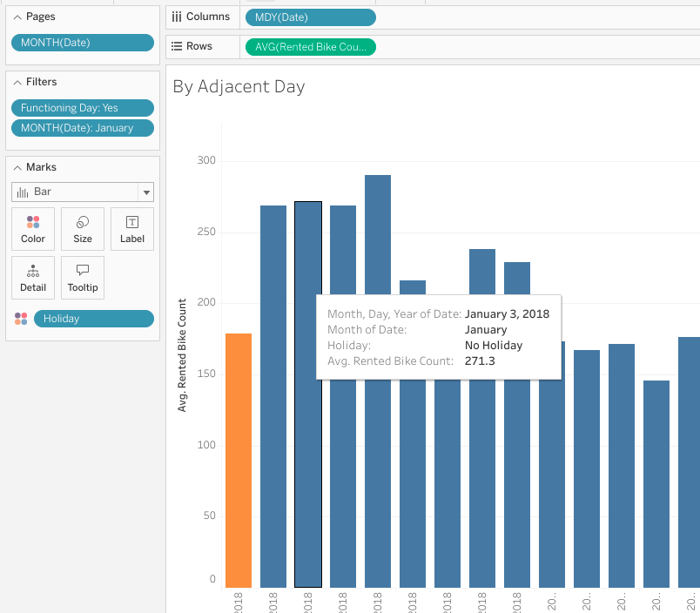

### **Step 7: Create a weekday worksheet**

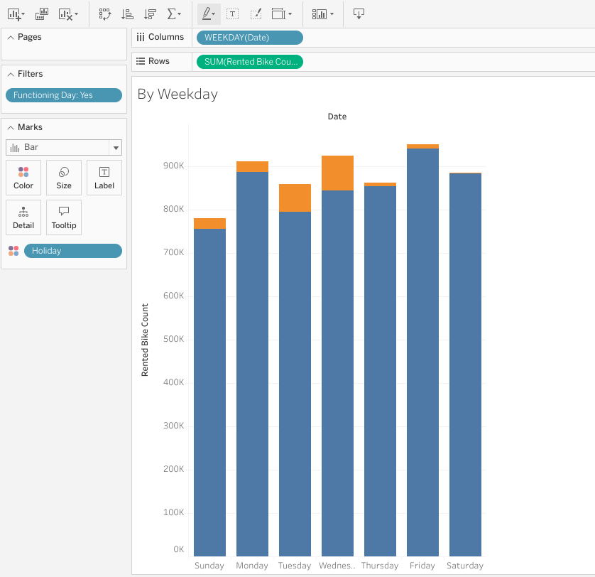

### **Step 8: Update pages and filters for weekday worksheet**

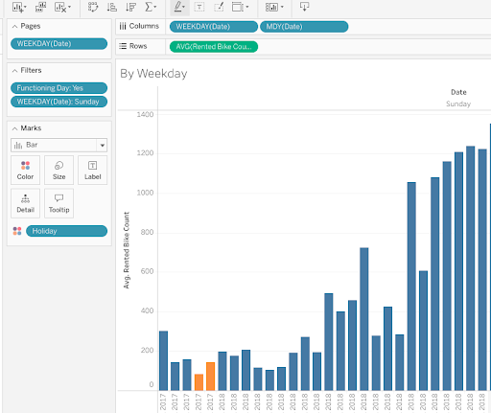

### **Step 9: Create a new dashboard**

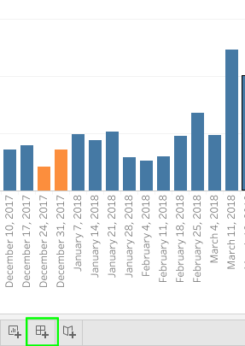

### **Step 10: Drag the worksheets to the dashboard**

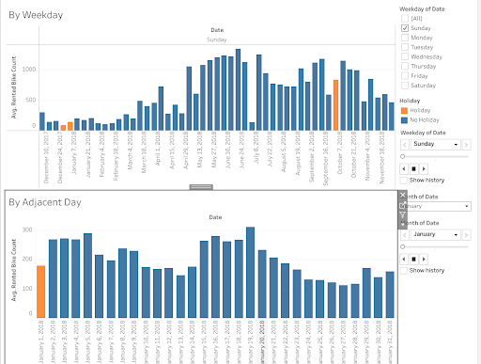

### **Step 11: Add design elements**

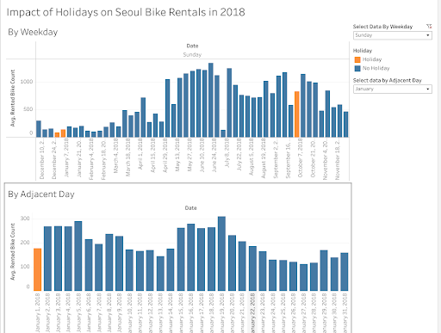

## What to Include in Your Data Visualization



Be sure to address the following elements in your completed activity:

* The data dashboard includes two dynamic worksheets.
* One worksheet divides data into dates and months.
* Another worksheet is divided into dates for each day of the week.
* The dashboard and worksheets are properly labeled.
* Holidays are shown in a clearly contrasting color.
* Filters are added to the dashboard sidebar to filter desired data.

### 1.

Question 1

## Did you complete this activity?

1 / 1 point

Yes

No

Correct

Thank you for completing this activity! Dynamic dashboards in Tableau are valuable for data professionals because they can condense vast amounts of data into easy-to-access pieces. Review the quiz question feedback to find out how you did. Then go to the next course item to compare your work to a completed exemplar.

### 2.

Question 2

The dashboard you built divides the data into two bar graphs. What do each of the bar graphs illustrate? Select two answers.

1 / 1 point

The data divided by dates and months

Correct

The Weekday bar graph is divided into dates for each day of the week, and the Adjacent Day bar graph is divided into dates and months.

 The data by dates for each weekend day

The data divided by dates for each day of the week

Correct

The Weekday bar graph is divided into dates for each day of the week, and the Adjacent Day bar graph is divided into dates and months.

 The data by dates for each holiday

### 3.

Question 3

Which design elements help you showcase relevant information in your dashboard? Select all that apply.

1 / 1 point

Filters

Correct

Creating relevant and useful filters in the sidebar helps eliminate clutter in the dashboard tab. Giving each worksheet a unique title and using contrasting colors can also help identify and highlight relevant information in your dashboard.

Contrasting colors

Correct

Using contrasting colors ensures that all members of the audience can still clearly perceive the difference in the bars’ contrast. Giving each worksheet a unique title and creating useful filters can also help highlight relevant information in your dashboard.

Portrait format

Titles

Correct

Titling each worksheet helps ensure that they are easily discernible in the dashboard. Creating useful filters and using contrasting colors can also help highlight relevant information in your dashboard.

# Test your knowledge: Advanced Tableau

### 1.

Question 1

A histogram is a data visualization that depicts a precise representation of the distribution of values in a dataset.

1 / 1 point

True

False

Correct

A histogram is a data visualization that depicts an approximate representation of the distribution of values in a dataset.

### 2.

Question 2

Which Tableau tool enables users to interact with data visualizations or dashboards by giving them control of a selection?

1 / 1 point

Set

Bin

Blending

Action

Correct

An action is a Tableau tool that enables users to interact with data visualizations or dashboards by giving them control of a selection.

### 3.

Question 3

A data professional wants to visualize data in a time series. Which approach should they take?

1 / 1 point

Specific-to-generic

Chronological

Systemized

Generic-to-specific

Correct

They should take a chronological approach, which is useful for data that is best understood as a time series.

# Module 4 challenge

### 1.

Question 1

Which of the following statements correctly describe dimensions and measures in Tableau? Select all that apply.

1 / 1 point

Dimensions are qualitative data values used to categorize and group data.

Correct

Measures are numeric values that can be aggregated or placed in calculations.

Correct

### 2.

Question 2

Fill in the blank: The term \_\_\_\_\_ is a mathematical concept indicating that a measure or dimension has an infinite and uncountable number of outcomes.

1 / 1 point

continuous

### 3.

Question 3 (NOT FINAL)

In Tableau, what feature enables the creation of data value groupings in a histogram?

Bins

### 4.

Question 4

A data analytics team at a beverage company creates a presentation for stakeholders about juice sales. They first focus on sales in 15 cities. Then, they share broader insights about sales throughout the state. What type of approach to data visualization does this scenario describe?

Specific-to-generic

### 5.

Question 5

A data professional working for an automotive company creates a presentation for stakeholders about vehicle repair efficiency. They first share broad insights about repair performance nationwide. Then, they focus on particular states and counties. What type of approach to data visualization does this scenario describe?

1 / 1 point

Generic-to-specific

### 6.

Question 6

A data professional at a shoe retailer creates a presentation for stakeholders about the best-selling sneakers. They share insights about three popular sneaker brand sales, beginning with January and continuing through year end. What type of approach to data visualization does this scenario describe?

Chronological

### 7.

Question 7

Fill in the blank: A \_\_\_\_\_ in Tableau is a custom field of data created from a larger dataset based on custom conditions.

set

### 8.

Question 8

Fill in the blank: A worksheet in Tableau Public is a data page that contains a \_\_\_\_\_ in a single view.

data visualization

**Module 5:**

**Experiential learning**

Understanding through doing

# Explore your Course 3 workplace scenarios

# **Overview**

This certificate offers you a choice of several different workplace scenarios to use when completing each end-of-course project:

* Automatidata, featuring a fictional data consulting firm
* TikTok, created in partnership with the short-form video hosting company
* Waze, created in partnership with the realtime driving directions app

Each scenario offers you an opportunity to apply your skills and create work samples to share when applying for jobs; so, you will be practicing similar skills regardless of the workplace scenario. It is recommended that you work with the same scenario for each end-of-course project to have a cohesive experience. However, you are welcome to investigate any of the workplace scenarios you are interested in as you progress through the program.

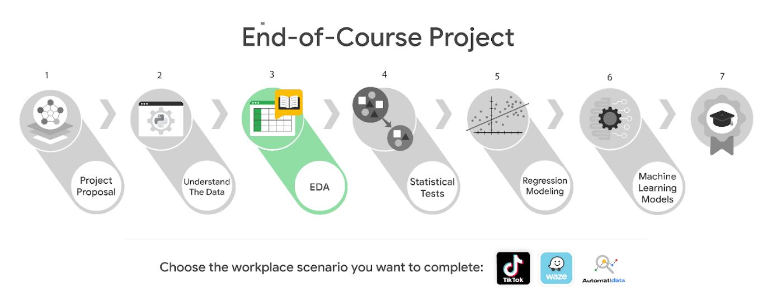

***Reminder:*** We recommend that you choose one workplace scenario to follow for all end-of-course projects to ensure end-to-end project development.

The minimum requirement to earn your Advanced Data Analytics Certificate is to complete the end-of-course project, using one workplace scenario, for each course. You may complete the project for as many of the workplace scenarios as you wish. Completing the project for more than one workplace scenario in a single course offers you additional practice and work examples you can add to your portfolio and share with prospective employers during your job search.

This reading offers an overview of all available workplace scenarios. Before moving on, identify the scenario you would like to complete for the Course 3 end-of-course project.

## **Course 3 workplace scenarios**

## **Automatidata**



**Project goal:**

In this fictional scenario, the New York City Taxi and Limousine Commission (TLC) has approached the data consulting firm Automatidata to develop an app that enables TLC riders to estimate the taxi fares in advance of their ride.

**Background:**

Since 1971, TLC has been regulating and overseeing the licensing of New York City's taxi cabs, for-hire vehicles, commuter vans, and paratransit vehicles.

**Scenario:**

The New York City TLC data is ready for exploratory data analysis (EDA) in Python. You will need to clean, join, validate, and create a visualization for the taxi commission data. The findings will be shared with internal stakeholders from different departments within Automatidata.

**Course 3 tasks:**

* Load data, explore, and extract the New York City TLC data with Python
* Use custom functions to organize the information within the New York City TLC dataset
* Build a dataframe for the New York City TLC project
* Create an executive summary for Automatidata for a general audience of internal professionals

***Note:*** The story, all names, characters, and incidents portrayed in this project are fictitious. No identification with actual persons (living or deceased) is intended or should be inferred. And, the data shared in this project has been created for pedagogical purposes.

## **TikTok**



**Project goal:**

The TikTok data team is developing a machine learning model for classifying claims made in videos submitted to the platform.

**Background:**

TikTok is the leading destination for short-form mobile video. The platform is built to help imaginations thrive. TikTok's mission is to create a place for inclusive, joyful, and authentic content–where people can safely discover, create, and connect.

**Scenario:**

It is now time to begin the process of exploratory data analysis (EDA). As a data analyst on TikTok's data team, you will complete the EDA process for the claims classification project. You’ll also use Tableau to create visuals for an executive summary to help non-technical stakeholders engage and interact with the data.

**Course 3 tasks:**

* Imports of relevant packages and TikTok data into Python
* EDA and cleaning
* Assess Tableau measures and dimensions
* Select and build visualization(s) type
  + Create plots to visualize variables and relationships between variables
* Share your results with the TikTok team

***Note:*** The story, all names, characters, and incidents portrayed in this project are fictitious. No identification with actual persons (living or deceased) is intended or should be inferred. And, the data shared in this project has been created for pedagogical purposes.

## **Waze**



**Project goal:**

Waze leadership has asked your data team to develop a machine learning model to predict user churn. An accurate model will help prevent churn, improve user retention, and grow Waze’s business.

**Background:**

Waze’s free navigation app makes it easier for drivers around the world to get to where they want to go. Waze’s community of map editors, beta testers, translators, partners, and users helps make each drive better and safer.

**Scenario:**

Your team is still in the early stages of their user churn project. So far, you’ve completed a project proposal, and used Python to inspect and organize Waze’s user data. Now, the data is ready for exploratory data analysis (EDA) and further data visualization.

**Course 3 tasks:**

* Clean data
* Handle outliers
* Perform EDA
* Visualize data
* Share an executive summary with the Waze data team

***Note:*** The story, all names, characters, and incidents portrayed in this project are fictitious. No identification with actual persons (living or deceased) is intended or should be inferred. And, the data shared in this project has been created for pedagogical purposes.

## **Key Takeaways**

In Course 3, Go Beyond the Numbers: Translate Data into Insights, you explored the process of exploratory data analysis (EDA). You learned to Identify the core steps, basic methods, and benefits of structuring and cleaning data. Additionally, you investigated raw data using Python, and created data visualizations using Tableau

### **Course 3 skills:**

* Conduct exploratory data analysis
* Create data visualization with Tableau
* Expand knowledge of Python coding
* Share insights and ideas with stakeholders

### **Course 3 end-of-course project deliverables:**

* Complete EDA with workplace scenario dataset using Python
* Executive summary including a Tableau visualization

The end-of-course portfolio projects are designed for you to apply your data analytical skills within a workplace scenario. No matter which scenario you work with, you will practice your ability to discuss data analytic topics with coworkers, internal team members, and external clients.

As a reminder, you are required to complete one project for each course. To gain additional practice, or to add more samples to your portfolio, you may complete as many of the scenarios as you wish.

# Course 3 end-of-course portfolio project overview: Automatidata

## **Learn about the Course 3 Automatidata workplace scenario!**

The end-of-course project in Course 3 focuses on your ability to use exploratory data analysis to organize and understand the data within a project. The end-of-course projects were designed with you in mind, offering an opportunity for you to practice and apply your data analytic skills. The materials provided here will guide you through discussions with co-workers, internal team members, and external stakeholders.

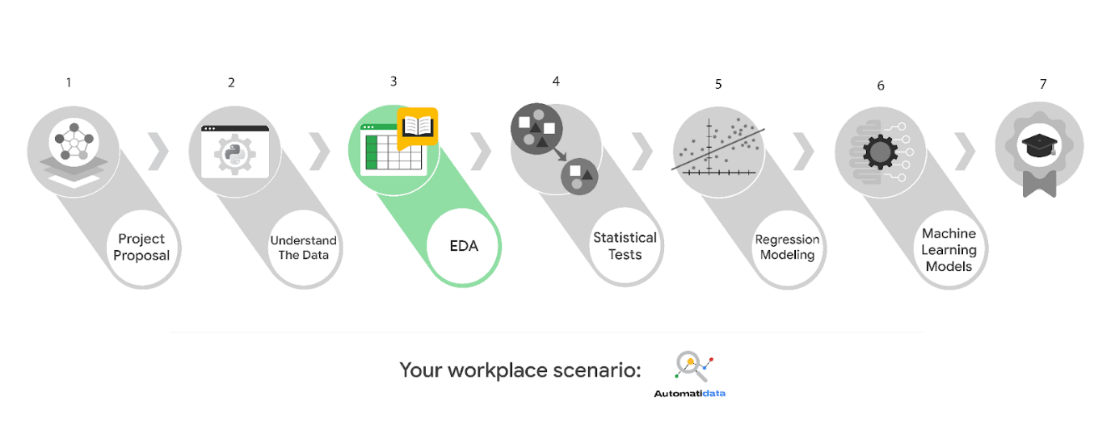

Learn more about the project, your role, and expectations in this reading.

## **Background on the Automatidata scenario**

Automatidata works with its clients to transform their unused and stored data into useful solutions, such as performance dashboards, customer-facing tools, strategic business insights, and more. They specialize in identifying a client’s business needs and utilizing their data to meet those business needs.

Automatidata is consulting for the New York City Taxi and Limousine Commission (TLC). New York City TLC is an agency responsible for licensing and regulating New York City's taxi cabs and for-hire vehicles. The agency has partnered with Automatidata to develop a regression model that helps estimate taxi fares before the ride, based on data that TLC has gathered.

The TLC data comes from over 200,000 taxi and limousine licensees, making approximately one million combined trips per day.

***Note:*** This project's dataset was created for pedagogical purposes and may not be indicative of New York City taxi cab riders' behavior.

### **Project background**

Automatidata is working on the TLC project. The following tasks are needed before the team can begin the data analysis process:

* EDA and cleaning
* Select and build visualization(s) type
  + Create plots to visualize relationships between relevant variables
* Share your results with the Automatidata team

### **Your assignment**

You will conduct exploratory data analysis on data for the TLC project. You’ll also use Tableau to create visuals for an executive summary to help non-technical stakeholders engage and interact with the data.

## **The members of Automatidata and the New York City TLC**

### **Automatidata Team Members**

* Udo Bankole, Director of Data Analysis
* Deshawn Washington, Data Analysis Manager
* Luana Rodriquez, Senior Data Analyst
* Uli King, Senior Project Manager

Your teammates at Automatidata have technical experience with data analysis and data science. However, you should always be sure to keep summaries and messages to these team members concise and to the point.

### **New York City TLC Team Members**

* Juliana Soto, Finance and Administration Department Head
* Titus Nelson, Operations Manager

***Note:*** The story, all names, characters, and incidents portrayed in this project are fictitious. No identification with actual persons (living or deceased) is intended or should be inferred. And, the data shared in this project has been created for pedagogical purposes.

The TLC team members are program managers who oversee operations at the organization. Their roles are not highly technical, so be sure to adjust your language and explanation accordingly.

## **Specific project deliverables**

With this end-of-course project, you will gain valuable practice of your new skills as you complete the following deliverables:

* Course 3 PACE Strategy Document to consider questions, details, and action items for each stage of the project scenario
* Answer the questions in the Jupyter notebook project file
* Create a Jupyter notebook of full EDA
* Create a Tableau visualization showing two important variables
* Write an executive summary of results and include a visualization

Good luck in your role! Automatidata looks forward to seeing how you communicate your creative work and approach problem-solving!

## **Key takeaways**

The end-of-course project is designed for you to practice and apply course skills in a fictional workplace scenario. By completing each course’s end-of-course project, you will have work examples that will enhance your portfolio and showcase your skills for future employers.

# Activity: Create your Course 3 Automatidata project

To pass this practice quiz, you must receive 100%, or 1 out of 1 point, by completing the following activity. You can learn more about the graded and practice items in the [course overview](https://www.coursera.org/learn/go-beyond-the-numbers-translate-data-into-insight/supplement/2wUrM/course-3-overview).



## Activity Overview



In this activity, you will demonstrate your ability to organize, present, and share data stories on Tableau Public. You will also update team members through an executive summary, demonstrating your ability to organize and communicate key information.

For additional information on how to complete this activity, review the previous readings: [End-of-course portfolio project introduction](https://www.coursera.org/learn/foundations-of-data-science/supplement/9Opfe/end-of-course-portfolio-project-introduction)  and[Course 3 end-of-course portfolio project overview: Automatidata](https://www.coursera.org/learn/go-beyond-the-numbers-translate-data-into-insight/supplement/jKAqn/course-3-end-of-course-portfolio-project-overview-automatidata).

Be sure to complete this activity before moving on. The next course item will provide you with completed exemplars to compare to your own work. You will not be able to access the exemplars until you have completed this activity.

## Scenario



Your team is still in the early stages of their project for the New York City Taxi and Limousine Commission (TLC). So far, you’ve completed a project proposal and used Python to inspect and organize the TLC dataset.

You check your inbox and notice a new message from Luana Rodriguez, the Senior Data Analyst at Automatidata. Luana is pleased with the work you have already completed and requests your assistance with some exploratory data analysis (EDA) and data visualization. You also notice a follow-up email from Udo Bankole, the Director of Data Analysis. Udo suggests including an executive summary of your analysis to share with teammates.

***Note:*** Team member names used in this workplace scenario are fictional and are not representative of the New York City TLC.

\_\_\_\_\_\_\_\_\_\_\_\_\_\_\_\_\_\_\_\_\_\_\_\_\_\_\_\_\_\_\_\_\_\_\_\_\_\_\_\_\_\_\_\_\_\_

**Email from Luana Rodriguez, Senior Data Analyst**

**Subject:** New York City TLC EDA & Vizzes

**From:**  “Luana Rodriguez” Luana@automatidata

**Cc:** “Deshawn Washington,” Deshawn@automatidata; “Udo Bankole,” Udo@automatidata

Hi there,

Thanks for the amazing work you’ve done so far.

We’re ready to perform EDA on the taxi data from the New York City TLC to get a general understanding of what taxi ridership looks like. Has Deshawn told you what the management team expects when it comes to EDA? If not, think of it as a “show your work” kind of report. They will want to see a Python notebook showing the structuring and cleaning you did, as well as any matplotlib/seaborn visualizations you plotted to help us understand the data. I would suggest at the very least a box plot of the ride durations and some time series plots, like a breakdown by quarter or month? Whatever you think makes most sense.

Additionally, the management team has recently asked all EDA to include Tableau visualizations. We’ve found these to be particularly helpful in status reports to the client and board members. Make sure it is easy to understand to someone who isn’t data savvy, and remember that the assistant director at the New York City TLC is a person with visual impairments. I understand you have some Tableau experience? Let me know if you need help with this.

By the way, I Cc’d our director, Udo, who is on the management team and will be reviewing/approving our analysis before the project manager reports it back to the client. @Udo, I just want to keep you informed on the progress!

Thanks!

Luana Rodriguez

Senior Data Analyst

Automatidata

**Email from Udo Bankole, Director of Data Analysis**

**Subject:** RE:New York City TLC EDA & Vizzes

**From:**  “Udo Bankole,” Udo@automatidata;

**Cc:** “Deshawn Washington,” Deshawn@automatidata; “Luana Rodriguez” Luana@automatidata

Thank you, Luana!

Welcome to the team, so glad to have you.

Along with the Tableau visualization and notebook, it would be really helpful if you included an executive summary of your analysis attached via email.

I appreciate your help!

Udo Bankole

Director of Data Analysis

Automatidata

## Step-By-Step Instructions



Follow the instructions to complete the activity. Then, go to the next course item to compare your work to a completed exemplar.

### **Step 1: Access the templates**



To use the templates for this course item, click the following links and select Use Template. Link to templates:

* [Course 3 PACE strategy document](https://docs.google.com/document/d/1iSHdbfQR6w8RClJNWai8oJXn9tQmYoTKn6QohuaK4-s/template/preview?resourcekey=0-ZIHnbxL1dd2u9A47iEVXvg)
* [Executive summary templates](https://docs.google.com/presentation/d/1Pps5GKxi1V31y2oRHRzU-xhJubkEYzCgEIfNjlEY3Og/template/preview)

OR

If you don’t have a Google account, you can download the templates directly from the following attachments.

[Activity Template\_ Course 3 PACE strategy document](https://d3c33hcgiwev3.cloudfront.net/8qJoHnALT_G8lLz-ALWRbg_9b9e52f9364b47f4ba65586618486bf1_Activity-Template_-Course-3-PACE-strategy-document.docx?Expires=1721606400&Signature=jDZ6y623h~Lc1zl~0YnI4eX5mK0ynn9cQ9KFqzwfg9y93TSzPiJBPq7PdFiy1tHHaKoeeJFBGDsdcjdL5KBEv1OKVXOQwzBTGCiGWkqAZDR7jsbb8nUhXgzqaTkHoKhDqPbNdN-ce2BELGVYp476ETf5~j5IB~Fx0~VJSC6oUfk_&Key-Pair-Id=APKAJLTNE6QMUY6HBC5A" \t "_blank)

[DOCX File](https://d3c33hcgiwev3.cloudfront.net/8qJoHnALT_G8lLz-ALWRbg_9b9e52f9364b47f4ba65586618486bf1_Activity-Template_-Course-3-PACE-strategy-document.docx?Expires=1721606400&Signature=jDZ6y623h~Lc1zl~0YnI4eX5mK0ynn9cQ9KFqzwfg9y93TSzPiJBPq7PdFiy1tHHaKoeeJFBGDsdcjdL5KBEv1OKVXOQwzBTGCiGWkqAZDR7jsbb8nUhXgzqaTkHoKhDqPbNdN-ce2BELGVYp476ETf5~j5IB~Fx0~VJSC6oUfk_&Key-Pair-Id=APKAJLTNE6QMUY6HBC5A" \t "_blank)

[Activity Templates\_ Executive summaries](https://d3c33hcgiwev3.cloudfront.net/qJ2nrFXnRRSLOWmk3hfPIg_26e2cc7aff364c1bbdf105f537cf6bf1_Activity-Templates_-Executive-summaries-.pptx?Expires=1721606400&Signature=jRke-KteXd8ckX4pnrmKM2y~WnUoHxdZO4Ebh3UFNbJer~LhAIzVKGkIwPyDzNHFh2HQSRhgpLBkxqGFtos0enuGy07pHFgnabxV6OYycQ2~XR3o8gfFDI73WPz8gAfOUTA~suzT6QhdDnPwdaX63pLZIlRRhd9X76wSupkyngs_&Key-Pair-Id=APKAJLTNE6QMUY6HBC5A" \t "_blank)

[PPTX File](https://d3c33hcgiwev3.cloudfront.net/qJ2nrFXnRRSLOWmk3hfPIg_26e2cc7aff364c1bbdf105f537cf6bf1_Activity-Templates_-Executive-summaries-.pptx?Expires=1721606400&Signature=jRke-KteXd8ckX4pnrmKM2y~WnUoHxdZO4Ebh3UFNbJer~LhAIzVKGkIwPyDzNHFh2HQSRhgpLBkxqGFtos0enuGy07pHFgnabxV6OYycQ2~XR3o8gfFDI73WPz8gAfOUTA~suzT6QhdDnPwdaX63pLZIlRRhd9X76wSupkyngs_&Key-Pair-Id=APKAJLTNE6QMUY6HBC5A" \t "_blank)

### **Step 2: Access the end-of-course project lab**

***Note***: The following lab is also the next course item. Once you complete and submit your end-of-course project activity, return to the lab instructions’ page and click ***Next*** to continue on to the exemplar reading.

To access the end-of-course project lab, click the following link and select Open Lab.

* [Course 3 Automatidata project lab](https://www.coursera.org/learn/go-beyond-the-numbers-translate-data-into-insight/item/orqne)

Your Python notebook for this project includes a guided framework that will assist you with the required coding. Input the code and answer the questions in your Python notebook to perform EDA and create data visualizations. Here are some helpful reminders for tasks:

* Import unstructured data
* Review and structure data
* Filter out unneeded data
* Clean the data

You will also discover questions in this Python notebook designed to help you gather the relevant information you’ll need to write an executive summary for your team.

Use your completed PACE strategy document and Python notebook to help you prepare your executive summary in the next step.

### **Data Dictionary**



This project uses a dataset called [2017\_Yellow\_Taxi\_Trip\_Data.csv](https://drive.google.com/file/d/1dukkevz_dONJf1aqojEy_4Q6pFZ8kK5_/view?usp=sharing). It contains data gathered by the New York City Taxi & Limousine Commission. For each trip, there are many different data variables gathered.

The dataset contains:

**408,294 rows** – each row represents a different trip

**18 columns**

| **Column name** | **Description** |
| --- | --- |
| ID | Trip identification number |
| VendorID | A code indicating the TPEP provider that provided the record.  **1= Creative Mobile Technologies, LLC;**  **2= VeriFone Inc.** |
| tpep\_pickup\_datetime | The date and time when the meter was engaged. |
| tpep\_dropoff\_datetime | The date and time when the meter was disengaged. |
| Passenger\_count | The number of passengers in the vehicle.  This is a driver-entered value. |
| Trip\_distance | The elapsed trip distance in miles reported by the taximeter. |
| PULocationID | TLC Taxi Zone in which the taximeter was engaged |
| DOLocationID | TLC Taxi Zone in which the taximeter was disengaged |
| RateCodeID | The final rate code in effect at the end of the trip.  **1= Standard rate**  **2=JFK**  **3=Newark**  **4=Nassau or Westchester**  **5=Negotiated fare**  **6=Group ride** |
| Store\_and\_fwd\_flag | This flag indicates whether the trip record was held in vehicle memory before being sent to the vendor, aka “store and forward,”  because the vehicle did not have a connection to the server.  **Y= store and forward trip**  **N= not a store and forward trip** |
| Payment\_type | A numeric code signifying how the passenger paid for the trip.  **1= Credit card**  **2= Cash**  **3= No charge**  **4= Dispute**  **5= Unknown**  **6= Voided trip** |
| Fare\_amount | The time-and-distance fare calculated by the meter. |
| Extra | Miscellaneous extras and surcharges. Currently, this only includes the $0.50 and $1 rush hour and overnight charges. |
| MTA\_tax | $0.50 MTA tax that is automatically triggered based on the metered rate in use. |
| Improvement\_surcharge | $0.30 improvement surcharge assessed trips at the flag drop. The  improvement surcharge began being levied in 2015. |
| Tip\_amount | Tip amount – This field is automatically populated for credit card tips. Cash tips are not included. |
| Tolls\_amount | Total amount of all tolls paid in trip. |
| Total\_amount | The total amount charged to passengers. Does not include cash tips. |

### **Step 3: Complete your PACE strategy document**



The **Course 3 PACE strategy document** includes questions that will help guide you through the Course 3 Automatidata project. Answer the questions in your PACE strategy document to prepare for using Python for EDA and both Python and Tableau for data visualization.

As a reminder, the PACE strategy document is designed to help you complete the contents for each of the templates provided. You may navigate back and forth between the PACE strategy document and the Python notebook. Make sure your PACE strategy document is complete before preparing your executive summary.

### **Step 4: Open Tableau Public and visualize your data**



While using [Tableau Public](https://public.tableau.com/app/discover), you will need to create the following deliverable for stakeholders:

* Data visualization in the form of a scatter plot

If you need additional help, review the [Course 3 Tableau follow-along guide: Automatidata project](https://docs.google.com/document/d/1pcfUlttD2Y_a9A4VrKPzikZWCAfFLsBAhuKuomjcUjA/template/preview)

OR

If you don’t have a Google account, you can download the guide directly from the following attachment:

[Course 3 Tableau follow-along guide\_ Automatidata project](https://d3c33hcgiwev3.cloudfront.net/6xG1EKCQSMW5LXXwx0z4gg_00c10c01284d4475a14264ed876192f1_Course-3-Tableau-follow-along-guide_-Automatidata-project.docx?Expires=1721606400&Signature=T-D3lziQivNuJAHWsBJaSblKyfJPBY58MY1hY4gZfBt5SqpQKgqJPJoM3tnkxYV8HYnE8ubNAUjWl6JwIMWPNwG14FHqPKsjnP5C4vNhujZIukBobBwWPFWDBs6VaXmMvDMu0pT3McrJ1L9fFbDV~HtFs~vfzXM~BYvWl1xzE7g_&Key-Pair-Id=APKAJLTNE6QMUY6HBC5A" \t "_blank)

[DOCX File](https://d3c33hcgiwev3.cloudfront.net/6xG1EKCQSMW5LXXwx0z4gg_00c10c01284d4475a14264ed876192f1_Course-3-Tableau-follow-along-guide_-Automatidata-project.docx?Expires=1721606400&Signature=T-D3lziQivNuJAHWsBJaSblKyfJPBY58MY1hY4gZfBt5SqpQKgqJPJoM3tnkxYV8HYnE8ubNAUjWl6JwIMWPNwG14FHqPKsjnP5C4vNhujZIukBobBwWPFWDBs6VaXmMvDMu0pT3McrJ1L9fFbDV~HtFs~vfzXM~BYvWl1xzE7g_&Key-Pair-Id=APKAJLTNE6QMUY6HBC5A" \t "_blank)

Use Tableau Public to create a scatterplot for your executive summary.

### **Step 5: Prepare an executive summary**

Your executive summary will keep your teammates at Automatidata informed of your progress. The one-page format is designed to respect teammates and stakeholders who might not have time to read and understand an entire report.

First, select one of the executive summary design layouts from the provided template. Then, add the relevant information. Your executive summary should include the following:

* A summary of the results of your exploratory data analysis (EDA)
* A proposed solution for dealing with outliers in your data

Complete your executive summary to effectively communicate your results to your teammates.

## Pro Tip: Save the templates

Finally, be sure to save a blank copy of the templates you used to complete this activity. You can use them for further practice or in your professional projects. These templates will help you work through your thought processes and demonstrate your experience to potential employers.

## What to Include in Your Response



Later, you will have the opportunity to self assess your performance using the following criteria. Be sure to address the following elements in your completed activity:

**Course 3 PACE strategy document**:

* Answer the questions in the PACE strategy document

**Course 3 Automatidata project lab**:

* Perform exploratory data analysis (EDA)
* Create data visualizations

**Course 3 Tableau visualization:**

* Create a scatterplot to enhance the visualization created with Python

**Course 3 executive summary**:

* Provide a summary of the results of your exploratory data analysis (EDA)
* Propose a solution for dealing with outliers in your data

### 1.

Question 1

## Did you complete this activity?

1 point

Yes

**Review**

* Understood how data can be useful for enacting change in a business
* Completed a Jupiter notebook
* Refined your presentation to meet the needs of your particular audience

**Transferrable skills**

* Following the PACE structure
* Using Python to manipulate data
* Organize and analyze a set of data

**Questions you might get in interviews**

* What is your process for cleaning data?
* What tools do you use for creating data visualizations?
* How and why do data visualizations enhance the stories data tells?
* What considerations are top of mind when sharing data stories with non-technical stakeholders?

# Assess your Course 3 end-of-course project

This is the rubric for the Course 3 end-of-course project. The rubric was designed to be applicable to all of the project scenarios. You will use this rubric to review and grade your own work. The rubric grading process is an important part of the learning experience because it allows you to objectively assess your end-of-course project against a set of criteria.

There are a total of 9 points for the end-of-course project and 9 items in this rubric. Each rubric item is worth 1 point. The items are grouped by topic and correspond to each step you completed for the Course 3 end-of-course project.

To use the rubric, first open your workplace scenario notebook, executive summary, and PACE strategy document. Next, review each rubric item’s grading criteria. Then respond to each statement by marking “yes” or “no.”

When you complete and submit the rubric, you will receive a percentage score. This score will help you confirm whether you completed the required steps of the end-of-course project; the recommended passing grade for this project is 80% (or 8/9 points). If you want to increase your score, you can revise your project and then resubmit this rubric to reflect any changes you make. Try to achieve at least 8 points on this rubric before continuing on to the next course.

## Imports

The following rubric items assess the imports for your end-of-course project.

### 1.

Question 1

Applicable packages and libraries were imported to the code notebook.

1 / 1 point

Yes

No

Correct

## Data Analysis

The following rubric items assess the data analysis work you completed for your end-of-course project.

### 2.

Question 2

Functions such as head(), describe(), and info() were used to analyze the data.

1 / 1 point

Yes

No

Correct

## **Visualizations**

The following rubric items assess the visualizations you created for your end-of-course project.

### 3.

Question 3

Histogram(s) were generated to examine key variables.

1 / 1 point

Yes

No

Correct

### 4.

Question 4

Box plot(s) were generated to examine key variables.

1 / 1 point

Yes

No

Correct

### 5.

Question 5

Scatter plot(s) were generated to examine key variables.

1 / 1 point

Yes

No

Correct

### 6.

Question 6

Bar or pie chart(s) were generated to examine key variables.

1 / 1 point

Yes

No

Correct

## **Results and/or Evaluation**

The following rubric items assess the concluding steps of your end-of-course project, including evaluation and summary of findings.

### 7.

Question 7

All questions in the code notebook were answered.

1 / 1 point

Yes

No

Correct

### 8.

Question 8

All questions in the PACE strategy document were answered.

1 / 1 point

Yes

No

Correct

### 9.

Question 9

The executive summary included a summary of the results of your exploratory data analysis (EDA).

1 / 1 point

Yes

No

Correct

(ANSWER IS ALL YES)

Reflect on your Course 3 project In this third end-of-course project, you began to expand your role as a data analyst. Within each of the available scenarios, you were given the opportunity to use Python to perform exploratory data analysis on a project dataset and construct data visualizations with Tableau. For this discussion prompt, consider the following: How did the tools available for the Python programming language assist you in accomplishing your tasks in this project? In what ways has Python and its tools helped you to gain a deeper understanding of the process of exploratory data analysis? What is an interesting aspect of Python, its available tools, and/or Tableau that you learned about during your time in this course that you were not previously aware of? Submit 3–4 sentences (80–100 words) responding to these questions. Then, visit the discussion forums to read what other learners have written, engage with two or more posts, and share your feedback.

The tools available in Python, such as pandas and matplotlib, were instrumental in performing data cleaning, manipulation, and visualization efficiently. Python's rich ecosystem allowed me to automate repetitive tasks and focus more on deriving insights from the data. Through using Python and its libraries, I gained a deeper understanding of exploratory data analysis by learning how to identify patterns and anomalies effectively. One interesting aspect I discovered is how seamlessly Python integrates with Tableau, enhancing the ability to create dynamic and interactive visualizations that can convey complex data stories more intuitively.

# Course 3 glossary

To use the template for this course item, click the link below and select “Use Template.”

Link to glossary: [Course 3 glossary](https://docs.google.com/document/d/1MhQYzO5O21UXAoo8XlVhImkUVKRjD_QbYzCGulQU5TA/template/preview)

OR

If you don’t have a Google account, you can download the template directly from the attachment below.

**Review**

* How data professionals take care of missing data and outliers
* How to change categorical data into numerical data using the label encoding technique
* How to design visualizations and present your data in impactful ways
* Advanced concepts of visualizing
* Started using Tableau

**Review (Workspace skills)**

* Communicating to different audiences
* Importance of ethics
* The need for accessibility
* The importance of following the PACE workflow

# Your Course 3 learning journey

In this part of the program, you examined how the elements of storytelling enrich the understanding of data and help those with whom we share our data with. You also practiced performing exploratory data analysis, finding trends, and developing insights to prepare data visualizations.

Coming up, you’ll be introduced to statistics as the foundation of data science.

For this discussion prompt, consider the following:

* How have your views on storytelling in data analysis changed since the start of this course?
* How has your understanding of exploratory data analysis expanded?
* What’s an interesting element of exploratory data analysis you discovered that you didn’t already know about?

Submit 3–4 sentences (80–100 words) responding to these questions. Then, visit the [discussion forum](https://www.coursera.org/learn/go-beyond-the-numbers-translate-data-into-insight/discussions) to read what other learners have written, engage with two or more posts, and share your feedback.

Participation is optional

Since the start of the course, my views on storytelling in data analysis have significantly evolved. I've come to appreciate how a compelling narrative can transform raw data into actionable insights, making it more accessible and engaging for diverse audiences. My understanding of exploratory data analysis (EDA) has deepened, highlighting its crucial role in uncovering patterns and trends before formal modeling. An intriguing element I discovered is the power of visualizations in EDA, which can reveal hidden relationships and anomalies that might be overlooked in purely numerical analysis.

# Course 3 end-of-course portfolio project overview: TikTok

# **Learn about the Course 3 TikTok workplace scenario!**

The end-of-course project in Course 3 focuses on your ability to use exploratory data analysis to organize and understand the data within a project. As a reminder, in Course 1 you developed a project proposal that outlined milestones, which progress with each of the end-of-course projects. A visual representation is provided in the graphic shown here:

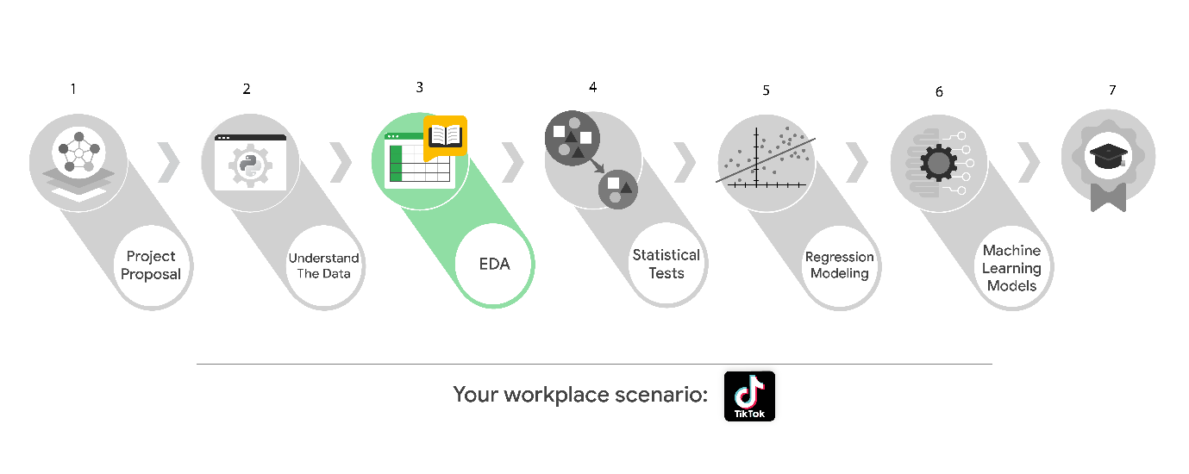

Learn more about the project, your role, and expectations in this reading.

## **Background on the TikTok scenario**

At TikTok, our mission is to inspire creativity and bring joy. Our employees lead with curiosity and move at the speed of culture. Combined with our company's flat structure, you'll be given dynamic opportunities to make a real impact on a rapidly expanding company and grow your career.

TikTok users have the ability to submit reports that identify videos and comments that contain user claims. These reports identify content that needs to be reviewed by moderators. The process generates a large number of user reports that are challenging to consider in a timely manner.

TikTok is working on the development of a predictive model that can determine whether a video contains a claim or offers an opinion. With a successful prediction model, TikTok can reduce the backlog of user reports and prioritize them more efficiently.

### **Project background**

TikTok’s data team is working on the claims classification project. The following tasks are needed before the team can begin the data analysis process:

* EDA and cleaning
* Select and build visualization(s) type
  + Create plots to visualize variables and relationships between variables
* Share your results with the TikTok team

### **Your assignment**

You will conduct exploratory data analysis on data for the claims classification project. You’ll also use Tableau to create visuals for an executive summary to help non-technical stakeholders engage and interact with the data.

## **Team members at TikTok**

### **Data team roles**

* Willow Jaffey- Data Science Lead
* Rosie Mae Bradshaw- Data Science Manager
* Orion Rainier- Data Scientist

The members of the data team at TikTok are well versed in data analysis and data science. Messages to these more technical coworkers should be concise and specific.

### **Cross-functional team members**

* Mary Joanna Rodgers- Project Management Officer
* Margery Adebowale- Finance Lead, Americas
* Maika Abadi- Operations Lead

Your TikTok team includes several managers, who oversee operations. It is important to adjust your general correspondence appropriately to their roles, given that their responsibilities are less technical in nature.

***Note:*** The story, all names, characters, and incidents portrayed in this project are fictitious. No identification with actual persons (living or deceased) is intended or should be inferred. And, the data shared in this project has been created for pedagogical purposes.

## **Specific project deliverables**

With this end-of-course project, you will gain valuable practice and apply your new skills as you complete the following:

* Course 3 PACE Strategy Document to consider questions, details, and action items for each stage of the project scenario
* Answer the questions in the Jupyter notebook project file
* Clean your data, perform exploratory data analysis (EDA)
* Create data visualizations
* Create an executive summary to share your results

## **Key takeaways**

The Google Advanced Data Analytics Certificate end-of-course project is designed for you to practice and apply course skills in a fictional workplace scenario. By completing each course’s end-of-course project, you will have work examples that will enhance your portfolio and showcase your skills for future employers.

Mark as completed

Like

Dislike

Report an issue

# Activity: Create your Course 3 TikTok project

Review Learning Objectives

To pass this practice quiz, you must receive 100%, or 1 out of 1 point, by completing the activity below. You can learn more about the graded and practice items in the [course overview](https://www.coursera.org/learn/go-beyond-the-numbers-translate-data-into-insight/supplement/2wUrM/course-3-overview).



## Activity Overview



In this activity, you will demonstrate your ability to organize, present, and share the stories within data. You will also update team members through an executive summary, demonstrating your ability to organize and communicate key information.

For additional information on how to complete this activity, review the previous readings: [End-of-course project introduction](https://www.coursera.org/learn/foundations-of-data-science/supplement/9Opfe/end-of-course-portfolio-project-introduction)  and [Course 3 end-of-course portfolio project overview: TikTok](https://www.coursera.org/learn/go-beyond-the-numbers-translate-data-into-insight/supplement/yVWEJ/course-3-end-of-course-portfolio-project-overview-tiktok).

Be sure to complete this activity before moving on. The next course item will provide you with completed exemplars to compare to your own work. You will not be able to access the exemplars until you have completed this activity.

## Scenario



Your team is still in the early stages of their latest project. So far, you’ve completed a project proposal and used Python to inspect and organize the TikTok dataset.

You check your inbox and notice a new message from Orion Rainier, a Data Scientist at TikTok. Orion is pleased with the work you have already completed and is requesting your assistance with some Exploratory Data Analysis (EDA) and data visualization. You also notice a follow-up email from the Data Science Lead, Willow Jaffey. Willow suggests including an executive summary of your analysis to share with teammates.

***Note:*** Team member names used in this workplace scenario project are fictional and are not representative of TikTok.

\_\_\_\_\_\_\_\_\_\_\_\_\_\_\_\_\_\_\_\_\_\_\_\_\_\_\_\_\_\_\_\_\_\_\_\_\_\_\_\_\_\_\_\_\_\_

**Email from Orion Rainier, Data Scientist**

**Subject:** Tik TokClaims ClassificationEDA & Vizzes

**From:**  “Rainier, Orion”—orionrainier@tiktok

**Cc:** “Bradshaw, Rosie Mae” —rosiemaebradshaw@tiktok; “Jaffey, Willow” —willowjaffey@tiktok

Hi there,

Thanks for the amazing work you’ve done so far.

We’re ready to perform EDA on the data. Has Rosie Mae told you what the management team expects when it comes to EDA? If not, think of it as a “show your work” kind of report. They will want to see a Python notebook showing the structuring and cleaning you did, as well as any matplotlib/seaborn visualizations you plotted to help us understand the data. I would suggest at the very least a graph comparing claim counts to opinion counts, as well as boxplots of the most important variables (like “video duration,” “video like count,” “video comment count,” and “video view count”) to check for outliers. Also a breakdown of “author ban status” counts. But whatever you think makes most sense works for us.

Additionally, the management team has recently asked all EDA to include Tableau visualizations. We’ve found these to be particularly helpful in status reports to the client and board members. For this data, I suggest a Tableau dashboard showing a simple claims versus opinions count, as well as stacked bar charts of claims versus opinions for variables like video view counts, video like counts, video share counts, and video download counts. Make sure it is easy to understand to someone who isn’t data savvy, and remember that the assistant director is a person with visual impairments. I understand you have some Tableau experience? Let me know if you need help with this.

By the way, I CC’d our Data Science Lead, Willow Jaffey, who is on the senior management team and will be reviewing and approving our analysis before the project manager reports it back to the client. @Willow, I just want to keep you informed on the progress!

Thanks!

Orion Rainier

Data Scientist

TikTok

–

“Big data isn’t about bits, it’s about talent.” — Douglas Merrill

**Email from Willow Jaffey, Data Science Lead**

**Subject:** RE:Tik TokClaims ClassificationEDA & Vizzes

**From:**  “Jaffey, Willow” —willowjaffey@tiktok

**Cc:** “Bradshaw, Rosie Mae” —rosiemaebradshaw@tiktok; “Rainier, Orion”—orionrainier@tiktok

Thank you, Orion!

Welcome to the team, so glad to have you.

Along with the Tableau dashboard and notebook, it would be really helpful if you included an executive summary of your analysis attached via email.

Appreciate your help!

Willow Jaffey

Data Science Lead

TikTok

## Step-By-Step Instructions



Follow the instructions to complete the activity. Then, go to the next course item to compare your work to a completed exemplar.

## Step 1: Access the templates



To use the templates for this course item, click each link below and select Use Template.

Link to templates:

* [Course 3 PACE strategy document](https://docs.google.com/document/d/1iSHdbfQR6w8RClJNWai8oJXn9tQmYoTKn6QohuaK4-s/template/preview?resourcekey=0-ZIHnbxL1dd2u9A47iEVXvg)
* [Executive summary templates](https://docs.google.com/presentation/d/1Pps5GKxi1V31y2oRHRzU-xhJubkEYzCgEIfNjlEY3Og/template/preview)

OR

If you do not have a Google account, you can download the templates directly from the attachments below:

[Activity Template\_ Course 3 PACE strategy document](https://d3c33hcgiwev3.cloudfront.net/I3R_rX7hRh6WYhDcpAUoLg_cfd23d447c224f4eb9b6adcdec354df1_Activity-Template_-Course-3-PACE-strategy-document.docx?Expires=1721692800&Signature=L-BRLVO8ppRV9EMKNveVo51oIhnuyqAMvQ1wCt~sLSgfF0z3qeLUkyeCcVS-WRJR1kCNNbYbd5kO-H2RMEznWb--2iUnYsy72rI8XkaAcPtr7-QebAONMjuOeQqGC2pRpNnd64J~0JnTyJrUe4ba1re0jgv5vYIU3zcu71cSiyA_&Key-Pair-Id=APKAJLTNE6QMUY6HBC5A" \t "_blank)

[DOCX File](https://d3c33hcgiwev3.cloudfront.net/I3R_rX7hRh6WYhDcpAUoLg_cfd23d447c224f4eb9b6adcdec354df1_Activity-Template_-Course-3-PACE-strategy-document.docx?Expires=1721692800&Signature=L-BRLVO8ppRV9EMKNveVo51oIhnuyqAMvQ1wCt~sLSgfF0z3qeLUkyeCcVS-WRJR1kCNNbYbd5kO-H2RMEznWb--2iUnYsy72rI8XkaAcPtr7-QebAONMjuOeQqGC2pRpNnd64J~0JnTyJrUe4ba1re0jgv5vYIU3zcu71cSiyA_&Key-Pair-Id=APKAJLTNE6QMUY6HBC5A" \t "_blank)

[Activity Templates\_ Executive summaries](https://d3c33hcgiwev3.cloudfront.net/xp13YI6fTsCMDOvov8Aiow_760eadf48edb4ad7b4ff97c87e7de8f1_Activity-Templates_-Executive-summaries.pptx?Expires=1721692800&Signature=lNPl5cp63x2yKcBIJ0v9rW6DjjQoduOMmgTYs2AYl9Fr4VHvyx2~UMD3mXYC9tBgppQ1FWeEsJ-2YkNK29qK7gxyV6ViVSOE90BUE5qW803~LoFdmIEo2eUp8rfrTkts01uvqJ9D27xqfwMzrn49E3SahnTh8WVmE8l~LeOtvlM_&Key-Pair-Id=APKAJLTNE6QMUY6HBC5A" \t "_blank)

[PPTX File](https://d3c33hcgiwev3.cloudfront.net/xp13YI6fTsCMDOvov8Aiow_760eadf48edb4ad7b4ff97c87e7de8f1_Activity-Templates_-Executive-summaries.pptx?Expires=1721692800&Signature=lNPl5cp63x2yKcBIJ0v9rW6DjjQoduOMmgTYs2AYl9Fr4VHvyx2~UMD3mXYC9tBgppQ1FWeEsJ-2YkNK29qK7gxyV6ViVSOE90BUE5qW803~LoFdmIEo2eUp8rfrTkts01uvqJ9D27xqfwMzrn49E3SahnTh8WVmE8l~LeOtvlM_&Key-Pair-Id=APKAJLTNE6QMUY6HBC5A" \t "_blank)

### **Step 2: Access the end-of-course project lab**



***Note***: The following lab is also the next course item. Once you complete and submit your end-of-course project activity, return to the lab instructions’ page and click ***Next*** to continue on to the exemplar reading.

To access the end-of-course project lab, click the following link and select Open Lab.

* [Course 3 TikTok project lab](https://www.coursera.org/learn/go-beyond-the-numbers-translate-data-into-insight/ungradedLab/aGQym/activity-course-3-tiktok-project-lab)

Your Python notebook for this project includes a guided framework that will assist you with the required coding. Input the code and answer the questions in your Python notebook to perform EDA and create data visualizations. You’ll find helpful reminders for tasks like:

* Importing data
* Reviewing and structuring data as needed for analysis
* Analyzing data for outliers
* Visualizing data

You will also discover questions in this Python notebook designed to help you gather the relevant information you’ll need to write an executive summary for your team.

Use your completed PACE strategy document and Python notebook to help you prepare your executive summary in the upcoming step.

### **Data Dictionary**



This project uses a dataset called tiktok\_dataset.csv. It contains synthetic data created for this project in partnership with TikTok. Examine each data variable gathered.

**19,383 rows** – Each row represents a different published TikTok video in which a claim/opinion has been made.

**12 columns**

| **Column name** | **Type** | **Description** |
| --- | --- | --- |
| # | int | TikTok assigned number for video with claim/opinion. |
| claim\_status | obj | Whether the published video has been identified as an “opinion” or a “claim.” In this dataset, an “opinion” refers to an individual’s or group’s personal belief or thought. A “claim” refers to information that is either unsourced or from a unverified source. |
| video\_id | int | Random identifying number assigned to video upon publication on TikTok. |
| video\_duration\_sec | int | How long the published video is measured in seconds. |
| video\_transcription\_text | obj | Transcribed text of the words spoken in the published video. |
| verified\_status | obj | Indicates the status of the TikTok user who published the video in terms of their verification, either “verified” or “not verified.” |
| author\_ban\_status | obj | Indicates the status of the TikTok user who published the video in terms of their permissions: “active,” “under scrutiny,” or “banned.” |
| video\_view\_count | float | The total number of times the published video has been viewed. |
| video\_like\_count | float | The total number of times the published video has been liked by other users. |
| video\_share\_count | float | The total number of times the published video has been shared by other users. |
| video\_download\_count | float | The total number of times the published video has been downloaded by other users. |
| video\_comment\_count | float | The total number of comments on the published video. |

### **Step 3: Complete your PACE strategy document**



The **Course 3 PACE strategy document** includes questions that will help guide you through the Course 3 TikTok workplace scenario project. Answer the questions in your PACE strategy document to prepare for using Python for EDA and both Python and Tableau for data visualization.

As a reminder, the PACE strategy document is designed to help you complete the contents for each of the templates provided. You may navigate back and forth between the PACE strategy document and the Python notebook. Make sure your PACE strategy document is complete before preparing your executive summary.

### **Step 4: Open Tableau Public and visualize your data**



While using [Tableau Public](https://public.tableau.com/app/discover), you will need to create the following deliverable for stakeholders:

* Data visualization in the form of a scatter plot

If you need additional help, review the [Course 3 Completed Tableau follow-along guide](https://docs.google.com/document/d/1p-d4-9QrcJZWky2tF9CK68X-22RIbXM-Fu76wxD3HHI/template/preview?resourcekey=0-L7ntrywzdZC0kbx7F59UTg).

[Follow-along guide\_ TikTok Project](https://d3c33hcgiwev3.cloudfront.net/Y_S23gZXSByKCw0l55Nm5A_c519a78093a645bcb332e41fecb77df1_Follow-along-guide_-TikTok-Project.docx?Expires=1721692800&Signature=IvP3Oj0nVprT~XA4ViAwyKl4jAn3GE8VG7wKUFka7bXp3DXYi0bxi9sJ9MbQCk-Pw5aak1oPRWgZzGCs~rOCnaOO0BhjtG~~lCjuNCpXpPddQAyaH-y~eCGeSmLVZ4vigCixtRymOj3KQ-Bs5PsWemJokqgnh7dZRP1LHw-yAhY_&Key-Pair-Id=APKAJLTNE6QMUY6HBC5A" \t "_blank)

[DOCX File](https://d3c33hcgiwev3.cloudfront.net/Y_S23gZXSByKCw0l55Nm5A_c519a78093a645bcb332e41fecb77df1_Follow-along-guide_-TikTok-Project.docx?Expires=1721692800&Signature=IvP3Oj0nVprT~XA4ViAwyKl4jAn3GE8VG7wKUFka7bXp3DXYi0bxi9sJ9MbQCk-Pw5aak1oPRWgZzGCs~rOCnaOO0BhjtG~~lCjuNCpXpPddQAyaH-y~eCGeSmLVZ4vigCixtRymOj3KQ-Bs5PsWemJokqgnh7dZRP1LHw-yAhY_&Key-Pair-Id=APKAJLTNE6QMUY6HBC5A" \t "_blank)

### **Step 5: Prepare an executive summary**



Your executive summary will keep your teammates at TikTok informed of your progress. The one-page format is designed to respect teammates and stakeholders who may not have time to read and understand an entire report.

First, select one of the executive summary design layouts from the provided template. Then, add the relevant information. Your executive summary should include the following:

* A summary of the results of your Exploratory Data Analysis (EDA)
* A proposed solution for dealing with outliers in your data

Complete your executive summary to effectively communicate your results to your teammates.

## Pro Tip: Save the templates

Finally, be sure to save a blank copy of the templates you used to complete this activity. You can use them for further practice or in your professional projects. These templates will help you work through your thought processes and demonstrate your experience to potential employers.

## What to Include in Your Response



Later, you will have the opportunity to self assess your performance using the criteria listed below. Be sure to address the following elements in your completed activity.

**Course 3 PACE strategy document**:

* Answer the questions in the PACE strategy document

**Course 3 TikTok project lab**:

* Perform Exploratory Data Analysis (EDA)
* Create data visualizations

**Course 3 Tableau visualization:**

* Create a scatterplot to enhance the visualization created with Python

**Course 3 executive summary**:

* Provide a summary of the results of your exploratory data analysis (EDA)
* Propose a solution for dealing with outliers in your data

### 1.

Question 1

## Did you complete this activity?

1 point

Yes

# Course 3 end-of-course portfolio project overview: Waze

# **Learn about the Course 3 Waze workplace scenario!**

The end-of-course project in Course 3 focuses on your ability to use exploratory data analysis to organize and understand the data within a project. As a reminder, in Course 1 you developed a project proposal that outlined milestones, which progress with each of the end-of-course projects. A visual representation is provided in the graphic shown here:

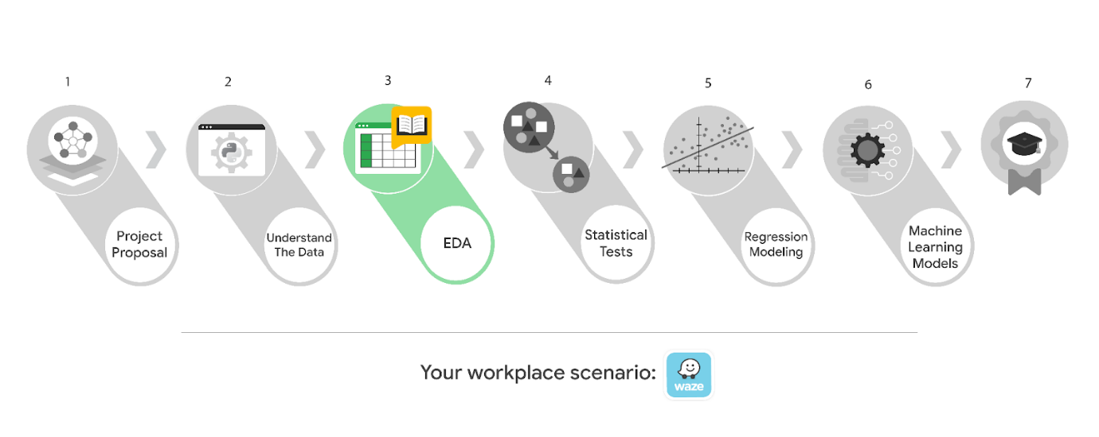

Learn more about the project, your role, and expectations in this reading.

## **Background on the Waze scenario**

Waze’s free navigation app makes it easier for drivers around the world to get to where they want to go. Waze’s community of map editors, beta testers, translators, partners, and users helps make each drive better and safer. Waze partners with cities, transportation authorities, broadcasters, businesses, and first responders to help as many people as possible travel more efficiently and safely.

You’ll collaborate with your Waze teammates to analyze and interpret data, generate valuable insights, and help leadership make informed business decisions. Your team is about to start a new project to help prevent user churn on the Waze app. Churn quantifies the number of users who have uninstalled the Waze app or stopped using the app. This project focuses on monthly user churn.

This project is part of a larger effort at Waze to increase growth. Typically, high retention rates indicate satisfied users who repeatedly use the Waze app over time. Developing a churn prediction model will help prevent churn, improve user retention, and grow Waze’s business. An accurate model can also help identify specific factors that contribute to churn and answer questions such as:

* Who are the users most likely to churn?
* Why do users churn?
* When do users churn?

For example, if Waze can identify a segment of users who are at high risk of churning, Waze can proactively engage these users with special offers to try and retain them. Otherwise, Waze may lose these users without knowing why.

Your insights will help Waze leadership optimize the company’s retention strategy, enhance user experience, and make data-driven decisions about product development.

### **Project background**

Waze’s data team is working on the churn project. The following tasks are needed before the team can begin the data analysis process:

* EDA and cleaning
* Select and build visualization(s) type
  + Create plots to visualize variables and relationships between variables
* Share your results with the data team

### **Your assignment**

You will conduct exploratory data analysis on data for the churn project. You’ll also use tools to create visuals for an executive summary to help non-technical stakeholders engage and interact with the data.

## **Team members at Waze**

### **Data team roles**

* Harriet Hadzic - Director of Data Analysis
* May Santner - Data Analysis Manager
* Chidi Ga - Senior Data Analyst
* Sylvester Esperanza - Senior Project Manager

Data team members have technical experience with data analysis and data science. However, you should always be sure to keep summaries and messages to these team members concise and to the point.

### **Cross-functional team members**

* Emrick Larson - Finance and Administration Department Head
* Ursula Sayo - Operations Manager

Your Waze team includes several managers overseeing operations. It is important to adapt your communication to their roles since their responsibilities are less technical.

***Note:*** The story, all names, characters, and incidents portrayed in this project are fictitious. No identification with actual persons (living or deceased) is intended or should be inferred. And, the data shared in this project has been created for pedagogical purposes.

## **Specific project deliverables**

With this end-of-course project, you will gain valuable practice and apply your new skills as you complete the following:

* Complete the questions in the Course 3 PACE strategy document
* Answer the questions in the Jupyter notebook project file
* Clean your data, perform exploratory data analysis (EDA)
* Create data visualizations
* Create an executive summary to share your results

Good luck with this project! Your Waze team members are looking forward to seeing how you communicate your creative work and approach problem-solving!

## **Key takeaways**

The Google Advanced Data Analytics Certificate end-of-course project is designed for you to practice and apply course skills in a fictional workplace scenario. By completing each course’s end-of-course project, you will have work examples that will enhance your portfolio and showcase your skills for future employers.

To pass this practice quiz, you must receive 100%, or 1 out of 1 point, by completing the activity below. You can learn more about the graded and practice items in the [course overview](https://www.coursera.org/learn/go-beyond-the-numbers-translate-data-into-insight/supplement/2wUrM/course-3-overview).



## Activity Overview



In this activity, you will demonstrate your ability to organize, present, and share the stories within data. You will also update team members through an executive summary, demonstrating your ability to organize and communicate key information.

For additional information on how to complete this activity, review the previous readings: [End-of-course project introduction](https://www.coursera.org/learn/foundations-of-data-science/supplement/9Opfe/end-of-course-portfolio-project-introduction) and [Course 3 end-of-course portfolio project overview: Waze](https://www.coursera.org/learn/go-beyond-the-numbers-translate-data-into-insight/supplement/pFnXC/course-3-end-of-course-portfolio-project-overview-waze).

Be sure to complete this activity before moving on. The next course item will provide you with completed exemplars to compare to your own work. You will not be able to access the exemplars until you have completed this activity.

## Scenario



Your team is making progress on their project to develop a machine learning model to predict user churn. So far, you’ve completed a project proposal and used Python to inspect and organize Waze’s user data.

You check your inbox and notice a new message from Chidi Ga, your team’s Senior Data Analyst. Chidi is pleased with the work you have already completed and requests your assistance with Exploratory Data Analysis (EDA) and further data visualization. You also notice a follow-up email from the Director of Data Analysis, Harriet Hadzic. Harriet suggests including an executive summary of your analysis to share with teammates.

***Note:*** Team member names used in this workplace scenario are fictional and are not representative of Waze.

\_\_\_\_\_\_\_\_\_\_\_\_\_\_\_\_\_\_\_\_\_\_\_\_\_\_\_\_\_\_\_\_\_\_\_\_\_\_\_\_\_\_\_\_\_\_

**Email from Chidi Ga, Senior Data Analyst**

**Subject:** EDA & Data Viz

**From:** “Chidi Ga,” Chidi@waze

**Cc:** “May Santner,” May@waze; “Harriet Hadzic,” Harriet@waze

Hi there,

Thanks for the amazing work you’ve done so far.

We’re ready to perform EDA on our user data. Has May told you what the leadership team expects when it comes to EDA? If not, think of it as a “show your work” kind of report. They will want to see a Python notebook showing the structuring and cleaning you did, and any data visualizations you created to better understand the data. To start, I suggest you create a box plot of the variable “drives,” and a scatter plot of the variables “drives” and “sessions.” Feel free to add any other visuals you think are useful.

By the way, I cc’d our director, Harriet Hadzic, who is on the leadership team and will be reviewing our analysis. @Harriet, I want to keep you informed on our progress!

Thanks!

Chidi Ga

Senior Data Analyst

Waze

 – -  - — - - - - - - - – - - - - - - - - – - - - - – - - - - – - - - - - - - - – - - -

**Email from Harriet Hadzic, Director of Data Analysis**

**Subject:** RE:EDA & Data Viz

**From:** “Harriet Hadzic,” Harriet@waze

**Cc:** ““May Santner,” May@waze; “Chidi Ga,” Chidi@waze

Thanks for the update, Chidi!

Welcome to the team. We’re so glad to have you.

Along with the notebook, it would be really helpful if you included an executive summary of your analysis attached via email.

I appreciate your help!

Harriet Hadzic

Director of Data Analysis

Waze

## Step-By-Step Instructions



Follow the instructions to complete the activity. Then, go to the next course item to compare your work to a completed exemplar.

**Step 1: Access the templates**



To use the templates for this course item, click each link below and select Use Template.

Link to templates:

* [Course 3 PACE strategy document](https://docs.google.com/document/d/1iSHdbfQR6w8RClJNWai8oJXn9tQmYoTKn6QohuaK4-s/template/preview?resourcekey=0-ZIHnbxL1dd2u9A47iEVXvg)
* [Executive summary templates](https://docs.google.com/presentation/d/1Pps5GKxi1V31y2oRHRzU-xhJubkEYzCgEIfNjlEY3Og/template/preview)

OR

If you don’t have a Google account, you can download the templates directly from the attachments below:

[Activity Template\_ Course 3 PACE strategy document](https://d3c33hcgiwev3.cloudfront.net/lPsrq6DtQWWXhsNXyEWtoQ_5a7414eddcc44dbb9362673c724974f1_Activity-Template_-Course-3-PACE-strategy-document-.docx?Expires=1721692800&Signature=C36YyDqyMEIznBL1eArtJ7ZFdcyKwFfMoy-zhFLj6hayzQBN67MNPgFu5e8-VC8NbBtEjXF0ogGaPMIg6CsRyZgWsFSQmiuOBw5pyQa~ydSUU-Kfi9nDroxav~N-60mjGuR9XvptGz-G7X2bAE878oXzgYatxN31eEPJWqR8iJE_&Key-Pair-Id=APKAJLTNE6QMUY6HBC5A" \t "_blank)

[DOCX File](https://d3c33hcgiwev3.cloudfront.net/lPsrq6DtQWWXhsNXyEWtoQ_5a7414eddcc44dbb9362673c724974f1_Activity-Template_-Course-3-PACE-strategy-document-.docx?Expires=1721692800&Signature=C36YyDqyMEIznBL1eArtJ7ZFdcyKwFfMoy-zhFLj6hayzQBN67MNPgFu5e8-VC8NbBtEjXF0ogGaPMIg6CsRyZgWsFSQmiuOBw5pyQa~ydSUU-Kfi9nDroxav~N-60mjGuR9XvptGz-G7X2bAE878oXzgYatxN31eEPJWqR8iJE_&Key-Pair-Id=APKAJLTNE6QMUY6HBC5A" \t "_blank)

[Activity Templates\_ Executive summaries](https://d3c33hcgiwev3.cloudfront.net/u8mKnh29RDWQtPcirEmZfg_2ad252bcb31e435a8e229fb13c80e4f1_Activity-Templates_-Executive-summaries.pptx?Expires=1721692800&Signature=SUHlowWOHpNW8Im8FEbfvLyzr4~PfbCB4AfYWo5ursttx89JESrRPRJnKcapJbY8sELpWtgCimBmHFrh5BgmQAHgk6XabTZrmVVCM0pkq123Em4~UPdUq06W3pQ5tNOWOwqHHVTRhZP6nS5h8OIa2zR-GOfulCuMJeoRjz1JGoE_&Key-Pair-Id=APKAJLTNE6QMUY6HBC5A" \t "_blank)

[PPTX File](https://d3c33hcgiwev3.cloudfront.net/u8mKnh29RDWQtPcirEmZfg_2ad252bcb31e435a8e229fb13c80e4f1_Activity-Templates_-Executive-summaries.pptx?Expires=1721692800&Signature=SUHlowWOHpNW8Im8FEbfvLyzr4~PfbCB4AfYWo5ursttx89JESrRPRJnKcapJbY8sELpWtgCimBmHFrh5BgmQAHgk6XabTZrmVVCM0pkq123Em4~UPdUq06W3pQ5tNOWOwqHHVTRhZP6nS5h8OIa2zR-GOfulCuMJeoRjz1JGoE_&Key-Pair-Id=APKAJLTNE6QMUY6HBC5A" \t "_blank)

### **Step 2: Access the end-of-course project lab**



***Note***: The following lab is also the next course item. Once you complete and submit your end-of-course project activity, return to the lab instructions’ page and click ***Next*** to continue on to the exemplar reading.

To access the end-of-course project lab, click the following link and select Open Lab.

* [Course 3 Waze project lab](https://www.coursera.org/learn/go-beyond-the-numbers-translate-data-into-insight/ungradedLab/xSJyH/activity-course-3-waze-project-lab)

Your Python notebook for this project includes a guided framework that will assist you with the required coding. Input the code and answer the questions in your Python notebook to perform EDA and create data visualizations. Here are some helpful reminders for tasks:

* Import data
* Clean data
* Explore data
* Visualize data

You will also discover questions in this Python notebook designed to help you gather the relevant information you’ll need to write an executive summary for your team.

Use your completed PACE strategy document and Python notebook to help you prepare your executive summary.

### **Data Dictionary**



This project uses a dataset called waze\_dataset.csv. It contains synthetic data created for this project in partnership with Waze. Examine each data variable gathered.

The dataset contains:

**14,999 rows** – each row represents one unique user

**12 columns**

| **Column name** | **Type** | **Description** |
| --- | --- | --- |
| label | obj | Binary target variable (“retained” vs “churned”) for if a user has churned anytime during the course of the month |
| sessions | int | The number of occurrence of a user opening the app during the month |
| drives | int | An occurrence of driving at least 1 km during the month |
| device | obj | The type of device a user starts a session with |
| total\_sessions | float | A model estimate of the total number of sessions since a user has onboarded |
| n\_days\_after\_onboarding | int | The number of days since a user signed up for the app |
| total\_navigations\_fav1 | int | Total navigations since onboarding to the user’s favorite place 1 |
| total\_navigations\_fav2 | int | Total navigations since onboarding to the user’s favorite place 2 |
| driven\_km\_drives | float | Total kilometers driven during the month |
| duration\_minutes\_drives | float | Total duration driven in minutes during the month |
| activity\_days | int | Number of days the user opens the app during the month |
| driving\_days | int | Number of days the user drives (at least 1 km) during the month |

### **Step 3: Complete your PACE strategy document**



The **Course 3 PACE strategy document** includes questions that will help guide you through the Course 3 Waze workplace scenario project. Answer the questions in your PACE strategy document to use Python to conduct EDA and create a data visualization.

As a reminder, the PACE strategy document is designed to help you complete the contents for each of the templates provided. You may navigate back and forth between the PACE strategy document and the Python notebook. Make sure your PACE strategy document is complete before preparing your executive summary.

### **Step 4: Prepare an executive summary**



Your executive summary will keep your teammates at Waze informed of your progress. The one-page format is designed to respect teammates and stakeholders who may not have time to read and understand an entire report.

First, select one of the executive summary design layouts from the provided template. Then, add the relevant information. Your executive summary should include the following:

* A summary of the results of your Exploratory Data Analysis (EDA)

Complete your executive summary to effectively communicate your results to your teammates.

## **Pro Tip: Save the templates**

Finally, be sure to save a blank copy of the templates you used to complete this activity. You can use them for further practice or in your professional projects. These templates will help you work through your thought processes and demonstrate your experience to potential employers.

## What to Include in Your Response



Later, you will have the opportunity to assess your performance using the criteria listed below. Be sure to address the following elements in your completed activity.

**Course 3 PACE strategy document**:

* Answer the questions in the PACE strategy document

**Course 3 Waze project lab**:

* Perform Exploratory Data Analysis (EDA)
* Create data visualizations

**Course 3 visualization:**

* Create a scatterplot to enhance the visualization created with Python

**Course 3 executive summary**:

* Provide a summary of the results of your exploratory data analysis (EDA)

### 1.

Question 1

## Did you complete this activity?

1 point

Yes

**END OF THE COURSE**